Implementing Social Value: Cyber Buyers Guide

Table of Contents
Cyber Buyers: Implementing Social Value Guide 1
Introduction to Social Value and PPN 06/20 3
Summary of changes implemented at PPN 06/20 3
How CCS can help 4
Where to start: 4
Market Engagement: 5
Research: 5
Cyber Relevance Assessment 6
Tackling Economic Inequality 7
Involves: Create new businesses, new jobs and new skills 7
Fighting Climate Change 7
Equal Opportunity 8
Wellbeing 9
Covid-19 Recovery 9
Applying the Model 10
Understanding Relevance and Proportionality: 10
Example of the Software and Cyber Category Applying Social Value in Practice 11
Annexe 1: Social Value Checklist 14
References 15

Introduction to Social Value and PPN 06/20
As Social Value continues to move higher up the commercial agenda, it is important to explore the ways in which the cyber category can support customers and suppliers to implement the policy effectively. Social Value consists of five major themes; Tackling Economic Inequality, Fighting Climate Change, Equal Opportunity, Wellbeing and COVID-19 Recovery. Whilst detailed guidance is available here, the purpose of this document is to provide an overview of what the new procurement policy notice means to the cyber category and how we can support the cyber buying community.

Summary of changes implemented at PPN 06/20
- All central government bodies will be required to explicitly evaluate social value in tenders from 01/01/2021.
- This involves including a social value qualitative assessment rather than just ‘considering’ social value as previously set out in the 2012 guidance.
- The weighting for social value evaluation must be a minimum of 10% of the qualitative assessment.
- Commercial teams retain flexibility in deciding which of the outcomes should be applied to their particular procurement to ensure relevance and proportionality
- Reporting is required.

How CCS can help
The section below outlines the support available to CCS cyber customers should they require any assistance when embedding Social Value assessments into their procurements. The section provides advice for approaching Social Value, Market Engagement and Research.

Where to start:
As with any new policy implementing Social Value may seem like a complicated challenge, however in practice it is quite simple. The steps below are not mandatory but have been designed to help develop an understanding of social value and what it means in practice. A checklist of these activities is also available in Annexe 1.
- Training: Register with the Government Commercial College and take the ‘Social Value for Commercial Success’ e-learning course. This course takes less than an hour to complete, it's available to all central government and ALB commercial staff. It provides a holistic overview of what social value is, why it is important and how to implement it.
- Familiarise yourself with PPN 06/20: The PPN outlines everything you need to know about the updates to the policy and how to implement it.
- Review Strategic Objectives: Before deciding which social value theme is most relevant to your cyber procurement, it is useful to consider what the strategic priorities and objectives of your own organisation are so that outcomes can be aligned. This will be different for every organisation e.g. Local Authorities may be more interested in creating jobs by developing local talent, whereas central government bodies may be more concerned with a reduction in energy consumption.
- Choose a Theme: Once you are comfortable with the requirements of the PPN and you have an idea of how social value can align with the strategic objectives of the organisation, the next step is to choose which theme to assess against. This will involve reading the published guidance on applying the model to determine which theme and deliverables are most appropriate for your cyber procurement.
- Test the Market: It is important to determine whether the theme and deliverables you have identified as relevant to your requirement are proportional to the capabilities of the market i.e. will suppliers realistically be able to deliver what you are asking. It is advised that at this stage you carry out pre-market engagement to determine whether there are any potential barriers that are preventing smaller organisations from bidding.
- Create the requirement: The social value assessment must be qualitative and make up at least 10% of the overall weighting. The guidance here offers details on how to approach this with examples of questions and scoring criteria. Writing any award question requires a skillful approach but for social value questions it is recommended to take ‘forward thinking’ (what suppliers plan to achieve, rather than what they have already done) instead of asking for policies.
- Reporting: The method and frequency of reporting is flexible and can take any shape that you deem appropriate e.g. monthly KPI reviews, SLAs etc. The reference table here includes suggestions on reporting metrics. Reporting should address progress and impact against the social value commitment that the chosen supplier is contracted for.

Market Engagement:
When embedding new policy into procurements it is important to offer support to the market. There are various routes to market for cyber buyers via CCS agreements (Cyber Security Services 3 DPS, GCloud, TEPAS, DOS) market engagement should be considered thoroughly to test which areas of social value are reasonable for suppliers to deliver. Should the buying community need help with this, CCS can support market engagement activities by leveraging their existing relationships with suppliers.
At CCS, we maintain regular communication with Cyber suppliers, through monthly and quarterly meetings. Social Value is increasingly incorporated into these discussions with the market, therefore if there is a particular area of social value you would like to test with the market, please do get in touch.

Research:
The Software and Cyber Team have a broad knowledge and understanding of the technology landscape. The Cyber Security Services Category Strategy includes a section on social value which investigates each social value theme and identifies which themes are most relevant to the cyber industry. The Relevance Assessment in the following section below offers an overview of areas fitting to the category. A range of sources including journals and cyber specific articles were consulted to inform this decision.

Cyber Relevance Assessment
As a starting block for cyber buyers, the below table offers assistance to commercial teams struggling to determine how relevant the social value themes may be to their cyber related procurement. The relevance assessment is designed to offer a snapshot of areas where the model ties in with their procurement and the cyber industry. Please note this should be used in conjunction with the Social Value Model and commercial teams (ccs customers) leverage the flexibility to determine their own social value requirements based on their departmental objectives.
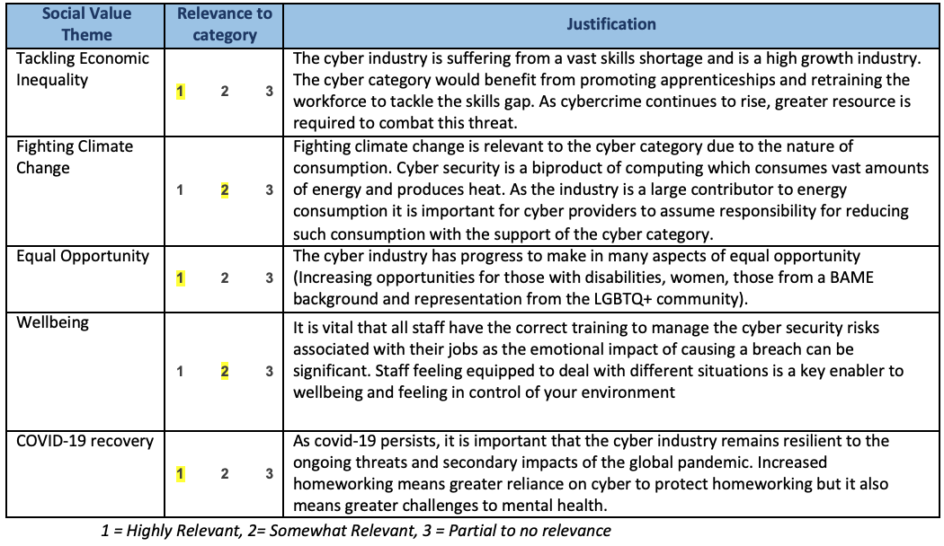

Tackling Economic Inequality

Involves: Create new businesses, new jobs and new skills
Cyber requirement
As the Cyber Industry is experiencing a vast skills shortage (80%) with over 10,000 vacancies in cyber security across the U.K., efforts should be focussed on reducing the skills gap. The deliverables below highlight measures that should be adopted to tackle economic inequality.
Deliverables Relevant to Cyber:
- Create employment and training opportunities, particularly for people in industries with known skills shortages or in high growth sectors.
- Support educational attainment relevant to the contract, including training schemes that address skills gaps and result in recognised qualifications.
- Influence staff, suppliers, customers and communities through the delivery of the contract to support employment and skills opportunities in high growth sectors.

Fighting Climate Change
Involves: Effective stewardship of the environment
Cyber requirement
Cyber security is a by-product of computing which contributes to climate change due to the large energy consumption and heating. The largest contributors to the issue lie with the following components of computing: Supercomputers, Blockchain mining & Data centres. It is therefore important for suppliers in the cyber industry to take responsibility for their contributions and reduce their emissions, ideally committing to operating at carbon net zero.
“Net zero” means achieving a state where the greenhouse gases (GHGs) emitted do not exceed the gases being removed from the atmosphere, so that the overall balance is zero.
Deliverables Relevant to Cyber:
  - Deliver additional environmental benefits in the performance of the contract including working towards net zero greenhouse gas emissions.
  - Influence staff, suppliers, customers and communities through the delivery of the contract to support environmental protection and improvement.

Equal Opportunity
Involves: Reduce the disability employment gap, Tackle workforce inequality.
Cyber requirement
Equality and diversity is pertinent to the Cyber Security industry as recent figures show that women make up less than 20% of the workforce (WEF, 2019). Tackling the gender disparity should remain a priority for the category in order to influence the market further. 11.7% of Civil Servants are disabled (UK Gov, 2019) therefore it is important that the cyber security systems procured are accessible for all end users. The cyber industry would benefit from prioritising this area of Social Value as there are currently concerns surrounding the under representation of Women, Trans People, Disabled people and people from a BAME background in Cyber Security (NCSC, 2020)
Deliverables Relevant to Cyber:
- Demonstrate action to increase the representation of disabled people in the contract workforce.
- Support disabled people in developing new skills relevant to the contract, including through training schemes that result in recognised qualifications.
- Influence staff, suppliers, customers and communities through the delivery of the contract to support disabled people.
- Support in-work progression to help people, including those from disadvantaged or minority groups, to move into higher paid work by developing new skills relevant to the contract.

Wellbeing
Involves: Improve health and wellbeing
Cyber requirement
The Covid-19 Pandemic has catalysed mental health challenges including loneliness, isolation, depression and anxiety (Health.org, 2020). This is a universal issue with far-reaching impacts for staff and suppliers alike. Those procuring within the cyber category would therefore benefit from promoting and improving wellbeing
It is important that all staff have the correct training to manage the cyber security risks associated with their jobs as the emotional impact of causing a breach can be significant. Staff feeling equipped to deal with different situations is a key enabler to wellbeing and feeling in control of your environment
Deliverables Relevant to Cyber:
- Demonstrate action to support the health and wellbeing, including physical and mental health, in the contract workforce.
- Influence staff, suppliers, customers and communities through the delivery of the contract to support health and wellbeing, including physical and mental health.

Covid-19 Recovery
Involves: Help local communities to manage and recover from the impact of COVID-19
Cyber requirement
As covid-19 persists, it is important that the cyber industry remains resilient to the ongoing threats and secondary impacts of the global pandemic. Increased homeworking means greater reliance on cyber to protect homeworking. It is expected that departments and suppliers adopt a collaborative approach to COVID-19 recovery. Given the nature and stability of the industry it seems appropriate for technology suppliers to support organisations and businesses to manage and recover from the impacts of COVID-19, including retraining those facing redundancy and supporting new ways of working to deliver services.
Deliverables Relevant to Cyber:
- Create employment, re-training and other return to work opportunities for those left unemployed by COVID-19, particularly new opportunities in high growth sectors.
- Support organisations and businesses to manage and recover from the impacts of COVID-19, including where new ways of working are needed to deliver services.
- Support the physical and mental health of people affected by COVID-19, including reducing the demand on health and care services.

Applying the Model
Applying social value can be approached from two major angles; local social value and strategic social value. As cyber security services are delivered remotely, it is most likely that cyber buyers will approach social value from a strategic perspective. Strategic social value may not be confined to a definite delivery date or plan, but as highlighted in the relevance assessment aims to create social impacts and benefits across an entire organisation, profession, supply chain or market.

Understanding Relevance and Proportionality:
As outlined above relevance and proportionality is largely determined at steps 3-6 of the ‘Where to Start’ section of this guidance. Further details on this is available below, as extracted from the cabinet office guidance.
● Social value award criteria are likely to be sufficiently relevant to the subject-matter of the contract if they relate to the works, goods or services to be provided under the contract. This could include how the works, goods or services are produced or provided, or how they are maintained or disposed of.
● Social value award criteria are likely to be proportionate if they are framed specifically to meet the requirement and they do not go beyond this. Proportionality will also be relevant to the weighting applied to social value. The overall weighting allocated to social value, and the weightings of individual evaluation criteria, should be proportionate taking into account how important the social value outcome is to the procurement and the other criteria.

Example of the Software and Cyber Category Applying Social Value in Practice

The cabinet office has published extensive guidance including examples of applying the model on the gov.uk website. An example of Social Value being incorporated into a CCS commercial agreement can be seen below. This question is adapted from a recent software framework competition and was evaluated in the Award Questionnaire of the bid:

Theme | COVID-19 recovery and Social Mobility
Weighting | 10%
Question | Describe your organisation’s contributions to helping communities to  manage and recover from the impact of COVID-19 and to improve social mobility. This may include activities that, in the delivery of the contract :-  - Create employment, training and other return to work opportunities for  those left unemployed by COVID-19, particularly for those who face barriers  to employment and/or who are located in deprived areas.  - Support people and communities to manage and recover from the impacts  of COVID-19, including those worst affected or who are shielding.  - Support organisations and businesses to manage and recover from the  impacts of COVID-19, including where new ways of working are needed to  deliver services.  - Support the physical and mental health of people affected by COVID-19,  including reducing the demand on health and care services.  - Improve workplace conditions that support the COVID-19 recovery effort  including effective social distancing, remote working, and sustainable travel solutions.  Criteria: You must demonstrate how your organisation will support the creation of employment, re-training and other return to work opportunities:  a) for those left unemployed by COVID-19, particularly new opportunities in high growth sectors;  b) for those who face barriers to employment and/or who are located in deprived areas, and/or work in industries with known skills shortages.  Your response for a) and b) should cover the following activities within the component parts:  i) What activities you lead or contribute to, which have or will result in educational attainment relevant to the contract, including training schemes that address skills gaps and result in recognised qualifications.  ii) How you will influence and support staff, suppliers, customers and communities through the delivery of the contract to support employment, skills opportunities, physical and mental wellbeing.
Guidance | Guidance:  Your answer may include examples where you have improved social mobility and how you will adapt these to specific groups/ areas affected by COVID-19.  You may include examples of activities to create a diverse supply chain to deliver the contract including new businesses and entrepreneurs, start-ups, SMEs, VCSEs and mutuals.]

Contact us

If you have any questions around the cyber buyers social value guidance or have any cyber procurement queries, please do get in touch with us at: cybercategory@crowncommercial.gov.uk

Annexe 1: Social Value Checklist

Activity | Completed
Undertake the Social Value e-training
Read PPN06/20
Review and Prioritise Strategic Objectives
Choose a Theme
Test theme with the market
Receive feedback from suppliers
Create the question
Determine deliverables
Determine criteria and weighting
Agree reporting method and frequency
Carry out Impact review

References
- Digital Skills Gap - 87% of Cyber firms state biggest challenge is the digital skills gap. https://assets.publishing.service.gov.uk/government/uploads/system/uploads/attachment_data/file/807830/No_Longer_Optional_Employer_Demand_for_Digital_Skills.pdf
- EU Exit and Cyber Security https://www.sciencedirect.com/science/article/pii/S1361372316300525
- ONS - UK economy - https://www.ons.gov.uk/economy/grossdomesticproductgdp/bulletins/gdpmonthlyestimateuk/june2020
- D&I in Cyber Security https://www.ncsc.gov.uk/files/Decrypting-Diversity-v1.pdf
- World Economic Forum - Gender Parity http://reports.weforum.org/global-gender-gap-report-2020/the-future-of-gender-parity/
- Annex A Accessibility Manual - https://www.gov.uk/service-manual/helping-people-to-use-your-service
- Annex B Cyber Essentials Scheme - https://assets.publishing.service.gov.uk/government/uploads/system/uploads/attachment_data/file/526200/ppn_update_cyber_essentials_0914.pdf

