Laundry and Linen Services
(RM1031)
Customer Guidance Notes

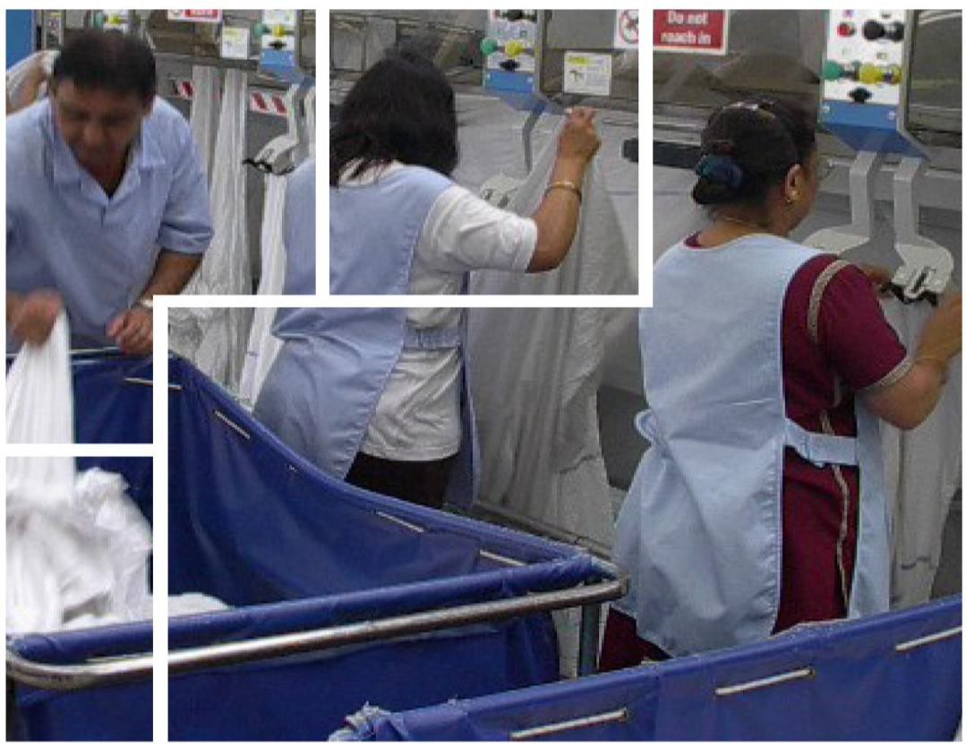

19 November 2015 to 18 November 2017
+ option to extend up to 24 months

Contents

- Introduction page 3
- Background page 4
- Framework overview page 5
- Mandatory services page 6
- Additional services page 11
- Standards page 12
- The benefits of using the agreement page 13
- Accessing and using the agreement page 14
- General Advice on running a Further Competition page 17
- Sustainability page 20
- Additional assistance page 21

- Introduction

This document is for guidance only. It is not a  contractual document and does not form part of the framework agreement nor any resulting call-off contracts.  From December 2015, if you are considering running a further competition or e-Auction, please contact:  Laundry Category Manager  Tel: 0151 672 2309  E-mail:  laundry.services@crowncommercial.gov.uk  This guide is designed for customers wishing to use the Laundry and Linen Services agreement (RM1031). It outlines the background to the agreement, the services available and the steps involved in undertaking further competition.  This guide to the Laundry and Linen Services agreement contains commercially confidential information  It will help you:  - Identify and work with suitable suppliers  - Access and make the most of the benefits and savings available  - Know who to contact for help and clarification  The guide contains commercially confidential information that must be used only for the purpose of official business and may be shared only with eligible parties.  Contract ref: RM1031 Period of Contract: 19/11/2015 – 18/11/2017  + 2 x 12 month options to extend | If you currently have a contract for any of  the services covered by this framework, you should ascertain whether better Value for Money could be obtained by using this framework agreement.  An investment analysis and business case may be required in order to support a decision to switch suppliers.  The guide will also help advise potential customers on how to work with suppliers through the framework.  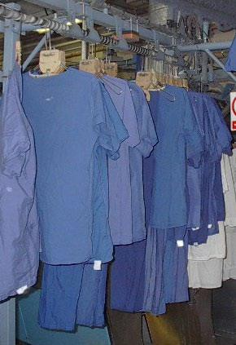

- Background

History  This framework was historically provided by the NHS Purchasing and Supply Agency (PASA) who transferred to Buying Solutions in October 2009. The RM849 agreement, which expired on 24 May 2015, was undertaken by Crown Commercial Service, and this agreement continues to provide laundry and linen services to all central government and wider public sector organisations, not just the NHS.  Aims of the agreement  The agreement aims to provide cost-effective and quality controlled laundry and linen outsourced services. It is a key project supporting the Department of Health’s objective to enhance the safety and quality of services for users and patients.  The Framework Agreement is delivered in line with the NHS Laundry Guidance (CFPP 01-04 Decontamination of linen for health and social care) issued to health and other organisations throughout England and the UK.  Barrier theatre textiles  The processing (collection, wash, finish and return) of re-useable CE marked barrier theatre textiles (gowns, drapes, clean air suits) will be covered a separate agreement which is scheduled for award in spring 2016. | Public bodies eligible to use the  agreement  The agreement is available to NHS trusts, NHS bodies, hospices, UK police forces, all UK central government departments, their agencies and arm’s length bodies, local authorities in England and Wales, Scottish, Welsh and NI public bodies, housing associations, third sector and charities, and all other contracting authorities as listed in  VI.3 of the OJEU Notice 2015/S 129- 237768.  While the agreement is primarily aimed at NHS Trusts and related bodies in England, it also allows for other Trusts in Scotland, Wales and Northern Ireland to access it. The agreement is also available to other bodies as outlined above. If your organisation is considering using the agreement, and is in any doubt as to the suitability and eligibility, please contract Crown Commercial Service at: laundry.service@crowncommercial.gov.uk

- Framework Overview

The Services  The framework for the provision of Laundry and Linen Services provides access to suppliers in one lot:  Lot 1: Processing (collection, wash, finish and return) of linen items / linen hire items  The agreement comprises Mandatory services (see Section 4 below) and Additional services (Section 5 below).  The mandatory services provided by suppliers are the processing (wash and finish) and transportation (collection and return) of linen items which are:  - owned by the contracting authority and / or  - hired by the contracting authority from the supplier.  Additional services, which are detailed in paragraph 7.1 of the specification, are also available.  Where services are provided to healthcare and social care establishments, suppliers will comply with the Department of Health’s policy and guidance Choice Framework for local Policy and Procedures (CFPP 01-04 Decontamination of linen for health and social care).  A list of 113 core articles form part of the framework (see Section 4: Mandatory Services, page 6). These articles account for the majority of most customer requirements.  Service enhancements and variations have been included as additional where possible (see Section 5: Additional Services, page 11). Some of these options will incur oncosts. | Suppliers  There are 11 suppliers in total:  - Berendsen UK Ltd  - Central Laundry Ltd  - East Lancashire Hospitals NHS Trust (ELHT)  - East Sussex Healthcare NHS Trust  - Express Linen Services Ltd  - Grosvenor Contracts (London) Limited  - Maidstone and Tunbridge Wells NHS Trust  - Royal Devon & Exeter NHS Foundation Trust  - Salisbury Trading Limited  - Synergy Health Managed Services Ltd  - The Pennine Acute Hospitals NHS Trust  Supplier contact details can be found on the framework page once you have logged onto the CCS website.  Pricing  Subject to paragraphs 8.11 to 8.15 of the Call-Off Schedule, the Call-Off Contract Charges will remain fixed for the first two years of the contract.  The earliest review date will be the first working day following the second anniversary of the Call-Off start date.

- Mandatory Services
Core List

Item Code | Category | Item
L1 | Bedding | Large Blanket
L2 | Bedding | Cot Blanket
L3 | Bedding | Knee / Half Blanket
L4 | Bedding | Thermal Covers - Lightweight
L5 | Bedding | Thermal Covers - Heavyweight
L6 | Bedding | Bed Sheet Single
L7 | Bedding | Bed Sheet Single high quality cotton
L8 | Bedding | Bed Sheet Double
L9 | Bedding | Bed Sheet Double high quality cotton
L10 | Bedding | Cot Sheet
L11 | Bedding | Pillowcases
L12 | Bedding | Pillowcases high quality cotton
L13 | Bedding | Canvasses stretcher
L14 | Bedding | Draw Sheet
L15 | Bedding | Counterpanes
L16 | Bedding | Counterpanes - cot
L17 | Bedding | Fitted Sheets Single
L18 | Bedding | Fitted Sheets Double
L19 | Bedding | Pillow
L20 | Bedding | Duvet Single
L21 | Bedding | Duvet Double

Item Code | Category | Item
L22 | Bedding | Covers Duvet single
L23 | Bedding | Covers Duvet Double
L24 | Bedding | Mattress Cover
L25 | Towels | Hand
L26 | Towels | Bath
L27 | Towels | Bath Sheet
L28 | Towels | Baby
L29 | Clothing | Dressing gowns - adult
L30 | Clothing | Nightdresses - adult (various)
L31 | Clothing | Nightshirts - adult
L32 | Clothing | Pyjama jackets – adult
L33 | Clothing | Pyjama trousers - adult
L34 | Clothing | Patient Clothing - small items
L35 | Clothing | Nappies
L36 | Clothing | Wrap - baby
L37 | Clothing | Dignity Giving Suit - top
L38 | Clothing | Dignity Giving Suit – bottom
L39 | Theatre Wear | Scrub suit trousers
L40 | Theatre Wear | Scrub suit tops
L41 | Theatre Wear | Surgeons gowns
L42 | Theatre Wear | Dresses
L43 | Uniforms | Nurses Dresses
L44 | Uniforms | White Coat long sleeved
L45 | Uniforms | White Coat short sleeved

Item Code | Category | Item
L46 | Uniforms | Dark Coat long sleeved
L47 | Uniforms | Cooks/Chefs Jacket
L48 | Uniforms | Cooks/Chefs Trousers
L49 | Uniforms | Skull Cap
L50 | Uniforms | Apron
L51 | Uniforms | Boiler Suit long sleeved
L52 | Uniforms | Boiler Suit short sleeved
L53 | Uniforms | Polo shirt
L54 | Uniforms | Shirts
L55 | Uniforms | Blouses
L56 | Uniforms | Jumpers
L57 | Uniforms | Tabard
L58 | Uniforms | Trousers
L59 | Uniforms | Tunic
L60 | Uniforms | Porters Jacket
L61 | Uniforms | Jackets
L62 | Uniforms | Skirts
L63 | Uniforms | Waistcoats
L64 | Uniforms | Ties
L65 | Uniforms | Bib & Brace
L66 | Uniforms | Overalls
L67 | Uniforms | Body Warmer
L68 | Uniforms | Long Coat
L69 | Uniforms | Tazer Suit

Item Code | Category | Item
L70 | Uniforms | Overcoat
L71 | Uniforms | High Visibility Jacket
L72 | Uniforms | Other
L73 | Gowns | Patient
L74 | Gowns | Bariatric
L75 | Gowns | Operation - adult
L76 | Gowns | X Ray-Blue
L77 | Gowns | Children
L78 | Gowns | Breast Screening
L79 | Gowns | Modesty
L80 | Gowns | Baby
L81 | Gowns | Custody
L82 | Other Items | Bath Mat
L83 | Other Items | Dish Cloth
L84 | Other Items | Dusters
L85 | Other Items | Cloth - Oven
L86 | Other Items | Gloves – Oven
L87 | Other Items | Slings
L88 | Other Items | Patient Slides
L89 | Other Items | Bed Pads
L90 | Curtains | Shower Curtain
L91 | Curtains | Curtains Small size upto 1.5 x 2m
L92 | Curtains | Curtains Medium size 2 x 2m
L93 | Curtains | Curtains Large size 3 x 3m

Item Code | Category | Item
L94 | Mops | Mops - Kentucky
L95 | Mops | Mops - Socket
L96 | Mops | Mops - Microfibre
L97 | Mops | Mops - Bonnet
L98 | Table Linen | Table Linen 144x70
L99 | Table Linen | Table Linen 90 x 90
L100 | Table Linen | Table Linen 108x70
L101 | Table Linen | Table Linen 70x70
L102 | Table Linen | Table Linen 54x54
L103 | Table Linen | Table Linen 36 x 36
L104 | Table Linen | Table Linen Round 110”
L105 | Table Linen | Table Linen Napkins
L106 | Table Linen | Cloths (waiter, glass, kitchen, oven)
L107 | Bags | Plastic
L108 | Bags | Polyester
L109 | Bags | Alginate Stitched Bag - Red
L110 | Bags | Water soluble bags (totally water soluble)
L111 | Towels | Tea Towel
L112 | Clothing | Tracksuit Top
L113 | Clothing | Tracksuit Bottom

- Additional Services
Service enhancements/variations, such as a 48 hour turnaround and a 6 or 7 day service, have been included where possible, as indicated in the table below. Some of these options incur a cost which will be advised by the category team.

Service

Supplier | Saturday service | Sunday service | Bank Holiday Service | 48 hours turnaround | Top up Service | Management of on-site bulk Linen storeroom | Management of uniforms | Scrub suit / theatre garment locker service | Pack to ward: onsite | Pack to ward: offsite | Barcoding / RFID | Finishing / Presentation on hangers | Repair / Alteration service
Berendsen UK Ltd. |   |  |  |  |  |  |  |  |  |  |  |  | 
Central Laundry Ltd. |  |  |  |  |  |  |  |  |  |  |  |  | 
East Lancashire Hospitals NHS Trust (ELHT) |  |  |  |  |  |  |  |  |  |  |  |  | 
East Sussex Healthcare NHS Trust |  |  |  |  |  |  |  |  |  |  |  |  | 
Express Linen Services Ltd. |  |  |  |  |  |  |  |  |  |  |  |  | 
Grosvenor Contracts (London) Ltd.
Maidstone and Tunbridge Wells NHS Trust |  |  |  |  |  |  |  |  |  |  |  |  | 
Royal Devon and Exeter NHS Foundation Trust |  |  |  |  |  |  |  |  |  |  |  |  | 
Salisbury Trading Ltd. |  |  |  |  |  |  |  |  |  |  |  |  | 
Synergy Health Managed Services Ltd. |  |  |  |  |  |  |  |  |  |  |  |  | 
The Pennine Acute Hospitals NHS Trust |  |  |  |  |  |  |  |  |  |  |  |  | 

Standards

Overall Approach  Suppliers are required to actively support current and emerging UK government initiatives throughout the duration of this agreement and any Call-Off Contracts. The policies include, but are not limited to:  Laundry Services for Health and Social Care Organisations  The health care aspect of the laundry and linen industry is now heavily regulated to ensure compliance with guidance regarding cleanliness. Some contracting authorities are NHS trusts and must comply with the ‘Health and Social Care Act 2008: Code of Practice on the prevention and control of infections and  related guidance’. These contracting authorities may wish to assure themselves that the services that they commission under this agreement comply with regulatory requirements, including a range of support services such as the provision of a laundry and linen service that reduces the risk of cross-infection and enhances the patient experience.  Where the services are being supplied to health and social care organisations (i.e. under Lot 1), the supplier will comply with the requirements of the Department of Health’s Choice Framework for local Policy and Procedures (CFPP 01-04 Decontamination of linen for health and social care). This publication provides guidance on the management, use and decontamination of healthcare and social care linen and consists of 4 parts: | - decontamination of linen for health and social care: management and provision  - decontamination of linen for health and social care: engineering, equipment and validation  - decontamination of linen for health and social care: social care  - decontamination of linen for health and social care: guidance for linen processors implementing European standard BS EN 14065.  The services and any standards set out in this specification may be refined (to the extent set out in Framework Schedule 4 (Call-Off Procedure)) by a contracting authority during a Call-Off Procedure to reflect its local CFPP 01-04 service requirements for a particular Call-Off Agreement. A contracting authority is entitled to conduct site visits to a supplier’s facilities as part of the further competition procedure.  Ecolabel Standard  The EU Ecolabel scheme is a commitment to environmental sustainability and is currently a voluntary scheme. If at any point this scheme is amended or replaced (either by enhancement, another agreement or by alternative government arrangements) the supplier will comply with or support the alternative as specified.

Benefits of using the agreement

13

- Saves time and money  - Simplifies the process and removes the cost to customers in procuring the services and providers  - Fully EU compliant agreement  - Consistent terms and conditions of contract  - Standardises KPIs  - Simplifies the process and removes the cost of procuring the services | - Robust and flexible solution  - Ability for customer to devise evaluation sub-criteria in line with specific requirements  - Range of regional and national suppliers  - Compliant service for the NHS to HTM01-04 (CFPP0104)  - Opportunities for further savings through further competition  - Fixed pricing mechanism for first two years of agreement

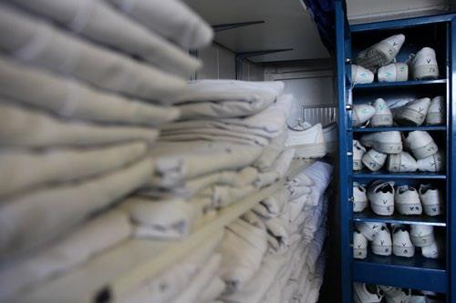

Accessing and using the agreement

Eligible Bodies  The agreement can be accessed by a wide range of public bodies throughout the UK, including: NHS trusts, NHS bodies, hospices, UK police forces, all UK central government departments, their agencies and arm’s length bodies, local authorities in England and Wales; Scottish, Welsh and NI public bodies, housing associations, third sector and charities, and all other contracting authorities as listed in VI.3 of the OJEU Notice 2015/S 129-237768.  How to access the framework  The agreement can be accessed via the Crown Commercial Service website: http://ccs-agreements.cabinetoffice.gov.uk/  Terms and Conditions  The agreement offers protection for users with one set of terms and conditions of contract. The framework is subject to specific terms and conditions. These apply between the Supplier and CCS (Framework Terms) and the Supplier and the Customer (Call-off Terms). If in doubt as to any of the provisions, please contact CCS for further guidance (see Additional Assistance, page 21.) | Additional / Non-core Services  Please refer to Section 6 (Framework Schedule 2) page 15 for full details of additional services, which include:  - Weekend and Bank Holiday services  - Express turnaround service  - On-site top-up service  - Management of on-site bulk linen storeroom(s)  - Specific packing / wrapping requirements (on or off site)  - Barcoding / Radio Frequency Identification (RFID)  - Finishing / presentation on hangers  - Management of uniforms  - Scrub suit / theatre garment locker service  - Curtain hanging and removal  - Total linen management service  - Sewing room / repair and alteration  - Logo affixing service  - Dry cleaning  - On-site theatre top-up service  - Colour flash affixing service

Further Competition process  PLEASE NOTE THAT DIRECT AWARD IS NOT PERMITTED UNDER THIS FRAMEWORK.  Contracting Authority 's Obligations  Any Contracting Authority awarding a Call Off Agreement under this Framework Agreement through a Further Competition Procedure shall:  - develop a Statement of Requirements for the Services and identify the Framework Suppliers capable of supplying the Services  - amend or refine the Template Call Off Form and Template Call Off Terms to reflect its Services Requirements;  - invite tenders by conducting a Further Competition Procedure for its Services Requirements and in particular:  - if an Electronic Reverse Auction is to be held, the Contracting Authority shall notify the Framework Suppliers identified and shall conduct the Further Competition Procedure in accordance with the framework rules.  - if an Electronic Reverse Auction is not used, the Contracting Authority shall:  - invite all the Framework Suppliers identified in accordance with the framework rules to submit a tender in writing for each proposed Call Off Agreement to be awarded by giving written notice by email to the relevant Supplier Representative of each Framework Supplier; and  - keep each tender confidential until the time limit set out for the return of tenders has expired. | - apply the Further Competition Award Criteria to the Framework Suppliers' compliant tenders submitted through the Further Competition Procedure as the basis of its decision to award a Call Off Agreement for its Services Requirements;  - on the basis set out above, award its Call Off Agreement to the successful Framework Supplier which Call Off Agreement shall:  - state the Services Requirements;  - state the tender submitted by the successful Framework Supplier;  - state the charges payable for the Services Requirements in accordance with the tender submitted by the successful Framework Supplier; and  - incorporate the Template Call Off Form and Template Call Off Terms (as may be amended or refined by the Contracting Authority in accordance with the framework rules) applicable to the Services  6) provide unsuccessful framework Suppliers with written feedback in relation to the reasons why their tenders were unsuccessful.

Award Criteria

Call-off contracts must be awarded on the basis of the top level award criteria contained in the framework agreement itself. Please refer to the main Framework Agreement document, p.88-89 for full details.
Contracting Authorities seeking to award a Call Off Agreement must do so on the basis of reopening competition under a Further Competition Procedure in accordance with the Call Off Procedure.
A Call Off Agreement shall be awarded on the basis of most economically advantageous tender ("MEAT") from the point of view of the Contracting Authority.
Framework Schedule 6 includes details of the evaluation criteria and any weightings that will be applied to that criteria.

Headline Criteria

The following criteria shall be applied to the Services set out in the Suppliers' compliant tenders submitted through the Further Competition Procedure:

E-Auctions

Please refer to the main Framework Document (Call off Procedure) p85.
The Contracting Authority shall be entitled to formulate its Statement of Requirements in accordance with the Further Competition process (summarised above) and invite the Supplier to a Further Competition Procedure including a reverse auction in accordance with the rules of the framework.
The Supplier acknowledges that Contracting Authorities may wish to undertake an electronic reverse auction, where Framework Suppliers compete in real time by bidding as the auction unfolds ("Electronic Reverse Auction").
Before undertaking an Electronic Reverse Auction, the relevant Contracting Authority will make an initial full evaluation of all tenders received in response to its Statement of Requirements. The Contracting Authority will then invite to the Electronic Reverse Auction only those tenders that are admissible in accordance with the Regulations. The invitation shall be accompanied by the outcome of the full initial evaluation of the relevant tenders.

Sub-Criteria
Criteria | % Evaluation | Max Score | Tolerance
Quality | 60% | 100% | +/- 10%
Price | 40%

Please refer to p89 of the main Framework Agreement (Award Criteria) Part B. Customers may refine sub-criteria (including weightings) in line with the overall headline criteria above in their Further Competition exercises.

General Advice

General advice on undertaking  a Further Competition  Use of Further competition allows you to re-open competition between the framework suppliers in a flexible, compliant way, allowing you to draw up a detailed specification which more precisely covers your requirements. For example, your specific requirements can include delivery and collection points, additional items not included in the core items, staffing and management arrangements for a total linen management requirement, transportation arrangements and costs where such opportunities are not provided for specifically in the framework itself.  Terms and Evaluation Criteria  Any new terms and evaluation sub-criteria should be in line with the overall terms and criteria laid down in the framework agreement.  Pricing of Mandatory Services  Suppliers’ prices for mandatory services are fixed for the first two years of the framework. This applies to the 113 core items as a maximum price, which may be improved upon (but not exceeded) at further competition (listed above in Section 4). These price schedules are available from Crown Commercial Service. | Drawing up your specification  The framework agreement utilises an output-based specification. Customer specifications should be drawn up on the same basis.  Running the Competition  There are a number of There are a number of options available to you when issuing further competition documents. You can use the online eSourcing tool or alternatively your own departmental standard tender process. This may be in hard format (involving the submission of paper tender documentation and receipt of paper bids) or electronic format (involving the use of an eTendering system or email process).  Documentation  As a minimum, customer documentation should include a brief, including:  - the information requested from the suppliers in response to the further competition;  - an explanation of the way in which bids will be marked  - details of the evaluation criteria that will be used to assess the bids  - details of the tender procedure and return date  - service information outlining the services that are to be included within the contract on a site by site basis  - confirmation and clarification for suppliers regarding operational and quality issues

Operational issues  Consider some or all of the following issues:  - Has the supplier sufficient capacity to undertake the work?  - Does the supplier have the capability to meet local turnaround times?  - What are the suppliers’ local contingency plans in the event of a plant failure?  - Ease of transport access (motorway and arterial road etc.) between plant and customer premises  - Confirmation that the supplier is able to meet contract start date  - The supplier should provide an Implementation Plan reflecting the customer’s specific needs set out in their Statement of Requirements / Specification  Quality  Consider some or all of the following issues:  - The service should comply with wider organisational requirements (e.g. local control of infection procedures)  - The provision of samples (linen hire)  - Tailor KPIs (see p65 of main Framework Document, “Part B, Framework Schedule 2 – Key Performance Indicators”) to your specification  - The customer should consider undertaking site visits to supplier premises  - The supplier to undertake site visits / surveys of customer premises | Contract Period  The individual contract between you and the supplier will form a standalone contract. You must specify the duration of this contract (and any options to extend) in your further competition and clearly state this in your documentation. The supplier must agree the length of the contract, and any contract extensions stipulated, particularly where this may extend the contract beyond the expiration date of the framework agreement.  Note that Crown Commercial Service recommends that the duration of the Call Off Contract Period should usually be no longer than four (4) years. If you consider that the Call Off Contract Period should be longer please speak to your legal and/or procurement team. See also Clause the template Call Off Terms for further guidance.  Supplier Interviews  As part of the further competition process, you may wish to hold clarification interviews with the participating suppliers, so that they are able to answer any questions you may have and explain elements of their bid further.  Award decision  Following the application of the weightings to your evaluation, a list of the participating contractors should be compiled, and ranked by the score achieved.  The contract should be awarded to the supplier that ranks first within the evaluation following the application of the pre-published evaluation and associated weightings. You should not change these at any time in the Further Competition

once you have started the tender process.

Making the Award

Once you have completed your evaluation exercise, and identified the successful supplier, communications should be issued to all participating suppliers notifying them of the outcome.

An opportunity should be given for each supplier to obtain debrief information which outlines the reasons why they have been unsuccessful with their tenders.

You should issue the template Call Off Order Form and Call off Terms to the supplier when you initiate your order and contract with the successful supplier. This must quote the Framework ID: RM1031

Contract Management

As the customer, you will effectively manage the supplier in the delivery and performance of the services they have been selected to undertake.
Regular review meetings should take place to discuss performance (using KPIs as a key tool in this process) and ensure that the services are being delivered to an acceptable standard, in accordance with your specification, call-off contract and local service arrangements.
If issues cannot be resolved to your satisfaction, then please inform the Crown Commercial Service Category Management team (see Section 12: Additional Assistance, below). We will then pursue your issue with the supplier and aim to provide you with a satisfactory outcome.

Sustainability

Introduction

Sustainability is an important issue across the Public Sector. Contracting bodies need assurance that services will be provided sustainably. Crown Commercial Service regards sustainability as a vital component of any and all commercial agreements formed under its frameworks and has mandated a detailed Sustainability Action Plan against which suppliers have to submit evidence of how they will reduce environmental impacts across the life-cycle of textile products. This can be found on p.134 of the main Framework Document (Framework Schedule 22: Sustainability Action Plan).

This Action Plan covers not just the delivery of environmental sustainability, but also covers social sustainability (the Government’s social agenda, equality issues, Labour standards, Social enterprises etc.)

Customers may wish to mandate their own specific milestones and priorities and targets within their own Statement of Requirements and Specifications that the supplier will meet in providing and improving its performance with regard to sustainability issues.

Additional Assistance

General Enquiries

Please contact the Customer Services Desk on 0345 410 2222

8.30am to 5.30pm Monday to Thursday 8.30am to 5.00pm Friday

or e-mail info@crowncommercial.gov.uk

Feedback

Should you experience any problems with the services provided by any of the suppliers under this framework and wish to register a complaint, in the first instance, please direct your concerns to the supplier to whom the complaint relates.

In the event that a resolution has not been provided to your satisfaction, the issue should be escalated to the Crown Commercial Service Contract Managers via the helpdesk, or by e-mailing:

laundry.services@crowncommercial.gov.uk

Liverpool  9th Floor Capital Building Old Hall Street Liverpool L3 9PP | London  1 Horse Guards Road Westminster  London SW1A 2HQ | Newport  Room 2Y92 Concept House Cardiff Road Newport NP10 8QQ | Norwich  Rosebery Court  St Andrews Business Park Norwich NR7 0HS

