Digital Outcomes and Specialists Buyer Webinar 2 – Guide to the Digital Marketplace 09.03.2020

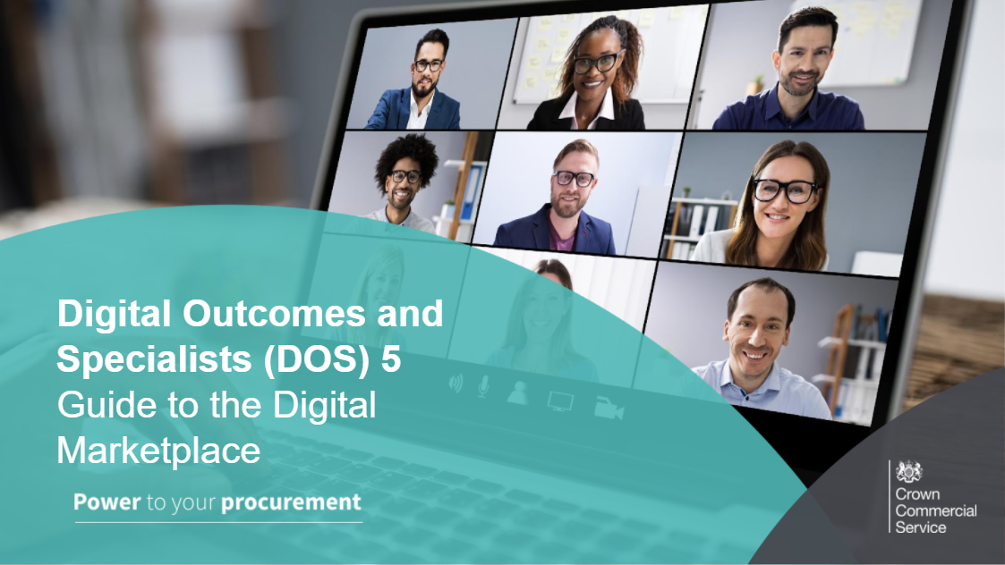
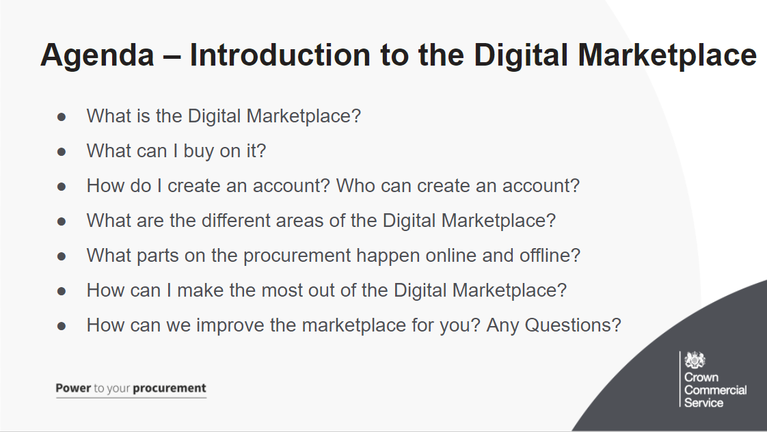
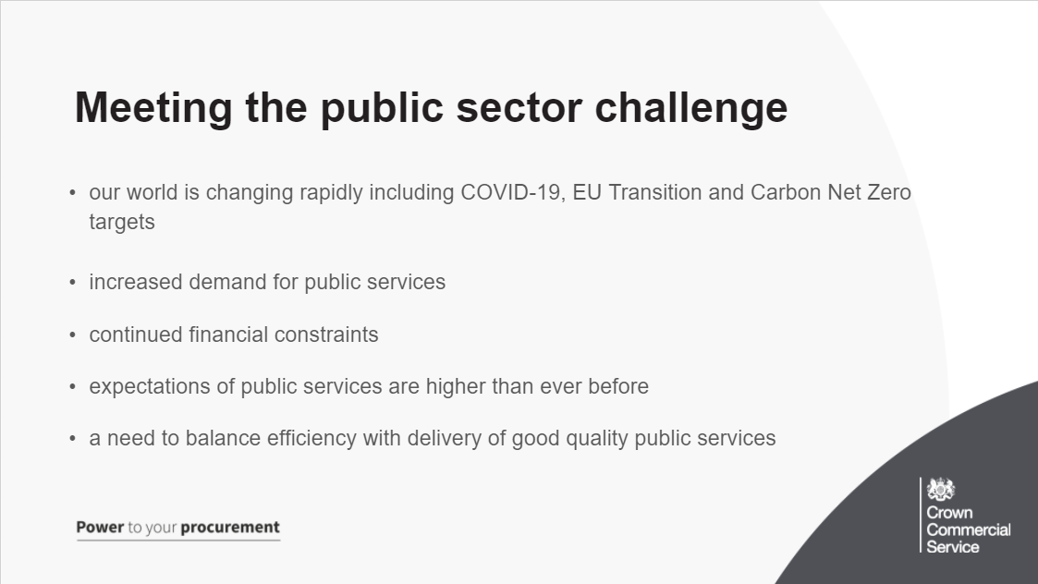
As you are all aware, the current world has changed a lot, with new challenges such as COVID19, the UK transition out of EU and a Carbon Net Zero target giving us more opportunities to adapt and overcome
Along with this comes increased demand for public services, alongside continued financial constraints
With the expectation of these public services higher than ever before, there is a need to balance efficiency with the delivery of a quality service
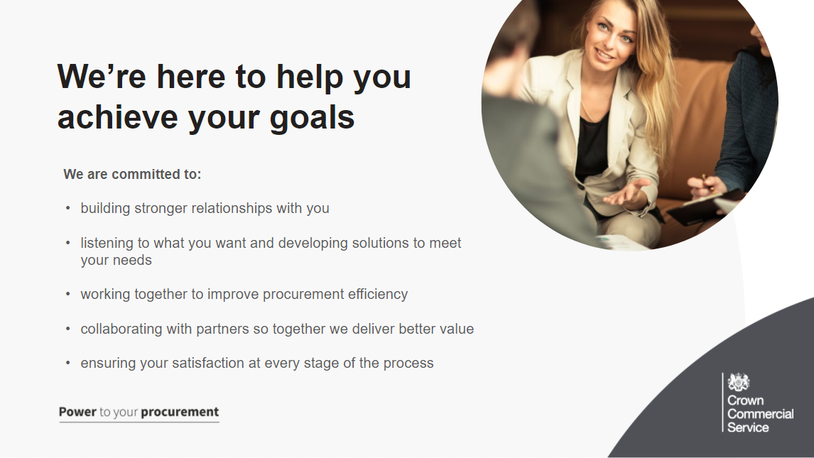
The team and wider CCS are committed to building this strong relationship, listening to what you want and need, develop solutions together in order to fulfil those.
Along the way, we want to have collaboration with partners and also to ensure satisfaction at any stage of the process. If you have any comments we are always here to listen.
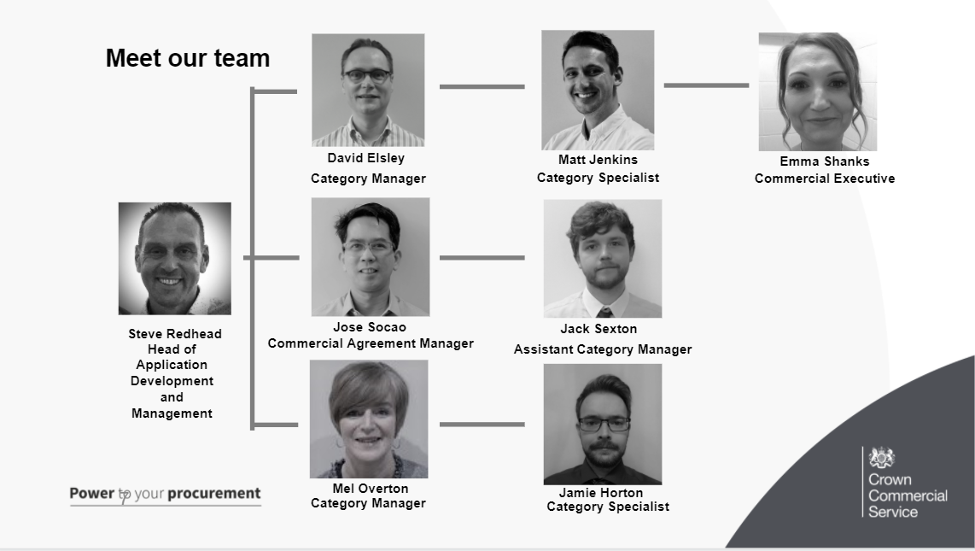

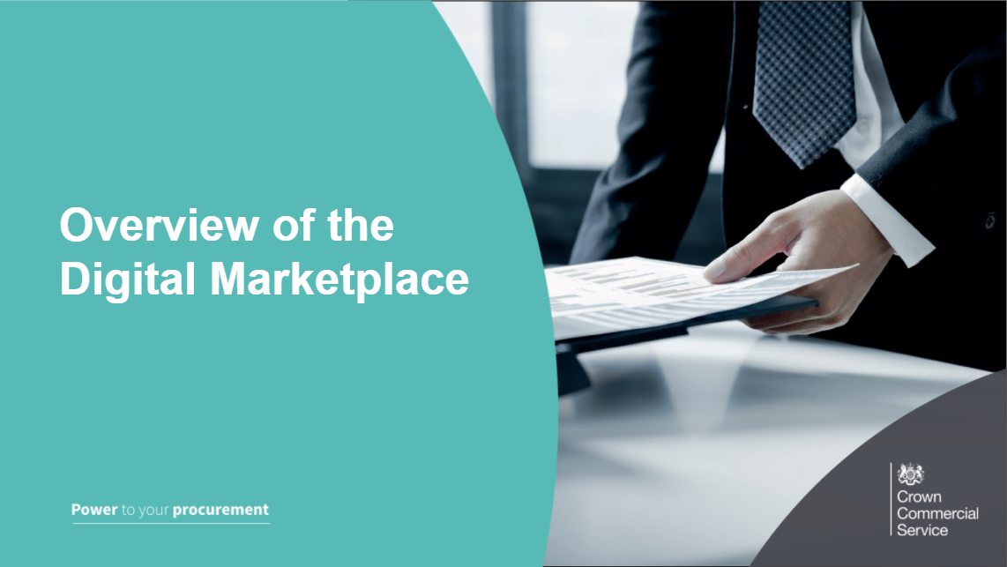
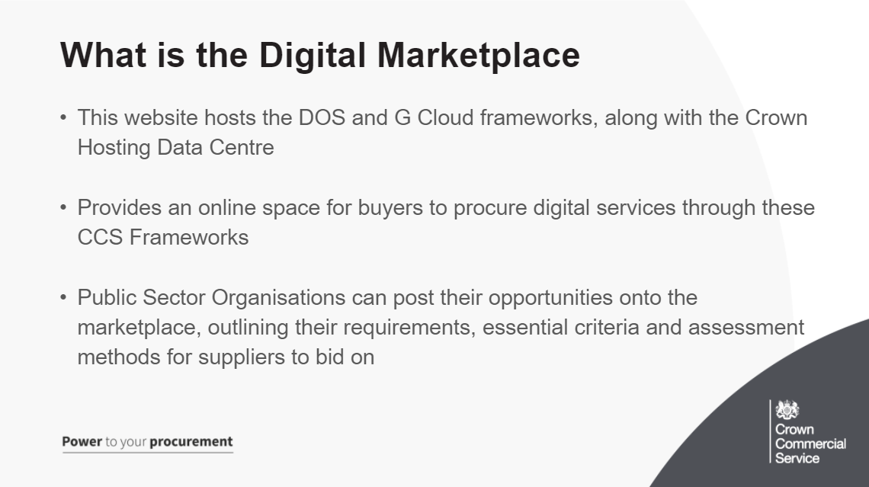
-The digital marketplace is a website that hosts the DOS framework and allows public sector organisations to find digital outcomes by posting their opportunities for suppliers to search through the marketplace and find ones relevant to the services they provide
-This is a space where buyers can advertise their opportunity on the marketplace and attract bids from the suppliers awarded to the framework. You will have a chance to answer their questions about your opportunity and then once the deadline has past read and shortlist their bids ready for the next stage of the procurement
-By having this part of the procurement online it saves time and money for you sourcing your own suppliers for a competition and acts in accordance to public contract regulations and creates a fair and open environment,
-Ensures your opportunity is seen by a range of qualified suppliers that results in a vast amount of quality responses for you to choose from and enhances the level of the service you procure at the end of the journey
-Just under 3,400 suppliers have been awarded onto the framework across 4 lots - 94% of these suppliers are SMEs
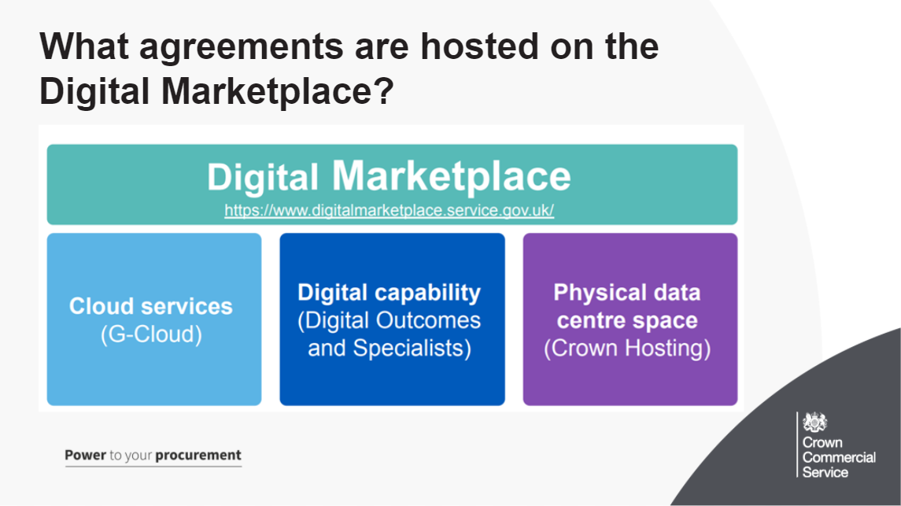
As you can see, the digital marketplace hosts 3 agreements, we will see where to locate these later in the webinar
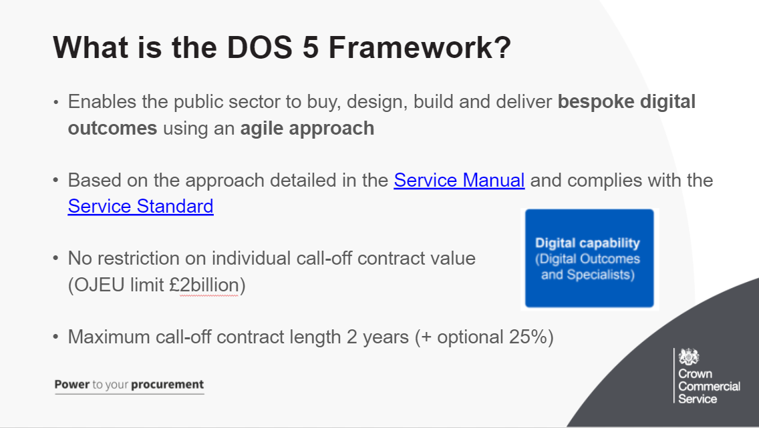
DOS enables the public sector to buy, design, build and deliver bespoke digital outcomes using an agile approach

Bespoke Digital Outcome: This is anything that solves a problem by offering you a digital solution for your particular needs. For example a digital outcome could be a discovery phase to create an information systems for a NHS department. This is tailored to the needs of the NHS department and uses a digital service to fix the need.
Agile Approach: This means that within the procurement, the approach to creating the bespoke outcome is based on user needs, and uses an iterative approach to recognise and accept changes when needed. The development is broken into smaller stages to capture changes in need, minimise risk and minimise any resources being wasted. By using Discovery, Alpha and Beta stages of development it allows the solution to evolve based on a possibly changing user need.
The Service Standard is a set of 18 criteria to help government create and run good digital services.
All public facing transactional services must meet this standard. It’s used by departments and the Government Digital Service (GDS) to check whether a service is good enough for public use. GDS do this checking through the spend control process for buyers in central government.
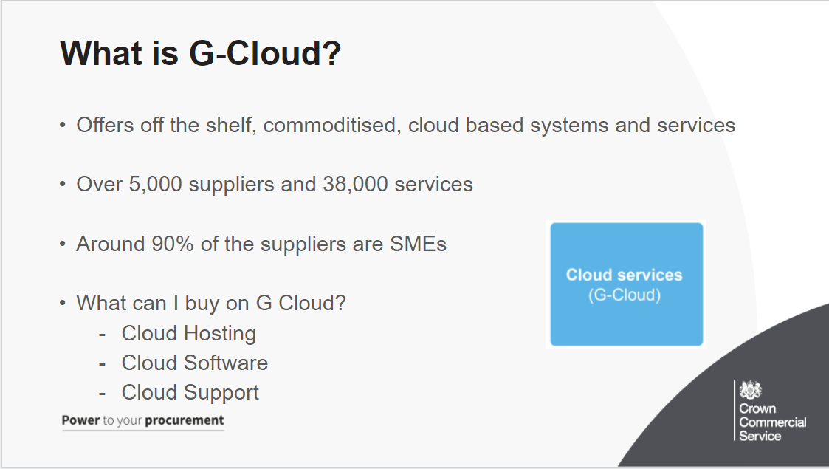
Cloud Hosting: Covers Infrastructure and Platform as a Service for example a computer server or storage in the cloud
Cloud Software: Is an application or service that can be run over the internet or cloud for example accounting tools or customer service management software
Cloud Support: Support your transition to IaaS, PaaS and SaaS for example migration to the cloud, configuration/implementation of services from Lots 1 & 2

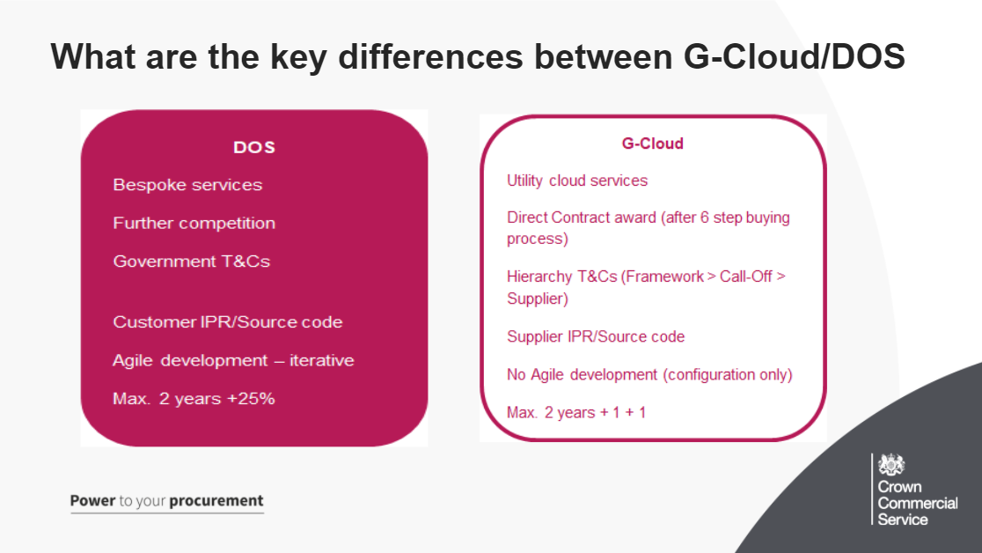
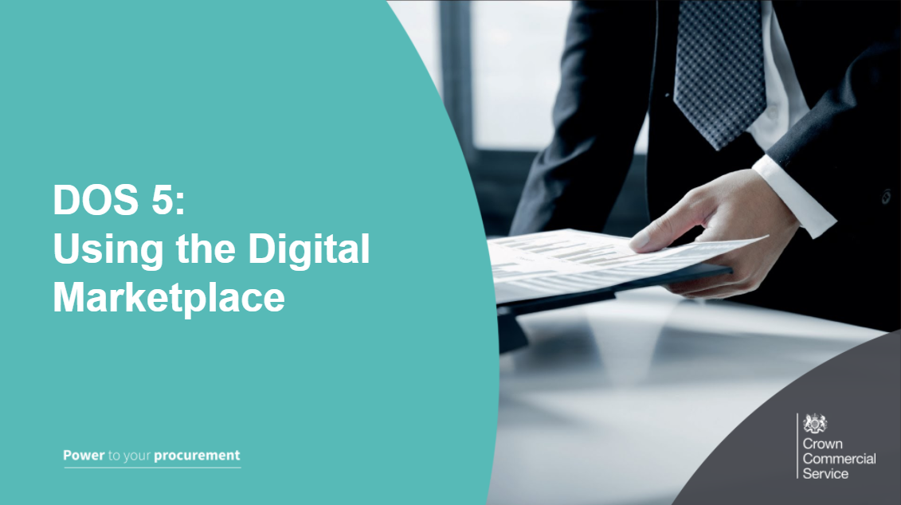
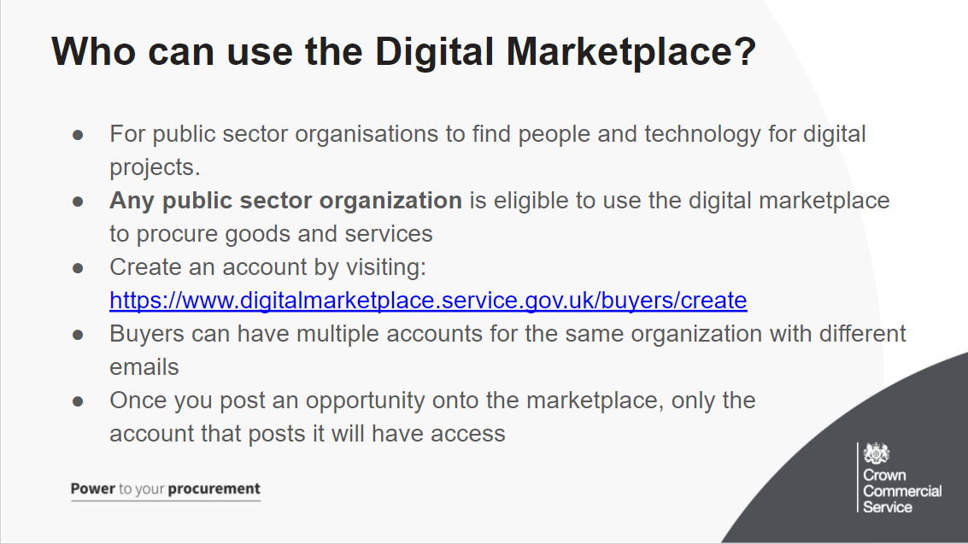
The digital marketplace is a website that hosts the DOS framework and allows public sector organisations to find digital outcomes by posting their opportunities for suppliers to search through the marketplace and find ones relevant to the services they provide
Any public sector organisation can create a buyer account on the Digital Marketplace and post an opportunity. If your domain isn’t accepted you can email the team and get them to check and add it to the marketplace
Although you can have multiple people within your organisation with accounts on the DmP, please be aware that only the account that posts the opportunitiy will have access to this – for the purpose of accessing supplier bids, answering supplier questions and other tasks within the procurement on the marketplace
Therefore, we recommend using an account that multiple people within your organisation have access to. This will avoid a situation where you cant access an opportunity posted if you happen to lose access to that email.
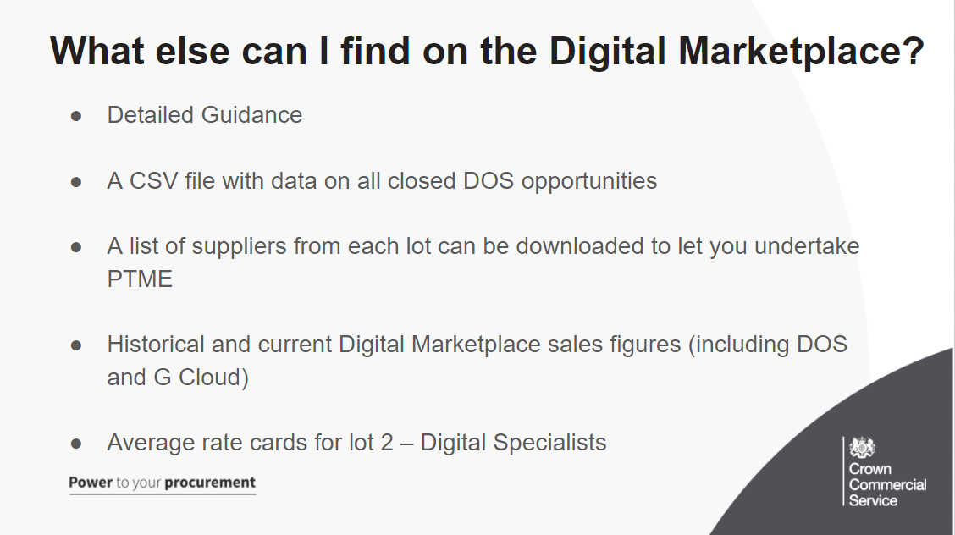
Not only is the DmP a place to post your opportunity, you can also find important information there to help with your procurement:
Guidance is available
A CSV file with data on the closed opportunities on the marketplace can be downloaded
A list of suppliers from each lot can be downloaded to let you undertake PTME
Historical and current Digital Marketplace sales figures (including DOS and G Cloud) are available
Average rate cards for lot 2 – Digital Specialists are available on request
If you needed any more bespoke information – contact the team at cloud_digital@crowncommercial.gov.uk to see what we can do for you
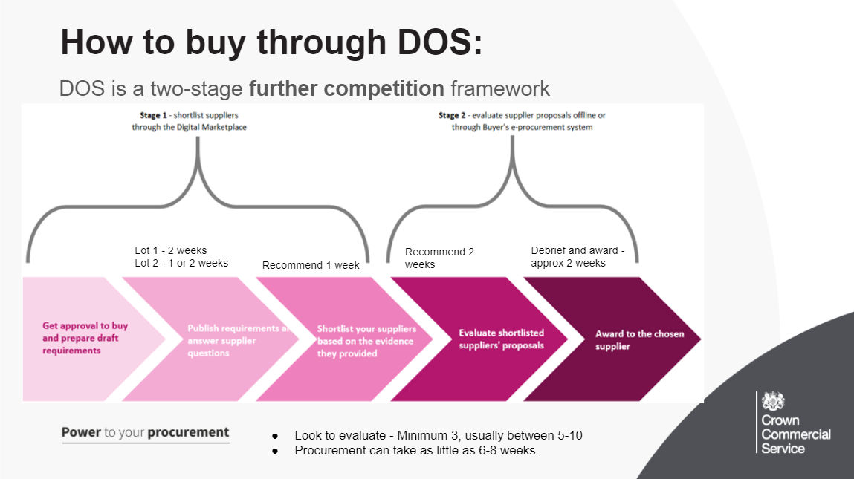
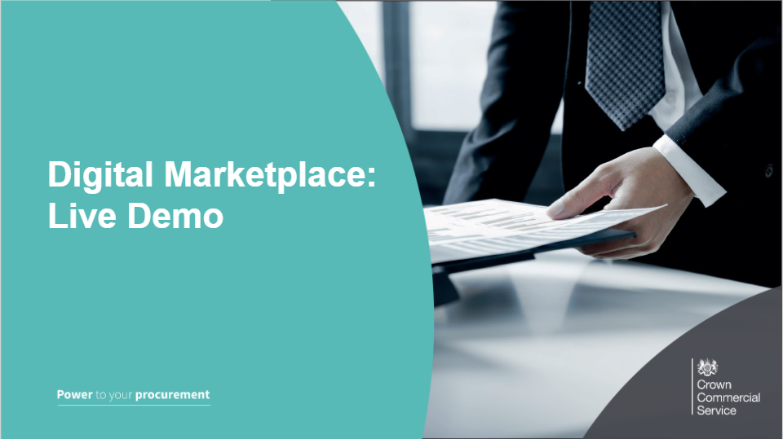

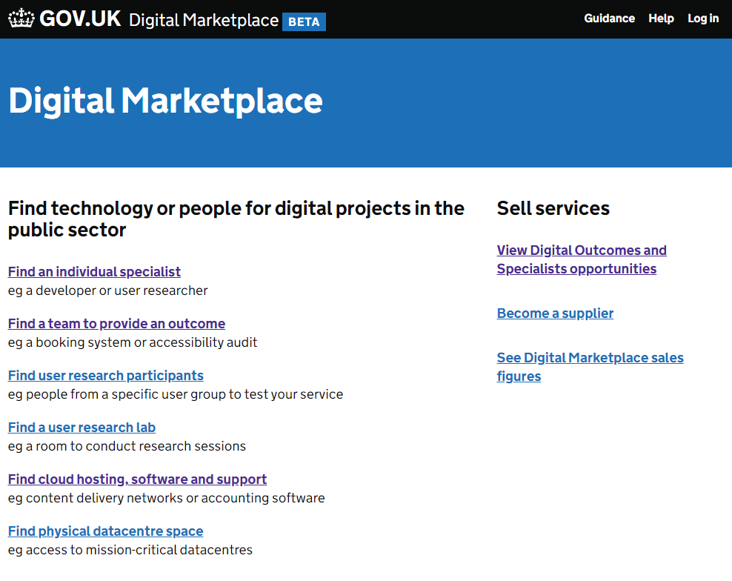
The Digital Marketplace is used to launch opportunities under DOS 5 and the system is open to all public sector buyers
Everything published on the Digital Marketplace is transparent and anybody can view opportunities that have been published, by heading to the link under Sell Services
Only appointed suppliers can respond to shortlisting opportunities
You can also view Digital Marketplace Sales figures, for G-Cloud and DOS, this includes historic spend and we also have a variety of buyer and supplier guidance available, which we suggest you read through.
On this page you can see DOS lots 1-2, G Cloud, Crown Hosting, Link through to the opportunities, DmP Performance and Sales Figures, Guidance Links, and other helpful links at bottom.

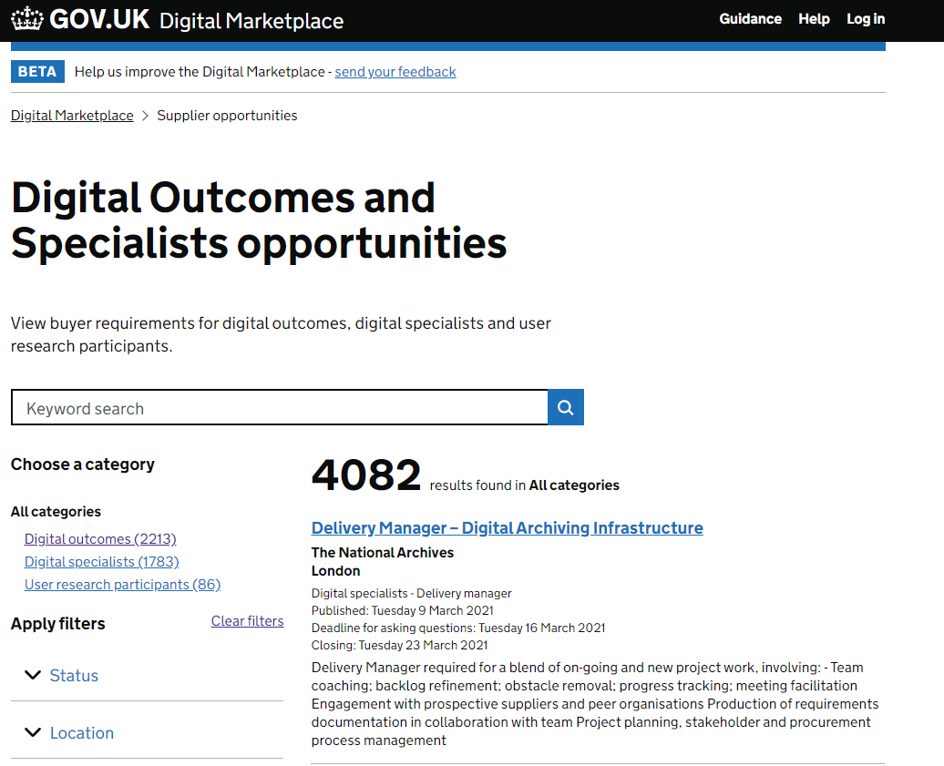
Here you can see we have followed the link from the homepage – “View digital outcomes and specialist’s opportunities”
On the left you can see a keyword search a supplier can use to find opportunities they are interested in, remember to think about what keywords can relate to your opportunity and use these within the title and the requirement
In addition, there are search filters for the lots, status of opportunity and location. Opportunities for lots 1, 2 and 4 of the DOS Framework will be here. (lot 3 – research studios, follows a different method so does not need a posted opportunity on the marketplace)
Please take time to look at current opportunities to help inform you on how to write your own and also to see how your opportunity will look once posted.
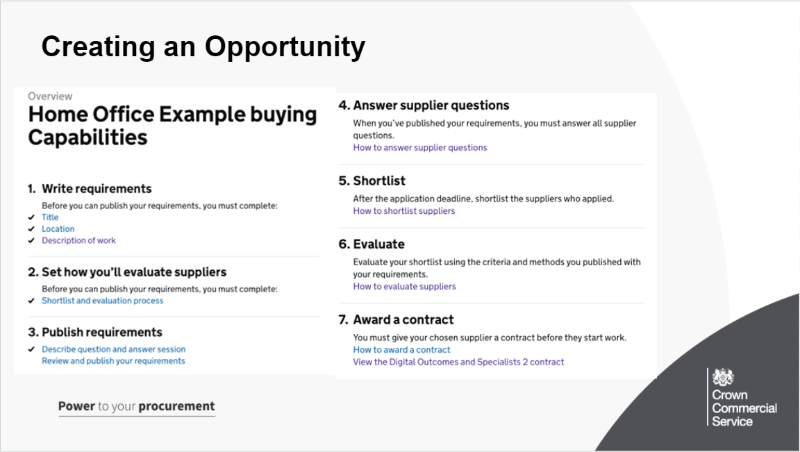
As you can see, the main page you will get for your opportunity when you are writing it sets out the buying process, and these first 2 sections open up into further pages where you can input all the information you need (which we will look at in the next slide)
The first two sub sections within section 1 are very straightforward, this is where you put your title (which can include reference numbers to make it easier for suppliers or colleagues to find) and also the Location of the work.
the next slide will be the page you reach after clicking on “description of work” and the slide after that will be in the second section, Set How You'll Evaluate Suppliers.
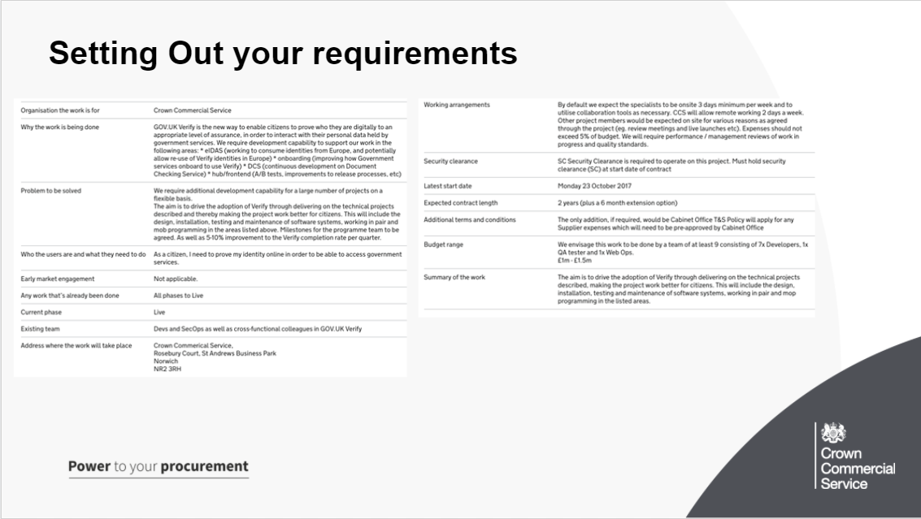
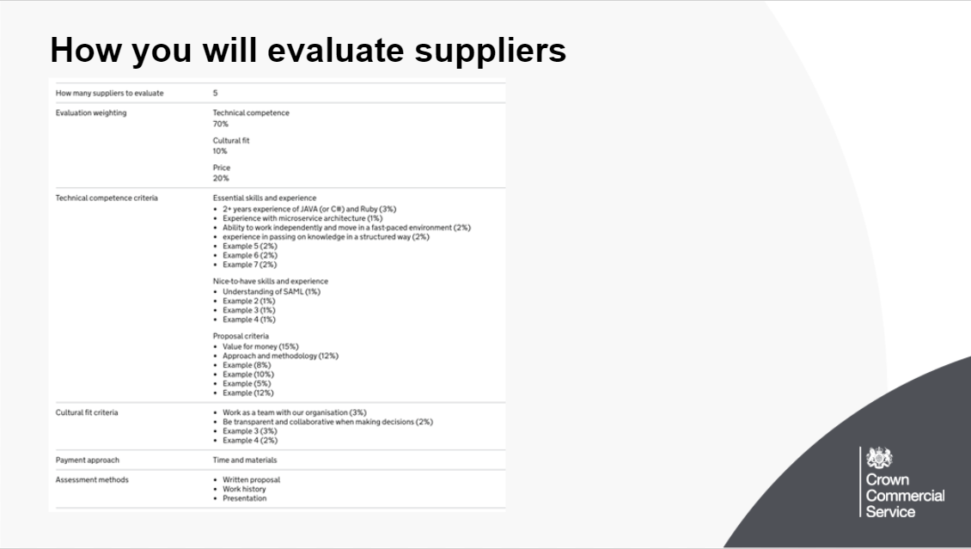
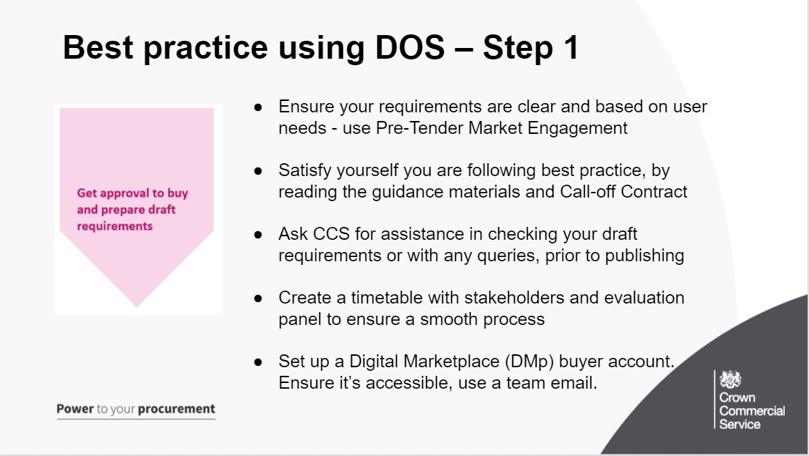
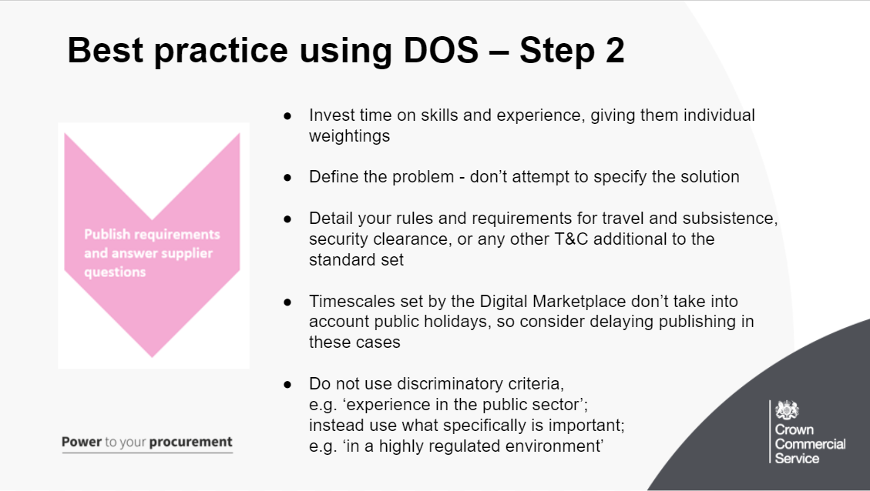
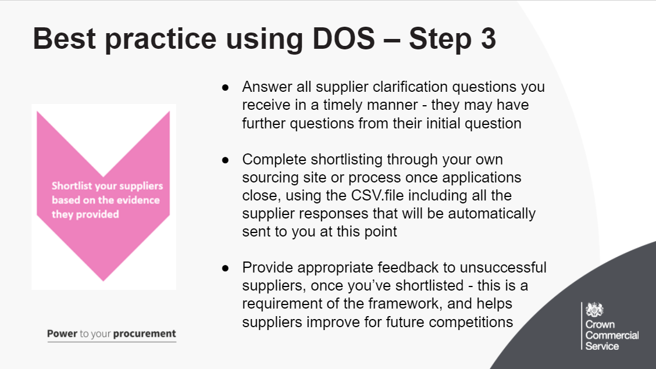
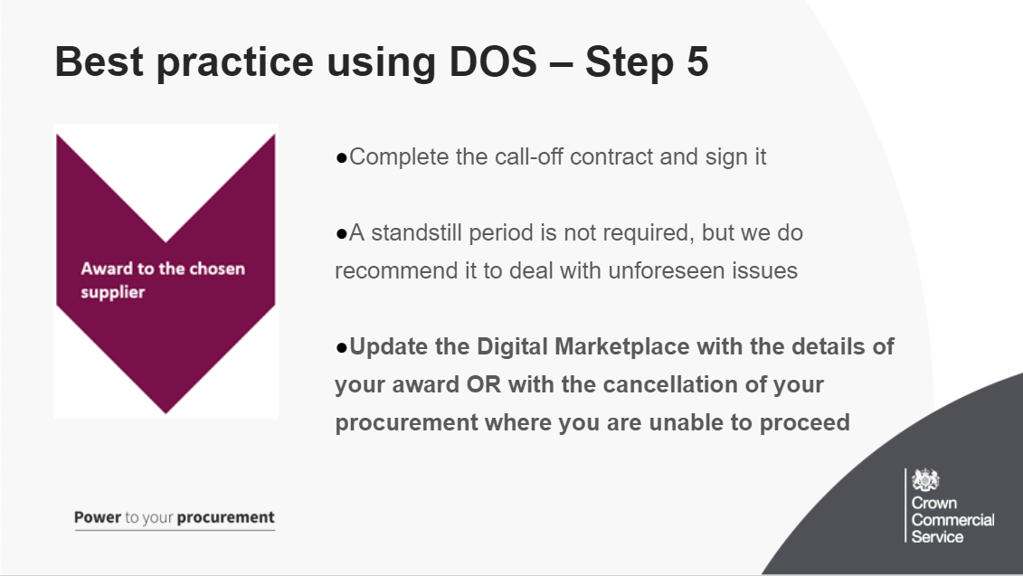
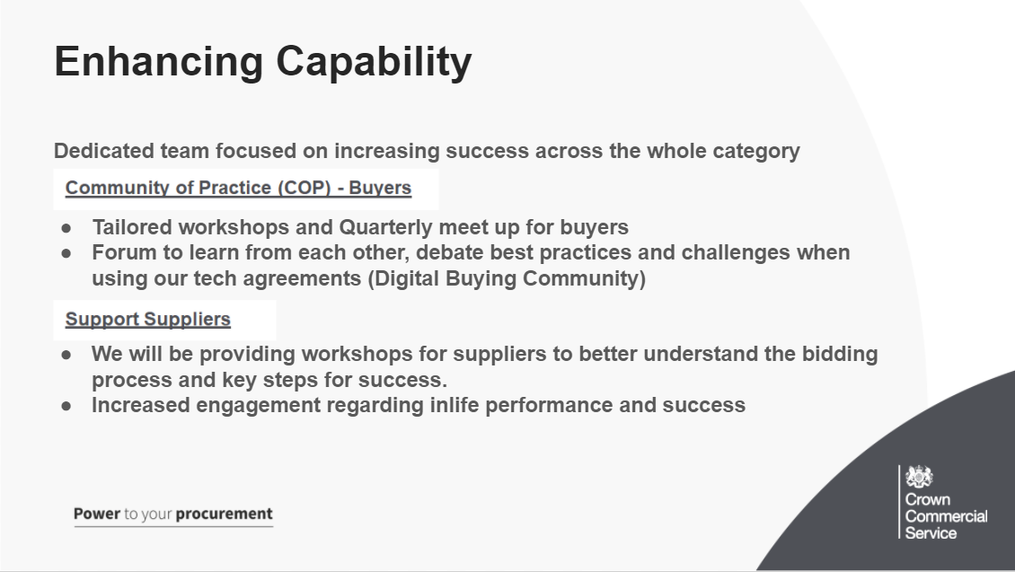
Enhancing Capability will be a dedicated programme to support the success for buyers and suppliers in participation in the digital future category, will expand the Community of Practice and start to mobilise supplier community options as well.
It looks to include:
Better understanding on the procurement process for both agreements
Steer when contracting outcomes
Support when identifying the correct route to market
To increase knowledge on how to write agile requirements

Dealing with more flexible contract management
The digital buying community exists to:
make sure that procurement practices support agile ways of working
create and support a peer group of buyers across government
share knowledge and best practice for buying digital and technology services
discuss common challenges and develop solutions
build commercial awareness across central government and the wider public sector

