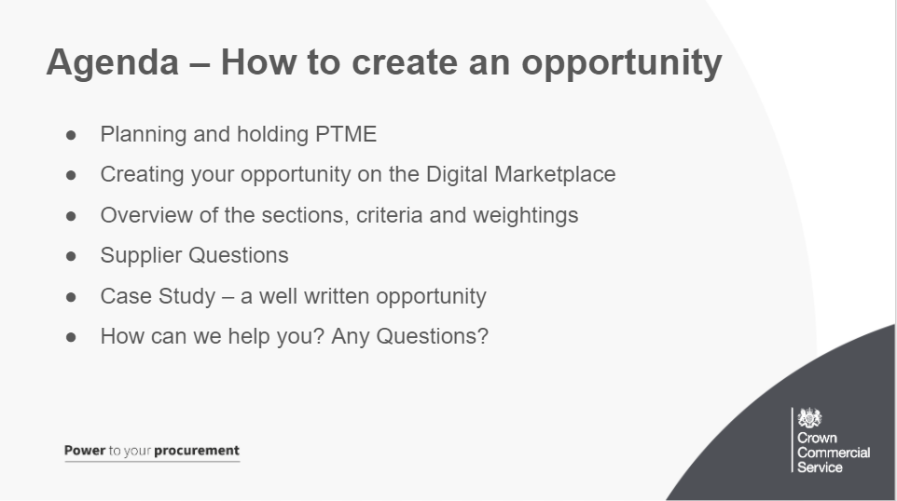
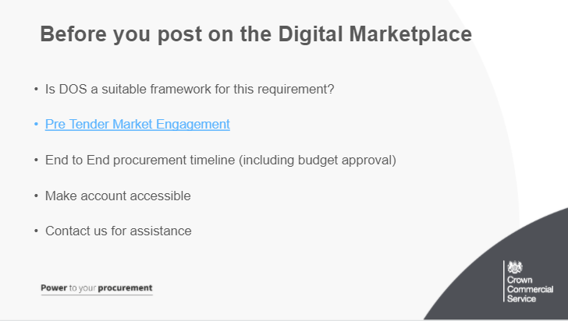
First of all, DOS is a framework to procure bespoke digital outcomes. It’s important to remember that DOS is an outcome based framework and not be used to staff interim labour
You can talk to suppliers before you start to help refine your requirements. This is sometimes called pre-tender market engagement’ (PTME).
Contact us at cloud_digital@crowncommercial.gov.uk for the current list of supplier contact details. From here you will be able to contact suppliers and learn more about what your requirements could look like and the digital landscape. PTME is a effective way to get the most out of the planning stage of your procurement. We also have a full PTME guidance document on the DOS5 webpage

Plan the end-to-end procurement timetable taking into account any security clearance lead times and the availability of internal resource for evaluators and moderators at the shortlisting and evaluation stages. You can send this timetable to the team to check the Digital Marketplace timescales are correct.
Get budget approval before you start the buying process, make sure you are go through the digital and I.T spend control process if you are buying for central government.
Also look out for Public holidays when publishing your requirement as the Digital Marketplace does not account for these (in terms of deadlines).
TOP TIP: Make sure your account login and associated contact email is available to colleagues so they can act on your behalf in case of absence. If you do not do this, your requirements will not be accessible and you may miss important deadlines
REMEMBER: You can only edit your requirements if the new content would not have affected a supplier’s original decision to apply. If you think this change could have affected a supplier’s decision to apply, you must withdraw your requirements.
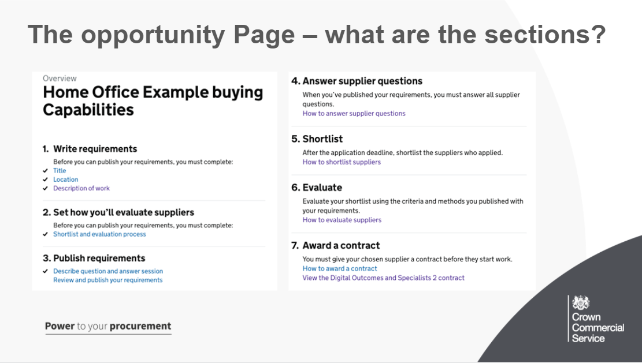
Here is what you will see once you create an opportunity, from the DmP you will select “find a team” (lot 1) or “find an individual specialists (lot 2)
The title is the first line to appear on the supplier opportunities page on the Digital Marketplace. It should be a clear statement of your key requirement. It can contain a reference - eg ABC123 - to help you refer to your opportunity when talking to suppliers.
Location You are only able to select one option so this should be the primary location the supplier will be working. You are able to provide further information later in the requirement, under 'Address where the work will take place' and 'Working arrangements‘ sections.
Description of work: This has a summary of information that you will enter in about your opportunity which we will go into more detail about on the next slide.
2.Write your requirements and say how you’re going to evaluate suppliers, this will be covered in more detail later
3.Publish your requirements and evaluation criteria so suppliers can apply for the work. This information will be published on the Digital Marketplace where anyone can see it. Suppliers will have two weeks to respond. (1 week for specialists)
5.Create your shortlist by reviewing and scoring the ‘essential’ and ‘nice-to-have’ skills and experience provided by suppliers against your published criteria. This information will be sent to you automatically by the Digital Marketplace. You will review and score outside the Digital Marketplace using your own systems or processes. Feedback
6.Invite shortlisted suppliers to the assessment stage. You must only use the assessment methods you said you’d use when you published your requirements. Additionally you cannot take through more suppliers than you stated in the original opportunity unless there is a tie in scores
7.Award a contract to the supplier that best meets your needs and give feedback to unsuccessful suppliers. A standstill period is not required but is recommended to deal with any supplier queries or challenges.
At this point you will publish the details on contracts finder and also update the digital marketplace.
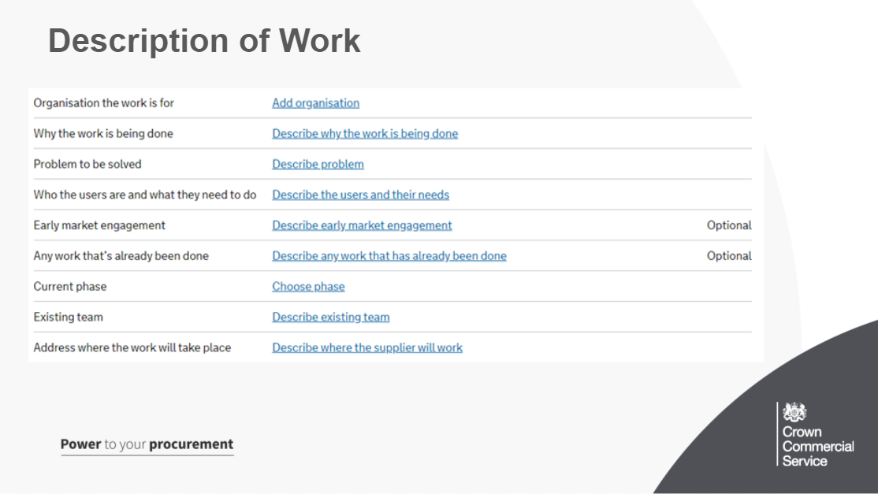
As you can see on the Description of work, this allows you to provide an overall summary of your requirements which will appear at the top of your opportunity page posted to the marketplace.
People who can help you write your requirements include:
-your procurement team, who can help decide on timescales
-your technical team, who can help if things such as security levels or existing technical platforms are important
-your service or product manager, who can help identify user needs

Some of these are optional, the ones that are not will be needed for all opportunities posted.

Organisation the work is for - eg National Audit Office
Why the work is being done - This needs to be clear to suppliers and give background as to why this work is needed. Describe the organisation or policy goal the work supports.
Include any important dates. You must say if you need the work to be done by a certain date. This will help suppliers understand any time constraints
Problem to be solved - You must be clear on what problem suppliers will be solving. You must not be describing the solution you want. Suppliers will be able to provide innovative solutions if the problem is clearly described.
If you had 60 seconds to explain what problem you as a buyer are trying to solve, how would you describe this to enable the supplier to propose a solution?
Who the users are and what they need to do - You must describe who the users of the digital service will be.
E.G: As a carer, I need to know if I can get Carer’s Allowance, so that I know if I should apply for it or not.
Early Market Engagement - If you’ve done early market engagement, with suppliers or users, you must include a summary of any relevant findings.
Any Work that has already been done
Current Phase: The phases described are for agile development. The maturity of the project will help to determine the type of specialists required.
Not started
Discovery: A short phase, in which you start researching the needs of your service’s users, find out what you should be measuring, and explore technological or policy-related constraints.
Alpha: A short phase in which you prototype solutions for your users needs. You’ll be testing with a small group of users or stakeholders, and getting early feedback about the design of the service.
Beta: You’re developing against the demands of a live environment, understanding how to build and scale while meeting user needs. You’ll also be releasing a version to test in public.
Live
Existing team: Describe the team the supplier will be working with (quoting their roles and titles)
Address where the work will take place
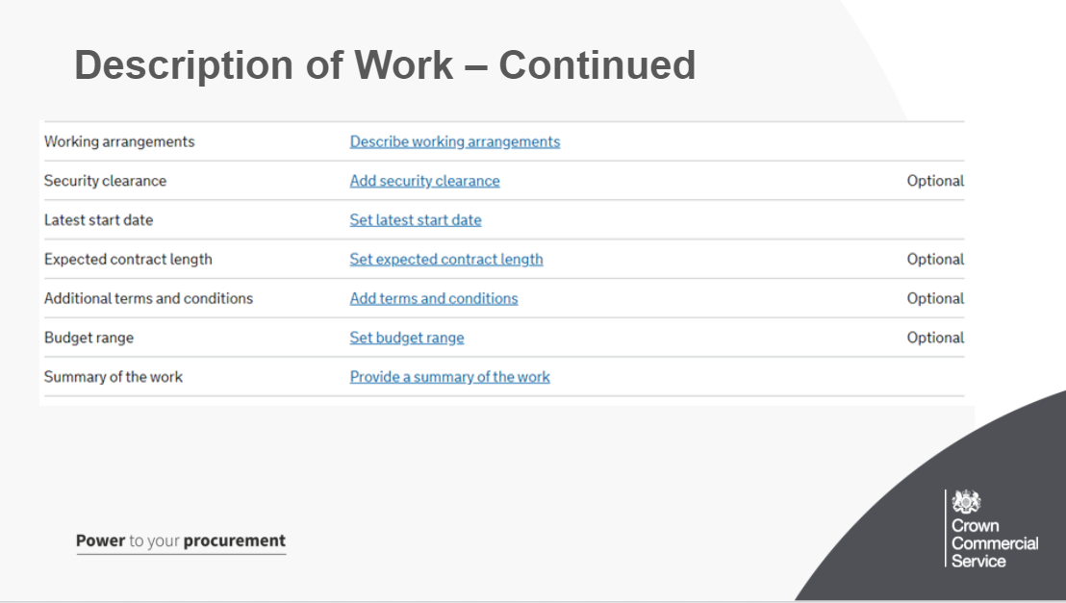
Some of these are optional, the ones that are not will be needed for all opportunities posted.
Working arrangements - Describe how you want to work with the individual or team. If the supplier's working arrangements are across multiple sites you can add detail of this here. Explain why you want to work with them in this way.Include any limits on expenses.
Security Clearance - Describe any security clearance the individual or team must have when they start work. We suggest all suppliers are subject to BPSS as a minimum for all requirements.
You shouldn’t exclude suppliers if they don’t currently have the security clearance you need.
You may need to organise security clearance and sponsor a supplier through this process if they are successfully awarded a contract.
Latest Start Date - Think about the procurement timeline and how long it will take to complete. You will be inviting shortlisted suppliers to provide written proposals and potentially presentations. These will all need to be evaluated, moderated, the contract agreed and signed, and the supplier receive security clearance before work can commence.
Expected Contract Length -
Additional Terms and Conditions: You should use the standard contract unless your organisation needs to include additional terms and conditions.
Budget Range - Include how much you can spend. Suppliers will find it helpful if you can provide a breakdown of costs so they can understand the size and scale of the project. Using a budget range is best practice,
Summary: This will appear on the supplier opportunities page on the Digital Marketplace. It will help suppliers decide whether or not to view your detailed requirements

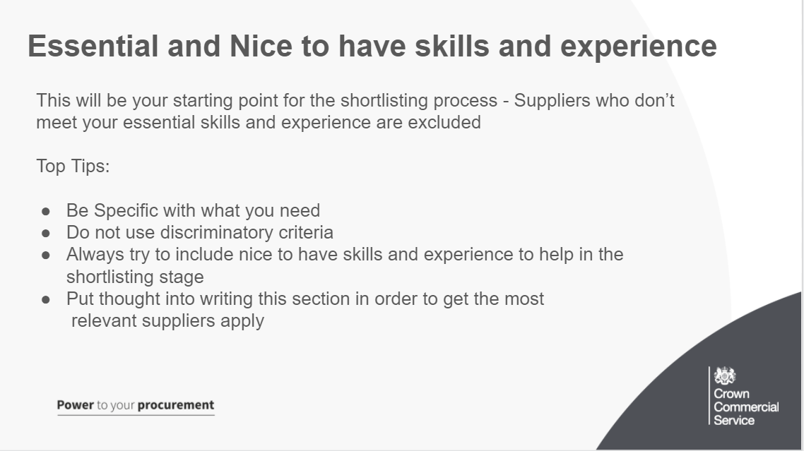
Once you have a list of eligible suppliers, in shortlisting you can exclude the suppliers who: - have the least nice‑to‑have skills and experience - can’t start when you need them to
For this reason, the Essential and Nice to have skills and experience section is the starting point for you to get the perfect supplier for your requirements. Careful planning and detailed and relevant information here will help you in the shortlisting process and also ensure that the right suppliers apply for your opportunity
The more specific you can be with these criteria, the easier it will be to find a supplier who meets your needs. Remember - it is the essential criteria which will largely determine your shortlist. Does a supplier just need experience or a minimum amount? eg a minimum of 2 years recent experience
It is discriminatory to suppliers to state that they must have previous experience working in the public sector or within your specific industry.
What is it about the public sector that requires specific skills or experience? Suppliers may have worked for complex commercial organisations which are highly regulated (eg financial or pharmaceutical) and could therefore demonstrate the required skills and experience within a different environment.
If too many suppliers have all the essential skills and experience, use the nice-to-have skills and experience to exclude suppliers. For this reason it is important to include this, even though it is optional it will help you greatly in the shortlisting stage
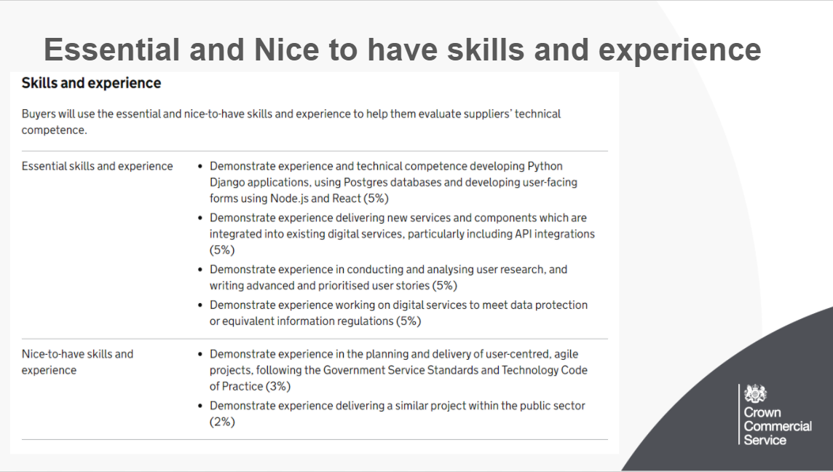
Here we can see a real example from an opportunity on the Digital Marketplace (This was for the Department for International Trade procurement) with the essential and nice to have skills and experience.
Firstly, take a look at the way this is written, the specific requirements they have and how they have made these clear and precise. In addition, you can see they have multiple nice to have skills and experience to help them in the shortlisting stage.
You can also see individual weightings added to this criteria which is something you can do and we will talk about later in the presentation. This procurement had a 60% weighting in Technical Competence, 10% on cultural fit and 30% on price.
The Technical competence weighting came from the 20% essential, 5% nice to have and then 35% in the written proposal, which comes at the further competition stage.
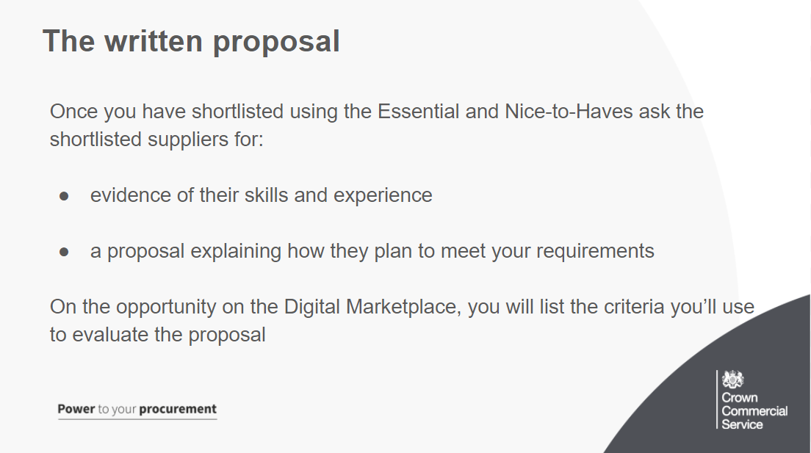
Once you have shortlisted using the Essential and Nice to have Ask the shortlisted suppliers for:
evidence of their skills and experience
a proposal explaining how they plan to meet your requirements
All suppliers must provide a written proposal.
List the criteria you’ll use to evaluate the proposal for example:
the proposed technical solution
the proposed approach and methodology
how the approach or solution meets your business or policy goal
how the approach or solution meets user needs
estimated timeframes for the work
how they’ve identified risks and dependencies and offered approaches to manage them
team structure
value for money
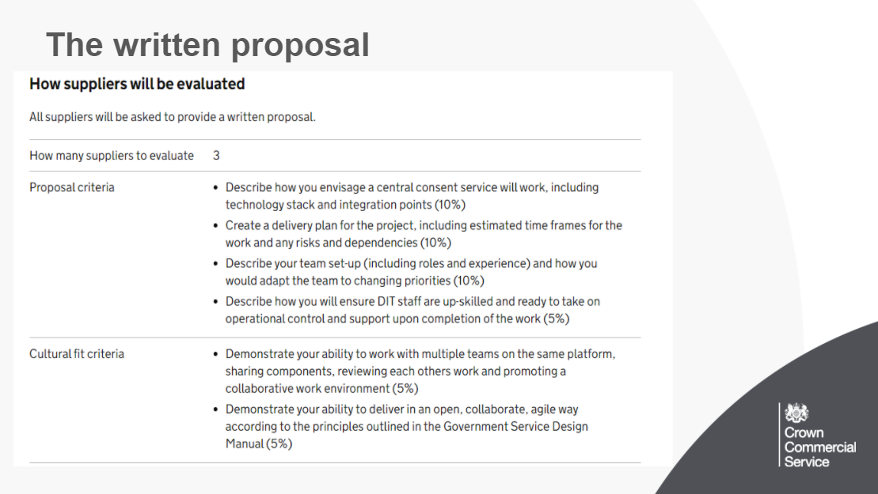
Here you can see the written proposal for the opportunity we were looking at before. As mentioned this makes up 35% of the 60% Technical competence mark.
Below this is cultural fit, which is weighted at 10%.
Within the proposal criteria we can see that this judges how the suppliers will provide a solution to your specific requirements and aims. It also covers timescales and delivery plans, along with team set up and working practises.
A good way to look at the parts of Technical Competence is that the Essential and Nice to have skills and experience are looking “back” at what the supplier has done before, whereas the written proposal is looking “forward” at what they will do for you and your requirements.
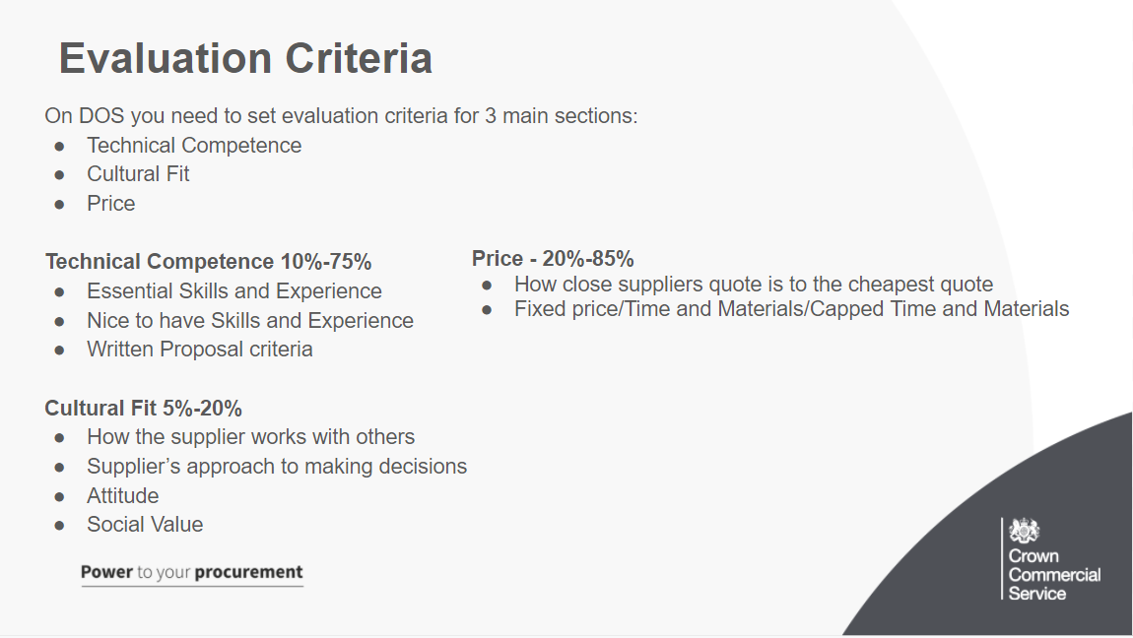
You need to set evaluation criteria for:
Technical competence, for example how well the supplier’s skills or proposal meet your needs (As we talked about in the last 2 slides)
cultural fit, for example how the supplier will work in your organisation (for outcomes and specialists only)
availability (for user research participant recruitment)
price of the proposal
You must assess a supplier’s technical competence by reviewing their:
essential skills and experience
nice-to-have skills and experience
Proposal
Cultural fit is:
how the supplier works with other people
how the supplier solves problems
the supplier’s approach to making decisions
how the supplier shares knowledge and experience
the supplier’s attitude to making mistakes
Social Value is also included here at a recommended 10%
Cultural fit isn’t:
whether the supplier looks, talks or behaves in the same way as you
about having agile skills – that’s technical competence
Price
Price is scored based on how close each supplier’s quote is to the cheapest supplier’s quote.
You need to tell outcomes suppliers how you want them to provide a quote for their proposal. They can quote for ‘fixed price’, ‘time and materials’ or ‘capped time and materials’
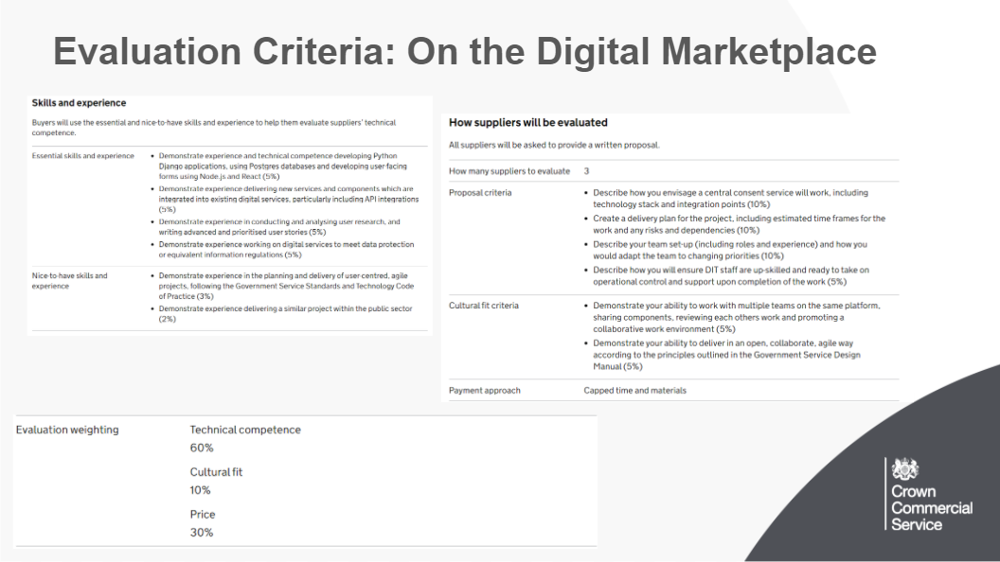
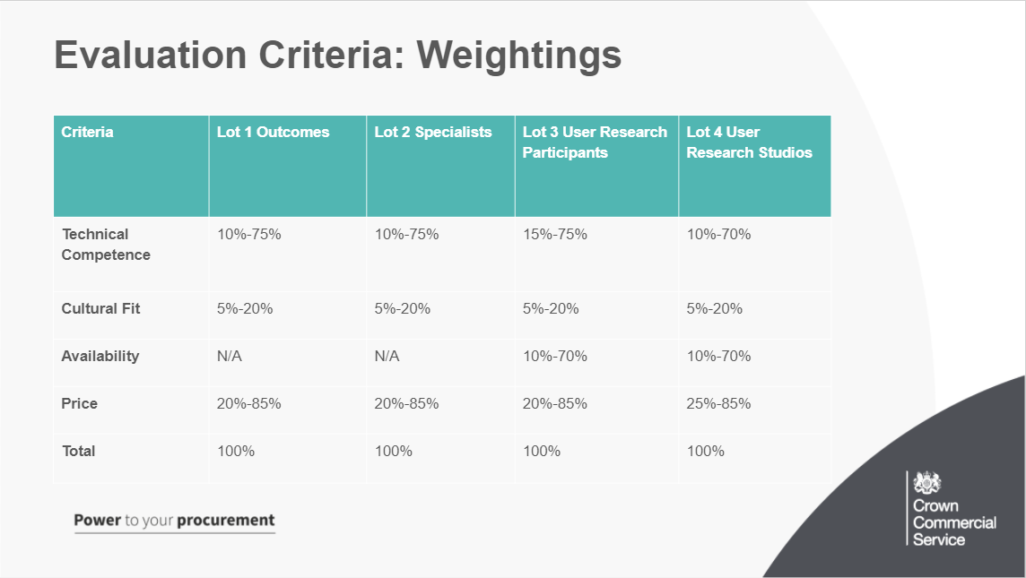
Depending on the service you’re buying, you’ll need to give a ‘weighting’ to technical competence, cultural fit, availability or price. You should set your weightings by deciding their relative importance to you
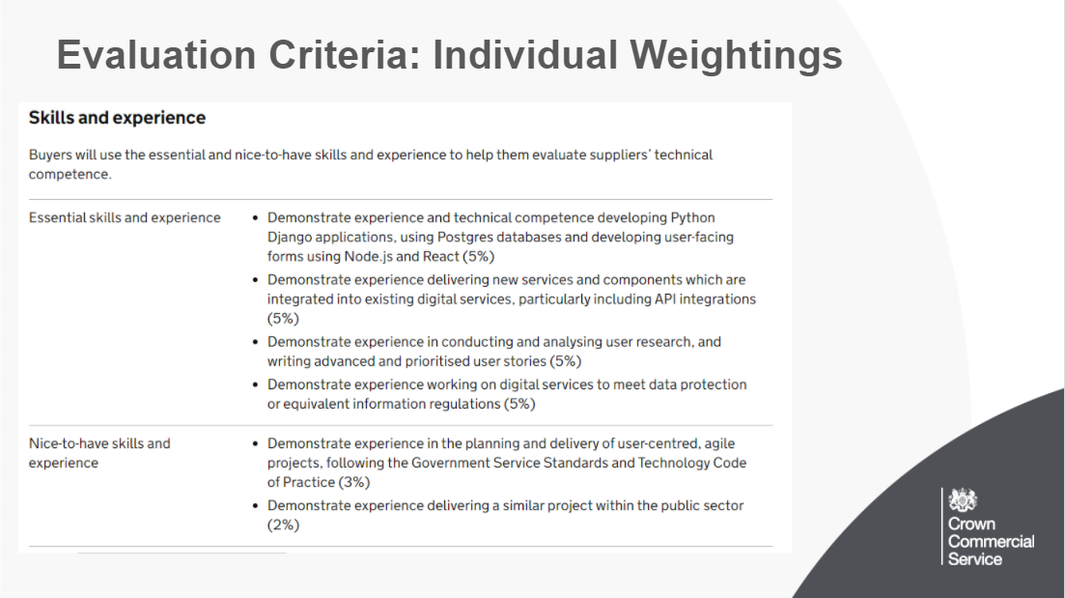
Giving points to individual criteria
You can give a weighting to individual criteria in Technical Competance and Cultural Fit .
If you choose to add a weighting, you must do it for all individual criteria.
The weighting is simply added as text at the end of your defined criteria.
You must tell suppliers the percentage you’ll give to each one when you publish your criteria
You should keep the majority of the weighting for the proposal, as it is within this that the supplier will answer how they propose to fulfil your outcome
The weighting you give for nice-to-have skills and experience must be lower than the weighting you give to the supplier’s essential skills and experience and proposal.
Here we can see the individual weightings for the opportunities essential and nice to have skills and experience
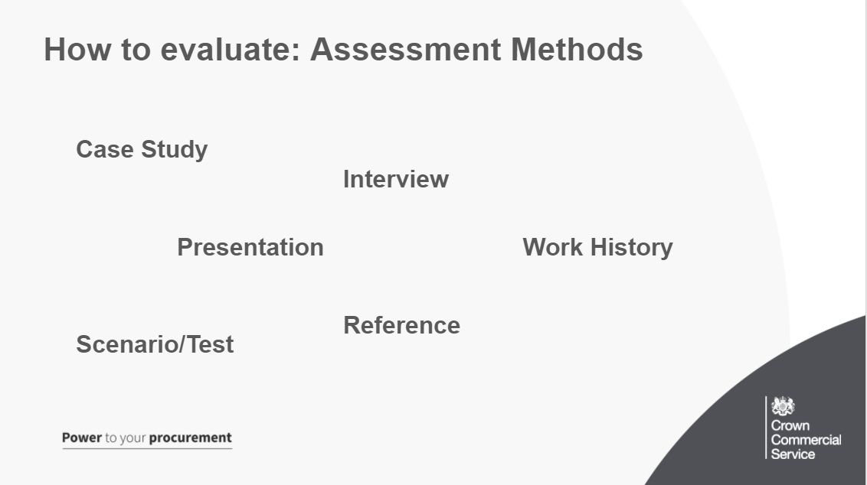
Here you can see the range of assessment methods available in the further evaluation process.

All suppliers will have to provide a written proposal. However, you can also choose additional ways to assess them, if you want to.
Choose additional ways to assess suppliers.
You can only use the methods you choose here, eg if you don’t select a case study now, you won’t be able to ask for one later.
Case study: A case study is a good way to see the work suppliers have done before. It can help you understand whether the people who’ll be working on your project have the right specific skills and experience and have shown this in practise.
Interview: (lot 2) An interview can help you understand whether a specialist or team has the skills needed to work on your project. It will also help you see whether they will be a good cultural fit for your existing team and give you direct interaction with them.
Work history: A work history lists the previous work a supplier has done. It should give you a view of the experience of the team members who’ll be working on your project.
Reference: A written reference is a good way of confirming whether a supplier has done the work they’ve said they’ve done. You should always ask for references that relate to a specific timeframe, eg work they’ve done in the last 2 years.
Presentation: A presentation can help you understand a supplier’s approach to delivering an outcome, eg a practical demonstration of a prototype or discovery kick-off meeting.
Scenario or test: (lot 2) A scenario or test can help you check a specialist’s skill level and understanding in a controlled environment. Examples include: a writing test for a content designer/ a coding test for a developer.
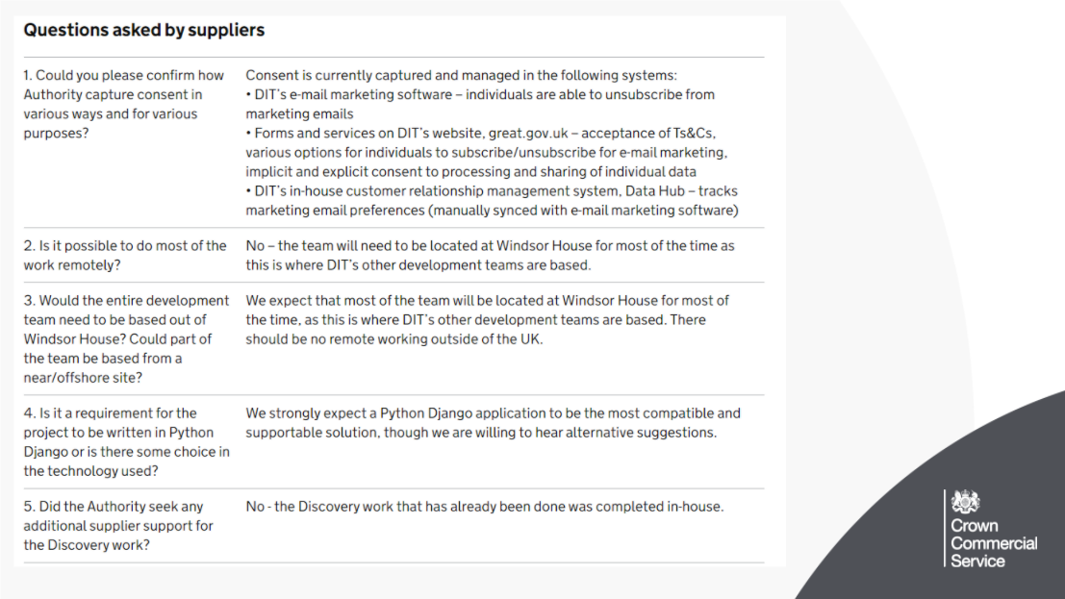
Firstly, although all opportunities will have an online function for suppliers to ask your questions that will be posted on your opportunity page, you can also choose to also have a Q and A session. You have the freedom to choose you want to hold, when it is and any details the attendees need.
the type of session you want to run, eg webinar, phone conference or meeting
the date and time of the session (this should happen within 1 week of publishing your requirements)
providing a dedicated question and answer session means you can explain your needs and answer any questions quickly.
The questions and answers given here should be written up and posted onto the marketplace for any suppliers who could not attend
In terms of the digital marketplace supplier questions, you should post all supplier questions and answers on the Digital Marketplace promptly. Answer all questions at least one working day before the deadline to give suppliers time to decide if the work is right for them.
Which of these could be answered by a better written requirement?
If you receive sensitive information within a supplier question, instead of ignoring or not answering this, answer with the sensitive information redacted, as this question and answer will go onto the Digital Marketplace for public to see.
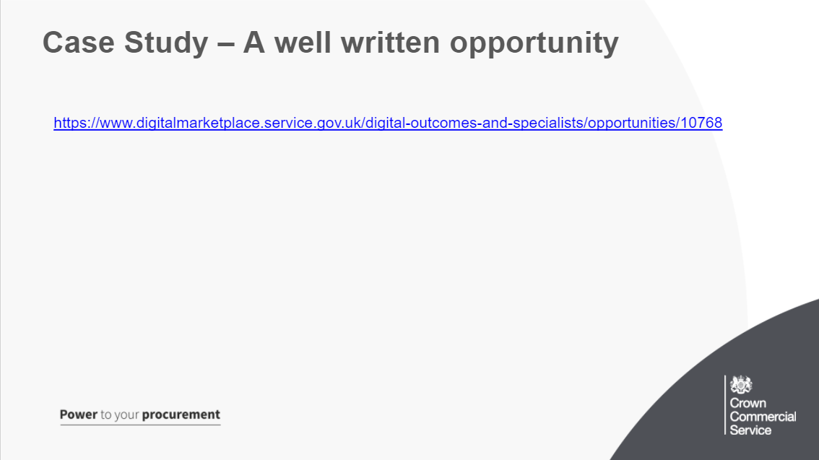
I linked an opportunity on the email invitation and also have linked it in the chat, if you can, Take a moment to look at this opportunity and think of 3 things it does well, what are the well written parts of this opportunity that help suppliers produce an effective response?
You could have mentioned:
- Included a budget range to help suppliers know about the size and scope of the work
-Very clear and detailed user needs section
-Included additional terms in the correct way
-Individually weighted essential and nice to have skills and experience to make it clear to suppliers what they are being evaluated on
-Clear weightings given in the evaluation section
-Answered all 40 supplier questions clearly to clear up gaps in knowledge from those who were applying
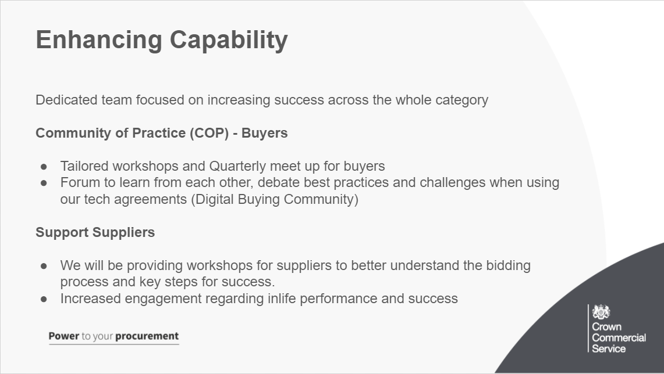
Enhancing Capability will be a dedicated programme to support the success for buyers and suppliers in participation in the digital future category, will expand the Community of Practice and start to mobilise supplier community options as well.
It looks to include:
Better understanding on the procurement process for both agreements
Steer when contracting outcomes
Support when identifying the correct route to market
To increase knowledge on how to write agile requirements
Dealing with more flexible contract management

The digital buying community exists to:
make sure that procurement practices support agile ways of working
create and support a peer group of buyers across government
share knowledge and best practice for buying digital and technology services
discuss common challenges and develop solutions
build commercial awareness across central government and the wider public sector

