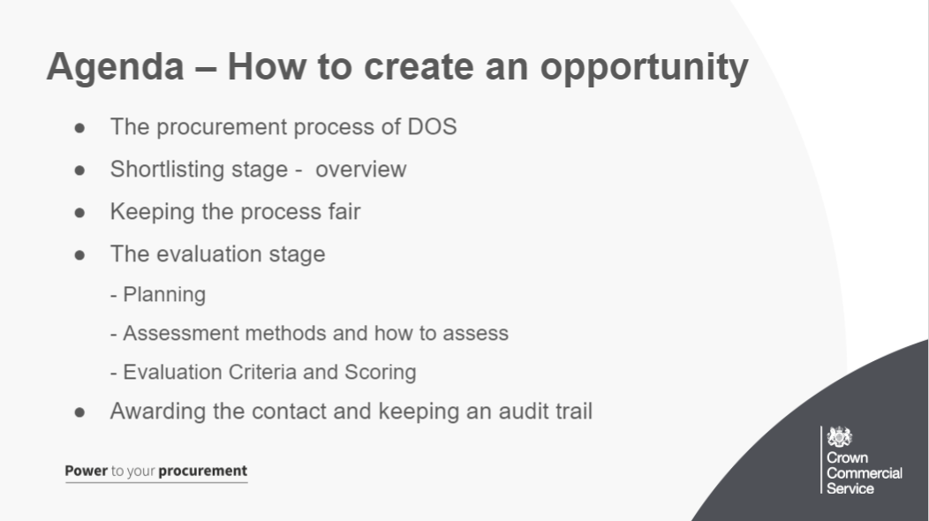
Over the next 30 minutes or so our aim is to give you guidance on creating your DOS opportunity
Main objectives …
●Recap the procurement process of DOS, giving you to information to know where this fits into the timeline and how it carrys on from the digital marketplace section where the opportunity is posted
●Understand the overview of how each section works with shortlisting and further evaluation, the responsibilities you have within these processes as a buyer and how they will result in you gaining a suitable winning supplier for your work
●How to keep the process fair and open for all suppliers during the procurement, adhering to the framework guidline and by PPR regulations
●Give you a look at the different sections within the evaluation stage, addressing how to plan efficiently, the different types of assessment methods you can use and how the scoring system will work for you
●Information on how to award the contract to the supplier that best meets your needs and how to keep an audit trail during this whole process
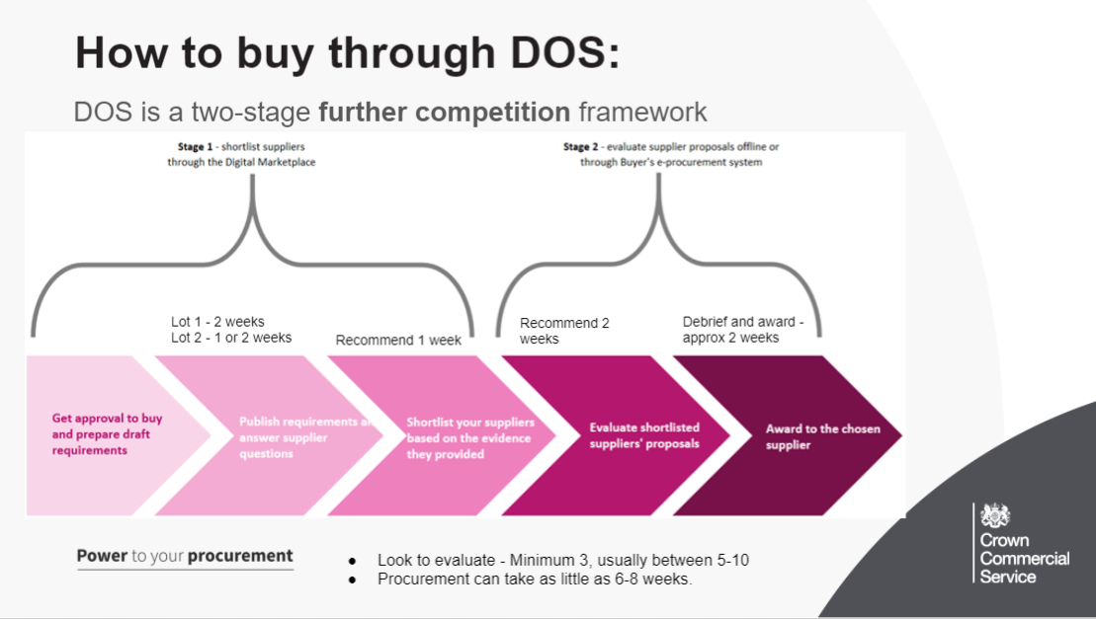
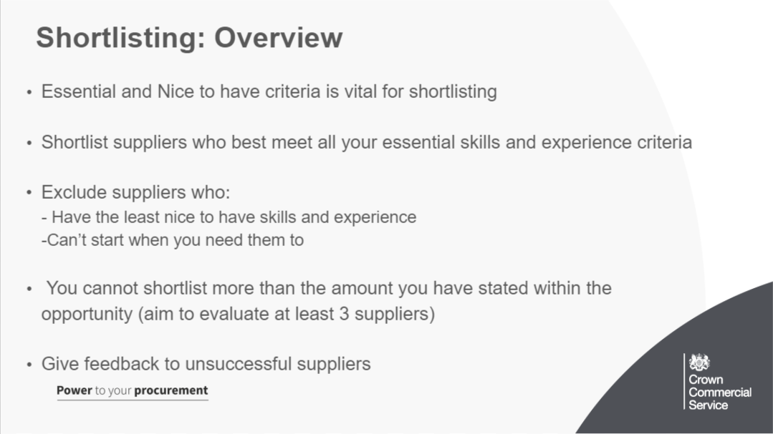
As mentioned in the last webinar (writing an opportunity): As part of the DOS Process, only suppliers who have said they can meet all your essential skills and experience will be notified to you. Suppliers will also declare which of your nice‑to‑have skills and experience they have.
Suppliers who don’t meet your essential skills and experience are excluded.
Once you have a list of eligible suppliers, you can exclude the suppliers who: - have the least nice‑to‑have skills and experience (also used to solve a tie with essential criteria) - can’t start when you need them to
For this reason, the Essential and Nice to have skills and experience section is the starting point for you to get the perfect supplier for your requirements. Careful planning and detailed and relevant information here will help you in the shortlisting process and also ensure that the right suppliers apply for your opportunity
It is important to note that you can only shortlist the amount of suppliers you originally stated unless there is a tie in essential AND nice to have skills and experience criteria.
You must aim to shortlist at least 3 suppliers for evaluation
Any late submissions by direct email should never be accepted as per the framework guidelines
With any submissions that go over the wordcount, do not evaluate any content past that 100 word limit in their response in order to keep the process fair for all suppliers
Make sure to give simple feedback to unsuccessful suppliers at this stage, feedback email templates can be found within our guidance using that link

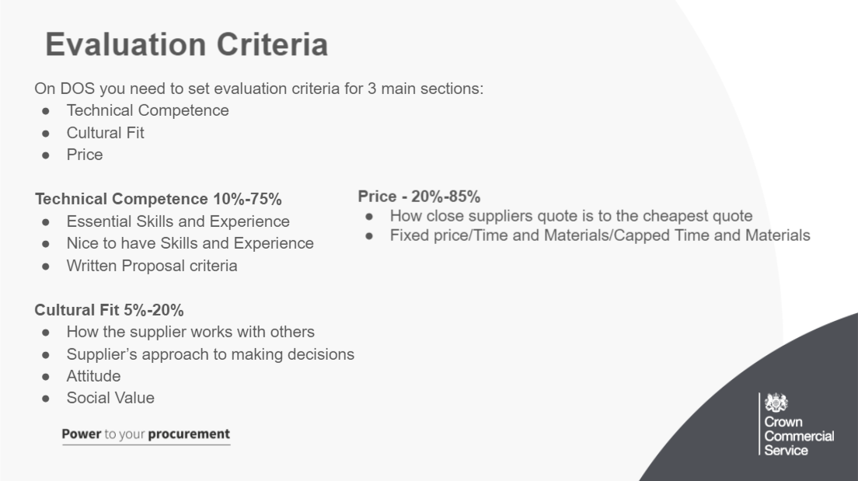
Technical competence, for example how well the supplier’s skills or proposal meet your needs (As we talked about in the last 2 slides)
Cultural fit, for example how the supplier will work in your organisation
Availability (for user research participant recruitment)
Price of the proposal

You must assess a supplier’s technical competence by reviewing their:
- Essential skills and experience
- Nice-to-have skills and experience
- Proposal

Cultural fit is:
- how the supplier works with other people
- how the supplier solves problems
- the supplier’s approach to making decisions
- how the supplier shares knowledge and experience
- the supplier’s attitude to making mistakes
- Social Value is also included here at a recommended 10%
Cultural fit isn’t:
whether the supplier looks, talks or behaves in the same way as you
about having agile skills – that’s technical competence

Price
Price is scored based on how close each supplier’s quote is to the cheapest supplier’s quote.
You need to tell outcomes suppliers how you want them to provide a quote for their proposal. They can quote for ‘fixed price’, ‘time and materials’ or ‘capped time and materials’.
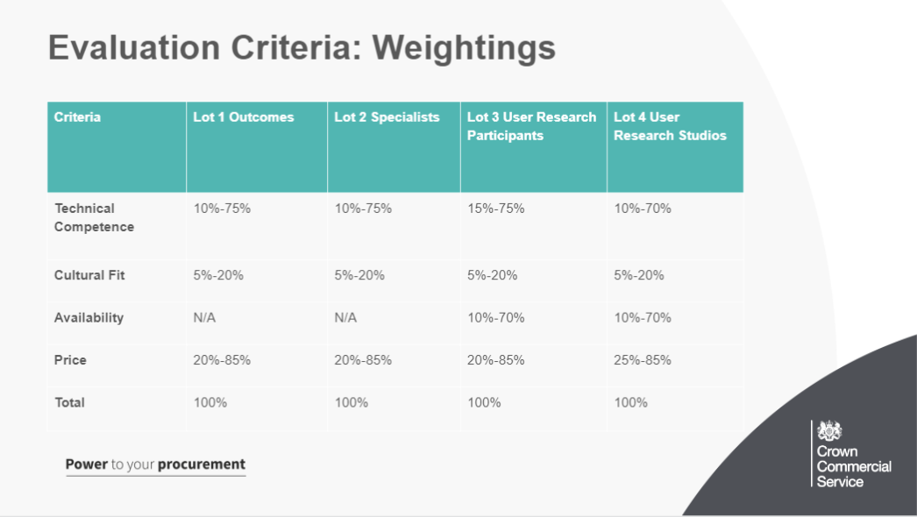
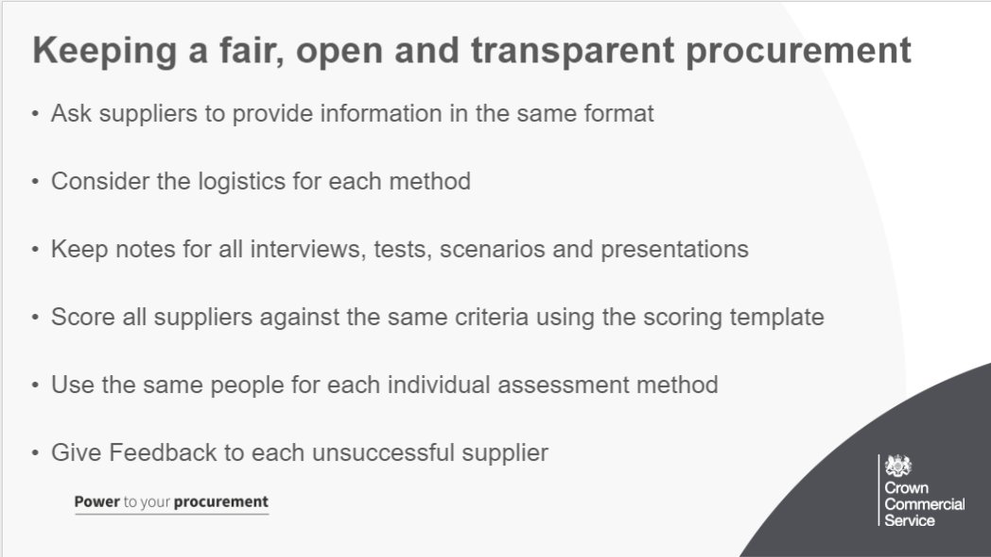
Here are some tips throughout the shortlisting and evaluation process to ensure you are keeping your procurement fair, open and transparent:

- ask suppliers to provide information in the same format, whichever method you choose, for example give suppliers a template to fill in so that it’s easier for you to assess them
- Do not look at any supplier responses until after the deadline
- Consider the logistics for each method, for example where the interview will happen or what equipment might be needed for a presentation. Is this all accessible if needed? Are the evaluation team free for these dates, is there a backup plan if the location/time is not available?
- keep notes for all interviews, tests, scenarios and presentations, this will be essential for audit logs and to assess how suppliers were scored (feedback)
- score all suppliers against the same criteria using the scoring template, makes feedback easier and ensures you have ran a fair procurement process
- use the same team to assess the suppliers at the shortlisting stage, and then the same team for each individual evaluation stage,
- You can use different people to assess different methods, for example if you’re conducting interviews, the same people should be present in each one
- Give feedback to each supplier in the shortlisting stage and also the further evaluation stage, this helps suppliers understand where they went wrong and allows them to provide a higher quality response next time
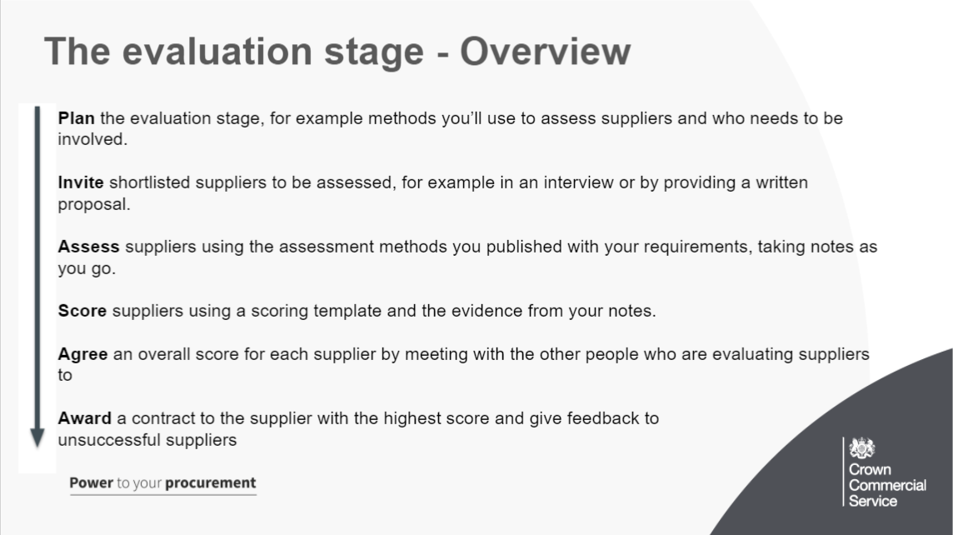
You must evaluate shortlisted suppliers to find the one that best meets your requirements using the methods and criteria you published.
You will use these assessment methods to assess suppliers, for example in an interview or with a written proposal. After you will score suppliers and award a contract to the supplier with the highest score.
You should consider the complexity of your project; the resource you have available for evaluating suppliers; and your general procurement timelines. This will guide the assessment methods you decide to use and state in your opportunity on the Digital Marketplace (no penalty for removing/not doing an assessment method)
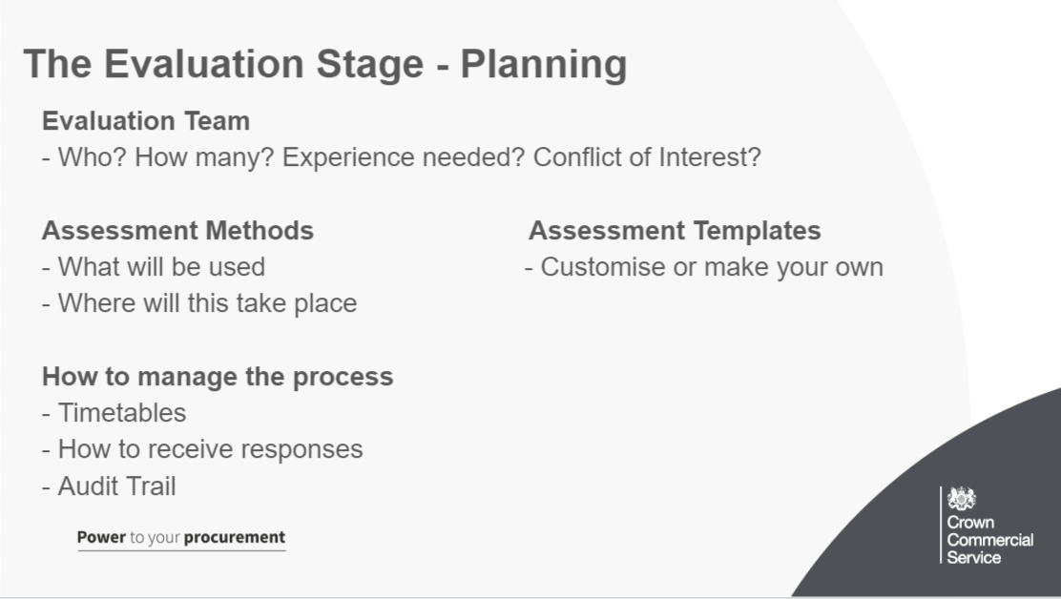
It is important to plan out the further evaluation stage carefully in order for you to have it run as smoothly as possible and also end up with a higher quality response and supplier.
key areas:
Who should be on your evaluation team: You need an evaluation team with the right skills and expertise to find the supplier who best meets your needs.
Your evaluation team should be made up of people who understand what you’re buying. This may include people with digital expertise in your organisation or another public sector organisation. You could also ask digital experts outside the public sector to help you evaluate.
Consider who needs to be involved in each assessment, for example you may use different people to assess supplier work histories than to assess a proposal.
You must ensure that no one on your evaluation team has a conflict of interest, for example doesn’t have shares in a supplier who has been shortlisted.
Your evaluation team should have a minimum of:
3 people for digital outcomes
2 people for digital specialists and user research participants

What your evaluation team needs to do
The people on your evaluation team will need to: Plan the order of the assessment methods and if you’ll do any at the same time, for example ask suppliers to provide both a written case study and a proposal
prepare for assessments
assess supplier responses, for example evaluate case studies or go to interviews
write up their individual evaluations and give a score to each supplier
agree an overall score for each supplier
You need to use the same team for each assessment method.

Assessment Methods:
We will get into the individual assessment methods in more detail later, but when planning you will need to think about
The order these will be in and key dates
What assessment methods are being used and how these link together
Where these will take place and the accessibility for suppliers to undertake these

Prepare your assessment templates
Add your evaluation criteria and how the supplier responded to your essential and nice-to-have skills and experience to the templates you’re using for each assessment method. The templates we provide are just for guidance and you are free to create your own

How your evaluation team will manage the process
Write a timetable for the evaluation process as early as possible and ensure that everyone in the team is available when they are needed.
You need to plan how written responses from suppliers will be received. Make sure that:
you give suppliers an email address to send their written responses to
no one in your evaluation team has access to the email account that written responses are sent to
no one in your evaluation team sees any supplier responses before the deadline
you keep an audit trail of who has access to the email account that written responses are sent to
If a supplier wants to change their written response before the deadline, ask them to resend it. You must use the latest version received before the deadline.
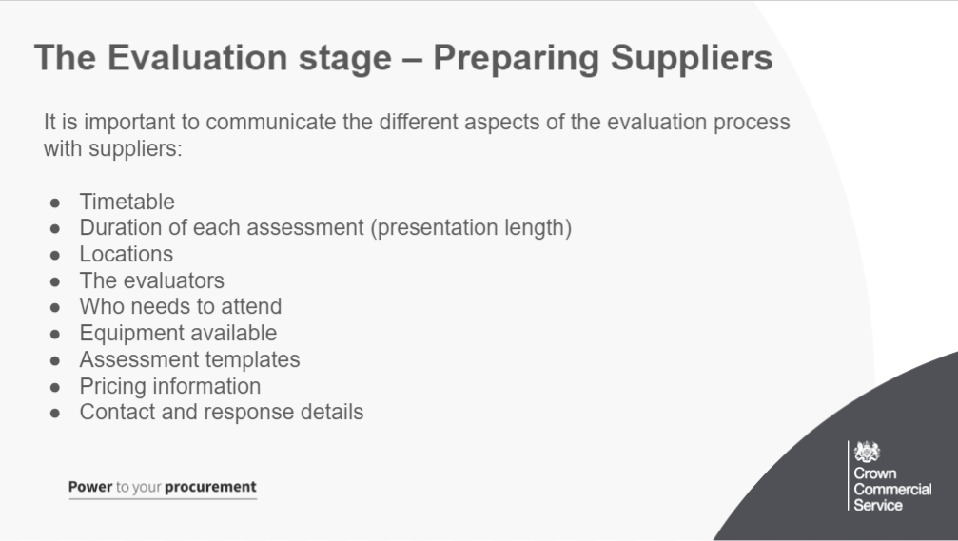
Tell suppliers how the assessment process will work, including:
- what the timetable for the assessment process is, for example any deadlines and dates for meetings
- how long each assessment will be, for example how much time is allocated for a presentation
- where each assessment will be, for example the address of your office
- who will be at the assessment, for example interview panel members
- who they should bring (if in person) to the assessment, for example they should bring everyone who will working on the project
- what equipment will be available for the assessment, for example wifi or projector
- what templates and formats you need them to use, for example for a case study or a work profile
- how you want them to break down their price, for example the price should show how many roles they are proposing, for how many days and what the day rates are for each role
- where they should send any written response, for example case study, work history or proposal
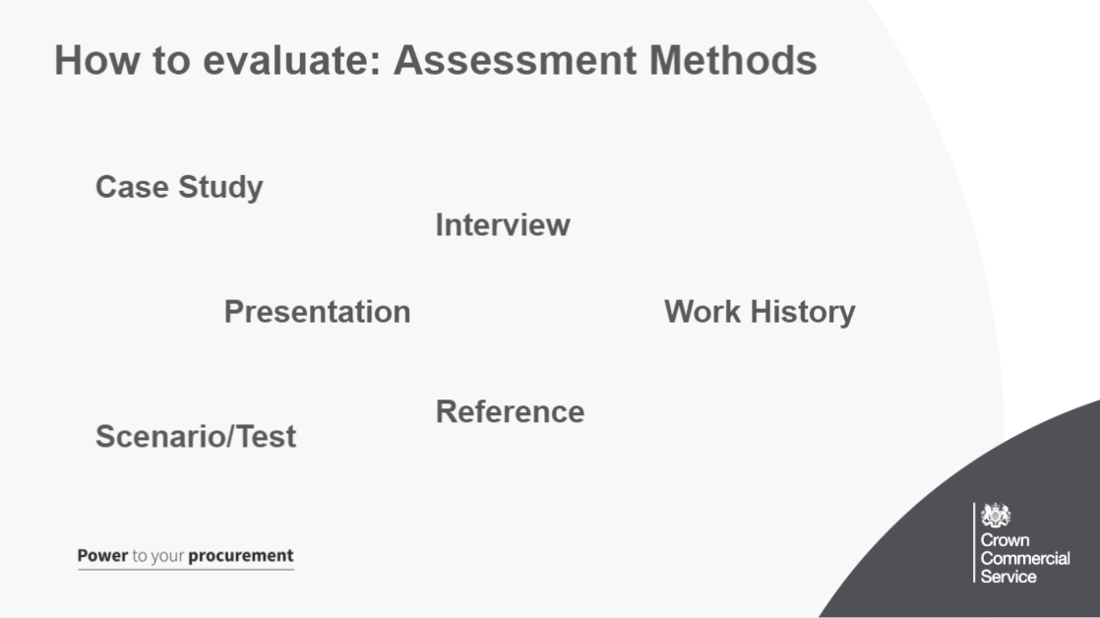
Here you can see the range of assessment methods available in the further evaluation process.

All suppliers will have to provide a written proposal. However, you can also choose additional ways to assess them, if you want to.
Choose additional ways to assess suppliers.
You can only use the methods you choose here, eg if you don’t select a case study now, you won’t be able to ask for one later.
Case study: A case study is a good way to see the work suppliers have done before. It can help you understand whether the people who’ll be working on your project have the right specific skills and experience and have shown this in practise.
Interview: (lot 2) An interview can help you understand whether a specialist or team has the skills needed to work on your project. It will also help you see whether they will be a good cultural fit for your existing team and give you direct interaction with them.
Work history: A work history lists the previous work a supplier has done. It should give you a view of the experience of the team members who’ll be working on your project.
Reference: A written reference is a good way of confirming whether a supplier has done the work they’ve said they’ve done. You should always ask for references that relate to a specific timeframe, eg work they’ve done in the last 2 years.
Presentation: A presentation can help you understand a supplier’s approach to delivering an outcome, eg a practical demonstration of a prototype or discovery kick-off meeting.
Scenario or test: (lot 2) A scenario or test can help you check a specialist’s skill level and understanding in a controlled environment. Examples include: a writing test for a content designer/ a coding test for a developer
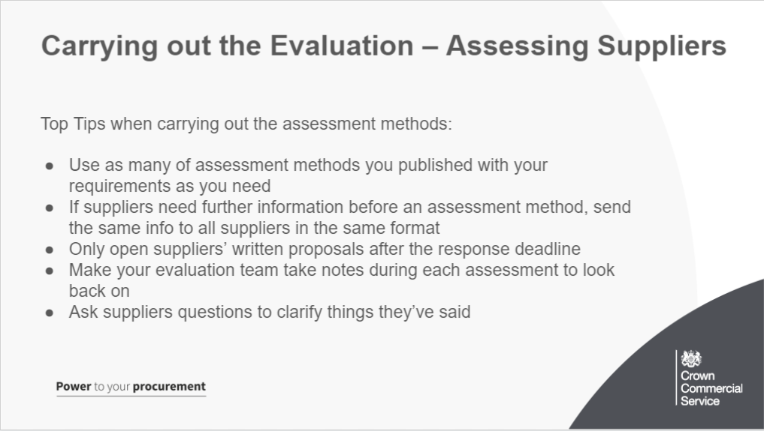
-Use as many of the assessment methods you published with your requirements as you need to. You don’t have to use them all if you find a supplier that meets your needs after the first assessment stage.
-If suppliers need further information before an assessment method, send the same info to all suppliers in the same format
-You can only open suppliers’ written proposals after the response deadline.
-In each assessment, suppliers will give you evidence of how they meet your evaluation criteria. Your evaluation team should take notes as it goes so you can measure how well the evidence they provide meets your requirements.
-You can ask suppliers questions to clarify things they’ve said.
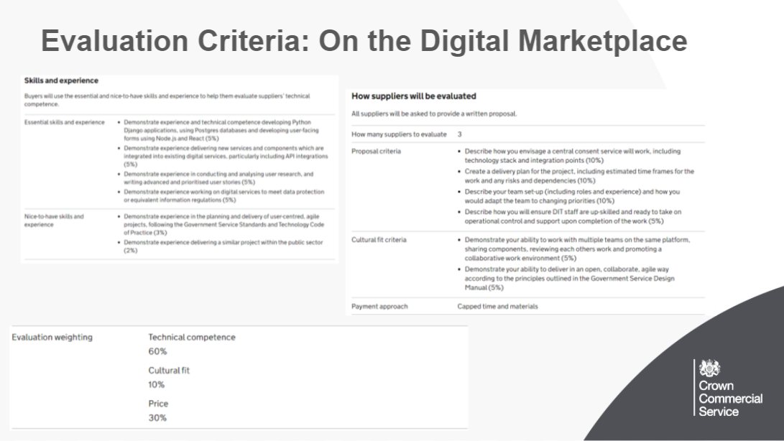
Now we have seen the preparation and assessment methods, lets recap on the evaluation criteria before going into scoring
Giving points to individual criteria:
You can give a weighting to individual criteria in Technical Competence and Cultural Fit .
If you choose to add a weighting, you must do it for all individual criteria.
The weighting is simply added as text at the end of your defined criteria.
You must tell suppliers the percentage you’ll give to each one when you publish your criteria, example is on the slide
You should keep the majority of the weighting for the proposal, as it is within this that the supplier will answer how they propose to fulfil your outcome
The weighting you give for nice-to-have skills and experience must be lower than the weighting you give to the supplier’s essential skills and experience and proposal.

In the further evaluation stage, you will be focusing mostly on the criteria within the written proposal (along with cultural fit and price), as this is the specific information around how they will deliver your outcome.
Written Proposal criteria can be:
- the proposed technical solution
- the proposed approach and methodology
- how the approach or solution meets your business or policy goal
- how the approach or solution meets user needs
- estimated timeframes for the work
- how they’ve identified risks and dependencies and offered approaches to manage them
- team structure
- value for money

Here we can see the individual weightings for the opportunities essential and nice to have skills and experience, which when added to the individual weightings within the proposal criteria make up the 60% weighing of technical competence
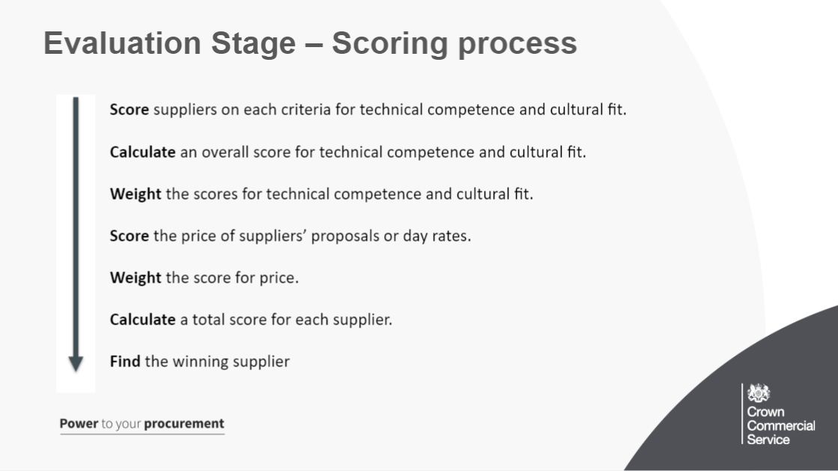
You must score shortlisted suppliers against your chosen criteria (as seen in the last slide- alot of written proposal) after each assessment.
The scoring process:
Score suppliers on each criteria for technical competence and cultural fit.
You must score shortlisted suppliers:
- using the criteria you published with your requirements
- after each assessment
- Score each criteria individually.
- Write notes on the evidence the supplier has given in all assessment methods for each criteria and give each criteria a score using the scoring scheme.
Your evaluation team must score each supplier individually and mustn’t share scores until all suppliers have been scored using every assessment method.
When your evaluation team has finished scoring all suppliers, you need to agree a score for each criteria. You can’t take an average of the evaluation team’s scores. You must:
Discuss why each evaluator gave each supplier the score they did for each criteria
Reach an agreement on each supplier’s score for each criteria
Calculate an overall score for technical competence and cultural fit.
- -Add up all the scores for technical competence (essential skills and experience, nice-to-have skills and experience and proposal)

Weight the scores for technical competence and cultural fit.
Score the price of suppliers’ proposals or day rates.
You’ll need to score price based on how close each supplier’s quote is to the cheapest supplier’s quote.
- If you think the supplier has offered an unusually low quote, you must ask them to explain their quote. If the supplier’s explanation isn’t good enough, you may need to exclude them.
Weight the score for price.
When you have scored the price for each supplier against the lowest price, you need to apply the weighting you published with your requirements.
Calculate a total score for each supplier.
Find the winning supplier.
Use the scoring template and the evidence from your notes that you take during the assessment. Your evaluation team shouldn’t share scores until all suppliers have been scored on every assessment method.
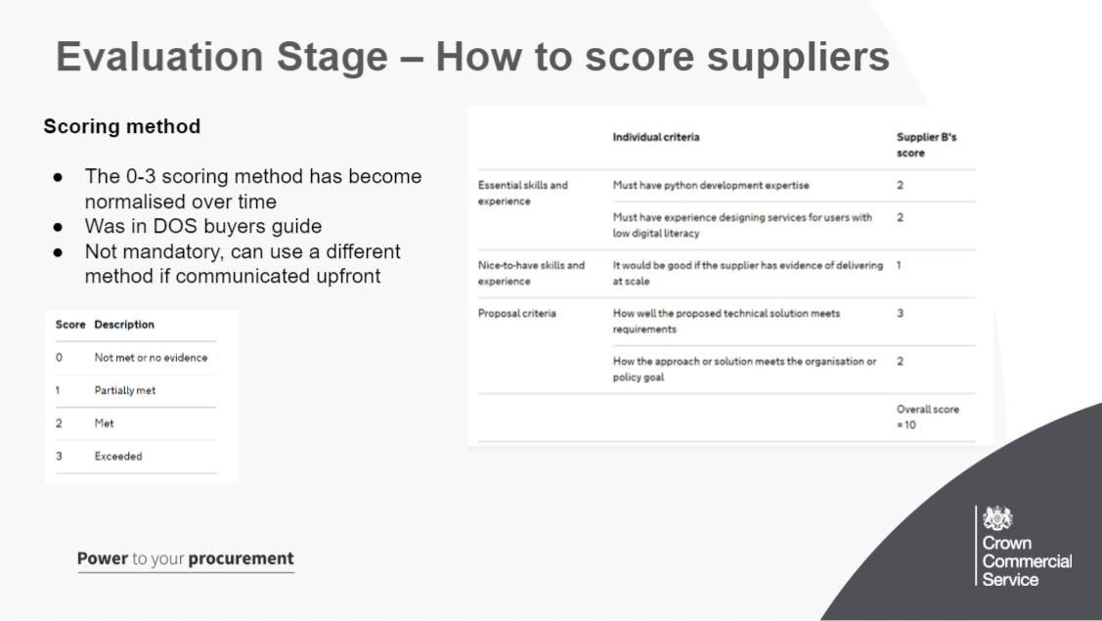
You must score shortlisted suppliers against your chosen criteria (as seen in the last slide)
- technical competence
- cultural fit
- price of the proposal

Here we will go through a simple, example scoring process for the technical competence - You can see this split between essential, nice to have and proposal criteria.
It is important to note that essential and nice to have were scored at the shortlisting stage, but any individual weightings are only applied when you get to further evaluation (which we will do in the next slide). These initial scores from shortlisting can change if the supplier shows a lack of evidence or if their performance of these elements in further evaluation is a lot different. However the further evaluation assessment methods are mostly focused on the proposal criteria and cultural fit.
As we said in the last slide, you will score suppliers after each assessment method and your evaluation team will agree a score for each supplier after the assessment methods have finished.
Scoring Scheme:
- 0 Not met or no evidence
- 1 Partially met
- 2 Met
- 3 Exceeded
The scoring scheme of 0 to 3, as provided in the guidance, has become normalised over time
Buyers can choose to use a different scoring scheme if they wish. This should be clearly communicated to suppliers upfront – we suggest you use the ‘Additional terms and conditions’ field
For consistency we also recommend the same scoring scheme is used throughout the procurement – for shortlisting and further evaluation.

On the right, you can see an example of the criteria and how the scoring could be done against them, the next slide to will look into how we make these scores into weighted scores to find the winning supplier
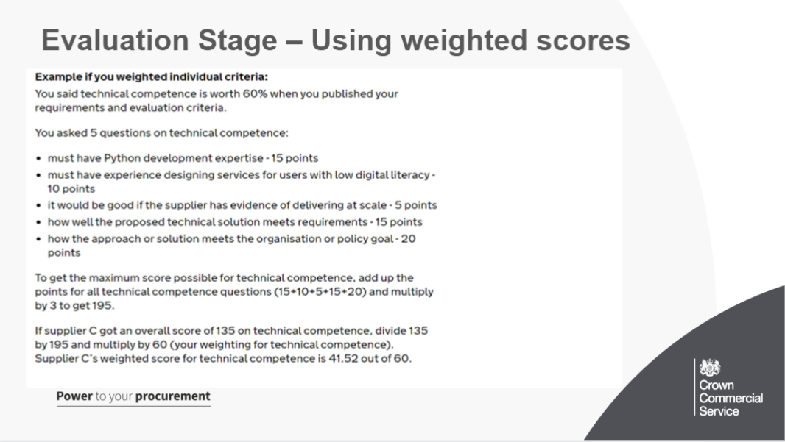
Lets take the example from the last slide and calculate an overall score for technical competence and cultural fit.

1. You can weight individual criteria by adding ‘points’ to each criteria you want to evaluate. You can only do this if you said you would when you published your requirements and evaluation criteria. This can be as “points” or as a “percentage” On this example you can see the points given after each criteria
2. When you’ve given each criteria a score, you need to calculate the overall score for technical competence and the overall score for cultural fit:
- Add up the possible points for technical competence for each question and then multiply the total by 3 (the maximum score for each question). to get the maximum score possible.
- Take the supplier’s overall score for technical competence and divide it by the maximum score possible.
- Multiply this by the weighting you gave to that criteria when you published your requirements.
In this example, (refer to last paragraph for real life example)
You can weigh the scores in other ways also if you want to, but you need to ensure this is done correctly and is fair. (this example is to help people who may not have experience with weighted scores before)
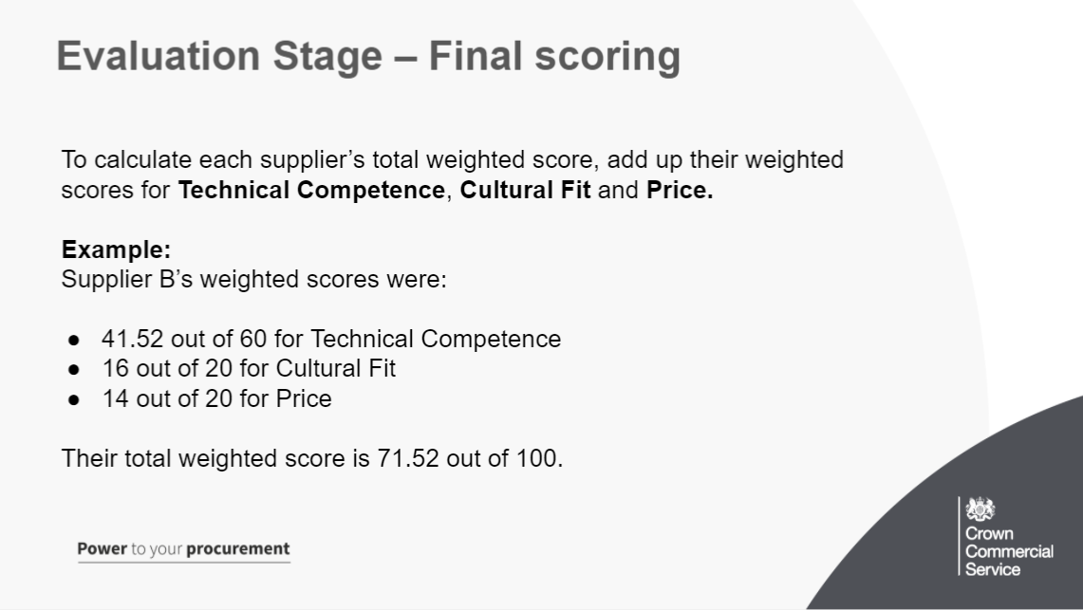
Use the scoring template and the evidence from your notes that you take during the assessment. Your evaluation team shouldn’t share scores until all suppliers have been scored on every assessment method.
Calculate a total score for each supplier.
To calculate each supplier’s total weighted score, add up their weighted scores for technical competence, cultural fit or availability and price.

Example:
Supplier B’s weighted scores were:
- 41.52 out of 60 for Technical Competence
- 16 out of 20 for Cultural Fit
- 14 out of 20 for Price
Their total weighted score is 71.52 out of 100.
Find the winning supplier.

What to do if there’s a tie
use the score from the criteria with the highest weighting, then the next highest weighting until the tie is broken, for example if you’ve weighted price as the most important criteria then the winning supplier is the one with the highest score for price
ask the tied suppliers to provide ‘best and final’ quotes. The winning supplier is the one with the lowest quote

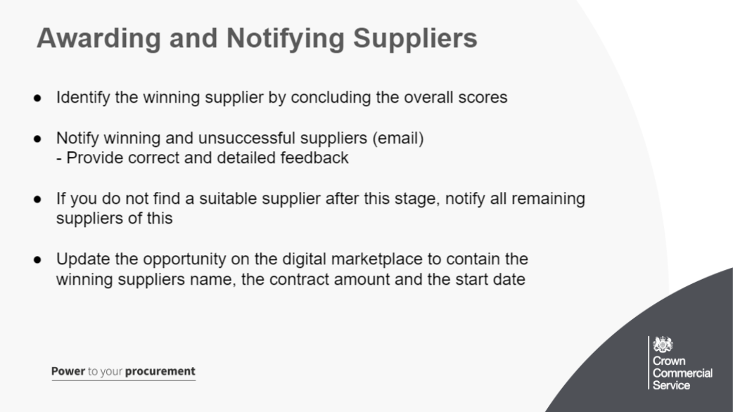
The winning supplier is the one with the highest overall score. When you’ve identified the winning supplier, you must notify the remaining suppliers of your decision at the same time. You can notify suppliers by email.
Tell the winning supplier you’ll award them a contract.

Notify unsuccessful suppliers: Suppliers need to know if and why they weren’t successful so they can plan for other work and improve any future applications they make.
- tell unsuccessful suppliers that you will not be awarding them a contract
- give feedback explaining why a supplier was unsuccessful, including the advantages of the successful bid compared to the unsuccessful bid
- -give positive feedback where appropriate
- only comment on that supplier’s scores, so don’t share specific details of other unsuccessful supplier’s scores
- give only the final agreed scores, not individual evaluator scores
- give the scores of the winning supplier

You don’t have to award a contract if you can’t find a suitable supplier. You must tell all remaining suppliers that:
- you haven’t found one that meets your needs
- you’re not going to award a contract
- You may choose to review what you need and then publish new requirements.
Update the DmP with contract information and the winning supplier so us at CCS know.
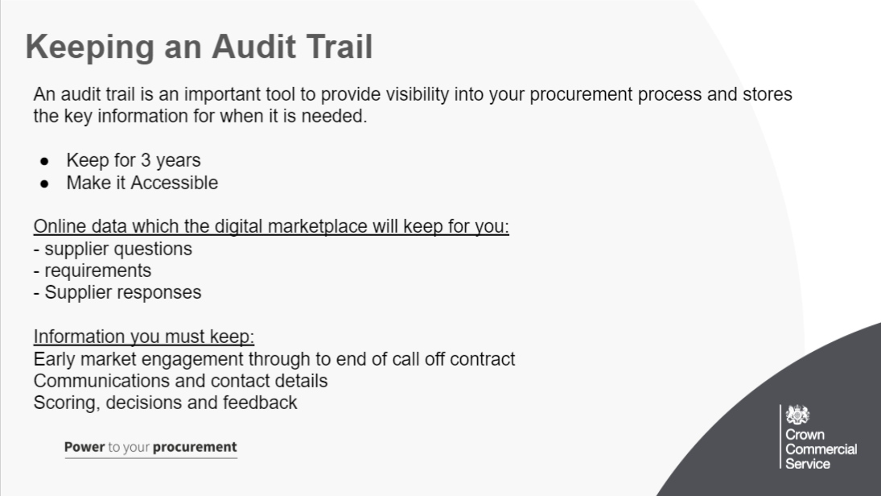
Audit trails help to provide visibility into your procurement process information, creating a system to accurately review operational activity, and improve the way information is stored. This audit can also be looked back upon to learn lessons.

Your audit trail must:
- be kept for at least 3 years
- be stored in an accessible format, in a place that other people in your team have access to, for example a shared folder
- keep a record of the buying process from your first contact with suppliers, for example from early market engagement until the contract (or ‘call-off’) ends

What is logged by the Digital Marketplace
When you buy digital outcomes, digital specialist and user research participant services the Digital Marketplace will automatically keep a copy of:
- questions asked by suppliers about your requirements, also known as clarification questions
- your answers to supplier questions
- the requirements you’ve created for every piece of work (drafts, published and closed)
- the responses suppliers provided when they applied for the work, eg answers to essential and nice-to-have questions, start date, supplier contact email and day rate (for specialists only)

What you must keep
You must keep a record of your communications with suppliers that aren’t already saved by the Digital Marketplace. You must save details of:
- all contact with suppliers during early market engagement:
- how you approached suppliers, eg in person at an event
- who was involved, ie the suppliers you approached and who approached them
- any correspondence or meeting notes
- what you learned and how you changed your requirements
- all decisions made, with supporting evidence, eg scores you award when you assess suppliers
- who you exclude when you shortlist, and why
- questions you ask shortlisted suppliers to answer during interviews and presentations
- feedback you give to successful and unsuccessful suppliers after the evaluation stage
- how written responses are received from suppliers
- who has access to written responses and when
- all types of communication with suppliers, eg:
- emails and other forms of written communication
- webinars
- face-to-face conversations
- all written proposals and supporting evidence
- notes you take during phone conversations and meetings

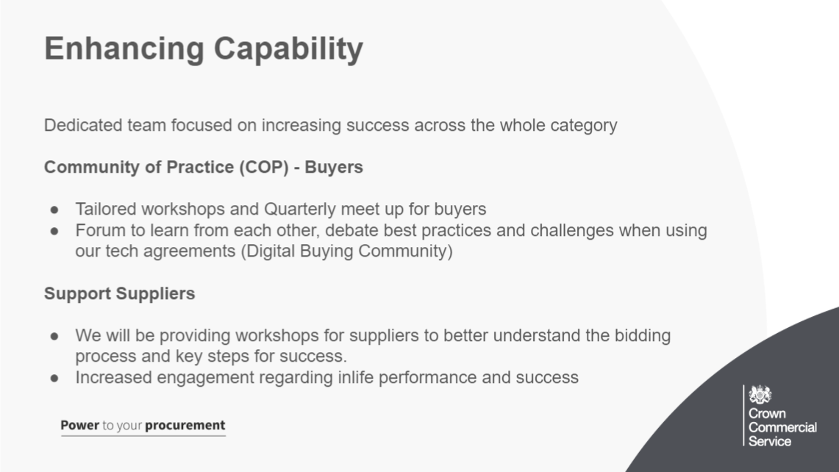
Enhancing Capability will be a dedicated programme to support the success for buyers and suppliers in participation in the digital future category, will expand the Community of Practice and start to mobilise supplier community options as well.
It looks to include:
- Better understanding on the procurement process for both agreements
- Steer when contracting outcomes
- Support when identifying the correct route to market
- To increase knowledge on how to write agile requirements
- Dealing with more flexible contract management
The digital buying community exists to:
- make sure that procurement practices support agile ways of working
- create and support a peer group of buyers across government
- share knowledge and best practice for buying digital and technology services
- discuss common challenges and develop solutions
- build commercial awareness across central government and the wider public sector

