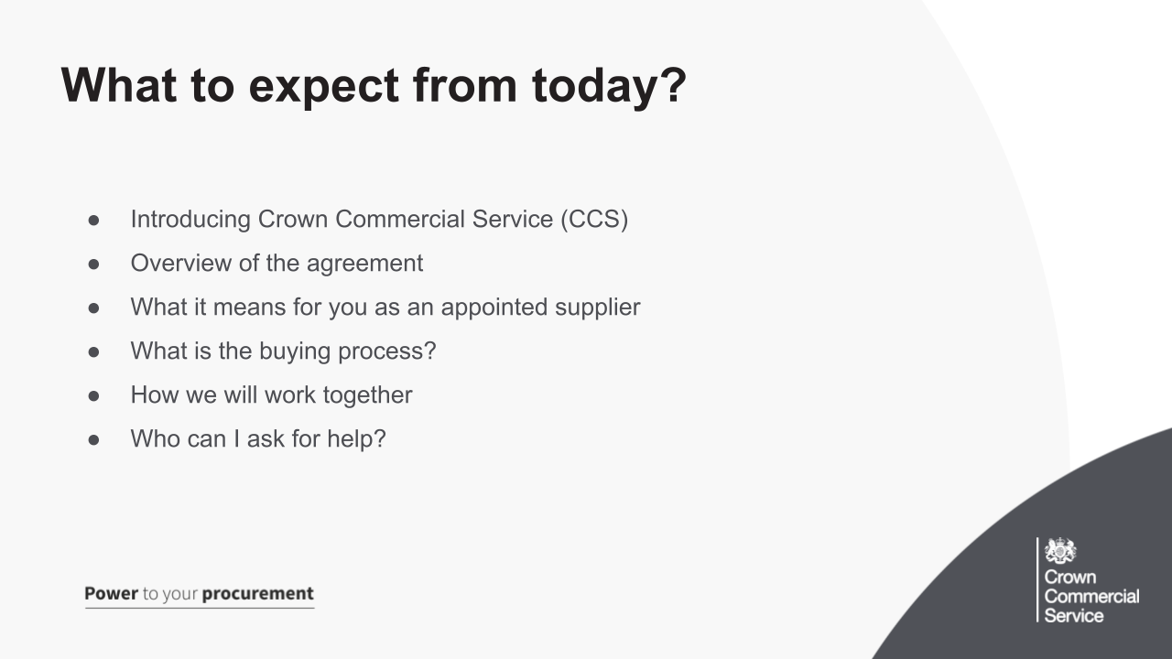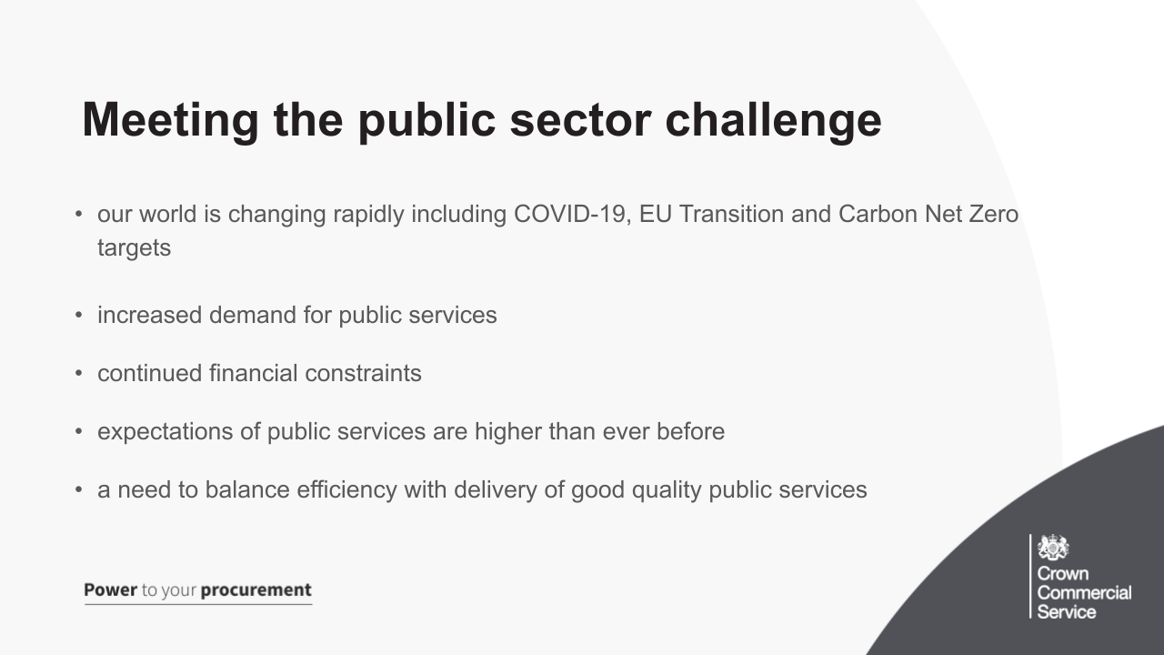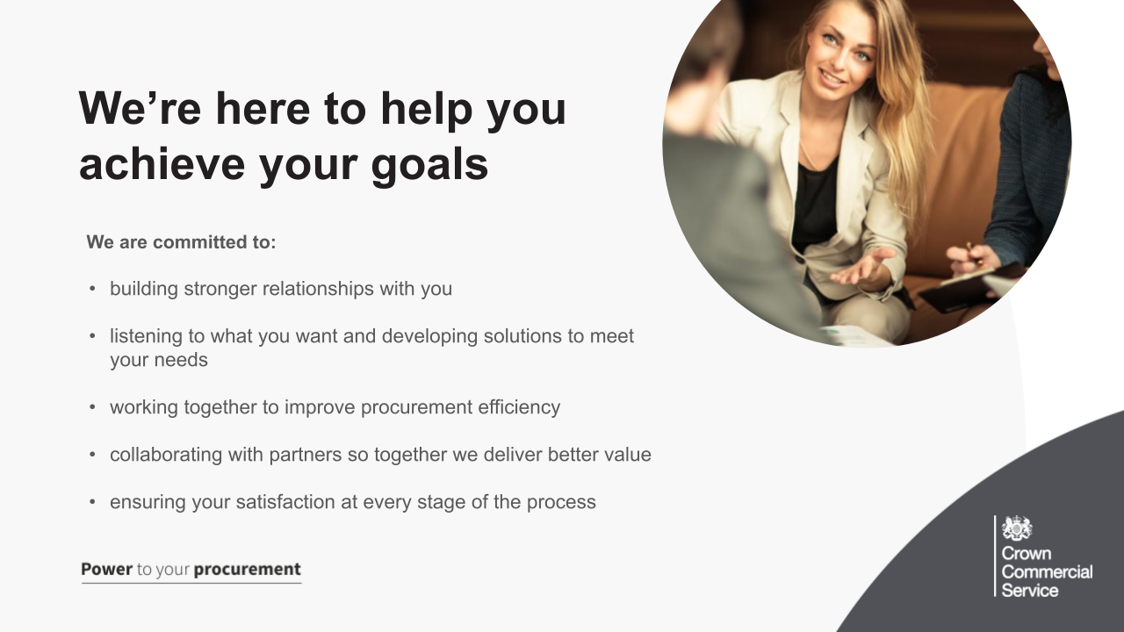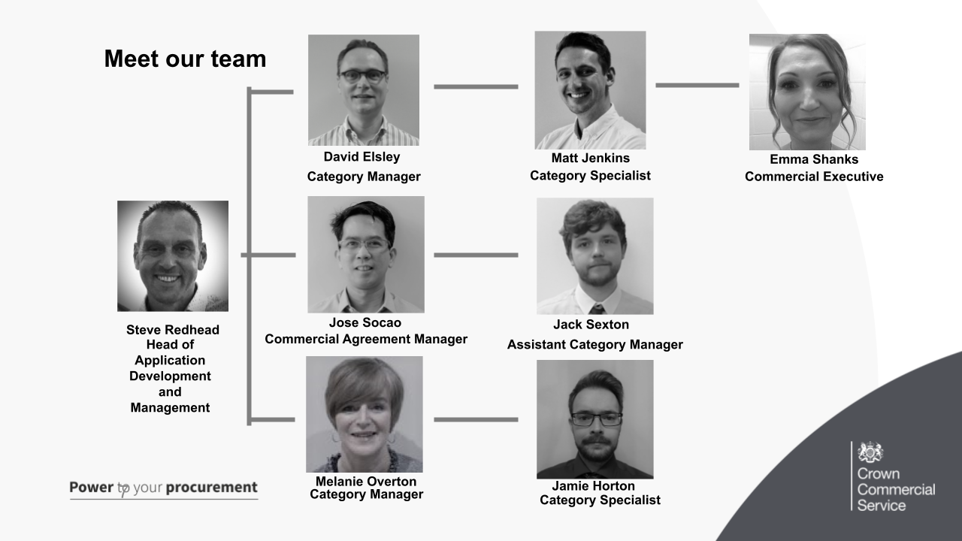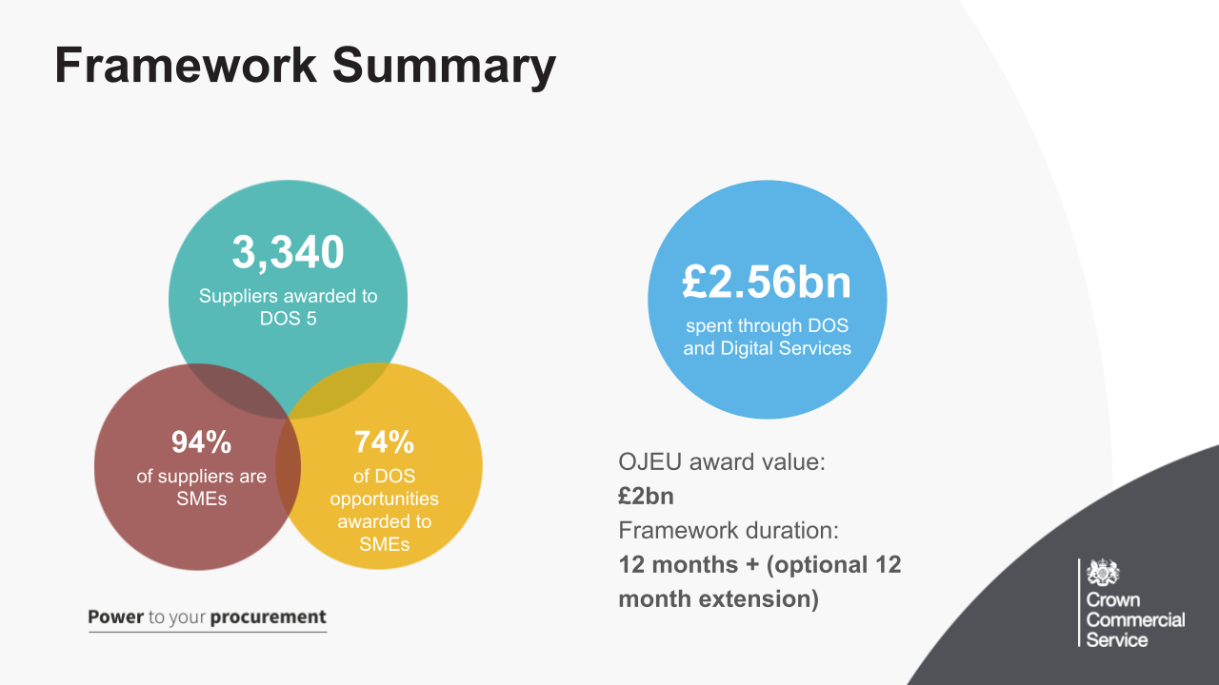
- 3,340 suppliers awarded to DOS 5
- 74% of DOS opportunities, which show as awarded on the Digital Marketplace have been to SMEs, this information came from the Download data CSV in the Digital Outcomes and Specialist Opportunities section of the Digital Marketplace
- So far we have seen £2.56 Billion spent through DOS and Digital services
- Expected OJEU value for this iteration of the framework is £2bn
- Framework duration (the agreement between ourselves and you) is 12 months, we then have the option of a 12 month extension, which doesn’t need to be fully taken.
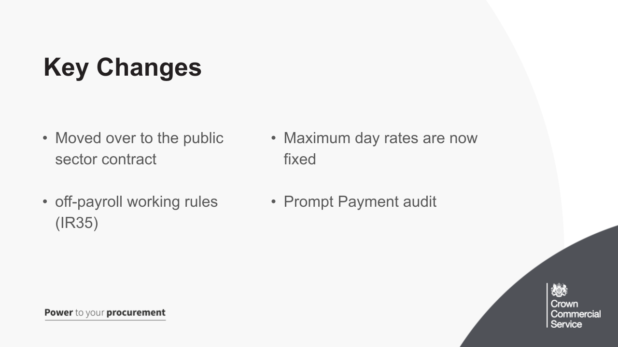

There have been a few key changes to DOS 5, these include:
- Used the Public Sector Contract as the basis for the framework agreement and call-off contract, this now brings DOS in line with other CCS framework agreements
- IR35: within the scope of defined digital outcomes buyers can undertake procurements that are deemed to be a supply of resource ('inside IR35') rather than a fully outsourced managed service (‘outside IR35’). Buyers will be expected to make it clear in their requirements if they are buying an outsourced managed service or a supply of resource. You also have the opportunity to ask a question if this is not clear. Your role, as the supplier, will need to be aware of this when deciding on your own supply chain and staff being proposed for engagements
- Prompt Payment: there has always been a legal requirement in the DOS framework to ensure all subcontractors in the supply chain are paid promptly (30 day payment terms). With standard frameworks suppliers are normally assessed against their payment performance as part of the framework evaluation and award process. Given the sheer numbers of suppliers applying to DOS it is not possible to conduct this assessment at the tender stage. Instead, suppliers were asked appropriate declaration questions during the DOS 5 application process. Consequently, we have a conditional exemption from the Minister, Lord Agnew. The condition is that we must have an audit process in place to check all (100%) suppliers awarded a contract valued at £5 million or more a year; and a sample of those awarded a contract valued at £2 - 5 million a year. We will be applying the annual value criteria based on the awarded contract value divided by the expected contract length
- Maximum day rates are now fixed for the duration of the framework agreement. Previous iterations you could amend both the Maximum and minimum day rate, we have removed this option and the minimum day rate.

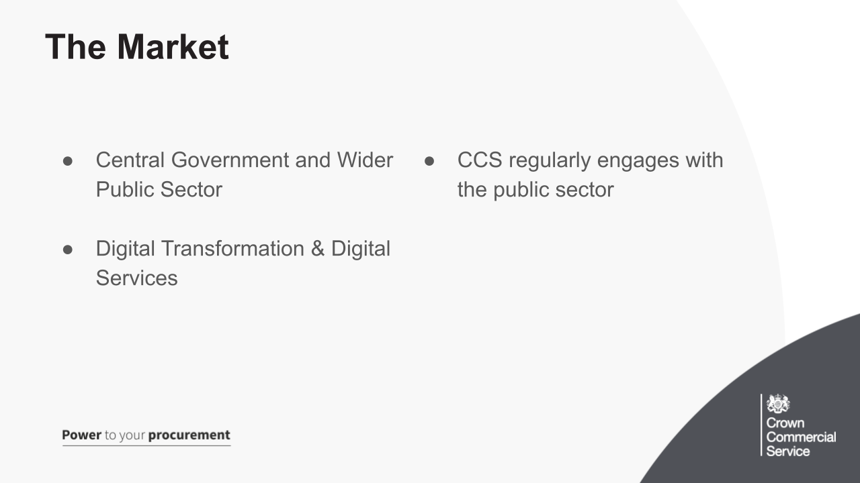

- DOS is available to the Central Government and Wider Public sector
- There to be used on Digital Transformation and Digital Services, such as:
  - Public sector undergoing extensive transformation - A new unitary authority formed from five former councils, had developed a new website and needed to design, develop and migrate the services that are still delivered through the legacy websites
  - Services for the general public - Blue badge service (online application form)
  - Internal services - DWP had multiple MI/BI data visualisation products and require the consolidation of these products into single source ERS.
- CCS regularly engages with the market through:
  - Digital Buying Community (community of practice)
  - Workshops
  - Our CXD department

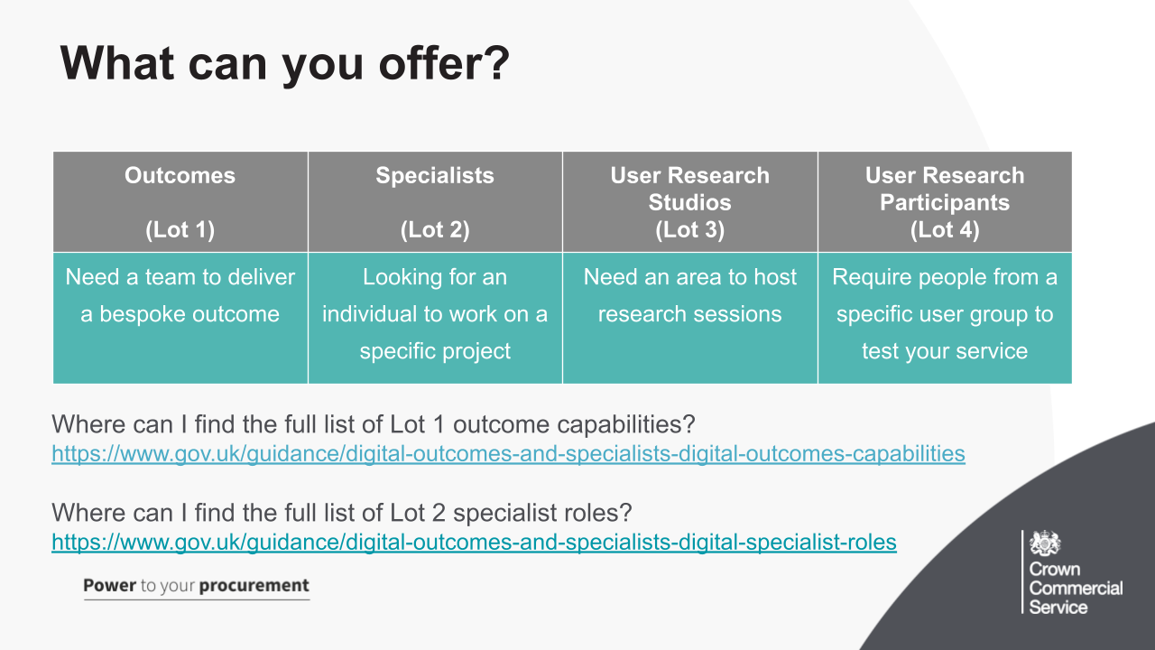
DOS 5 like previous iterations is split into 4 lots.

There is a full list of the Lot 1 outcome capabilities and Lot 2 specialist roles available on the GOV.uk website, with a description of each role.

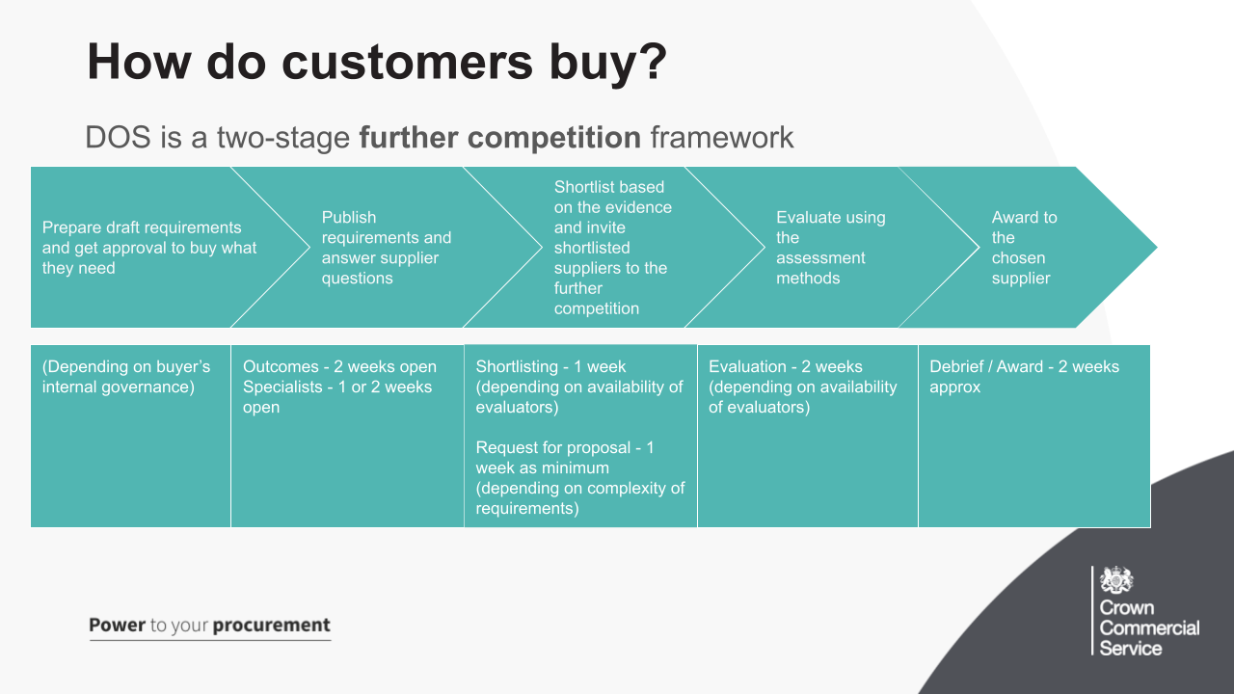

DOS is a further competition framework and there is no direct award option. It is composed of two stages – shortlisting and further competition or evaluation stage.

- Buyers are required to prepare draft requirements and get approval to buy what they need. They’re also encouraged to carry out Pre-Tender Market Engagement, where they will contact you to help make their requirement clear and concise. The team are also available to all buyers if they wish for us to run through their requirement before they upload it to the DMp.
- Requirements are published for a set time and can only be uploaded on the Digital Marketplace. For Digital outcomes, closing of applications is 2 weeks from publication whilst for Digital specialists, they have the option of having it for 1 week or 2 weeks. The buyer has no control over this and they are unable to extend their opportunities. It is at this stage where you will have the opportunity to ask clarification questions and then apply for the requirement by answering their essential and nice to have criteria.
- The buyer will specify how many suppliers will be shortlisted in their requirement. Shortlisting takes place on the Digital Marketplace and buyers will shortlist you by reviewing your answers to their Essential and Nice-to-have criteria. It isn’t mandatory for you to respond to each opportunity. Once the buyer has shortlisted they should notify successful suppliers of the next stage and provide feedback to those unsuccessful.
- Shortlisted suppliers take part in a full further competition/evaluation. Where you are expected to submit tenders. This stage takes place outside of the Digital Marketplace via the buyers own sourcing suite. They will assess you on Technical competence, cultural fit (Social Value questions should appear here) and price.
- The contract is awarded to the most economically advantageous tender ("MEAT“) and the Buyer awards the contract to the bidder who has the highest score. They are then required to update the Digital Marketplace and you notify CCS of any contracts you sign via the MI template
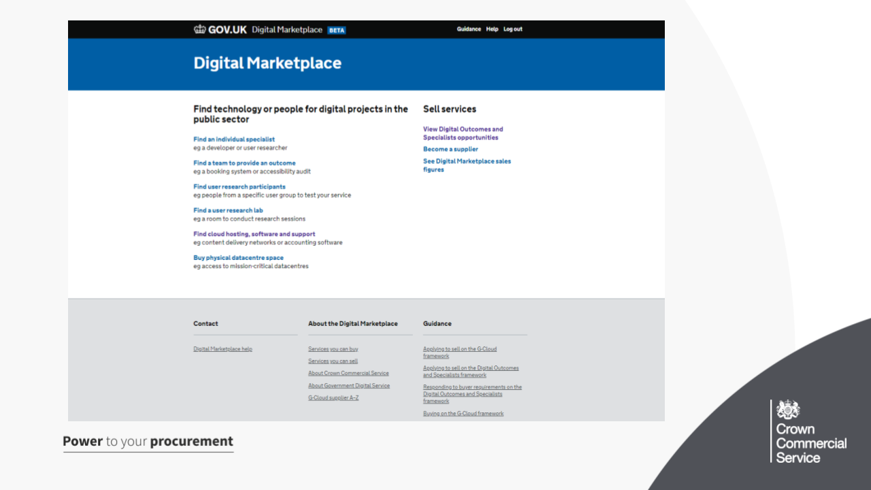

- The Digital Marketplace is used to launch opportunities under DOS 5 and the system is open to all public sector buyers
- Everything published on the Digital Marketplace is transparent and anybody can view opportunities that have been published, by heading to the link under Sell Services
- Only appointed suppliers can respond to shortlisting opportunities
- You can also view Digital Marketplace Sales figures for G-Cloud and DOS (most recent figures can be found under Sales figures for the Digital Marketplace after 31 December 2018, this includes historic spend
- We also have a variety of buyer and supplier guidance available, which we suggest you read through.

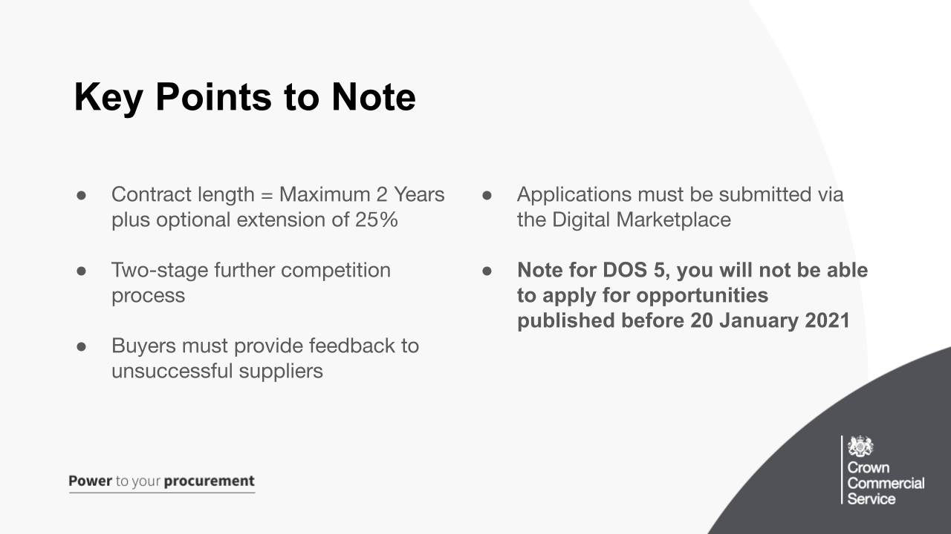

- Maximum call-off contract length is 2 years plus a optional 25% extension (6 months), use of the extension must be advertised on the buyers opportunity
- As mentioned a moment ago it’s a 2 stage further competition, no option for direct award
- Suppliers must submit their application through the Digital Marketplace, you are unable to send an email with your responses to them.
- With feedback buyers can send the same email to all suppliers they’re excluding because:
  - you can’t start when you need them to
  - you had the fewest nice-to-have skills and experience
  - you scored less than the suppliers you’re taking through to the evaluation stage
  - your day rate is above the budget you gave in your requirements (specialists only)
They need to send more detailed feedback if they’re excluding you for any other reason. You can also contact them if you want any further information. If you haven’t received feedback, contact the team and we will give the buyer a chase for you.
- Finally if you are new to DOS 5, not been on DOS 4 you will only be able to apply for opportunities dated from 20 January onwards.

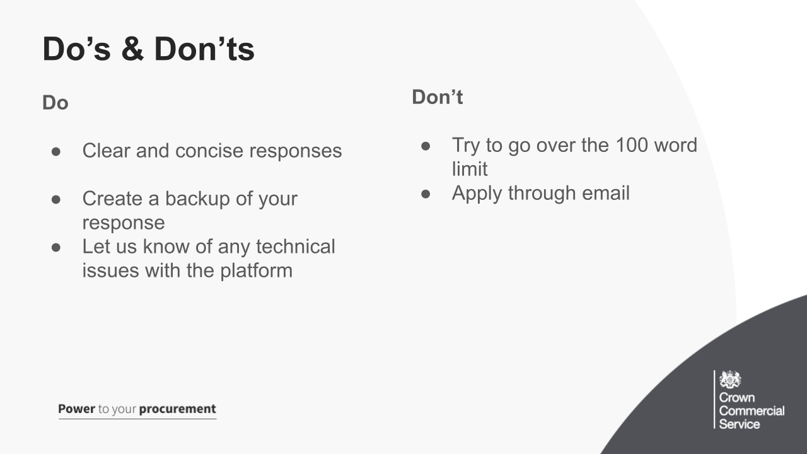
Do
- Give a clear and concise answer when responding to a buyers criteria, explain
  - what the situation was
  - the work you did
  - what the results were
- Create a backup of your response, for you to look at later for future applications, we recommend saving these in another document - We have had cases before of suppliers wanting to find their previous responses to bids in order to inform future ones. Also for the reason of if a buyer removes their opportunity or if there was a network error on the buyers end which made you lose your responses
- Let us know of any technical issues with the platform - let us know quickly and provide as much detail as possible, UR of page affected; field; action; error message and take screenshots where you can.

Don’t
- There are 100 words against each criteria and the Digital Marketplace will force this. Don’t abuse it, by abuse we mean not including spaces between words, dashes etc. This is not tolerated by buyers and they have the right to exclude your application!
- You cannot send an application to the buyer through email, this must be sent via the Digital Marketplace. Late applications are not accepted.

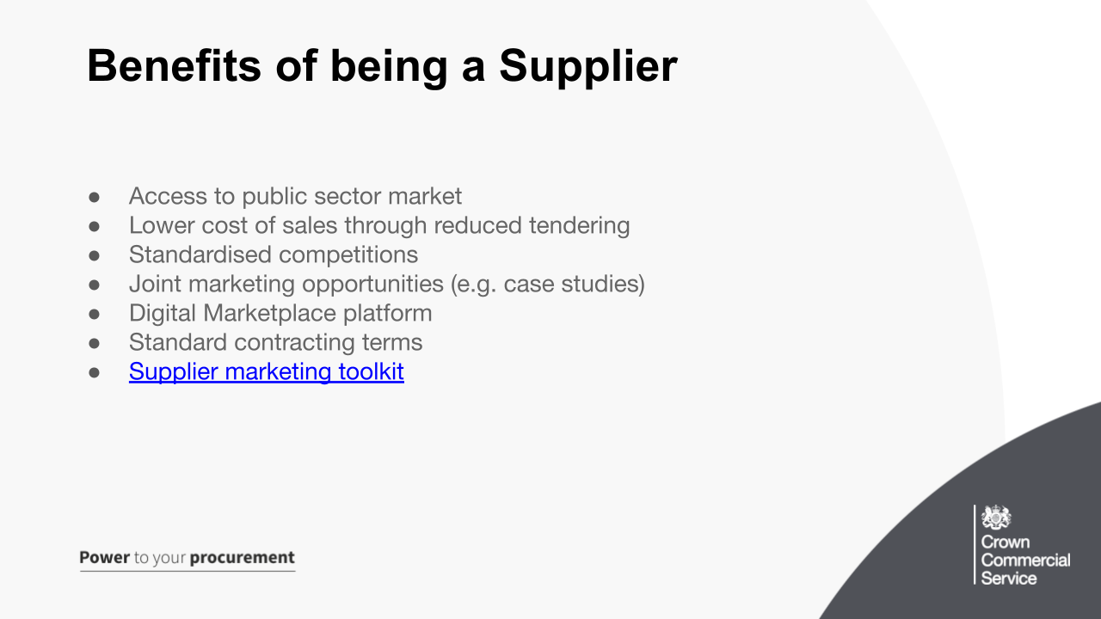

The supplier marketing toolkit is available on the DOS 5 webpage on the CCS website, we also have a variety of help documents available to both our buyers and supplier.s
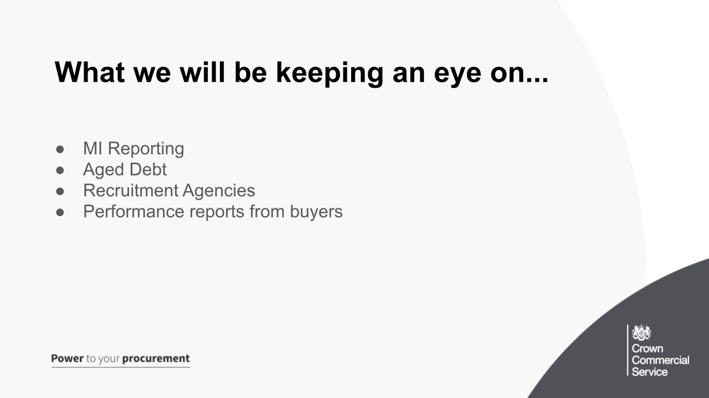
These are areas we are keeping an eye on and are entitled to remove you off the framework, should these not be met
- MI reporting - make sure these are done every month and you declare both spend and no business, more information to follow
- This is where we have invoiced you the management charge and this hasn’t been paid within the given time frame.
- Any supplier acting as a recruitment agency (sourcing all staff on an ad-hoc basis to meet a buyers requirements) will be deemed to have applied to the framework fraudulently. At the application stage suppliers were asked a series of declaration questions which they had to answer truthfully. Questions like providing suitable services (delivering services yourself and not solely sourcing staff for others) and working with the government (practising continuous professional development of employees) these cannot reasonably be answered truthfully where the prime supplier has no staff to deliver digital services. Where such suppliers are brought to our attention they will be investigated and challenged. Recruitment agencies distort the buying process when the same specialist is put forward by more than one supplier. When suppliers propose a specialist to a buyer, they should do so on the basis that they have an existing contractual relationship with the individual.
- Performance reports from buyers, as per Call Off Schedule 14 (service levels and balanced scorecard) These are the standards of service required by the buyer and what happens when these are not met. The buyer may choose to use Service Levels and/or Balanced Scorecard KPIs to manage the supplier and Call-Off Contract.

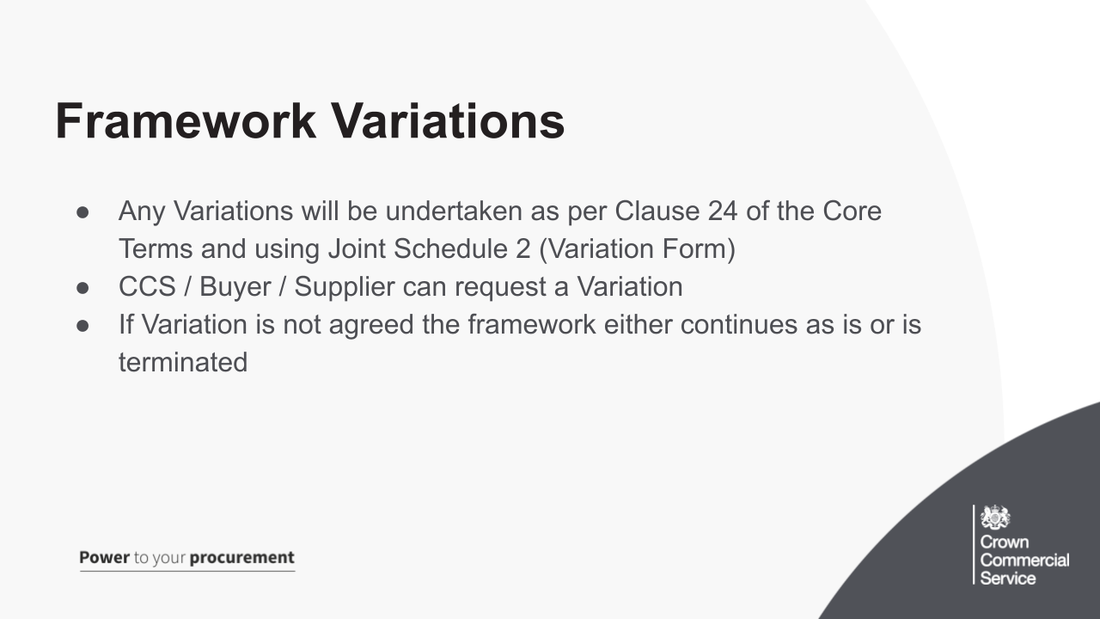

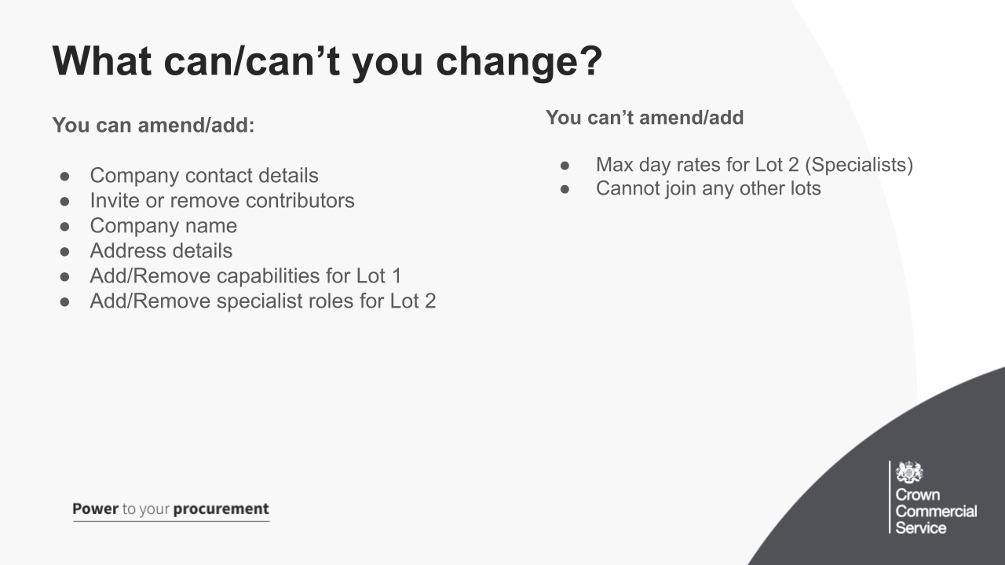
Can amend
- Ensure your company contact details are up-to-date and correct on your Digital Marketplace Supplier account, these are the details to which successful/unsuccessful notifications will be sent. Consider using a group email address.
- Contributors: These are the contacts who will receive the daily file of new opportunity notifications and any other Digital Marketplace comms
- Company name, you can amend yourself, providing there’s no registration number change, if there is a change you will need to contact us
- Address details, you can also amend these, but again let us know as we will need to update some systems
- You can Add/Remove capabilities for Lot 1 and also Add/Remove specialist roles for Lot 2. Just fill in the linked form for the required lot and we will be able to add these for you. If you need to remove a capability or specialist role, please contact the team.

Can’t amend
- Max day rates, these are fixed for the duration of the framework agreement
- You cannot be added to any new lots after framework applications close and when you’ve been accepted onto the framework. These are also fixed for the duration of the framework agreement.

Why do we need Management Information?

- Provide granular detail of Buyer activity within the framework for government monitoring purposes
- Provide information on where the public sector is spending its money, on the type of products and services
- Demonstrate that the public sector is receiving the best price and value for money on its purchases
- Ensure that Government Procurement Policy and framework obligations are being upheld

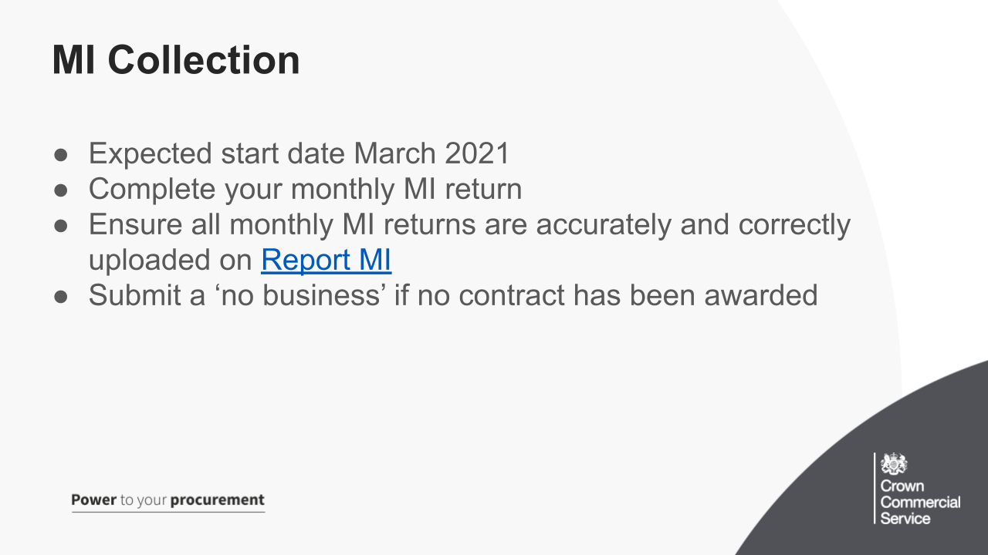
You will receive an email notifying you of when this will start, with all the information you will need to know. This will go to the contact you used entered in your contact details for your DOS application, this can be changed if required, just respond to the onboarding email.

Make sure you complete your monthly MI return, there will be a seperate template to use for your DOS 5 submissions.

You will be required to declare if a contract has been won and the amount you have invoiced to a buyer for that month.

Where there has been no activity for a particular month, you must submit a ‘no business’ for that month, which is a simple click of a button on the MI Portal.

Keep your eye on the documents section of DOS 5 Webpage as we are working on some MI Guidance to help you with the process.

You also need to be aware of MI Failures, these include:
- omissions or errors in the Supplier’s submission
- Uses of the wrong template
- Yours report is late
- failure to submit a report

Also if there are 2 or more MI Failures in any 3-month rolling period, CCS will charge the Supplier for the costs (an ‘admin fee’) of chasing the Supplier to provide the required information

Finally, CCS may choose to suspend or terminate this Framework Agreement at its discretion if at least 3 MI Failures occur within a 6-month rolling period

Full details can be found in Framework Schedule 5 Management Information and Charges

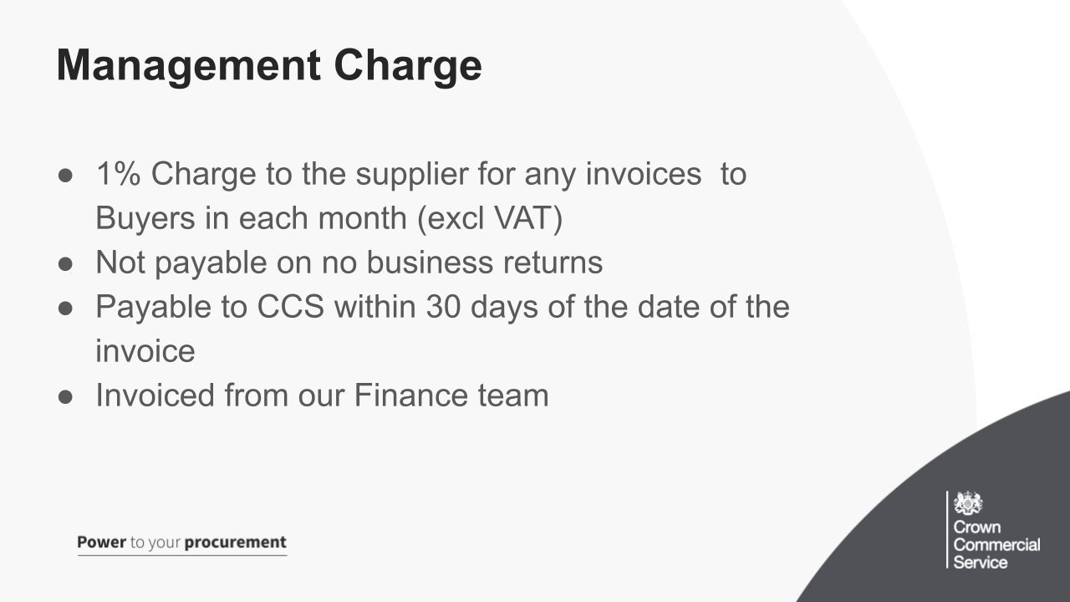
We are a Trading Fund – this means we are not funded from the taxpayer directly, but via the management charge

The Management Charge is the sum paid by the Supplier to CCS being an amount of 1.0% of all Charges for the Services invoiced to Buyers (net of VAT) in each month throughout the duration of the Framework Agreement and thereafter, until the expiry or termination of any Call-Off Contract. This doesn’t apply if you haven’t done any business for that month.

The Supplier will pay the Management Charge to CCS each month, with the amount invoiced which is calculated based on the monthly MI returns, within 30 days of the date of the invoice.

