Dashboard status for a successful submission of a DOS 7 application

Your Digital Outcomes and Specialists 7 application will be submitted automatically at 3pm BST on Friday 20 June 2025 providing you have completed each of the 5 sections (as applicable) of the application.

A supplier submitting an application to all 4 Lots (services) must have the dashboard display as below:

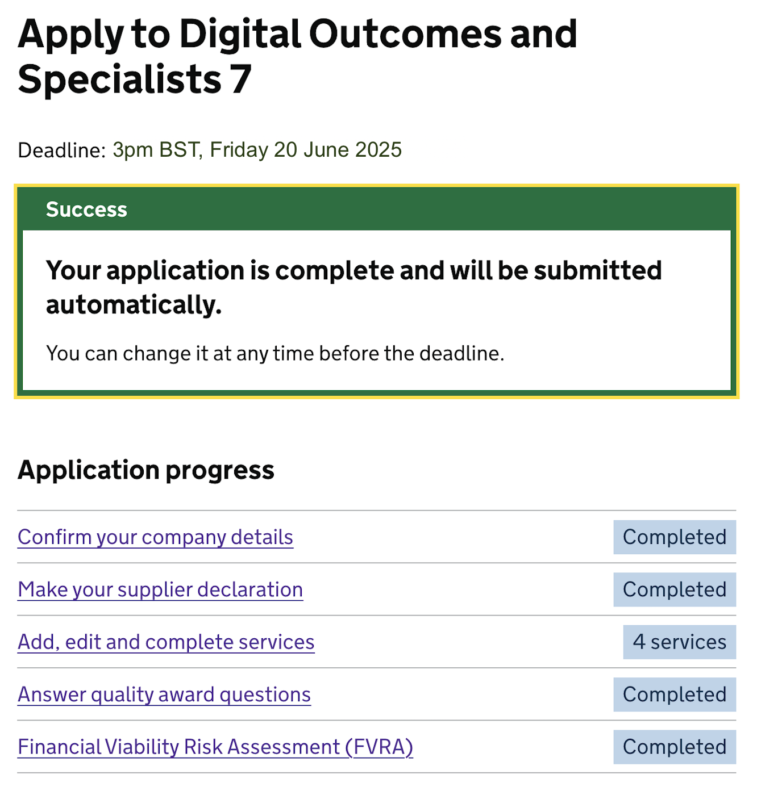

If you are submitting an application for Lots 1 and/or 3 and/or 4, but not Lot 2 your dashboard must have the display as below:

Note: the number displayed against the services will denote the number of Lots you have made an application to, for example:
- if you have applied to only Lot 1, then it will say ‘1 Service.’
- If you have applied to Lot 1 and Lot 3, then it will say ‘2 Services’.
- the ‘Answer quality award questions’ is only applicable to Lot 2 and therefore displays ‘Not required.’


