RM1043. 9 DOS 7 Broadcast emails
This document contains a list of the emails we have broadcasted on the Digital Marketplace to suppliers who had started a framework application
New clarification questions and answers have been published 2
Email sent on 2
Email text 2
Screenshot 3
New clarification questions and answers have been published (after clarifications closed) 4
Email sent on 4
Email text 4
Screenshot 5
Final Digital Outcomes and Specialists 7 clarification log and applications close on Friday 20 June 2025 at 3:00pm BST 6
Email sent on 6
Email text 6
Screenshot 8
Clarification on RM1043.9 Clarification Question and Answers log Version 8.0 10
Email sent on 10
Email text 10
Screenshot 11
What your dashboard should look like for a successful application 12
Email sent on 12
Email text 12
Screenshot 13
IMPORTANT – RM1043.9 DOS 7 – Tender Deadline Extended 14
Email sent on 14
Email text 14
Screenshot 15
IMPORTANT INFORMATION – please read all sections carefully 16
Email sent 16
Email text 16
Screenshot 19

New clarification questions and answers have been published

Email sent on
- 14 May 2025, 15:48
- 16 May 2025, 15:31
- 20 May 2025, 08:31
- 21 May 2025, 14:58
- 23 May 2025, 15:58
- 27 May 2025, 13:28
- 28 May 2025, 13:35
- 30 May 2025, 15:29

Email text
Hello,

We’ve posted new clarification questions and answers about the Digital Outcomes and Specialists 7 framework.
https://www.applytosupply.digitalmarketplace.service.gov.uk/suppliers/frameworks/digital-outcomes-and-specialists-7/updates

Questions and answers are published regularly, as well as other questions we have not yet answered.

You can ask further questions about Digital Outcomes and Specialists 7 through your Digital Marketplace account.

Please note that Applicants must submit their Clarification questions by Friday 30 May 2025 at 2:59pm BST. Any Clarification questions received after this time will not be responded to.

Thank you,

Crown Commercial Service

You’re receiving this email because you, or someone at your company, started a Digital Outcomes and Specialists 7 application.

Screenshot
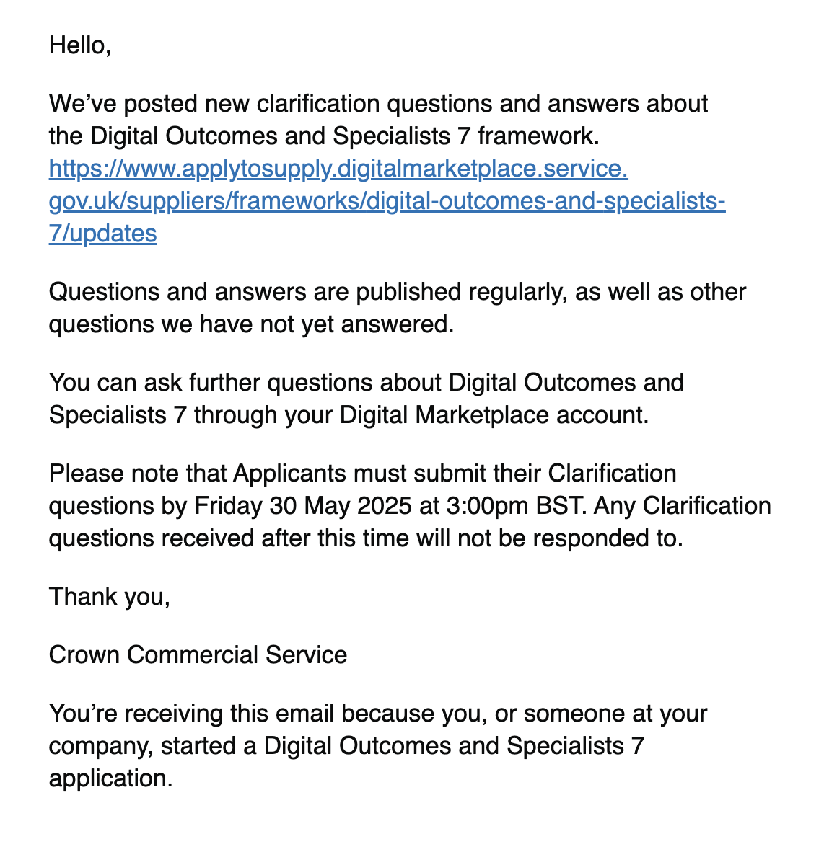

New clarification questions and answers have been published (after clarifications closed)

Email sent on
- 2 Jun 2025, 16:43
- 4 Jun 2025, 16:00
- 6 Jun 2025, 14:25
- 10 Jun 2025, 08:11
- 11 Jun 2025, 17:26

Email text
Hello,

We’ve posted new clarification questions and answers about the Digital Outcomes and Specialists 7 framework.
https://www.applytosupply.digitalmarketplace.service.gov.uk/suppliers/frameworks/digital-outcomes-and-specialists-7/updates

Questions and answers are published regularly, as well as other questions we have not yet answered.

Thank you,

Crown Commercial Service

You’re receiving this email because you, or someone at your company, started a Digital Outcomes and Specialists 7 application.

Screenshot
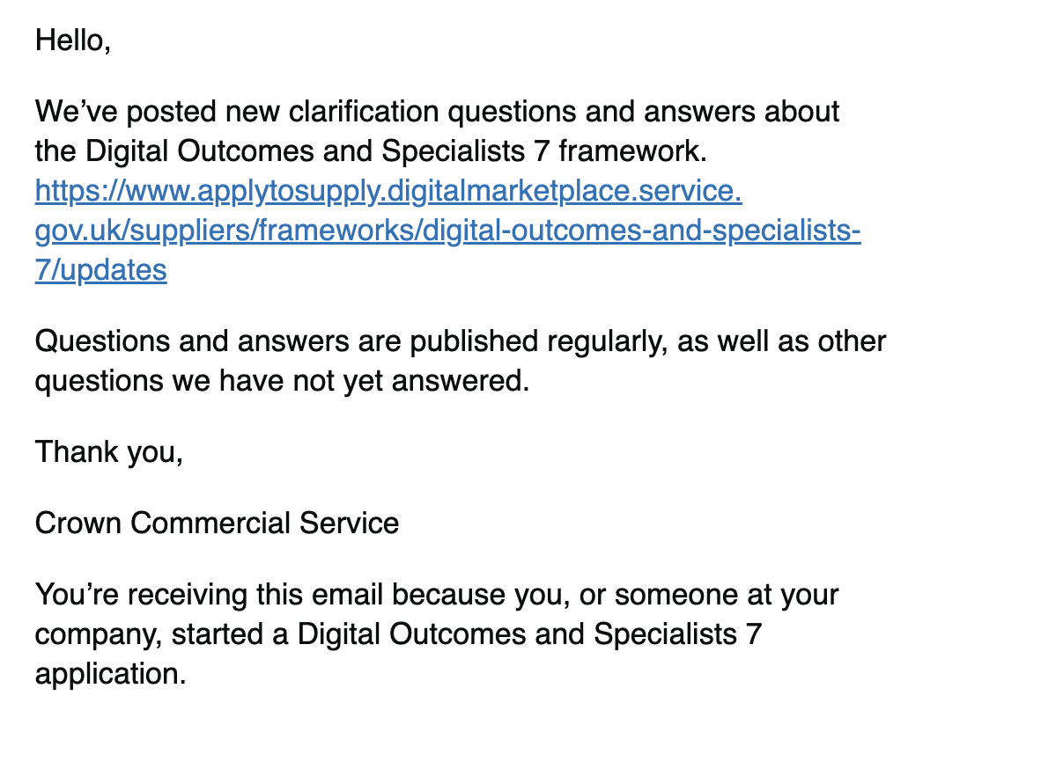

Final Digital Outcomes and Specialists 7 clarification log and applications close on Friday 20 June 2025 at 3:00pm BST

Email sent on
- 12 Jun 2025, 14:04

Email text
Hello,

We’ve posted the final clarification questions and answers about the Digital Outcomes and Specialists 7 framework.
https://www.applytosupply.digitalmarketplace.service.gov.uk/suppliers/frameworks/digital-outcomes-and-specialists-7/updates

All clarification questions have now been answered and posted on Digital Marketplace. We will also make it available as an Excel spreadsheet on the Digital Outcomes and Specialists 7 – Tender Documents webpage in due course. You can access this through the Digital Marketplace dashboard.

Bidders are advised that the responses to questions 239, 363, 364, 365 and 366 have been updated to provide further clarity

The deadline to complete your application to the Digital Outcomes and Specialists 7 framework is Friday 20 June 2025 at 3:00pm BST, so please do not leave completion of your application until the last few days.

Your application will be automatically submitted on Friday 20 June 2025 at 3:00pm BST if you have:

completed your company details
made your supplier declaration
marked at least one service as ‘complete’
completed your quality award questions (applicable to Lot 2 only)
To check the status of your application, log into your account on the Digital Marketplace:
https://www.applytosupply.digitalmarketplace.service.gov.uk/suppliers/frameworks/digital-outcomes-and-specialists-7/

Thanks

Digital Marketplace Team
Crown Commercial Service

You’re receiving this email because you, or someone at your company, started a Digital Outcomes and Specialists 7 application.

Screenshot
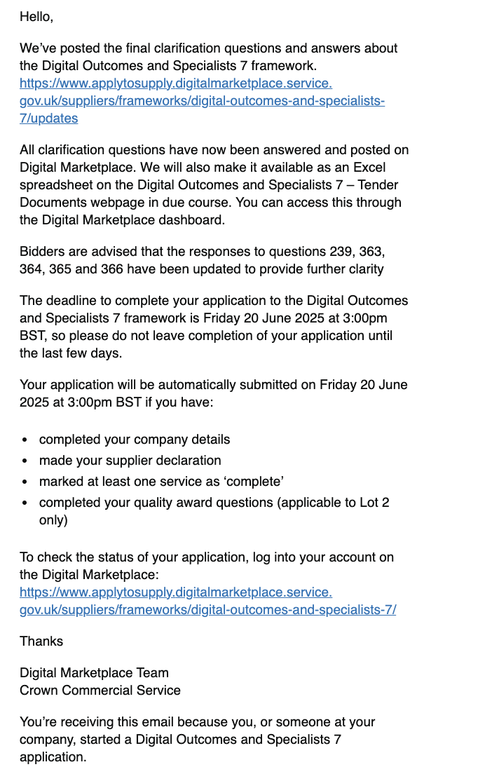

Clarification on RM1043.9 Clarification Question and Answers log Version 8.0

Email sent on
- 2 Jun 2025, 11:54

Email text

Dear Suppliers,

We would like to clarify that the RM1043.9 Clarification Question and Answers log version 8.0, issued on Friday, 30th May 2025, erroneously included responses from version 7.0 highlighted in yellow. We can confirm that there were no changes to the version 7.0 responses from those previously published.

An updated version has been provided today, which removes the yellow highlighting from all previously published responses in version 7.0 to eliminate any potential confusion. Please note that no new responses have been included at this time; these will be released once version 9.0 is published.

We apologise for any confusion this may have caused.

Kind regards,
Crown Commercial Service

Screenshot
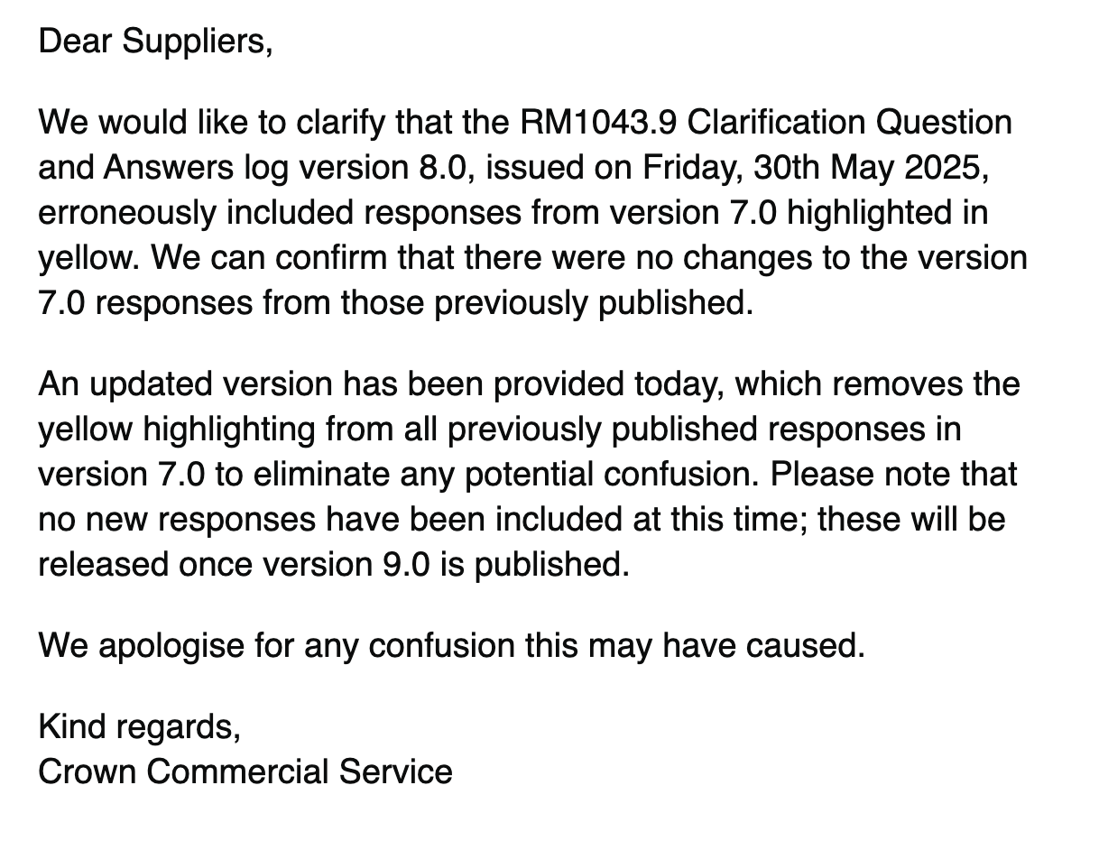

What your dashboard should look like for a successful application

Email sent on
- 16 Jun 2025, 16:52

Email text
Dear supplier,

On the 20th of June at 3 pm applications for DOS 7 will close. At this time, your application will be automatically submitted if you have:

completed your company details
made your supplier declaration
marked at least one service as ‘complete’
completed your quality award questions (applicable to Lot 2 only)
To check the status of your application, log into your account on the Digital Marketplace.

To support your understanding of this process, we have linked below a document which includes screenshots of what your dashboard will need to look like.

RM1043.9 What your dashboard should look like for a successful application submission

Or you can access the document in the “For Information Only” section of the tender documents section. You can access it by selecting the link ‘Please see Tender Document (opens in new tab)’ from the DOS 7 application dashboard page.

Kind regards,
Crown Commercial Service

Screenshot
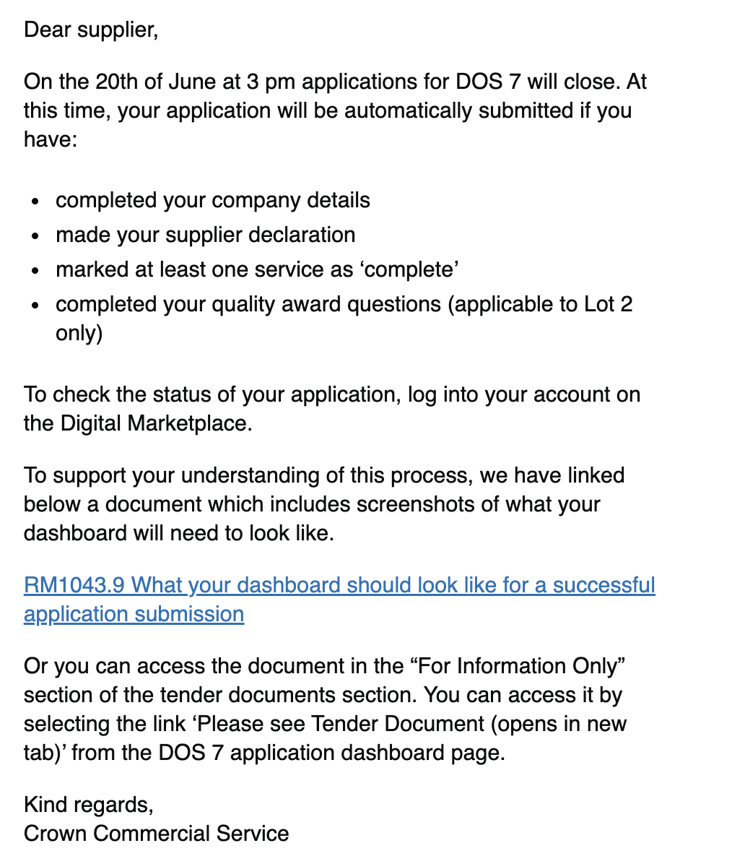

IMPORTANT – RM1043.9 DOS 7 – Tender Deadline Extended

Email sent on
- 19 Jun 2025, 17:18

Email text
Dear bidder,

CCS has extended the final tender submission deadline for RM1043.9 Digital Outcomes and Specialists 7 to 3pm on Friday 27 June 2025. This is to assist a small number of bidders who have had some issues in completing their applications. The clarification period remains closed.

Refer to the updated tender notice (https://www.find-tender.service.gov.uk/Notice/033811-2025) for confirmation of the amended deadline of 3pm Friday 27 June 2025.

Please note that the date shown on the Digital Marketplace (https://www.applytosupply.digitalmarketplace.service.gov.uk) reflects the original deadline of 3pm BST, 20 June 2025, which is no longer correct and will be updated in due course.

Kind regards,
Crown Commercial Service

Screenshot
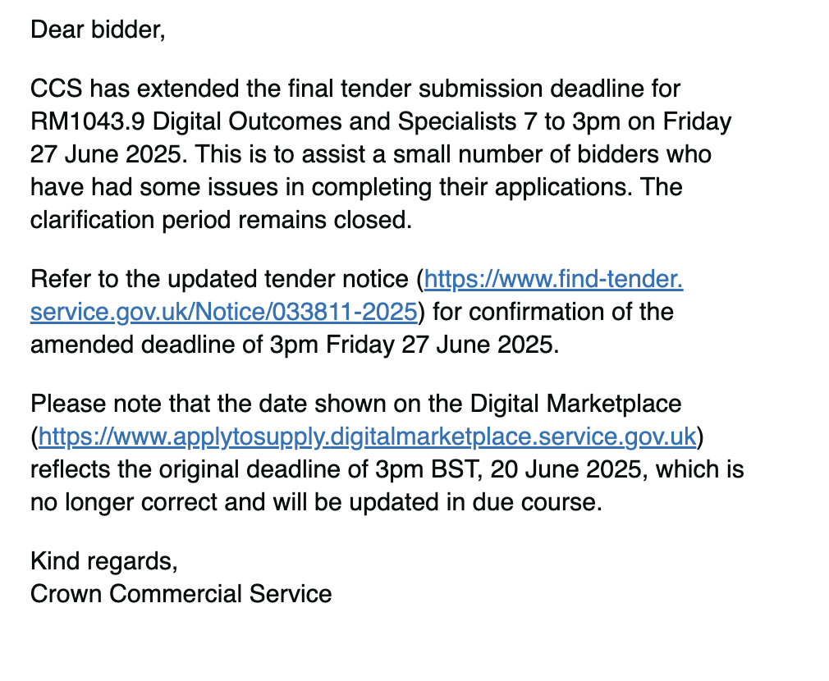

IMPORTANT INFORMATION – please read all sections carefully

Email sent
- 20 Jun 2025, 15:51

Email text
Dear Bidder

Important updates
DOS 7 application deadline extended
The final tender submission deadline for RM1043.9 Digital Outcomes and Specialists 7 has been extended to 3pm Friday 27 June 2025. Ensure you allow plenty of time to check and update any details ahead of the revised deadline.

Refer to the updated tender notice for confirmation of the amended deadline of 3pm Friday 27 June 2025.

Please note:

the new tender deadline has been updated in ‘Attachment 2 how to tender v5’ available from the Tender documents section in Digital Marketplace
the date shown on the Digital Marketplace reflects the original deadline of ‘3pm BST, 20 June 2025’, which is no longer correct and will be updated in due course
FVRA file size update
Effective from 9am on 19 June 2025, the file size limit for all FVRA questions was increased from 5MB to 20MB. This fix was deployed to resolve file size issues experienced by some bidders.

If your upload exceeds 20MB (for the completed FVRA attachment along with the required information for your organisation, parent company, and ultimate parent company) then follow the steps below:

Upload only the completed FVRA attachment (in the permitted format) to the question to ensure that your application is submitted.
Use the messaging facility in the Digital Marketplace to send us a message that includes:
Any attachments such as additional information required regarding your organisation, parent company, and ultimate parent company.
Categorise your message as ’system query’ and include in the subject heading ‘Bidder Name – FVRA Additional Files’.
Please note: the file size limit per message is 100MB, therefore, if your file size exceeds this, please repeat the process until all the documents have been provided. We also recommend that if you do hit any limits, to compress your file into a.zip file.

Please be aware that the steps above must be completed prior to the tender deadline closing. Failure to provide all of the requested information before the tender submission deadline (3pm Friday 27 June 2025) may result in your tender being disregarded.

Consortium bids
If you are bidding as a single entity for one or more Lots and as a lead consortium member in another, you should follow the steps below:

Amend the tender information section at question 3 in the ‘Make your supplier declaration’ section to state that you are bidding as part of a group or consortium.
Add all the consortium members in your ‘Make your supplier declaration’ section. Once completed select ‘Save and continue’.
Ensure you have answered all other questions in the ‘Make your supplier declaration’ section.
Submit your tender against each applicable Lot in the ‘Add, edit and complete services’ section.
If bidding on Lot 2 ensure you have completed all questions in the section ‘Answer quality award questions’.
You will then be able to progress to the Financial Viability Risk Assessment (FVRA) section.
Message CCS using the Digital Marketplace messaging functionality to confirm which Lots you are intending to bid as a single entity and which Lot you intend to bid as a consortium.
By making this change, if you have already completed your FVRA section, you may need to re-do the FVRA section again.
Example scenarios:

Scenario 1: Where you are bidding as a consortium in Lot 1, but as a single entity in Lot 3 and or Lot 4, you will need to complete the FVRA section. In this scenario CCS will not assess the consortium members for Lots 3 or 4.

Scenario 2: Where you are bidding as a consortium in Lot 1 and Lot 2, but as a single entity in Lot 3 and or Lot 4, you will need to complete the FVRA section. In this scenario CCS will not assess the consortium members for Lots 3 or 4.

Scenario 3: Where you are bidding as a consortium in Lot 2, and as a single entity in Lot 1, 3 or 4, please upload blank documents in the sections that relate to consortium members attachment 5b Lot 1, 3 and 4; but please complete all questions for attachment 5a Lot 2. In this scenario CCS will not assess the consortium members for Lots 1, 3 or 4.

As a reminder, your application will be automatically submitted to CCS at 3pm Friday 27 June 2025 provided you have:

completed your company details
made your supplier declaration
marked at least one service as ‘complete’
completed your quality award questions (applicable to Lot 2 only)
completed your Financial Viability Risk Assessment (FVRA) (*Correction from communication issued 16/06/2025 – included in list*)
To check the status of your application, log into your account on the Digital Marketplace. Check the document RM1043.9 What your dashboard should look like for a successful application submission.

BPSS
We wish to clarify the requirement in Lot 3 Digital Specialists, where you are required to provide the security clearance of the Digital Roles that you offer.

There is not an option to select ‘none’. It is a Government requirement, that where any individual is working on behalf of the Government, the minimum standard they need to meet is the Baseline Personnel Security Standard (BPSS). This is reinforced by clause 7 of the General Terms and Paragraph 5.11 of Framework Schedule 1 – Specification. BPSS requires the employing organisation to conduct four main checks:

identity
right to work
employment history
criminal record (unspent convictions)
As BPSS requires the employing organisation to conduct these checks, it is not equivalent to the National Security Vetting (NSV) clearances: Counter Terrorist Check (CTC), Security Check (SC), or Developed Vetting (DV), where the individual is given accreditation by the Government.

CCS cannot speak to the specific circumstances of each bidder’s company organisation, and therefore it is for each bidder to read the BPSS guidance and understand if their employees meet this requirement. Buyers will have the ability to confirm with suppliers whether they still meet the security clearances.

Kind regards

Crown Commercial Service

Screenshot
