Cost Model template adaptation - Guidance for customers

FURTHER COMPETITION UNDER
FM SERVICES FRAMEWORK AGREEMENT (RM1056)

CONTENTS

1. introduction 3
2. gENERAl Information 3
3. Selecting the appropriate template (TFM, HFM or SFM) 4
4. Property and Building Mapping sheet 5
5. Year 1 Cost Summary sheet 6
6. Key Variables Sheet 8
7. Hard FM Services Sheet 9
8. Soft FM Services sheet 14
9. Property Based Labour & Sub contractor Summary sheet 15
10. Building Based Labour Summary 16
11. Mobilisation Sheet 16
12. Consumables, Plant, Equipment and Others SHEET (cON, p, e&o) 17
13. Reactive Cost Scenario sheet 18
14. Service Checker sheet 18
15. Change Log sheet 18
16. Evaluation Export sheet 18
17. Price List clt 1 sheet 18
18. checking calculations are working – post amendment of the Cost Model template 19
19. Select TFM, HFM or SFM Price List clt 1 sheet – POST AMENDMENT of the Cost Model template 21
20. Locking appropriate cells – Pre Locking down worksheets and the Cost Model template – creating a blank template for publication 22

introduction

This document provides Customers with guidance and instructions on how to update the structure of Attachment 6 – Cost Model (Cost Model) so that it may meet the needs of the Customer’s costing requirements and be updated to reflect the services required across their Estate Portfolio.

There are numerous formulas applied throughout the Cost Model. It is important that these formulas are not overwritten during the process of adapting the template.

Please read these instructions in full before looking to update the Cost Model.

If any guidance within this document is unclear or further explanation is required, please contact the FM Services team.

gENERAl Information

Each Affected Property may comprise of several buildings. Some example building information has been input to the ‘Property and Building Mapping’ worksheet to prevent ambiguity and make it as easy as possible for the Customer to update the template’s structure.

Please note that yellow shaded cells indicate that a value is required to be populated into the appropriate cell. If there is already example text in a yellow cell the Customer may overwrite this text.

The Cost Model has been built to automatically cross-check specific data fields and calculations across different worksheets. To ensure that the Cost Model is calculating correctly, Customers should review all prompts and error messages that may indicate where a formula has been overwritten or amended incorrectly. Failure to ensure that all formulas are calculating correctly will result in a false ‘Total Aggregated Cost’ being displayed within the ‘Tender Cost Summary’ worksheet and the sub-totals that feed into these values.

Hints & Tips – it is highly recommended that Customers use a/the Cost Model populated with sample data provided (as oppose to the blank Cost Model template), when updating the structure of the template. Sample data is populated into the yellow shaded cells. This will enable calculation and formula errors to be visible immediately should an incorrect update to the structure be made. Important Note – When the Customer is satisfied that all areas of the Cost Model has been updated across all worksheets with the relevant Affected Property data, only then should formulas, calculations and error messages be reviewed. Some formulas that display error messages look up to more than one worksheet and therefore some error messages will not be resolved until all worksheets have been updated in full.

Please note that each worksheet must be unlocked before any amendments can be made to the structure of the template. Worksheets have been locked to ensure where possible that formulas or data fields are not deleted or completed in error by the Potential Provider when pricing data is being entered into the yellow shaded cells during the bidding process.

Note – all worksheets within the Cost Model template must ultimately be ‘Locked’ (Protected), when the Customer has made their final amendments. All except for the ‘Hard FM Services’, ‘Soft FM Services’ and ‘Service Checker’ worksheets. The former two because additional service lines may need to be added or some service lines removed, and the ‘Service Checker’ worksheet as this tool will not work if the worksheet is ‘Protected’.

Each worksheet can be unlocked by clicking onto the “Review” button at the top of the screen, followed by the “Unprotect Sheet” button as per Figure 1. A password is required to do this and is available from the FM Services team upon request. Once each worksheet has been updated, it will need to be protected again. This is done by clicking on the ’Protect Sheet’ icon within the ‘Review’ ribbon.

Figure 1

Hints & Tips – if you are unsure if a tab is locked or not, a quick check is to look at the highlighted ‘Unprotect Sheet’ button above in ‘Figure 1’. If the sheet is locked then this will show as ‘Unprotect Sheet’. If the sheet is unlocked, this will show as ‘Protect Sheet’.

Potential Providers should be advised to complete the Cost Model from left to right - starting with the ‘Tender Cost Summary’ sheet, then ‘Key Variables’ and so on. However, as the Customer, the structure of the Cost Model should be updated in accordance with the order that the instruction for each worksheet appears in this guidance, starting with the ‘Property and Building Mapping’ tab.

This guidance uses the ‘Standard’ Cost Model template, which currently has 6 example properties entered. This Cost Model template is extended by way of example tab by tab to include a further 4 properties, extending the Customers estate portfolio to 10 Affected Properties. The methodology by which this is done, may be applied by all Customers, to the Cost Models relating to their own estate portfolio.

As stated above, the Cost Model comes pre-populated with 6 example properties. The instructions below illustrate the method for the addition of 4 further example properties to the Cost Model template. The intention is for this to help the Customer to familiarise themselves with how the sheets function before inputting their own Affected Property data.

The following guidance shows how the Cost Model may be updated when selecting ‘Lot 1 – Total Facilities Management (TFM) 1’.

Selecting the appropriate template (TFM, HFM or SFM)

The same Cost Model template is used for ‘Lot 1 - Total Facilities Management (TFM)’, ‘Lot 2 – Hard Facilities Management (HFM)’ and ‘Lot 3 – Soft Facilities Management (SFM)’. The Cost Model needs to be filtered to reflect the correct Lot that is being tendered.

It is recommended ‘Lot 1 – Total Facilities Management (TFM)’ should be selected in cell D4, ‘Tender Cost Summary’ worksheet, irrespective of the Lot being tendered (see figure 2. below). This selection will display all areas of the Cost Model template to be updated by following this guidance and instruction. Once the template has been completed and reflects the Customer’s Affected Property list, the Customer may then select the appropriate Lot (TFM, HFM or SFM). In doing so, the appropriate areas of the Cost Model will be ‘greyed out’ and if necessary the relevant worksheet or sections within worksheets may be hidden from view.

To select TFM, HFM or SFM, the Contracting Body should navigate to the ‘Tender Cost Summary’ tab. Then select the drop down list shown below, and click onto the appropriate Lot 1, 2 or 3.

Figure 2

Property and Building Mapping sheet

This worksheet shows a summary of the Affected Property list. The Customer needs to include all areas they wish to be individually priced throughout the Cost Model. These could be specific areas within a building (rooms or spaces), a building itself (part of the property or within a property boundary) or the property.

Reminder - To start, ‘unprotect’ the sheet, as described in ‘2.General Information’.

The table below shows the sample data within the Cost Model template. Additional buildings/properties should be added below row 12 (for example purposes only - when completing with real Customer data, this should start at row 7). There are various drop down menus that require consideration and completion as the user moves across the worksheet (not all columns are shown below in Figure 3).

Figure 3

The following Figure 4 shows 4 additional properties included and highlighted in red text. All properties to be shown in the column headed ‘EPIMS Property Reference’ (Electronic Property Information Mapping Service (EPIMS) is the reference number used to define an area of Government Central Civil Estate Properties and Land) are typically copied from the Customer’s completed ‘Attachment 8 - Data Pack’ for consistency. The details for each building/property is completed by the Customer across the tab as appropriate.

Hints & Tips - If the EPIMS reference is not available in ‘Attachment 8 -Data Pack’ this does not need to be used. In such circumstances, simply remove the text ‘EPIMS’ from the heading i.e. change to ‘Property Reference’ and/or ‘Building Reference’.

Figure 4

Figure 5 below shows the remaining sections to be completed. Note that most of the fields within the cells shown may be over typed with appropriate buildings/property information. Those containing drop down list menus should be completed by using these lists. The column headed ‘Regional Adjustment Factor’ has a formula that looks up to the ‘Labour Cost’ tab. The user should ensure that this formula is maintained against each row of property data and not overwritten. The column headed ‘Department Total GIA’ has a formula associated with the cells that fall within it. This formula needs to be copied down if the number of departments within a group or cluster procurement dictate that more rows are required. For example, in the column headed ‘Department List (if clustered)’ the first cell is populated with ‘Department of A’. Next to this in the ‘Department Total GIA’ column cell, the figure ‘456.000’ is shown. This figure is derived from the formula within this cell. Where a department name is needed in ‘Department List (if clustered)’ the formula needs to be copied down against it in the next column along headed ‘Department Total GIA’.

Figure 5

There may be a requirement to include more areas, buildings or properties than the current template provides for. The template caters for up to 42 lines of data. If the requirement is for more than 42 buildings/properties, then the fields highlighted in figure 6 below need to be pulled down to the required number of buildings/properties needed. For the purpose of example, Figure 6 looks to pull down and copy the appropriate cells from immediately beneath the last property added in red text. In the actual Cost Model, cells will need to be copied down or highlighted and dragged down from row 48.

Figure 6

Conversely, if rows need to be removed, then the appropriate blank row immediately below row 48 may be copied or highlighted and pulled up to the number of rows required for the Customer’s Affected Property list.

Once all amends to the structure have been made, and the Customer’s Affected Property list has been added, the worksheet should be protected by re-entering the password provided by the FM Team. When protecting a worksheet, MS Excel will prompt the user to enter the same password twice.

Year 1 Cost Summary sheet

This worksheet shows a summary of the year 1 costs for the tender broken down per building/property.

Figure 7 below, uses the ‘Table 1: Year 1 Cost per Property using Option 1 Reactive Works’ cost table (details of why this is used is covered in more detail later on in this guidance in the ‘6.Key Variables sheet’). Currently hidden from sight is an additional table, ‘Table 2: Year 1 Cost per Property using Option 2 Reactive Works’. Table 2 may be required for Further Competition (details of why this may be used is covered in more detail later on in this guidance in the ‘6.Key Variables sheet’).

Hints & Tips – There is a Table 1 and a Table 2 in consideration of if a Comprehensive Liability Threshold (CLT) is required for Reactive Works. If a CLT is required, and the Customer only wishes to test one scenario, then only Table 1 will be required to be displayed in the ‘Year 1 Summary’ sheet. If two CLT’s are required to be considered as part of the tender exercise, then Table 2 will also be required to be used in the Cost Model, and should therefore be unhidden. A maximum of two CLT thresholds may be applied and used in the Cost Model.

The greyed out rows below highlight row 30, and immediately underneath row 53. Un-hiding rows 31 to 52 will reveal Table 2. An example of Table 2 is not shown. However, highlighting and ‘unhiding’ rows 31 and 53, will show Table 2 which in format mirrors ‘Table 1: Year 1 Cost per Property using Option 1 Reactive Works’ cost table.

Note - For example purposes, ‘Table 1: Year 1 Cost per Property using Option 1 Reactive Works’, shown in Figure 7 will be the only part of the tab amended. Should ‘Table 2: Year 1 Cost per Property using Option 2 Reactive Works’ be required, it may be unhidden and amended in exactly the same way as Table 1.

Hints & Tips – To unhide rows, highlight the greyed out rows shown in Figure 7.

Right click on the row number/s.

From the menu displayed, click on ‘unhide’.

Rows 31 to 52 will be revealed. To unmerge cells, highlight the cells containing the text ‘Property’. Right click and select the option to ‘Format Cells’.

Select ‘Alignment’ tab. Uncheck the ‘Merge Cells’ box and click ‘OK’. This will unmerge the cells.

Re merge cells, highlight the cells to merge, and follow the reverse of this process.

In the first instance, the Customer should unmerge the cells with the text ‘Property’ within row 10.

Figure 7

Figure 8 below shows the additional 4 properties which have been copied across as follows. The column showing property b6 should be highlighted from row 9 down to row 28 (note –rows 9 and 28 contain hidden formulas and must be pulled across, as do rows 31 and 52 should ‘Table 2: Year 1 Cost per Property using Option 2 Reactive Works’ be required). These highlighted cells should then be dragged across to extend the property portfolio by a further 4 properties. This action copies across all of the required formulas and pulls in the newly included properties from the ‘Property and Building Mapping Sheet’. Space and format the borders for the new columns appropriately.

Figure 8

Key Variables Sheet

If a Comprehensive Liability Threshold (CLT) is required by the Customer, table 3a in the ‘Key Variables’ worksheet will need to be updated to include the additional 4 properties added to the Affected Property list. The CLT value should be entered into the pink cell shown below in Figure 9. The cells containing the text ‘Cost per Property for Year 1 (£)’ should be unmerged, ready for the additional properties to be added.

Figure 9

Figure 10 below shows the end column, currently containing data for property b6, being highlighted and dragged across to extend the property portfolio by a further 4 properties. This action copies across all of the required formulas and pulls in the newly included properties from the ‘Year 1 Cost Summary’ sheet. Highlight the copied columns and then space each column accordingly.

Reminder - Note that any data copied across in the yellow shaded cells is sample data to illustrate how the Cost Model calculates. The Potential Provider will ultimately be in a position to put appropriate values into all yellow shaded cells across the entire Cost Model, not just in the case of Figure 10.

Figure 10

If the Customer wishes to test the Reactive Maintenance Cost with an alternative additional CLT figure, they may do so using table 3b. Table 3b is contained in the hidden rows 35 to 45 beneath table 3a. Table 3b may be adapted following exactly the same process used to update table 3a.

Hints & Tips – Remember to remerge the cells containing ‘Cost per Property per Year 1 (£)’ text, which were previously unmerged, to include the additional buildings/properties added. This action simply tidy’s the format of the appropriate Table – it does not affect formulas or calculations if the action is not completed.

If the Customer does not want to use a CLT, tables 3a and 3b are not required. If this is the case, then the Customer should “grey out” table 3a, delete the cell values in each of the property columns for rows 28 to 32 and then merge these as illustrated in Figure 11. In the title heading in row 23, add the wording “Not Applicable for this procurement” to the text to make it clear that CLT is not required. Leave Table 3b hidden from view.

Figure 11

Hints & Tips – If the Customer is looking to use only the Soft FM (SFM) contract then Reactive Maintenance is not required/appropriate. Under these circumstances, the Cost Model will have already “greyed” out tables 3a and 3b.

Hard FM Services Sheet

Figure 12 below shows the end 4 columns, currently containing data for property b6, being highlighted and dragged across to extend the property portfolio by a further 4 properties (only 2 shown in figure 12). Highlight the columns to be copied in full before dragging these across the worksheet (not just the cells containing visible text and formatting). Note that each building/property utilises 4 columns, and on this basis 16 columns are required for the additional 4 properties. This action copies across all of the required formulas and pulls in the newly included properties from the ‘Property and Building Mapping’ tab.

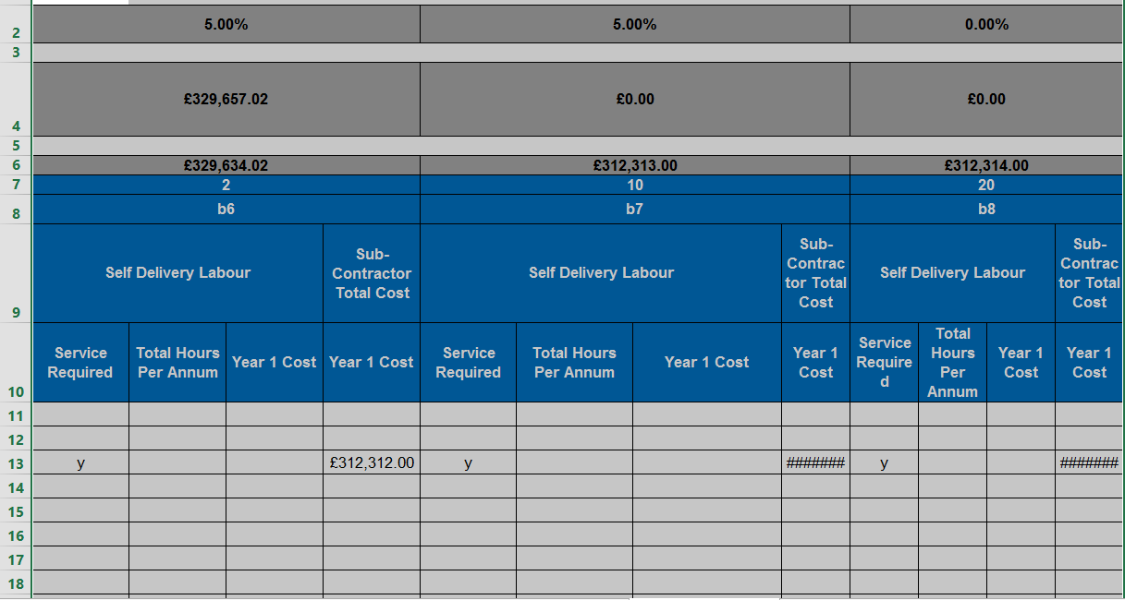

Figure 12

The Customer must then add or remove the appropriate services they require to be priced as part of the fixed fee payable. Figure 13 below provides an example of the format of the ‘Hard FM Services’ worksheet within the Cost Model. There are currently 35 Hard FM services included within the Cost Model template. The Customer will need to remove services not required or add those that are. To remove service lines, highlight the appropriate row or rows and delete this/these. In this case, the ‘Re-lamping’ service line. The tab will then shift all of the rows remaining up.

Figure 13

Note that in the ‘Ref’ column, the numbering will not run consecutively as it should because the ‘Re lamping’ service has now been removed. This should be amended as illustrated in Figure 14 below. This will produce error codes in the column to the right of the ‘Service Descriptions’.

Within the Cost Model template, there is a hidden ‘Calc’ sheet. This worksheet will need to be unhidden and updated to ensure that the error codes formulas are updated and fixed. How this is done is explained in detail below.

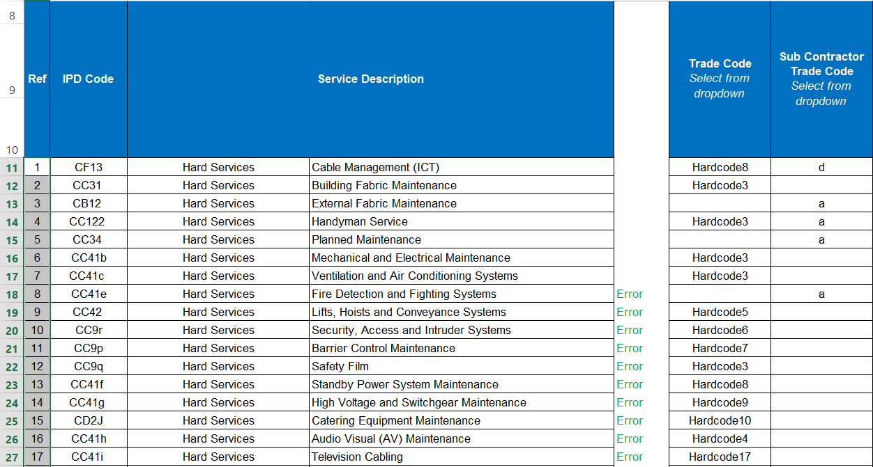

Figure 14

To display the ‘Calc’ worksheet, see figure 15 below,

Click on the ‘Review’ button, and select ‘Protect Workbook’. This will then highlight the command shown below. Enter the password and select ‘Ok’.

Figure 15

This allows the ‘Calc’ worksheet to be viewed. To do so

Right click on the ‘Hard FM Service’ tab label at the foot of the ‘Hard FM Services’ tab.

In the menu displayed, click on ‘unhide’ and the box shown as Figure 16 will appear. Highlight ‘Calc’ and click ‘Ok’.

The ‘Calc’ tab will now be visible in the Cost Model as an additional worksheet.

Figure 16

Click into the ‘Calc’ worksheet and navigate to where the following data for Hard FM services is situated as shown below in Figure 17. The following data in Figure 17 has been previously created by using the ‘Concatenate’ formula provided by Excel, i.e. the service line data in the ‘Hard FM Services’ tab has been effectively joined together. This is the data that needs to be updated in order to update and fix the error codes showing in the ‘Hard FM Services’ tab. The data has been joined together in this way to provide a look-up table to ensure that when the Customer looks to create another line of data within the ‘Hard FM Services’ tab, this service line is correctly named. It is important that the Customer does not amend the naming of the service lines in any way, as this may affect the functionality of the template, i.e. it will incorrectly calculate the aggregated cost of the service displayed in the ‘Tender Cost Summary’ worksheet. This look-up table warns the Potential Provider by way of an error code, if an error has been made in the naming of a service when a service line has been copied (‘Attachment 7- Cost Model Instructions’ separately issued as part of the ITT documentation, provides instructions on how additional service lines may be copied and pasted into the Hard and Soft FM Services tabs).

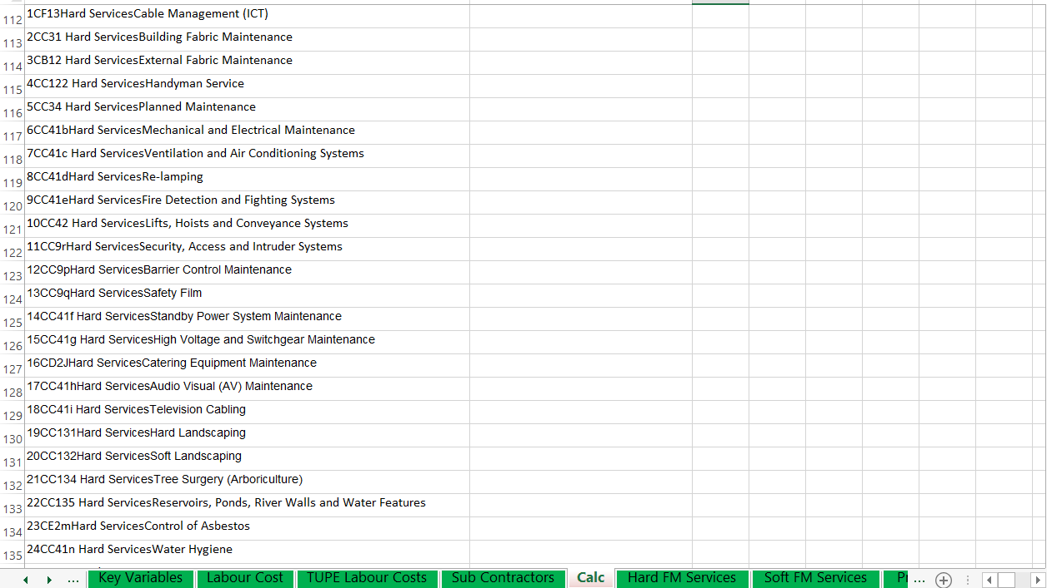

Figure 17

To update the above data, copy all of the like data in the ‘Hard FM Services’ tab shown below in Figure 18 (not just the data highlighted below)

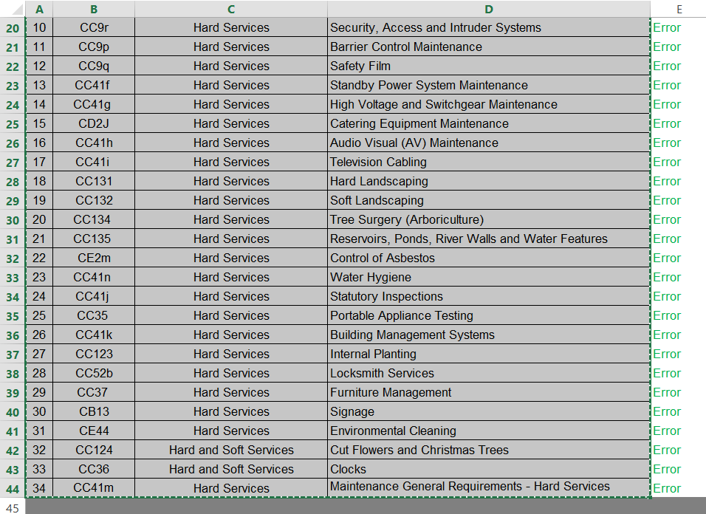

Figure 18

Paste the data into the ‘Calc’ tab as shown in Figure 19, with the first line of data copied aligned with the top row of the existing data. Note that this data will not all match because a service line (Re-Lamping) has been removed from the ‘Hard FM Services’ tab.

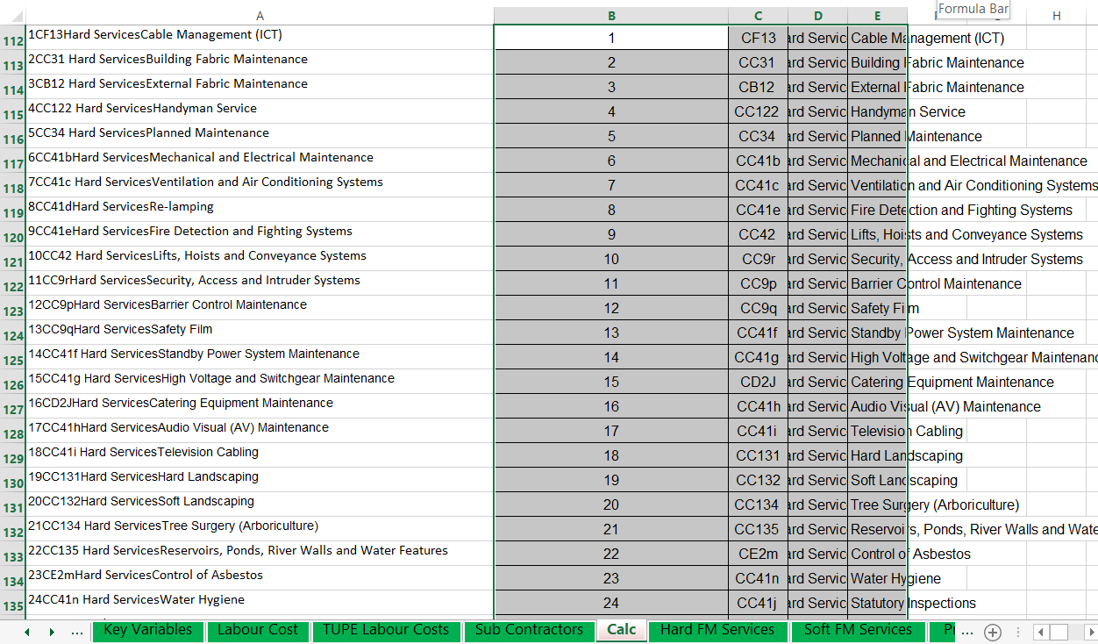

Figure 19

Then click into cell F112;

Enter the formula ‘=Concatenate’, click on cell B112.

Holding the ‘Ctrl’ key down, click on cells C112, D112 and E112. Then press the ‘enter’ key.

This will join the data together.

Copy down column F as shown in Figure 20, so that each line of new data copied into the ‘Calc’ tab has been joined together.

Once the formula is copied down, highlight and copy the ‘concatenated’ data and click into cell A112.

Select ‘Paste Special’, select ‘values and number formats’ option. Click ‘OK’.

This method will remove all formulas from the new table created and copy over the existing data in column A. The data held in columns B to F may now be deleted (NOTE – Do not highlight the whole of columns B and F and delete. There are important formulas in the top rows of the ‘Calc’ sheet which need to remain. Just delete the actual data). The error codes should now have disappeared from the ‘Hard FM Services’ sheet.

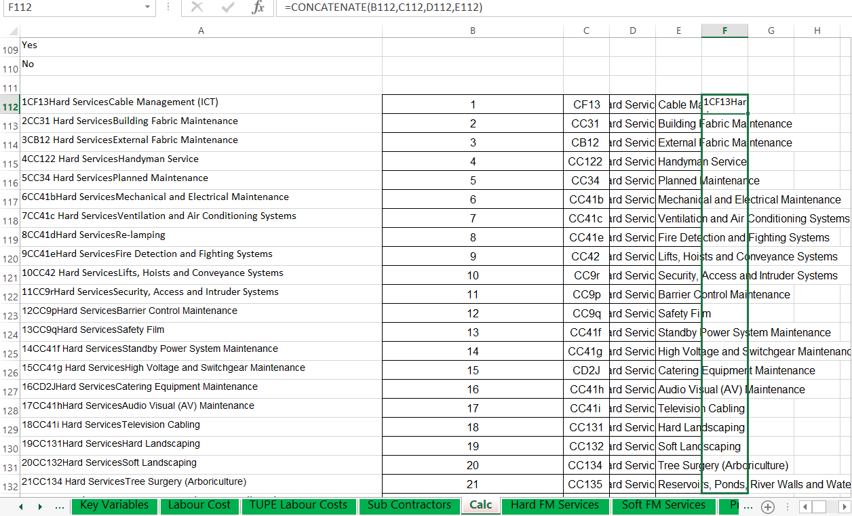

Figure 20

Hints & Tips – within the ‘Calc’ tab, remember to delete data relating to Hard FM services that remains below the data pasted into column A, which is now surplus to requirements. Conversely, make sure that any additional service lines added which increase the length of this list are accommodated by first clicking into the existing list within column A, and then inserting a cell or cells depending on the number of additional service lines. This will have the effect of ensuring that all formulas are adjusted appropriately within both the ‘Calc’ tab and the ‘Hard FM Services’ sheet.

The process for adding additional rows to accommodate service lines which are not already included in the ‘Service Requirements’ column shown in Figure 21 is similar. This is most easily achieved by copying an existing line of data. In the following example, row 44 (service number 34) has been copied and pasted by using the ‘Insert Copied Cells’ function. Copying a row in this way retains the formulas along the entire row. The Customer must then overtype the copied line. In this case, row 45 should have the service number changed to 35, the IPD code should be updated with the appropriate code (as displayed in ‘Attachment 3 – Annex A Service Matrix’ and in the ‘Service Level Requirements’), followed by text ‘Hard Service’ (or the appropriate category) and then by the appropriate service line name. The Hard FM data held in the ‘Calc’ tab should be updated as described above, as should all new service lines.

Figure 21

Note that once the updates have been made to the ‘Calc’ tab, this should be hidden again using the reverse process of ‘un hiding’ the tab, as described above.

Soft FM Services sheet

The updates that may be necessary in the ‘Soft FM Services’ tab should be made in exactly the same way as described in ‘7.Hard FM Services’ guidance above.

Property Based Labour & Sub contractor Summary sheet

This worksheet outlines the ‘Service Delivery Management/Admin Staffing’ and ‘Mobilisation’ labour required for the required Services for each Affected Property.

Table 1 as seen in Figure 22. below shows the end 3 columns, currently containing data for property b6, being highlighted and dragged across to extend the Affected Property list by a further 4 properties (only 2 shown in the Figure 22). Note that each building/property utilises 3 columns, and on this basis 12 columns are required for the additional 4 properties. This action copies across all of the required formulas and pulls in the newly included properties from the ‘Property and Building Mapping’ tab as well as the hidden ‘Calc’ tab.

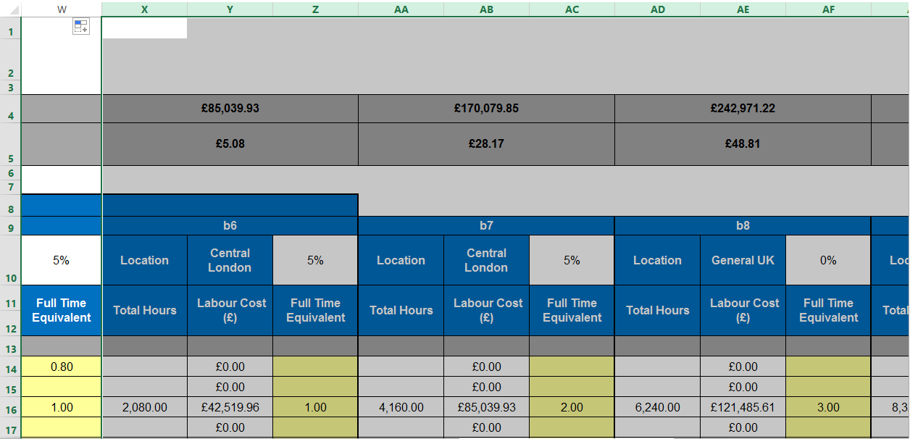

Figure 22

Table 2 starting from row 124 covers the costs associated with Sub Contractors, and has already been extended across to the appropriate number of columns as it follows the individual Properties/Buildings in Table 1. The action of extending the columns for Table 1 has followed through to Table 2/Figure 23 below.

Figure 23

Hints & Tips – cells I8 to Z8 and cells I124 to Z124 are merged to run across the ‘standard’ six properties/buildings included in the Cost Model Template. Once the additional properties have been introduced, these fields need to be un-merged and then merged together again to cover/include the additional properties/buildings.

Building Based Labour Summary

This worksheet outlines the total labour required for the stipulated Services for each building. The ‘Total Hours per Annum’, ‘Labour Cost (£)’ and ‘Full Time Equivalent’ are shown for each building.

The table below at figure 24 shows the end 3 columns, currently containing data for property b6, being highlighted and dragged across to extend the property portfolio by a further 4 properties (only 2 shown in the screenshot). Note that each building/property utilises 3 columns, and on this basis 12 columns are required for the additional 4 properties. This action copies across all of the required formulas and pulls in the newly included properties from the ‘Property and Building Mapping’ tab as well as the hidden ‘Calc’ tab.

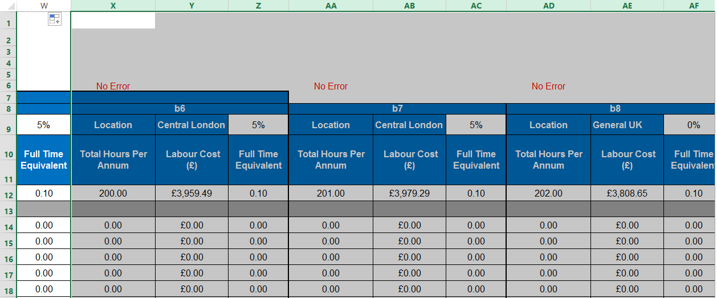

Figure 24

Note that the newly added columns for additional buildings/properties will need appropriate spacing and formatting applied to them.

Hints & Tips – cells I7 to Z7 are merged to run across of the ‘standard’ six properties/buildings. Once the additional properties have been introduced, these fields need to be un merged and then merged back together again to include the additional properties/buildings.

Mobilisation Sheet

The four tables within this sheet allow the Potential Provider to input the cost of Mobilisation for ‘Sub-Contractors’, ‘Consumables’, ‘Plant and Equipment’ and ‘Others’ as applicable. Each table includes Sub Total rows. At the bottom of the four tables, two Grand Total rows are included, the total for Sub-Contractors being separate.

The table below in Figure 25 shows the end column, currently containing data for property b6, being highlighted and dragged across to extend the property portfolio by a further 4 properties. This action copies across all of the required formulas within the 4 tables contained within this tab and pulls in the newly included properties from the ‘Yr1 Cost Summary’ tab.

Figure 25

Note that the newly added columns for additional buildings/properties may need appropriate spacing and formatting applied to them.

Hints & Tips – cells H7 to M7 are merged to run across of the ‘standard’ six properties/buildings. Once the additional properties have been introduced, these fields need to be un merged and then merged back together again to include the additional properties/buildings.

Consumables, Plant, Equipment and Others SHEET (cON, p, e&o)

The three tables within this sheet allow you to input the cost of ‘Consumables’, ‘Plant and Equipment’ and ‘Others’ as applicable. Each table includes Sub Total rows. At the bottom of the 3 tables, a Grand Total row is included.

The table below in Figure 26 shows the end column, currently containing data for property b6, being highlighted and dragged across to extend the property portfolio by a further 4 properties. This action copies across all of the required formulas within the 3 tables contained within this tab and pulls in the newly included properties from the ‘Yr1 Cost Summary’ tab.

Figure 26

Note that the newly added columns for additional buildings/properties may need appropriate spacing and formatting applied to them.

Hints & Tips – cells H7 to M7 are merged to run across of the ’standard’ six properties/buildings. Once the additional properties have been introduced, these fields need to be un merged and then merged back together again to include the additional properties/buildings.

Reactive Cost Scenario sheet

The Table contained within the ‘Reactive Cost Scenario’ tab does not require to be updated. This worksheet contains ‘standard’ tables that under normal circumstances do not require their structure to be changed, unless specifically requested by the Customer to meet their needs. Under these circumstances, the Customer should contact the FM Team at CCS.

Service Checker sheet

The ‘Service Checker’ tab and the tables contained within do not require to be updated.

Change Log sheet

The ‘Change Log’ tab and the tables contained within do not require to be updated.

Evaluation Export sheet

The table below in Figure 27 shows the end column, currently containing data for property b6, being highlighted and dragged across to extend the property portfolio by a further 4 properties. This action copies across all of the required formulas within this table. It also copies in all of the tables and cells below it as well as pulling in the newly included properties from the ‘Yr1 Cost Summary’ tab.

Figure 27

Note that the newly added columns for additional buildings/properties may need appropriate spacing and formatting applied to them.

Hints & Tips – cells C5 to H5 are merged to run across of the “standard” six properties/buildings. Once the additional properties have been introduced, these fields need to be un merged and then merged back together again to include the additional properties/buildings.

Price List clt 1 sheet

The table below in Figure 28 shows the additional 4 properties having been copied across. To achieve this, the column showing property b6 should be highlighted from row 1 down to row 25. These highlighted cells should then be dragged across to extend the property portfolio by a further 4 properties. This action copies across all of the required formulas and pulls in the newly included properties from the ‘Evaluation Export’ tab.

Figure 28

checking calculations are working – post amendment of the Cost Model template

There are a number of ways to check that the changes the Customer has made to the Cost Model have been successful, with all formulas calculating and returning the correct ‘Total Cost’ to Table 2 of the ‘Tender Cost Summary’ tab.

In the first instance, note in Figure 29 below the ‘Grand total year 1’ value in cell B493 of the ‘Evaluation Export’ tab. 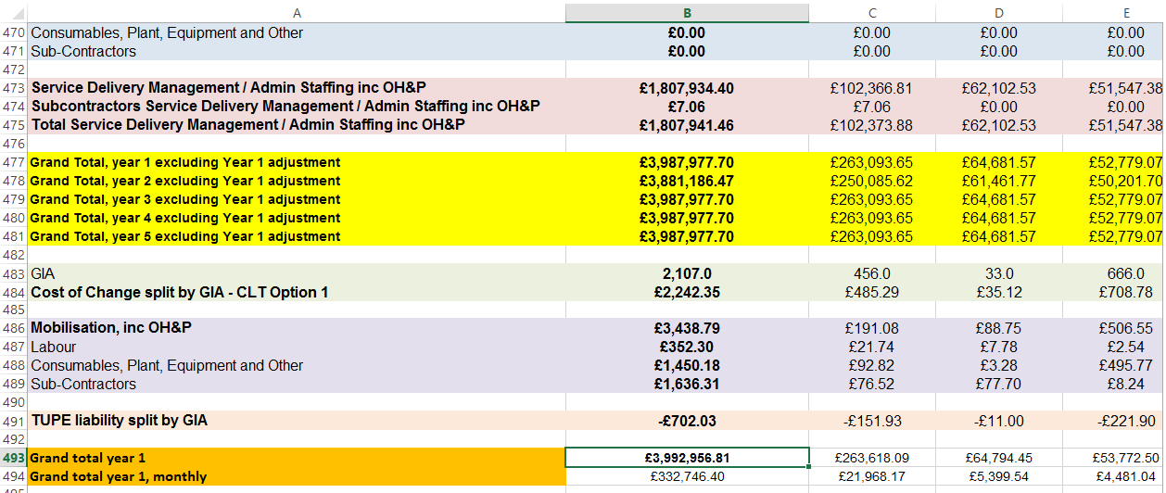

Figure 29

The aforementioned figure of £3,992,956.81 should match the sum of the ‘Total Cost’ figure for Year 1 provided in the ‘Tender Cost Summary’ tab in Figure 30 below, cell B48 (£3,990,156.81) and the ‘Within Year 1 Efficiency Adjustment’ figure in cell B45 (-£2,800). These two added together should total £3,992,956.81, which in this example they do.

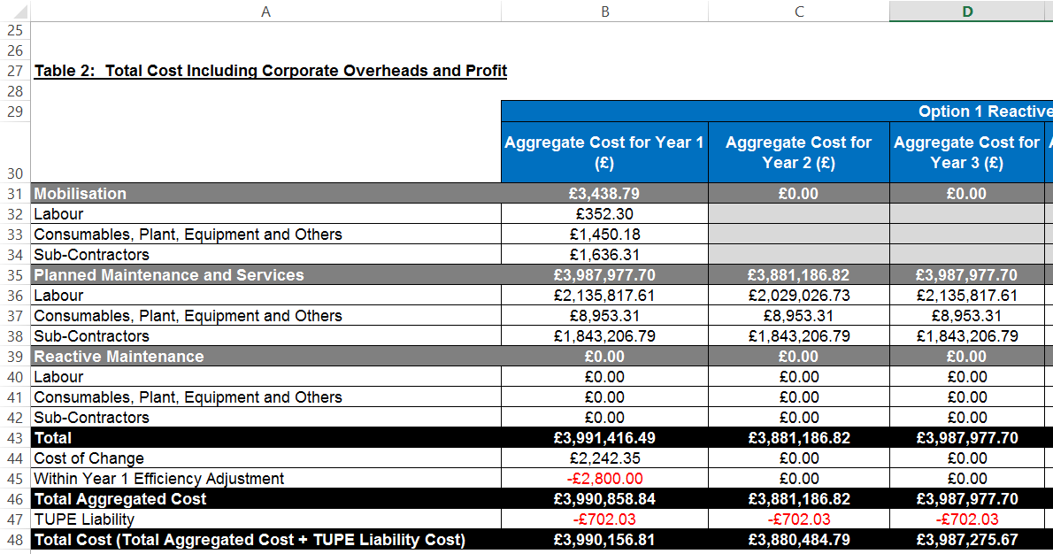

Figure 30

Another quick test is shown in Figure 31 below whereby the table from the ‘Price List CLT 1’ worksheet cell D17 uses a formula (shown as =E24*12) to check against the value in cell B48 in the Figure 30 table above, from the ‘Tender Cost Summary’. The two values displayed in both the ‘Tender Cost Summary’ tab and the ‘Price List CLT 1’ tab should match, which in this case they do at £3,990,156.81.

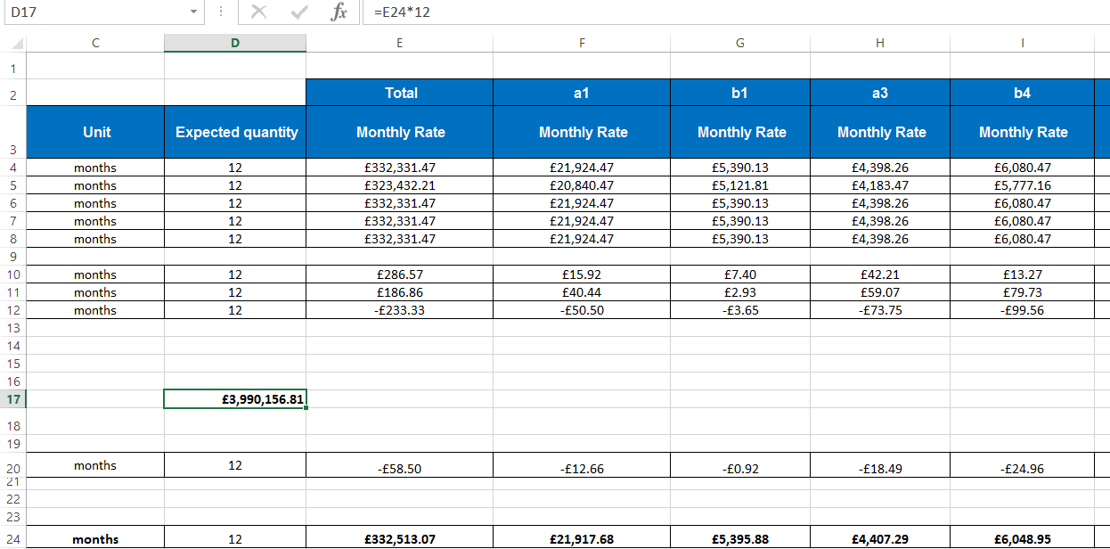

Figure 31

The Customer should check all of the error codes throughout the template to ensure that no errors are being highlighted. Any error codes indicating that there is an issue, should be checked. If necessary, use the formulas within the error codes to check where to look within the other worksheets in order to find where the miscalculating formula is.

Hints & Tips – the formula in cell D17 should be created by the Customer to test that both figures/values reconcile. It is not a standard formula included in the ‘Price List CLT1’ tab. Once it has served its purpose, the Customer should delete it.

If errors are still showing throughout the template and the aforementioned checks have been made, contact the CCS FM Team for clarification.

Select TFM, HFM or SFM Price List clt 1 sheet – POST AMENDMENT of the Cost Model template

Once the structure of the Cost Model Template has been updated to reflect the Customer’s Affected Property list, the Customer must then select TFM, HFM or SFM from the drop down list in the ‘Tender Cost Summary’ sheet. This process of selection has been explained in ‘3.Selecting the Appropriate Template (TFM, HFM or SFM)’ of this guidance.

By way of example, the following instructions now assumes that ‘Lot 2 – Hard Facilities Management’ is the required Lot. The Customer may just as well have picked Lot 1:TFM or Lot3:f SFM as the preferred option.

Figure 32 below shows that ‘Lot 2: Hard Facilities Management’ has been selected. To the left of this table, the user will immediately note that the heading of the table has changed to ‘Lot 2: Hard Facilities Management’ from ‘Lot 1: Total Facilities Management’. This change will be reflected through the whole of the Cost Model Template.

Figure 32

The table in Figure 33 below is copied from the ‘Year 1 Cost Summary’ sheet. It shows the ‘Soft FM Operatives’ pricing line greyed out along with an error message above stating that no Soft Services should be priced. This is correct in view of the fact that the Cost Model template has been changed to price for ‘Lot 2: Hard facilities Management’ only. This error message will disappear when the Customer goes to the ‘Soft FM Services’ tab and removes any ‘sample/example’ pricing information included.

The removal of data from the ‘Soft FM Services’ tab is illustrated in Figure 33 below (all data from all properties should be removed being careful not to delete any formulas contained in the ‘Self Delivery Labour’, ‘Year 1 Cost’ columns). Note that the ‘Soft FM Services’ tab is greyed out. This is also as a consequence of changing the Cost Model Template to ‘Lot 2: Hard Facilities Management’ from ‘Lot 1: Total Facilities Management’. Once the data has been removed, error messages will automatically be removed from the ‘Year 1 Cost Summary’ sheet and the ‘Soft FM Services’ tab may be hidden as it will not be used.

Hints & Tips – It is important that the data is removed from the ‘Soft FM Services’ tab. This will mean that when the ‘Service Checker’ tab is used to check if Hard Services have been priced, it will not pick up any perceived errors relating to ‘Soft FM Services’ which do not need to be priced for ‘Lot 2: Hard Facilities Management’.

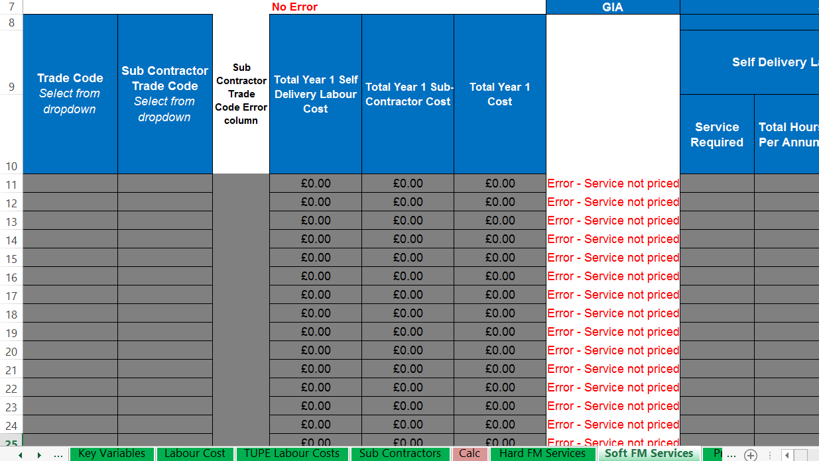

Figure 33

There are a number of areas within the Cost Model template that will also now be greyed out as a result of ‘Lot 2: Hard Facilities Management’ being selected. These include;

In the ‘Key Variables’ tab – ‘table 6, Planned & Reactive Labour Rates’, the section headed ‘Soft FM Operatives’.

In the ‘Labour Cost’ tab – the table containing rates that is headed ‘Soft FM Operatives’.

In the ‘Building Based Labour Summary’ tab – the table with the heading of ‘Soft FM Operatives’.

It is important to note that where ‘Lot 3: Soft Facilities Management’ has been selected by the Customer, then those areas relating to the ‘Lot 2: Hard Facilities Management’ will be greyed out and should be updated accordingly in exactly the same way as described above. If TFM is selected no further changes are required.

Locking appropriate cells – Pre Locking down worksheets and the Cost Model template – creating a blank template for publication
The final updates are now ready to be made to the Cost Model. The Cost Model must be ‘locked down’ (Protected), prior to its publication once all of the updates to the structure have been made to it. This has been stated earlier in this guidance in ‘2.General Information’. This blocks the user’s ability to overwrite formulas or update the structure of the Cost Model once the Contracting Body has agreed on a final version.
Before any of the worksheets are ‘locked down’, the Customer must ensure the appropriate cells (the yellow shaded cells) are ‘set up’ to accept changes. The yellow shaded cells should already be ‘set up’ so that when appropriate worksheets are ‘locked down’, the yellow shaded cells may be populated and all other cells are locked down correctly.
Creating a blank template for publication;
It is important the Customer checks throughout the proposed final Cost Model Template to ensure that all cells are locked and unlocked as they should be, i.e. none of the formatting has been overwritten in error. The way this is done, is by ensuring that all appropriate worksheets have been locked down/protected as appropriate. The Customer should then go through each worksheet and delete out the ‘sample’ data held in each of the yellow shaded cells. Any cell which is not ‘yellow shaded’ should be locked. No changes should be able to be made to ‘non yellow shaded’ cells, and as the Customer works through the worksheets they should check this theory by attempting to do just that. Once this exercise has been fully completed showing no errors in this respect, the ‘blank’ template is ready for publication along with the rest of the ITT documentation. If issues are highlighted, the following instructions to remedy these should be adhered to.

To update each worksheet and change which cells are able to be updated when the worksheet is ‘Protected’, the worksheet must first be ‘Unprotected’ in the normal way. To lock or unlock the appropriate cells when the worksheet is ‘Protected’, go through the following process,

Select the cell or cells that need to be locked/unlocked when the worksheet is ‘Protected’.

Then right click, and the following drop down menu in Figure 34 will appear. Select ‘Format Cells’.

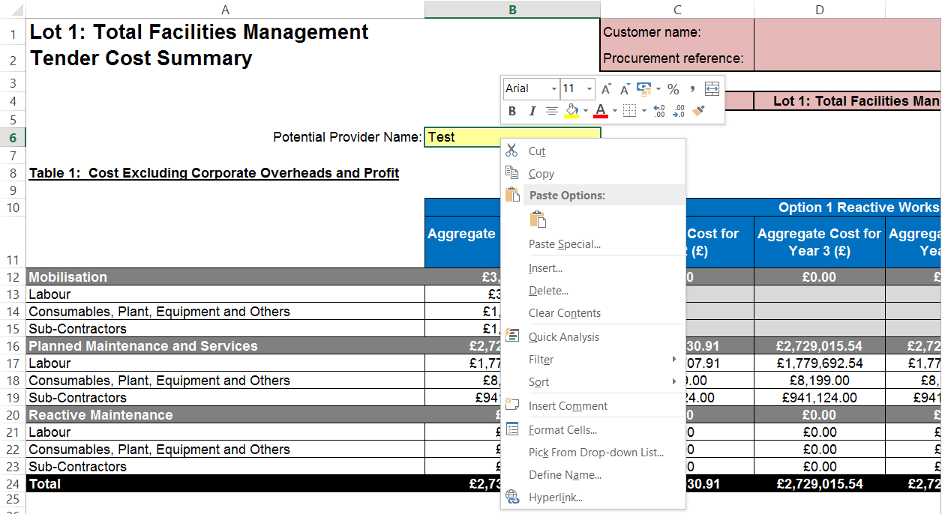

Figure 34
- Then select the ‘Protection’ tab from the table displayed in Figure 35 below.
- The ‘Locked’ box will be unchecked if the selected cell or cells are currently not locked down when the worksheet is ‘Protected’. In order to lock the selected cells when the worksheet is ‘Protected’, check the ‘locked’ box and click ‘Ok’.

This action completes the required process. The worksheet may now be ‘Protected’ again using the required password.

Hints & Tips – if a lot of amendments or updates are required in order to either lock or unlock cells in this way, highlight the whole worksheet and follow the process in order to lock all cells. Then select the required cells that need to be unlocked when the worksheet is ‘Protected’ and follow the process again.

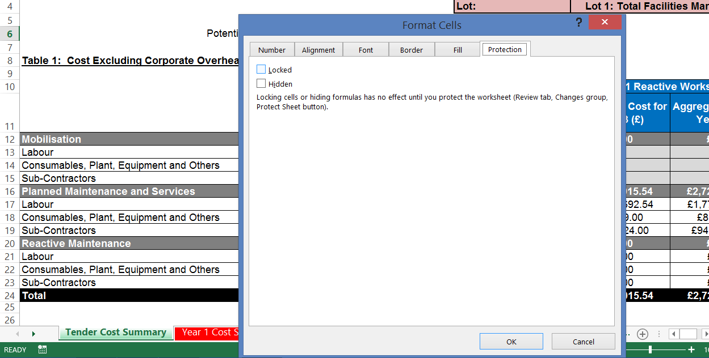

Figure 35

