G-Cloud 12

RM1557

Customer guidance


Contents

1.
Key facts summary 2

2. What is G-Cloud and Digital Marketplace 4

3. What services can I buy 5
Lot 1 cloud hosting
Lot 2 cloud software
Lot 3 cloud support
Notes to buyers
IR35
Transfer of undertakings (TUPE)
General Data Protection Regulation (GDPR)
Modern slavery
Social value

4. How to access and use the Digital Marketplace 13
Intelligent search

5. G-Cloud buying process 16
Prepare
Search and longlist
Longlist to shortlist
Evaluation and selection
Award
Customer benefit

6. Terms and conditions 27
Hierarchy of terms

7. Templates 29

Further information 30

Key facts summary
The G-Cloud framework facilitates the purchase of commoditised cloud-based services only

Services are off-the-shelf, many pay-as-you-go cloud solutions

Services are up-to-date innovative solutions

The framework is compliant and regularly refreshed

The catalogue details suppliers’ service information, including service definitions, pricing and suppliers’ terms and conditions

Moving away from long term contracts – maximum duration is 24 months with the option to extend twice by up to 12 months each time (subject to approval for central government customers)

Over 5,000 suppliers, 91% of which are SMEs

Offering over 38,000 services across the 3 lots

No OJEU, Invitation to Tender (ITT), Request for price (RFP), request for quote (RFQ), request for information (RFI) or negotiation. Clarification questions only.

A more time and cost effective buying process

Central government and customers in the wider public sector have spent over £6 billion through the G-Cloud frameworks

What is G-Cloud and the Digital Marketplace?

The G-Cloud framework allows public sector customers to buy commoditised cloud-based solutions through a framework that is compliant and regularly refreshed allowing CCS to provide our customers with up-to-date innovative solutions.

All services within this framework are visible within the online catalogue - Digital Marketplace

The Digital Marketplace (DMp) showcases all services available through the G-Cloud framework.

Within the DMp, customers can find supplier service information, including detailed service definitions, pricing documents and suppliers’ terms & conditions which enable our customers to evaluate the capabilities.

The G-Cloud framework supports the Cloud First policy to access and use cloud-based services in a flexible and agile fashion, buying only the services needed, when they are needed.

3. What can I buy?
The G-Cloud framework facilitates the purchase of commoditised, cloud-based services only. These services are ‘off the shelf’, many pay-as-you-go cloud solutions. Services span across 3 ‘lots’. These lots are defined as follows:

3.1. Lot 1 Cloud hosting

Cloud hosting suppliers provide cloud platform or infrastructure services that can help customers:

- deploy, manage and run software onto the cloud; customer-created or acquired applications created using programming languages, libraries, services, and tools supported by the provider.

- provision processing, storage or other fundamental computing resources where the customer is able to deploy and run arbitrary software, which can include operating systems and applications.

The customer does not manage or control the underlying cloud infrastructure including:

- network server
- operating systems, or
- storage

They have control over the deployed applications and possibly configuration settings for the application-hosting environment.

3.2. Lot 2 Cloud software

The capability provided to the customer is to use the provider’s applications running on a cloud infrastructure. The applications are accessible from various client devices through either a thin client interface, such as a web browser (for example, web-based email) or a program interface.

The customer does not manage or control the underlying cloud infrastructure including network, servers, operating systems, storage or even application capabilities, with the possible exception of limited user-specific application configuration settings.

3.3. Lot 3 Cloud support

Cloud support provides services to help customers set up and maintain their cloud services.
- planning
- set-up and migration
- testing
- training
- ongoing support

Please note that consultancy and people-based resource services, with the exception of those listed above should not be procured through the G-Cloud framework.

Quality Assurance & Testing services should be procured through the Quality Assurance and Testing for IT Systems 2 (RM6148) framework, which uses a Dynamic Purchasing System (DPS).

These services are needed for new digital systems and services to make sure they are suitable for public launch. The agreement offers the following services:
- testing environments
- Specialists
- automation
- services (such as consultancy)

National Cyber Security Centre (NCSC) schemes should be procured through the Cyber Security Services 3 (RM3764.3) framework. Should timescales using this route be detrimental to a procurement, then only in this instance will it be permissible to use the G-Cloud framework.

For clarity the following services are excluded from G-Cloud including, but not limited to:
- co-location services – see Crown Hosting Services (RM1069)
- non-cloud related services / consultancy – see Technology Services 2 (RM3804), Management Consultancy RM3745
- bespoke design and development – see Digital Outcomes & Specialists (RM1043.6)
- hardware – see Technology Products 2 (RM3733) or Technology Products & Associated Services (RM6068) and Data & Application Solutions (RM3821)
- recruitment – only support relating to the cloud is permitted, not the provision of staff or interims
3.4. Notes to buyers

Consider if G-Cloud is the best route to market for your requirements.

Recommended for:
- off-the-shelf services
- short duration requirements
- benchmarking for business case purposes
- where ‘exit’ is primarily concerned with extracting your data

Not recommended for:
- requirements where a high level of people-based resources are needed
- design and bespoke development – Digital Outcomes & Specialists (RM1043) should be used
- long contracts where there is a ‘lock in’ to a particular supplier
- extending contracts that have expired from other frameworks

3.5. IR35

Employment Status of Suppliers and Specialists.

G-Cloud is not a contingent labour framework and any requirements for contingent labour must be sourced through CCS’s Public Sector Resourcing or Management Consultancy frameworks.

Off-payroll legislative requirements (IR35) will apply where you are deemed to be procuring off-payroll workers or resource from suppliers. For example, where you, the buyer, are effectively acting as the client from the perspective of the worker.

The G-Cloud and Digital Outcomes & Specialists frameworks are for the procurement of “cloud services” or “outcomes”. However, it is common for the workers delivering those outcomes to be deployed into mixed teams with some control and direction of day to day activities resting with the buyer.
Where this is the case, off-payroll working legislation will apply. For example:

- where the supplier provides discreet delivery teams to produce deliverable increments under Buyer led agile development

- where the supplier provides an individual or squad of individuals to work alongside Buyer staff in “rainbow teams”, directed at an operational level by the Buyer.

Where you are procuring a fully contracted out service the off-payroll legislation will not apply. A true service will have the following characteristics:

- the deliverable is fully outsourced to the supplier who will have full responsibility for delivering the outcome and risk of non-delivery sits with the supplier;

- the workers are not embedded within your organisation but are engaged, directed and controlled entirely by the supplier with no input from you, the client.
It is your responsibility to decide whether your procurement represents a supply of an outsourced managed service or a supply of resource. The reality of working arrangements should be considered and not just contractual terms. Please read the following guidance and case studies to help you with this decision:

- “IR35 Guidance for Off-Payroll Working in the Public Sector” which can be found here - Tax Centre of Excellence.
Please note the website is hosted on OneFinance which does require a user to register (process takes about a minute so is very easy) and is accessible to public sector organisations.
HMRC Employment Status Manual Guidance

Where you are procuring “resource”, you will need to meet your obligations under off-payroll legislation, including:

- undertaking an IR35 assessment to determine the employment status of the off-payroll worker for that particular contract / piece of work. HMRC’s ‘Check Employment Status for Tax’ tool can be used for this. The assessment should be undertaken by somebody with expertise in carrying out IR35 assessments;

- communicating the status determination to the supplier you are contracting with for the worker’s services

- from 6 April 2021, you will need to issue a “Status Determination Statement” to both the worker and the supplier you are contracting with, which describes the employment status of the worker and your reasons for reaching that conclusion

- from 6 April 2021, you will also need to operate a status disagreement process, reviewing and considering any challenges to the status from either the worker or the deemed employer (the body that pays the worker’s company) and responding within 45 days with a conclusion

The Tax Centre of Excellence “IR35 Guidance for Off-Payroll Working in the Public Sector” can be found here - Tax Centre of Excellence

This information includes:
- the requirements of off-payroll working legislation for Public Sector Bodies

- determining whether you are procuring resource or a contracted out service

- guidance on answering and interpreting the questions in HMRC’s Check Employment Status for Tax Tool (CEST)

- various case studies focused on Digital working.
HMRC guidance on the off-payroll working rules can be found here: HMRC Employment Status Manual

3.6. Transfer of Undertakings (TUPE)
Services under the G-Cloud framework should not attract TUPE provisions. However, in the event that TUPE should apply then TUPE obligations shall be applicable. The supplier agrees that if the Employment Regulations apply to this call-off contract on the start date then it must comply with its obligations under the Employment Regulations and (if applicable) New Fair Deal (including entering into an admission agreement) and will indemnify the customer or any former supplier for any loss arising from any failure to comply.

Please see section 29 of the call-off agreement for full information.

3.7. General Data Protection Regulation (GDPR)

GDPR was introduced on 25th May 2018. Customers and suppliers should familiarise themselves with GDPR using the Information Commissioner’s Office (ICO) communications.

The G-Cloud 12 call-off includes GDPR clauses and schedules for customers to populate their data protection details and requirements.

The G-Cloud framework supports the Cloud First policy as a way to access and use cloud-based services in a flexible and agile fashion, buying only the services needed, when they are needed.

3.8. Modern Slavery

The Modern Slavery Act 2015 is an Act of the Parliament of the United Kingdom. It’s designed to combat modern slavery in the UK and consolidates previous offences relating to trafficking and slavery. The act extends to England and Wales.

The Transparency in Supply Chains Provision (TISC, s.54) of the Modern Slavery Act (MSA) requires commercial entities with an annual turnover of £36m or more to report annually on their actions to identify, prevent and mitigate modern slavery in their supply chain.

It is the responsibility of the customer to ensure they are following their own policies.
3.9. Social Value
Legislation
Public Services (Social Value) Act 2012 legislation requires buyers of public sector services to consider related social, economic or environmental benefits that can be delivered through a contract. They must be relevant and proportionate and specific to the customer.

You need to be confident that you choose the right commercial solutions to help you deliver real benefits – whether that’s creating more apprenticeships, reducing carbon emissions in your local area or your own unique local priorities.

Policy
Procurement Policy Note (PPN) PPN 06/20 applies to procurements covered by the Public Contracts Regulations 2015. It applies to:
- all Central Government Departments
- Executive Agencies
- Non Departmental Public Bodies
Together these are referred to in the PPN as ‘In-Scope Organisations’.
However, the principles within this PPN can be considered by all Public Sector bodies. The social value model outlined in PPN 06/20 should be applied to all new procurements from 1 January 2021.

The G-Cloud 12 framework was awarded before PPN 06/20 became a mandatory obligation and therefore as Social Value is not specifically covered in the framework it will be voluntary rather than contractual at call-off level.

The framework refers to the Supplier Code of Conduct and the Government Buying Standards. It takes into consideration social value legislation in delivering goods and services and supporting key government corporate social responsibility policy areas such as:
- diversity and inclusion
- sustainability
- prompt payment
- small and medium sized enterprise engagement
- the Armed Forces Covenant
- apprenticeships and skills development
- addressing the gender pay gap.
Social value themes to consider in your procurement:
- covid-19 recovery
- tackling economic inequality
- fighting climate change
- equal opportunity
- wellbeing
We advise buyers to apply ‘best endeavours’ to their G-Cloud 12 call-off contracts. Social Value (as per PPN 06/20) will be fully addressed within the next iteration of the framework.

Customers are advised to refer to the Social Value Act and include within their evaluation of services. More information can be found here: PPN 06/20

https://www.gov.uk/government/publications/social-value-act-information-and-resources/social-value-act-information-and-resources

How to access and use the Digital Marketplace?

Customers can access the DMp catalogue using the following link: https://www.gov.uk/digital-marketplace

Find technology or people for digital projects in the public sector using G-Cloud, DOS or Crown Hosting.
DOS - Find an individual specialist for example a developer or user researcher
DOS - Find a team to provide an outcome for example a booking system or accessibility audit
DOS - Find user research participants for example people from a specific user group to test your service
DOS - Find a user research lab for example a room to conduct research sessions
G-Cloud - Find cloud hosting, software and support for example content delivery networks or accounting software
Crown Hosting - Buy physical datacentre space for example access to mission-critical datacentres
The DMp showcases all services available under the G-Cloud framework. Customers must search the DMp to find services which best meet their requirements. To help customers refine their searches we have provided some intelligent search hints below:

4.1. Intelligent search

Customers may wish to use double quotation marks when searching phrases for example “workflow management”.

The reason for this is when multiple words are typed into the search box, the search is looking for services containing the individual words. However, by including the double quotations the exact phrase will be searched and not the individual words.

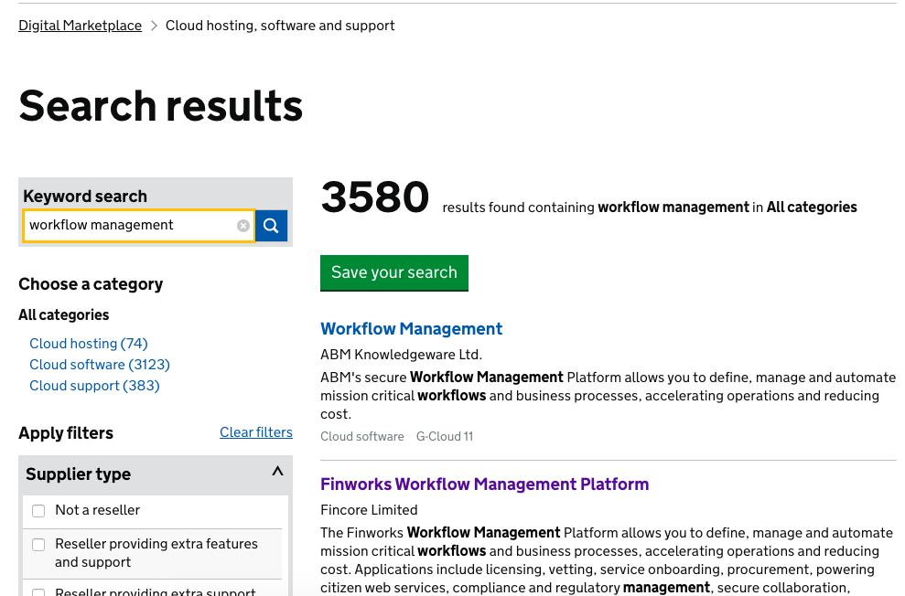

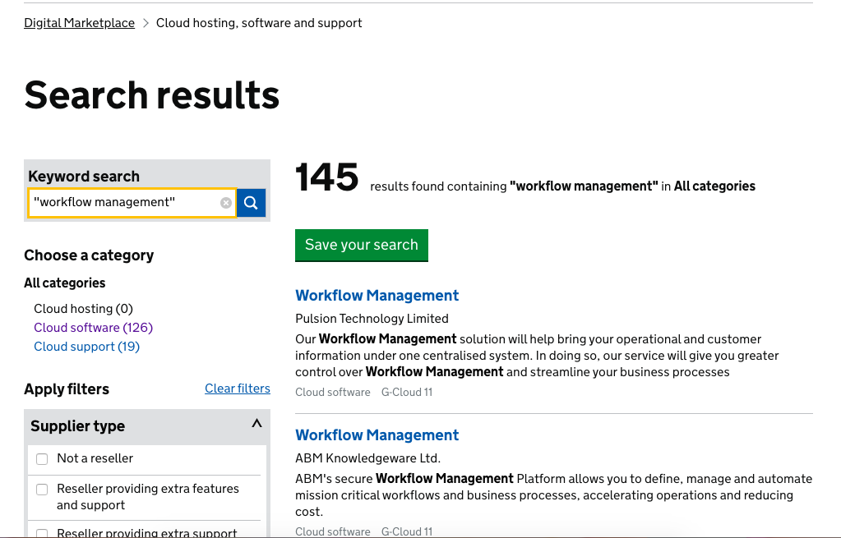

Try using different search terms to make sure you get the most complete set of results possible. For example, if you want to buy a content management system, try searching for ‘document management system’ as well as ‘content management system’.

Add keywords to create a list of services that meet your wants as well as your must-haves. For example, a search for ‘content management system’ and ‘open standards’ could be further refined by adding ‘Firefox support’, ‘content rating’ and ‘link management’.

If you want to exclude a word, put a minus sign before the word you don’t want. For example, if you don’t need training, type: ‘hosted content management system - training’.

G-Cloud buying process
The online catalogue ensures that all service information is available up front to allow customers to evaluate services based upon best fit and/or price.

This method helps a direct award following the six step buying process, therefore if a customer deviates from this process through mini competition, Request for proposal (RFP), Request for Quotation (RFQ), Request for information (RFI), negotiation or issuing an Invitation to tender (ITT), they will actively breach the terms of the framework.

Non-compliant buying will directly affect the legality and reputation of the framework and call-off and so is strictly forbidden. Customers who do not follow the correct buying process will be at risk, and the terms of the framework will be null and void.

The G-Cloud buying process comprises 6 important steps. These steps must be followed to ensure that a compliant process is adhered to.

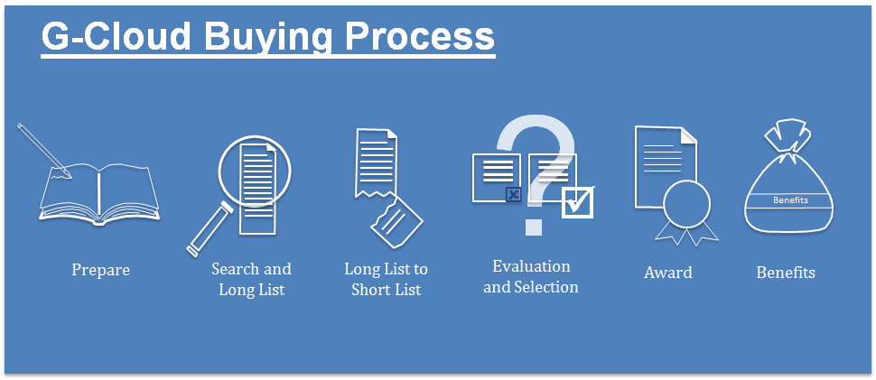

5.1. Step 1 prepare

Before exploring the DMp, it is essential for you to understand what it is you are looking to buy. We would recommend partnership working between procurement and technical professionals to establish high-level requirements, service outputs and timescales.

Procurement expertise is essential to ensure a compliant buying process is followed, whereas technical experts are needed to evaluate the capabilities of the service offerings available to buy within the DMp. You may wish to consider the following:

- what funds are available for the purchase of the service?

- high level understanding of your requirements, without limiting yourself to specific details

- ensure that both technical and procurement interests are covered in the requirements

- what selection criteria will your choice be based upon? Best price or Most Economically Advantageous Tender (MEAT)

- is G-Cloud the correct framework for your needs?
Creating an extensive list of search terms will help you when proceeding to the longlist stage. Therefore, market research would be advisable at the start of your buying process.

5.2. Step 2 Search & longlist

The purpose of formulating a longlist is so that you can refine the broad range of services available and find the service which best fits your high-level requirements within the DMp.

At tender stage suppliers are restricted as to how they describe their service offerings. This means that the short description is formulated by suppliers using their own language and terminology to best describe their service.

In order for you to form a longlist of services and not exclude any potential suppliers, we suggest you run multiple searches using different semantics and terminologies.

As an example, eProcurement, eTendering and eSourcing ultimately mean the same thing. This in turn will ensure a comprehensive and robust longlist of services are filtered from the DMp.

The results of these longlists must be shortlisted as per guidance in step 3 below.

To help refine and assist with your searches please refer to section 4; How to access and use the DMp.

When forming your longlist, it is important that you keep an audit trail of your search criteria. This will show how and why you chose a specific service.

The audit trail needs to be done offline and away from the DMp. However, there is a ‘save search’ button facility.

It is important that you can provide sufficient evidence to mitigate against any risk of challenge.

Please refer to the CCS templates. Please note these are purely an example and not mandated forms G-Cloud 12 evaluation templates.

5.3. Step 3 Longlist to shortlist

On the DMp you will find a list of filters which will help to refine your search, this can be seen in the image below. Using multiple filters your longlist will reduce to a manageable shortlist of services, which can then be evaluated individually.
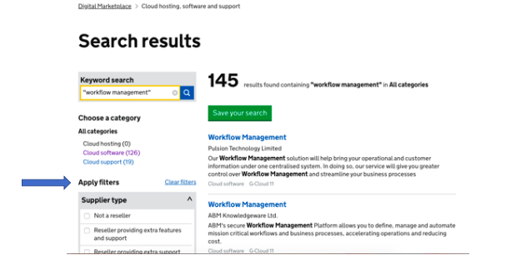

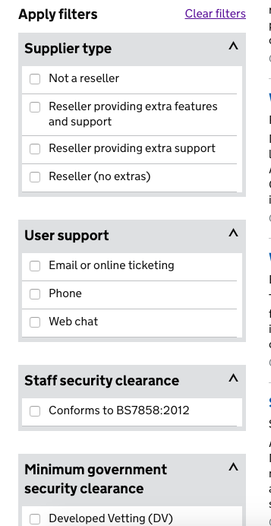
You will need to establish which filters best suit your specific requirements and apply as necessary. Please be aware that buyers need to be able to justify the reasoning behind using the filters to mitigate any risk of challenge.

Customers must ensure that they have recorded and
audited the filtering process for each catalogue
search criteria. As mentioned in step 3, customers
can use the G-Cloud 12 evaluation templates to help record this.

If you have run multiple longlists these need to have
the same filters applied to ensure fairness and
transparency.

Before proceeding with your shortlist evaluation, CCS
would advise that you contact the shortlisted suppliers directly in order to confirm they hold the resource capabilities to deliver to your timescales, if they were to be successful in the shortlist evaluation.

5.4. Step 4 Evaluation and selection

Before customers begin their shortlist evaluation process, it is important for them to understand that terms are fixed at the point of tender and therefore are non-negotiable. Services which are available on the DMp cannot be deviated from and are the only services available from the supplier.

The information and documents provided by a supplier on the DMp is what will form the contract and therefore needs to be evaluated accordingly.

To enable customers to evaluate services they need to review the shortlisted services following their search and assess suitability against their requirements.

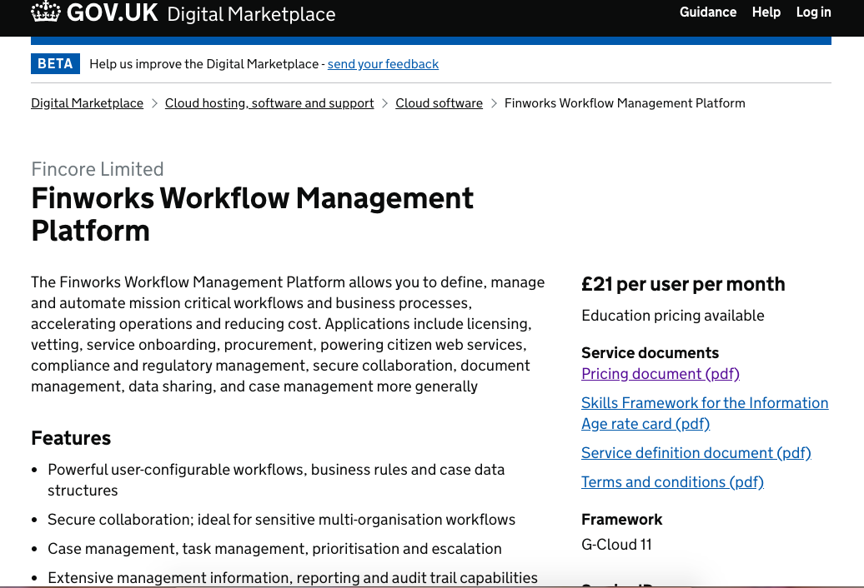

A supplier’s overall service offering will include the following:
- pricing document

- service definition document

- terms & conditions

- modern slavery statement (if annual turnover exceeds £36m)

When customers are assessing shortlisted service offering documents they have to show that each service was evaluated in a fair and transparent manner.

Shortlisted suppliers can be evaluated in 2 ways:

- Most economically advantageous tender (MEAT) criteria

- Direct award on lowest price only if they are comparable services
The most efficient way to compare services is using the MEAT evaluation criteria which will allow you to consider best functional fit, quality and whole life cost accordingly.

If you request a demonstration from a supplier then this can only be scored if you have evidenced this as a mandatory requirement and stated this in the award criteria. All shortlisted suppliers must be given the opportunity to demonstrate.

Customers can include Modern Slavery in their MEAT evaluation within their non-functional characteristics criteria.

Offboarding costs can be taken into consideration within the whole life cost.

Social Value should be included within the ‘after sales service management’ criteria. A minimum of 10% must be included in the evaluation. This applies to:
- all Central Government Departments
- Executive Agencies
- Non Departmental Public Bodies

However, other organisations should consider this as part of their evaluation.

Customers must ensure they record and report how they evaluated in accordance with clause 3.20 (Award Criteria) of the framework and be able to evidence that this was done fairly across all services evaluated.

 | Award criteria
1. | Whole life cost - the cost effectiveness, price and running costs of the service
2. | Technical merit & functional fit - coverage, network capacity and performance as specified in relevant service levels
3. | After sales service management - help desk, account management function and assurance of supply of a range of services
4. | Non-functional characteristics - for example, supplier terms, help with onboarding and offboarding, scalability, reliability and automatic disaster recovery

Your final choice should be based on best fit, rather than ruling out suppliers that don’t meet either your current contract or an ideal set of terms.

In the event that the services you are looking to purchase are comparable you may instead consider comparing in terms of lowest price alone. Your findings should be recorded in order to identify the ‘best fit’ service. Our G-Cloud 12 evaluation templates may help with this.

Ultimately how you weigh/evaluate the suppliers is up to you; the overall selection process must be auditable, fair and transparent.

Handy hint

CCS do not conduct financial checks as part of the procurement for G-Cloud. This presents an unnecessary barrier to entry and as suppliers’ financial status is monitored by CCS (in relation to their Dun & Bradstreet credit score) for the duration of the framework this adds little value.

CCS recommend that customers may wish to conduct their own financial assessment of the suppliers that they have shortlisted prior to award if they have a need to do so in line with their internal governance.

Customers must remember all of the information they need to evaluate a supplier’s service can be found as attachments within the supplier’s service offering page on the DMp. (For example, pricing, SFIA rate card, service definition and supplier terms & conditions).

This information is fixed at the point of tender, and therefore cannot be materially changed or negotiated. However, suppliers are allowed to reduce their service offering price at any time during the life of the framework.

Before customers can accept the price reduction suppliers must update their pricing documents on the DMp to reflect this new revised price.

It is the information on a supplier’s catalogue which forms and defines your call-off contract, so this information must be correct and up-to-date before you proceed to award.

Please note: It is not permissible for customers to negotiate and/or accept individual price discounts. Suppliers are to treat all CCS customers as ‘one’.

Handy hint

Clarification of understanding

If you have any uncertainty regarding the supplier’s catalogue entry or service offering, you can contact suppliers directly to seek ‘clarification’ of your understanding.

Please be aware that suppliers are not allowed to materially change their service offering. This clarification can be done either by email, eSourcing suite or conference call, as long as you have a clear audited process and all shortlisted suppliers should be treated equally and fairly.

Non-compliance with the clarification process will directly affect the legality of the call-off contract and is strictly prohibited. Please make sure that this tool is used for clarification of understanding and not a negotiation process.
5.5. Step 5 Award and buy
Once you have evaluated and decided which service provision best meets your requirements, you are then ready to award a contract. In order for you to proceed you need to complete the G-Cloud 12 call-off agreement.

Please note that within the contract, guidance notes are available and mandatory fields have square brackets. The call-off agreement can be found by the following links:

G-Cloud 12 call-off contract
G-Cloud 12 framework agreement

Handy hint

It is imperative for customers to use the correct Call-Off Agreement when buying a G-Cloud service.

You will also need the Service ID which can be found on the DMp within the service offering. EXAMPLE: 3702 9576 1234 456 (15 digits).

Within the call-off contract, customers must clearly stipulate their service requirements up front in line with the service offering defined on the DMp.
Once complete, a copy of the call-off agreement must be signed by all interested parties (i.e., both the customer and supplier) before the call-off can commence.
The initial call-off term of up to 24 months can be extended by 1 or 2 periods of up to 12 months each giving a maximum term of 48 months. Please note that customers must ensure they have a robust exit plan prior to placing any order to prevent supplier lock-in.

The supplier must give an ‘additional exit plan’ to approve at least 8 months before the contract ends.

It is worth considering raising this issue with the supplier before a call-off contract is finalised.

Customers may also wish to consider the levels of data backup, restore, and disaster recovery provided by the supplier and whether this is sufficient. For example, business continuity and disaster recovery plans. Implementation plans should also be taken into account before the completion of the call-off contract.

Contracts Finder: All UK central government (CG) and wider public sector (WPS) bodies with the exception of devolved administrations and other exceptions mentioned in the PPN Action Note 07/16 need to post contract award details when they exceed the thresholds. £10k for Central Government & agencies and £25k for NHS and Wider Public Sector.

For more details see Procurement Policy Note – Legal requirement to publish on Contracts Finder

CCS do not have formal templates for the variation of contracts. For details on amending and extending contracts more guidance can be found within this document https://www.gov.uk/government/uploads/system/uploads/attachment_data/file/560262/Guidance_on_Amendments_to_Contracts_-_Oct_16.pdf

For central government departments, prior approval must be obtained from the Government Digital Service (GDS) under the spend controls process before extending beyond 24 months. Contact gdsapprovals@digital.cabinet-office.gov.uk

At the end of a call-off, if the customer’s scope has not changed and a service is still needed, they must still conduct a re-evaluation of services available on the DMp.

This exercise is to ensure that the customer is still receiving the best value for money and no alternative services have been added through new iterations of the Framework.

As a matter of best procurement practice, CCS would advise that customers build in a standstill period after they have notified the successful and unsuccessful shortlisted suppliers.

CCS would also suggest that in order to help aid the maturity of the marketplace customers should offer feedback relating to all of the supplier’s services offerings which have been evaluated.

Feedback will help suppliers to implement improvements, if they choose to re-tender and improve their service offering, adding value to both new and existing services, which you in turn can then use in the future.

5.6. Step 6 - Benefits

Crown Commercial Service’s remit is to work with departments and organisations across the whole of the public sector to ensure maximum value is extracted from every commercial relationship and improve the quality of service delivery.

In order to record savings for the nation and monitor the performance of the G-Cloud Framework, it is essential that customers complete the G-Cloud Customer Benefit Record.

Customers should complete this form every time that they enter into a call-off agreement. This is now an on-line process and once a customer has downloaded a saved search, they will see a link with 'Tell us the outcome' next to the particular search in their list.

Please note: CCS will not publish savings relating to specific procurements – it is purely to record and validate the benefits of utilising the G-Cloud framework agreement(s) in line with auditable savings for government and public sector organisations.

6. Terms & conditions and contractual obligations
6.1. G-Cloud hierarchy of terms:
- G-Cloud framework
- order form
- call off agreement
- suppliers terms and conditions
The G-Cloud framework is unlike most other frameworks as it incorporates the suppliers’ terms and conditions. It was recognised that to support the SME agenda, CCS needed to move away from the traditionally lengthy and unrealistic terms & conditions and embrace innovation and change.

CCS, in collaboration with our legal team were able to determine which compulsory and legally compliant terms were needed for this framework. This enabled us to refine the terms and conditions and remove any unnecessary and unrealistic terms.

Although customers have the reassurance that the G-Cloud framework and call-off agreement terms will take precedence, ultimately these do not determine the commercial details themselves. Instead, the suppliers’ terms and conditions will define the way in which the service will operate.

Please note: in the case of any contradiction of terms, the call-off and framework terms will take precedence.

Therefore, as part of a customer’s shortlist evaluation, CCS insists that they familiarise themselves with both the G-Cloud framework and call-off terms and evaluate all shortlisted suppliers’ terms and conditions accordingly.

We would recommend that this evaluation is done by a lawyer or suitably qualified professional to assess and determine if those are in line with their organisational objectives.

Handy hint

Collaboration Agreement Schedule 3

G-Cloud customers can draw up a formal collaboration agreement. This agreement will allow our customers to formally co-ordinate a partnership working approach among all parties, so that they can deliver their overall IT requirements in an efficient and effective way.

This agreement can be drawn up to provide ongoing cooperation of suppliers across differing contractual arrangements.

Handy hint

Variation Process (Section 32)

Buyers can request in writing a change to the call-off contract if there isn’t a material change to the framework agreement/call-off contract. Once implemented, it is called a variation.

This offers our customers flexibility, but can only be done with the full agreement of the supplier.

Variations are only permissible if they do not materially change the suppliers’ service offer. More guidance can be found in this document https://www.gov.uk/government/uploads/system/uploads/attachment_data/file/560262/Guidance_on_Amendments_to_Contracts_-_Oct_16.pdf

7. Templates and training

G-Cloud Customer Benefit Record

G-Cloud 12 evaluation templates

G-Cloud 12 call-off contract

G-Cloud 12 framework agreement

All documents can be found on the DMp https://www.digitalmarketplace.service.gov.uk/

The National Audit Office has guidance on cloud services that buyers may find useful:
https://www.nao.org.uk/report/guidance-for-audit-committees-on-cloud-services/

Webinars

Further support and training can be provided through scheduled webinars. These provide an overview of the information given in this customer guidance and also a live demonstration of the DMp. G-Cloud webinars

In addition to the scheduled webinars and customer guidance there is also recorded tutorial information on the Crown Commercial Service website. ‘G-Cloud - what you can buy’ and ‘G-Cloud - how to buy’. For more information on these and other technology support please visit https://www.crowncommercial.gov.uk/products-and-services/technology

Further information

If you need any further information please contact
info@crowncommercial.gov.uk | 0345 410 222


You can also learn more about Crown Commercial Service at:
Website:  crowncommercial.gov.uk | Twitter:  @gov_procurement | LinkedIn:  Crown Commercial Service

