Welcome to Project Management and Full Design Team Services

(RM3741)
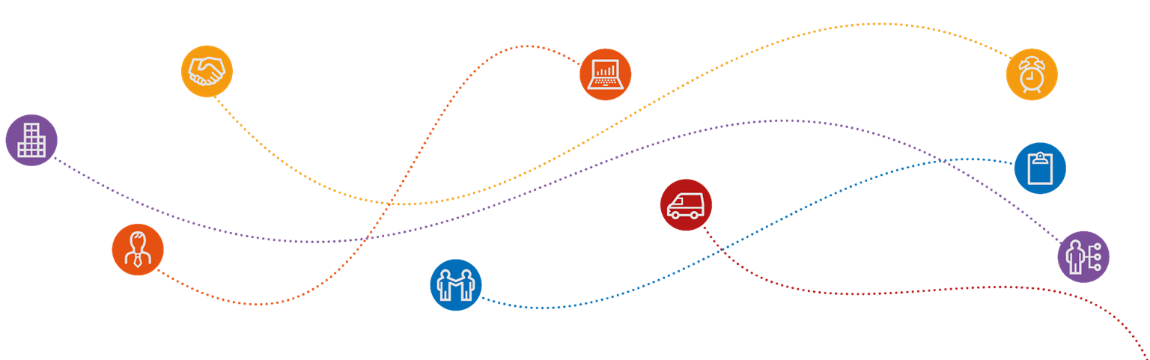
PMFDTS- Considering Liability

CALL OFF ORDER FORM and removal of Square Brackets
The RM3741 Project Management and Full Design Team Services Attachment 5 Call-Off Contract 2.1 is NOT a complete appointment document ready for signature. The Contracting Authority will need to consider all aspects of the template Call-Off Order Form in line with the specific project requirements and complete it prior to seeking bids from the potential Supplier. The use of square brackets within the template Call-Off Order Form indicates that specific drafting has not yet been agreed.
The Supplier will be unable to agree to the contract terms until the template Call Off Order Form has been completed, all square brackets have been removed and all aspects of the call-off contract are known.

SUPPLIERS LIMITATION OF LIABILITY (Clause 36.2.1)
2
The Customer will need to consider and agree an appropriate limitation on liability with the Supplier. It is not common practice for Suppliers to agree to unlimited liability as this means they are liable to the full extent of their assets and it may not be reasonable to ask them to sign up to this.
Note that the default limits are examples only. The Customer will need to consider the losses that it might suffer in the event of a Default and the likelihood of those losses occurring.
The agreed limitation on liability figure can be agreed between the parties and does not need to be a per annum limit.
Note that a lower level of liability and PI insurance requirement may have the benefit of reduced fees as the supplier’s risk profile will be smaller/reduced.
It is key for Contracting Authorities to clearly outline their requirements (including respective Liabilities) before they issue their Tender via pre market engagement, or if there is not enough time for this, it needs to be explicitly clear in the ITT documents.

