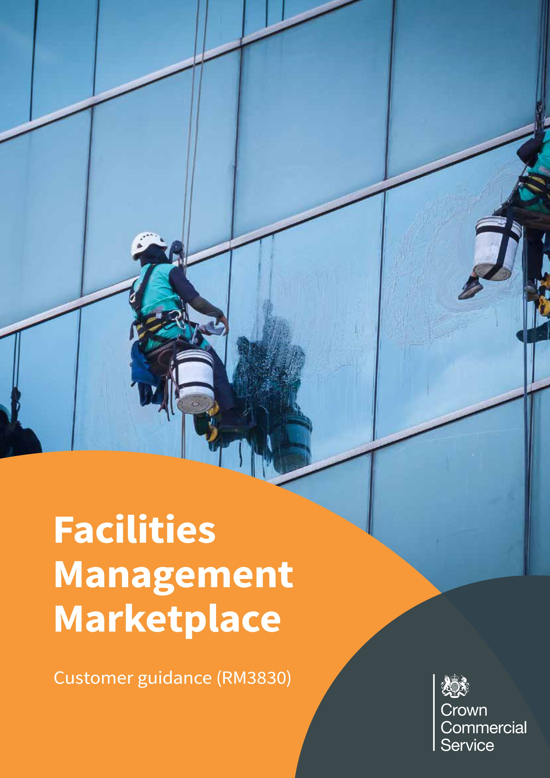
2
Contents

Contract Overview 3
Benefits 4
What services are available 5
Framework prices 6
How to access the agreement - Next steps 7
How to access additional support during your procurement 9
Framework structure 9
Direct award 10
Further competition 11
Terms and conditions 12
Cabinet Office controls 12
Suppliers 13
Estates information 16
Communicating your awarded contract with CCS 17

1

Contract Overview

Crown Commercial Service (CCS) is an executive agency of the Cabinet Office which supports the public sector to achieve maximum commercial value when procuring common goods and services.
This framework has been developed to meet our customers’ (the buyer) Facilities Management (FM) requirements by providing the best route to market. It has been designed to provide the right structure for buyers with a variety of suppliers and services, whilst ensuring unrivalled ‘value for money’ for public sector organisations.
The FM framework provides bespoke FM services suitable for all public sector, devolved administrations and third party entities including but not limited to: schools, hospitals, local authorities, blue light services, charities and central government departments. For more information as to who can access this framework, please refer to the contract notice.
The Facilities Management Marketplace Framework (RM3830) commenced on 10 July 2018 and will expire on 10 July 2022.
Call-off contracts can be let for an initial period of up to seven years (with a maximum contract period of ten years inclusive of all call-off optional extension periods and the mobilisation period).

2

Benefits
The framework agreement has a number of key benefits that include but are not limited to:

- Free: The framework is free of charge for all public sector buyers to use.
- Fast: It provides a streamlined route for all buyers to access a comprehensive range of FM suppliers through either a further competition or direct award process.
- Simple Call-Off Contract Terms: Terms and conditions are based on the new simplified Public Sector Contract terms and conditions.
- Flexibility: The framework has been designed to cater for a wide range of FM requirements based on range of complexities and contract values.
- Social value: Buyers can request suppliers tailor their offer to match the buyer’s social value priorities to deliver measurable benefits in line with the buyer’s social value policies.
- Compliant: All further competitions and direct awards are fully compliant with the Public Contracts Regulations 2015.
- Digital: New self-serve Digital Portal allowing customers’ fast, simple access to the framework. Contract creation and offer for direct award plus guided information for further competition.
- Competitive: The framework provides proven value for money and commercial benefits.

3

What services are available

There are 15 service areas covered referred to as ‘work packages’. Each supplier on the agreement can provide all the mandatory core services within each of the following work packages:

- Contract Management
- Contract Mobilisation
- Maintenance Services
- Horticultural Services
- Statutory Obligations
- Catering Services
- Cleaning Services
- Workplace FM Services
- Reception Services
- Security Services
- Waste Services
- Miscellaneous FM Services
- Computer Aided Facilities Management (CAFM)
- Helpdesk Services
- Management of Billable Works

There are also a number of non-mandatory services within each work package. Suppliers have identified which of these they can provide.
Framework Schedule 1 - Specification provides detail on the full scope of services available under this agreement.

4

Framework prices

Framework prices established at framework tender stage will be used as the basis for charges of mandatory services. These are the maximum prices a supplier can charge for mandatory services, however these prices may be reduced at further competition based on individual requirements. Non-mandatory services will only be priced at further competition stage there are therefore no available rates for non-mandatory services.
Framework prices are accessible by requests sent to info@crowncommercial.gov.uk. Our Customer Service Centre will then provide the relevant information.
Please note a confidentiality undertaking must be signed prior to any access given to the schedules of rates for mandatory services.

5

How to access the agreement - Next steps
The Buyer can access the agreement via the FM Marketplace digital portal, which has a step by step guide on how to use it. Further information and supporting documents can be found on the webpage.
The information submitted on the portal will allow it to run a report which will provide the buyer with a shortlist of suppliers within an allocated sub-lot based on their requirements.
The portal will provide a procurement summary document which will provide the information to assist you in the development of your “Supplier Brief”. The Supplier Brief provides suppliers with an overview of the upcoming opportunity, outlining details of the buyer’s needs, therefore allowing shortlisted suppliers to make an initial decision on whether they wish to proceed to the next stage (if a further competition)
The portal will also identify which routes to procurement are available to the buyer:
- Direct award
- Further competition
Once you reach this point there are additional documents (Bid Pack, and Order Form) that will help you to conduct your further competition or direct award, along with step by step guidance.
Once awarded you must provide CCS with a written confirmation of award details once the contract is in place. A template is available in the documents section of the website. This must be sent to info@crowncommercial.gov.uk
If you are unable to use the portal, need guidance at any stage or would like to enquire about an assisted service (see below), please contact the FM team who will discuss your requirements in more detail via info@crowncommercial.gov.uk

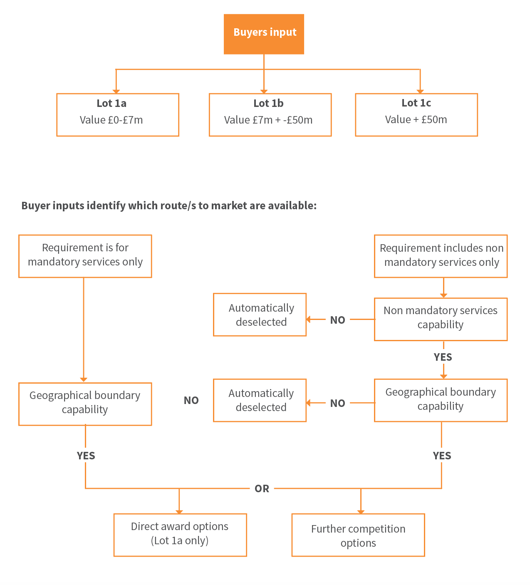
6

How to access additional support during your procurement
CCS can provide a range of support if you require during your procurement process called the assisted service. Please contact info@crowncommercial.gov.uk for more information.

7

Framework structure

To ensure buyers have access to the right suppliers, the agreement is broken down into three lots. Each lot is determined by the total contract value as follows:
- Lot 1a: Assessed contract value £0m - £7m
- Lot 1b: Assessed contract value £7m+ - £50m
- Lot 1c: Assessed contract value £50m+
Assessed value is the estimated value of the call-off contract and is calculated using the average of the following three inputs provided by the buyer:
- Unit of Measure of Deliverables required;
- Current costs or estimated annual costs; and
- Benchmarked costs.
The framework is designed this way to allow all scales of requirements to be satisfied by the agreement, making it suitable and flexible for all public sector organisations to use.

8

Direct award

What is a direct award?
Direct award means the award of a contract directly to a supplier without the need for a further competition. This is only permitted on lot 1a of this framework agreement.
This means that the contract is awarded based on price only.
A direct award is only available when all of the below are met:
- Only mandatory services are required;
- Standard call-off terms are required; and
- The total contract value is up to £1.5m.
The full award criteria can be found in Framework Schedule 7; Part 2; Annex A.
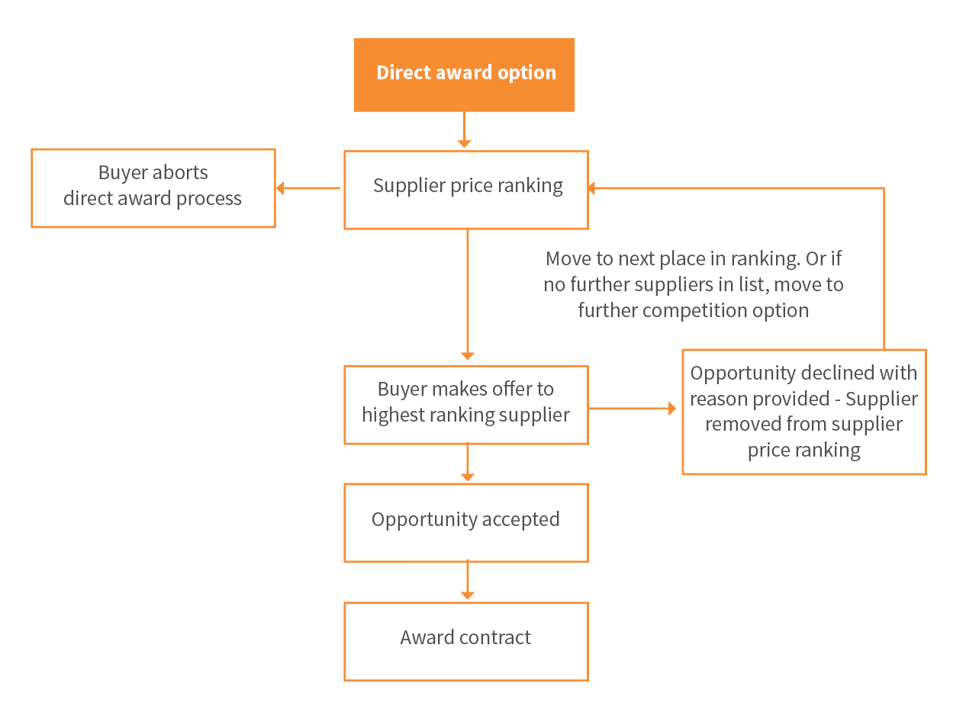
If all of the above requirements are met, the new Digital Portal shall be used as a quick and easy way of procuring your requirements.
9

Further competition
What is a further competition?

A further competition is when the identified shortlisted suppliers who can meet a buyer’s requirements compete against each other by tendering for an opportunity.
This can be done by inputting your requirements through the digital portal.
Buyer inputs provided on the digital portal will help to create a “Supplier Brief". This is used to communicate to the suppliers details of the buyer’s needs, and allows shortlisted suppliers to make an initial decision on whether they wish to proceed to the next stage.
CCS advises that the following suppliers are given the following amount of days as a minimum to respond to a supplier brief.
- Lot 1a – 5 working days;
- Lot 1b – 10 working days;
- Lot 1c – 10 working days.
Suppliers who wish to progress to the next stage are then invited to the further competition.
If you do not receive any expressions of interest for your supplier brief please inform the FM Team on, info@crowncommercial.gov.uk. The team can conduct pre market engagement to identify the reasons.
If the initial list of down selected suppliers do not wish to bid, the FM team can revisit your requirements and process the data using an alternative lot.
Both price and quality is tested in a further competition.
Benefits of a further competition include but are not limited to:
- it allows the buyer to test the supplier’s approach to delivering the services, aligning quality criteria to the buyer’s requirements and policies;
- it enables a competitive environment for pricing and reduction on supplier's maximum framework rate;
- It allows further flexibility for buyers to be specific on the terms and conditions they chose for their contract and tailor where possible under the Procurement Contract Regulations 2015;
- it enables buyers specific social value requirements to be addressed and incorporated as KPIs along with additional performance measures to monitor adherence;
- The full award criteria can be found in Framework Schedule 7; Part 2; Annex B - Standards and Processes; and
- If you would like more information on the further competition process please contact one of the team to discuss by emailing info@crowncommercial.gov.uk.

10

Terms and conditions
The call-off contract
The call-off contract is an agreement between the buyer and supplier and governs the purchase and delivery of the services. It is entered into once the order has been placed (i.e. at the end of a further competition or direct award process). The call-off contract will be created using the Public Sector Contract terms and conditions. The call-off contract and all schedules can be found on the RM3830 webpage.

11

Cabinet Office controls
The call-off contract
Buyers from central government (including arm’s length bodies) are required to adhere to the Cabinet Office Spending Controls when buying common goods and services. One of the categories within controls scope is consultancy and facilities management. Therefore, please refer to the guidance via the attached link to find out whether your procurement requires pre-approval via the controls process. https://www.gov.uk/government/publications/cabinet-office-controls.
12

Suppliers
There are over 40 suppliers across three lots on the framework agreement with over 20% of them classed as small to medium sized enterprises (SMEs). There are also many more SMEs taking on the form of subcontractors throughout various suppliers’ supply chains.
Please see links below under the relevant lots for an up to date list of suppliers.
Lot 1a Suppliers
Lot 1b Suppliers
Lot 1c Suppliers
The framework has been set up to ensure both local and national coverage. There may also be limited opportunities for suppliers to provide international coverage.

13

Estates information
Buyers are required to provide their estate information to build their supplier brief and subsequent tender documentation. The better the data the less risk overall as suppliers will have more accurate information to base their tenders on.
If you need help understanding your assets and estate, CCS have an Estates Professional Services framwork agreement (RM3816) that have services in Lot 4 that could assist. If you would like to discuss this further, please contact info@crowncommercial.gov.uk.

14

Communicating your awarded contract with CCS

As soon as a supplier is successful and a contract has been signed, the buyer must complete and return a contract award notification form to info@crowncommercial.gov.uk. This can be found on the RM3830 webpage under the documents tab. This is mandatory for all self-service buyers.

Facilities Management Marketplace RM3830 | 16
6194-20 (
Feb
20)
Help and advice
If you would like help deciding which service
or buying option will best meet your specific needs
please get in touch with our category experts via our
contact for
m
.

0345 410 2222
info@crowncommercial.gov.uk
www.crowncommercial.gov.uk

@gov_procurement

Crown Commercial Servic
e

