

**Modular Building Solutions RM6014 - Framework Alliance Contract**

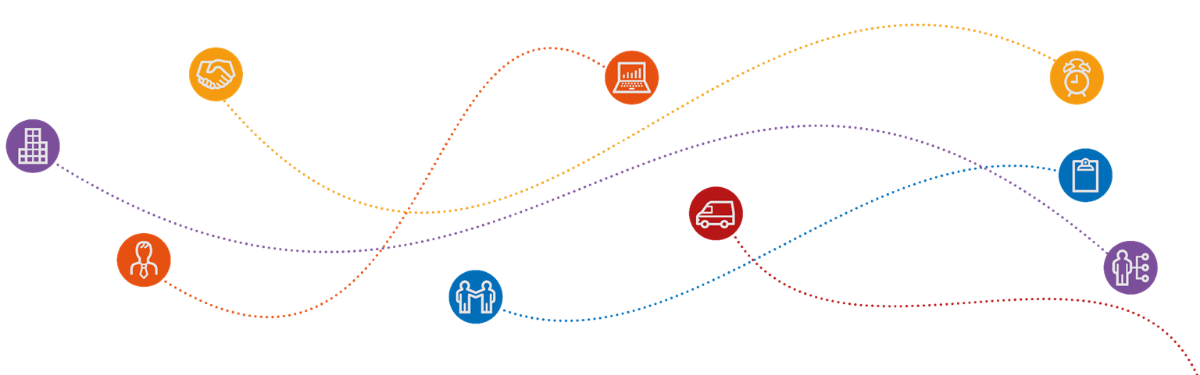

**Additional Client User Agreement**

**ANNEX B: Additional Client User Agreement**

**Modular Buildings Solutions – RM6014**

**Additional Client User Agreement (ACUA)**

The Modular Building Solutions Framework offers an alternative solution to traditional build accommodation, providing a comprehensive range of solutions designed to cover most accommodation requirements.

Prior to any supply market engagement, commencing your tender or placing an order through this agreement, please complete the below form and return to Crown Commercial Service via [info@crowncommercial.gov.uk](mailto:info@crowncommercial.gov.uk). Please provide an answer for every question, for multiple choice questions (identified by **\***) **please choose the relevant option by highlighting in yellow. Please complete ALL rows.**

|  |  |  |  |  |  |  |  |  |  |  |  |  |  |
| --- | --- | --- | --- | --- | --- | --- | --- | --- | --- | --- | --- | --- | --- |
| **Contact Details** | | | | | | | | | | | | | |
| Additional Client Organisation Name |  | | | | | | | | | | | | |
| Contact Name |  | | | | | | | | | | | | |
| Contact Number |  | | | | | | | | | | | | |
| Contact Email Address |  | | | | | | | | | | | | |
| CCS will share the names of our customers from this form with our RM6014 suppliers in confidence. This is to allow our suppliers to plan and prioritise their workloads so they can best meet your needs.  Are there any security and/or confidentiality reasons why your name should not be shared with our suppliers?  **YES / N/A \*** | Yes – The Contracting Authority name must be withheld from the pipeline of works which is shared with Suppliers.  **or**  N/A | | | | | | | | | | | | |
|  |  | | | | | | | | | | | | |
| **Additional Client Project Contract Requirements** | | | | | | | | | | | | | |
| Nature of Service Requirement (short description of project) |  | | | | | | | | | | | | |
| Lot **(Please Select One) \*** | 1 | 2 | | 3 | | 4 | | 5 | | 6 | | 7 | |
| Further Competition or Direct Award? |  | | | | | | | | | | | | |
| Procurement Portal Used (Please include address) |  | | | | | | | | | | | | |
| Supplier Alliance Member(s) Invited (Please note ALL suppliers on your chosen Lot should be invited if undertaking Further Competition) |  | | | | | | | | | | | | |
| Project Value (Value of Modular works) |  | | | | | | | | | | | | |
| TOTAL Project Value (i.e. Modular works + other project services not tendered through this framework) |  | | | | | | | | | | | | |
| Planned Commencement Date of Procurement |  | | | | | | | | | | | | |
| Anticipated start date of project contract |  | | | | | | | | | | | | |
| Anticipated project completion date (target) |  | | | | | | | | | | | | |
| Project Contract to be used **(Please Select one) \*** | NEC3 | | NEC4 | | JCT | | PPC | | TAC-1 | |  | |  |

Upon receipt of the completed form you will be provided with an Additional Client User Agreement Reference Number (ACUA). This should be quoted in your documentation when placing an order through the framework with your service provider(s). This should also be quoted to CCS when discussing the Project Contract in question.

Additional Client project requirements will be collated and shared as a pipeline with framework suppliers to ensure capacity and resource planning for projects within the market. Additional Client Contact Details are redacted in line with GDPR.

|  |  |
| --- | --- |
| Additional Client User Agreement - Reference Number  **(to be completed by Crown Commercial Service)** |  |