Modular Building Solutions RM6014 - Framework Alliance Contract
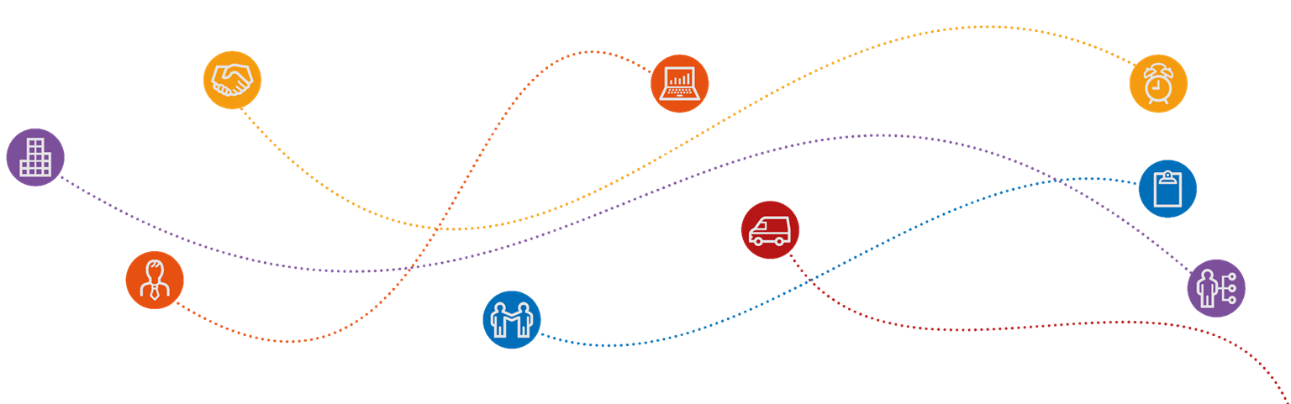

Registration Document

Crown Commercial Service has embedded the Framework Alliance Contract (FAC-1) within this framework in order to support collaborative working throughout the organisation. By signing the registration document you are effectively joining an alliance of like-minded organisations including suppliers (Supplier Alliance Members) who strive for continuous improvement. If you have any further questions please do not hesitate to ask.

Note: If your organisation has previously registered to use this framework agreement, you will only need to complete the Annex A: Additional Client User Agreement in order to access your unique project specific reference number.

ANNEX A: Registration Document

REGISTRATION DOCUMENT

Framework: RM6014 Modular Building Solutions

N.B. See clause 1.11 of FAC-1 Contract Terms

Parties:
Crown Commercial Service (the Client and Alliance Manager)
9th Floor,
The Capital,
Old Hall Street,
Liverpool
L3 9PP

And
[Insert name of your organisation] (Additional Client)
- I/We can confirm that [Insert name of your organisation)
wishes to gain access to use the Modular Buildings Framework Alliance Contract.
- I/We understand that the submission of this Registration Document is the means by which each Additional Client agrees to be bound by the Framework Alliance Contract.

Organisation Name | Crown Commercial Service | [Additional Client Name]
Organisation Address | 9th Floor,  The Capital,  Old Hall Street,  Liverpool  L3 9PP
Signed
Full Name | John Welch
Position | Alliance Manager
Date

