Government Hubs Fit Out Framework

Agreement Number RM6073
Framework Rates Guidance

Introduction

This is a step by step guide on how to access the Maximum Framework Rates on Crown Commercial Service’s eSourcing portal.

Please note the Maximum Framework Rates only apply to further competitions above £5million (ex VAT).

Step 1:
The eSourcing portal can be accessed here: https://gpsesourcing.cabinetoffice.gov.uk/sso/jsp/login.jsp

Please note if there is any problems accessing eSourcing portal, the Customer support telephone number is 0345 410 2222.

Step 2:
Log in to the portal, click on RFx and then click on Manage RFX

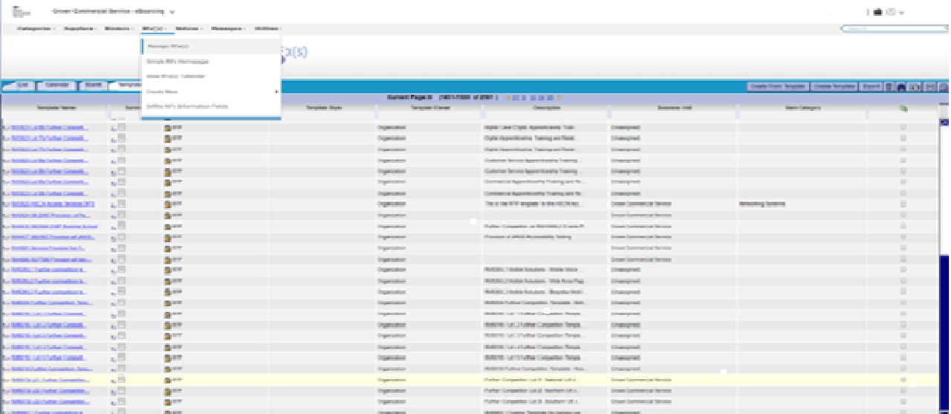

Step 3:

Click on ‘Templates’ tab on the left hand side, then click on the binocular symbol on the right hand side of the screen
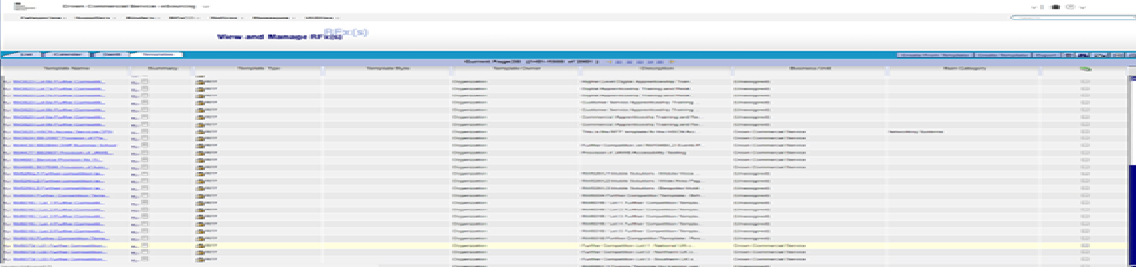

Step 4:

The search window (below) will now open up. Type *RM6073* into the Unique ID bar and click Search Now

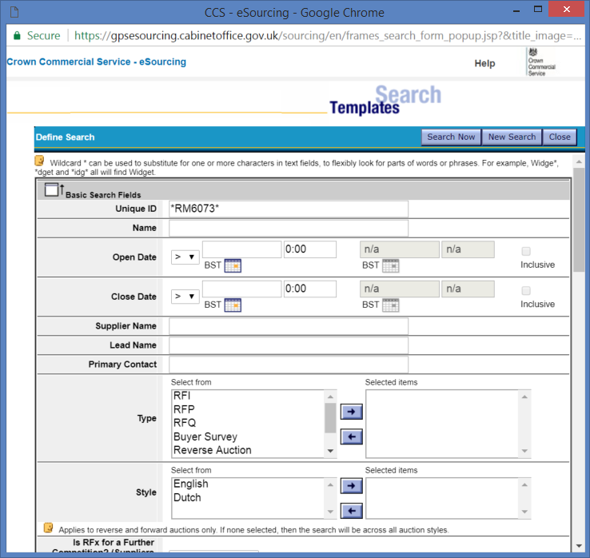

Step 5:

Click on the applicable Lot number that you’re interested in

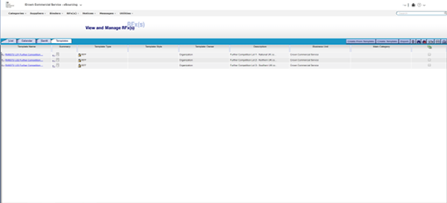

Step 6:

Click on Attachments on the left hand side of the screen. This will now bring up all the Rate Cards related to that Lot number.

