CROWN COMMERCIAL SERVICE
AND
SUPPLIER
WORKPLACE SERVICES CONTRACT
(FM MARKETPLACE PHASE 2)
REF: RM6089
Lot 1A, 1b and lot 2c

FRAMEWORK SCHEDULE 7

CALL-OFF ORDER PROCEDURE AND AWARD CRITERIA Part A (Lot 1a, 1b and 2c)
Part 1: ORDER PROCEDURE

- AWARD PROCEDURE overview
  - If a Buyer decides to source Deliverables through this Framework Contract then it will award its Call-Off Contract in accordance with the procedure in this Schedule and the requirements of the Regulations.
  - Buyers who wish to access the Framework Contract will do so using an online platform (once available) or an alternative off line process provided by CCS, both the online and offline process will follow the same principles.
  - CCS will issue a Buyer reference number to each potential Buyer and the Supplier shall:
    - include the Buyer reference number in each Call-Off Contract prior to activity commencing; and
    - Include the Buyer reference number as part of its Management Information submitted to CCS in accordance with Framework Schedule 5 (Management Charges and Information).
  - In order to commence the potential award of a Call-Off Contract potential Buyers will prepare a supplier brief to define their requirements ("Supplier Brief") which will include:
    - Deliverables required
    - Geographical Boundary(s) for provision of the Deliverables;
    - Buyer information;
      - organisation type;
      - building type; and
      - special requirements;
    - Terms and conditions
    - Contract period
    - Estimated award date
    - Mobilisation Period
    - Price/Quality split
    - Inclusive Repair Threshold level
    - TUPE option
    - KPI’s
  - Mandatory Deliverable Process
    - If the requirement solely concerns Mandatory Deliverables – the Buyer passes straight to Geographical Boundary capability stage to determine which Suppliers are able to provide the Mandatory Deliverables in the required geographical Location (as per the Diagram at 1.6.3)
    - Buyer Inputs will identify whether each Supplier can provide the required Deliverables in the Buyers geographical location
    - If a Supplier can provide the required Deliverables in the Buyers geographical location, they will proceed to the next stage in the process as per the diagram at 1.6.3.
    - The system will then create a shortlist of Suppliers who can meet the Buyer’s needs in the required geographical Location.
    - If a Supplier cannot provide the required Deliverables in the Buyers geographical location, they are automatically deselected at this stage and will not proceed any further
  - Non Mandatory Deliverable Process
    - If the requirement includes any Non Mandatory Deliverable(s) – all Suppliers are assessed to see if they can or cannot provide the Non Mandatory Deliverable specified:
      - If a Supplier CAN provide all of the Non Mandatory Deliverables they will be proceed to the Geographical Boundary capability stage (as per the diagram at 1.6.3)
      - If a Supplier CANNOT provide all of the Non Mandatory Deliverables they are automatically deselected at this stage, and will not proceed any further
    - Buyer Inputs will identify whether each Supplier can provide the required Deliverables in the Buyers geographical location
      - If a Supplier can provide the required Deliverables in the Buyers geographical location, they will proceed to the next stage. (as per the diagram at 1.6.3) The system will then create a shortlist of Suppliers who can meet the Buyer’s needs in the required geographical Location.
      - If a Supplier cannot provide the required Deliverables in the Buyers geographical location, they are automatically deselected at this stage and will not proceed any further
    - The diagram below illustrates the process

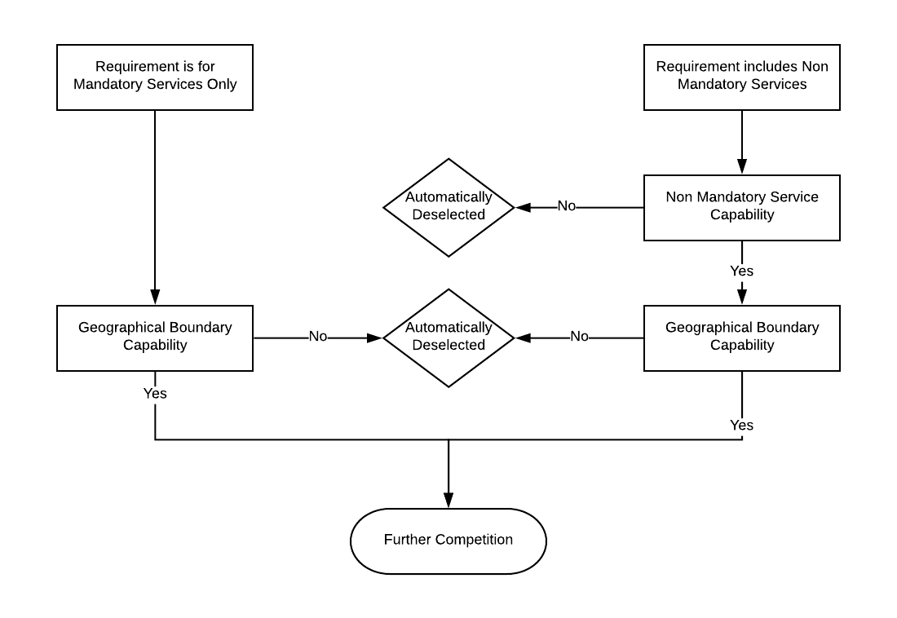
FURTHER COMPETITION PROCEDURE
Buyer’s Obligations
The following applies to the Buyer awarding a Further Competition under lot 1 and 2b of this Framework Contract:
    - The system will have identified the shortlist of Suppliers who are able to supply Deliverables to the location specified by the Buyer.
    - Suppliers must be able to deliver all the mandatory and any of the non-mandatory Services indicated in their selected Geographical Boundary(s).
    - Shortlisted Suppliers will receive the Supplier Brief that has been made up of Buyer Inputs (as per paragraph 1.4)
    - The Supplier will review the Supplier Brief to assess whether they wish to accept or decline the proposed opportunity to tender:
      - Accept – If the Supplier accepts the proposed opportunity to tender they will be invited to take part in the further competition procedure
      - Decline – If the Supplier declines the proposed opportunity to tender they will be removed from the process and not proceed any further for that particular Supplier Briefing. Suppliers who decline an opportunity to tender must provide a reason for this decision.
      - Suppliers have the following timescales to respond to a Supplier Brief. After this period they will be deemed to have decline the opportunity will be removed from the process and not proceed any further
        - Lot 1a Suppliers – [5 working days].
        - Lot 1b Suppliers – [5 working days].
        - Lot 2c Suppliers - [5 working days].
    - If none of the Suppliers shortlisted accept the opportunity to proceed as part of a Further Competition Procedure, the Buyer has the option to review the reasons why Suppliers are not interested in bidding, review their requirements and re-issue the Supplier Briefing.

    - Prior to the commencement of the Tender the Buyer may hold a Supplier event to present the opportunity before the Tender period.
    - In addition, recognising the size and scale of procurements to be procured under the FM marketplace, Buyers with larger requirements will have options to hold briefings and site visits with suppliers on a multiple/individual basis. Buyers may also wish to incorporate supplier presentations into the Further Competition Award Criteria. All interactions through this framework shall comply with openness, transparency principles of the Regulations.
    - For requirements under Lot 2a, 2b and 3 only, Buyers may also choose to hold one to one clarification meetings, and incorporate scored assessment processes such as interviews, facilitated workshops and scenario testing.

    - This process is outlined in the diagram below:

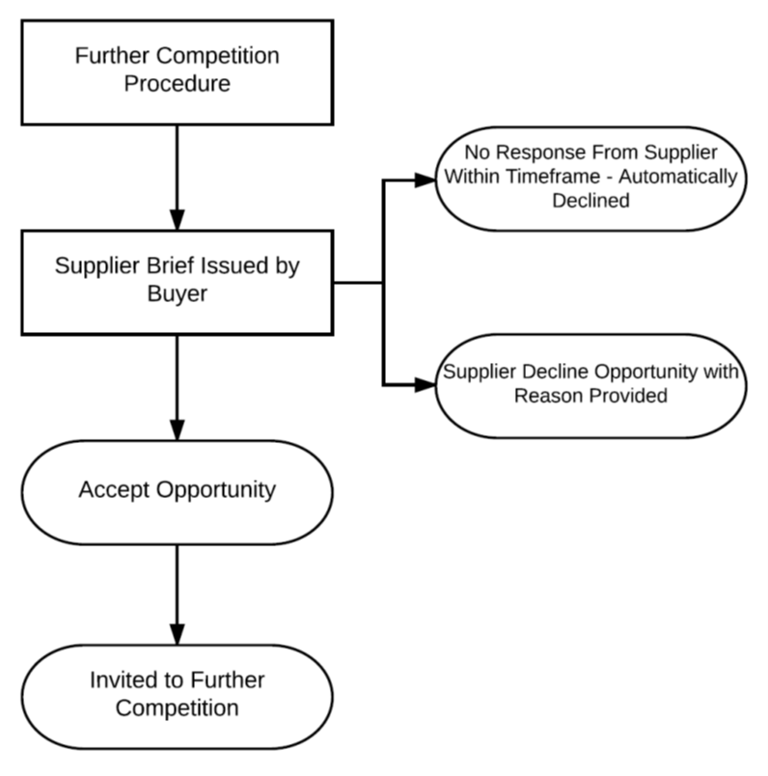

The Buyer awarding a Call-Off Contract under this Framework Contract through a Further Competition Procedure shall then:
    - Expand on the Supplier Brief and produce a full suite of Invitation to Tender documents
    - Complete the Order Form to reflect the Deliverables
    - invite tenders by conducting a Further Competition Procedure for its Deliverables in accordance with the Regulations and in particular:
      - if an Electronic Reverse Auction is to be held, the Buyer shall notify the Suppliers identified in accordance with paragraph 2.2.1 and shall conduct the Further Competition Procedure in accordance with the procedures set out in paragraph 3.2; or
      - if an Electronic Reverse Auction is not used, the Buyer shall:
        - invite the Suppliers identified in accordance with paragraph 2.2.1 to submit a tender in writing for each proposed Call-Off Contract to be awarded by giving written notice by email to the relevant Supplier Representative of each Supplier;
        - set a time limit for the receipt of the tenders which takes into account factors such as the complexity of the Deliverables and the time needed to submit tenders; and
        - keep each tender confidential until the time limit set out for the return of tenders has expired.
    - apply the Further Competition Award Criteria to the Suppliers' compliant tenders submitted through the Further Competition Procedure to determine which Supplier is to be awarded a Call-Off Contract for its Deliverables;
    - on the basis set out above, award its Call-Off Contract to the successful Supplier in accordance with paragraph6. The Call-Off Contract shall:
      - state the Deliverables;
      - include the tender submitted by the successful Supplier;
      - state the charges payable for the Deliverables in accordance with the tender submitted by the successful Supplier; and
      - incorporate the terms [of the Order Form and Contract (as may be amended or refined by the Buyer in accordance with paragraph 2.2.2 above) applicable to the Deliverables,
    - provide unsuccessful Suppliers with written feedback in relation to the reasons why their tenders were unsuccessful.
The Supplier's Obligations
The Supplier shall in writing, by the time and date specified by the Buyer following an invitation to tender pursuant to paragraph 2.2.3 above, provide CCS and the Buyer with either:
    - a statement to the effect that it does not wish to tender in relation to the Deliverables with reasons for this decision; Failure to bid on further competitions without an acceptable reason may result in the Supplier being suspended from the Framework (as per paragraph 2.8 of Framework Schedule 4) or
    - the full details of its tender made in respect of the Deliverables. including, as a minimum:
      - an email response subject line to comprise unique reference number and Supplier name, so as to clearly identify the Supplier;
      - a brief summary, in the email (followed by a confirmation letter), stating that the Supplier is bidding for the Statement of Requirements;
      - a proposal covering the Deliverables;
      - confirmation of discounts applicable to the Deliverables, as referenced in Framework Schedule 3 (Framework Prices) (if applicable).
    - The Supplier shall ensure that any prices submitted in relation to a Further Competition Procedure held pursuant to this paragraph 2 shall be based on the prices and mechanism and take into account any discount to which the Buyer may be entitled as set out in Framework Schedule 3 (Framework Prices).
    - The Supplier agrees that:
      - all tenders submitted by the Supplier in relation to a Further Competition Procedure held pursuant to this paragraph 2 shall remain open for acceptance by the Buyer for ninety (90) Working Days (or such other period specified in the invitation to tender issued by the Buyer in accordance with the Call-Off Procedure); and
      - all tenders submitted by the Supplier are made and will be made in good faith and that the Supplier has not fixed or adjusted and will not fix or adjust the price of the tender by or in accordance with any agreement or arrangement with any other person. The Supplier certifies that it has not and undertakes that it will not:
        - communicate to any person other than the person inviting the tenders the amount or approximate amount of the tender, except where the disclosure, in confidence, of the approximate amount of the tender was necessary to obtain quotations required for the preparation of the tender; and
        - enter into any arrangement or agreement with any other person that he or the other person(s) shall refrain from submitting a tender or as to the amount of any tenders to be submitted.
E-AUCTIONS
Where indicated in the Order Form, the Buyer shall be entitled to include a reverse auction in the Further Competition Procedure in accordance with the rules laid down by the Buyer and the Regulations.
Where Buyer wishes to undertake an Electronic Reverse Auction where Suppliers compete in real time by bidding as the auction unfolds ("Electronic Reverse Auction") then before undertaking it, the Buyer will make an initial full evaluation of all tenders received in response to its Statement of Requirements. The Buyer will then invite to the Electronic Reverse Auction only those tenders that are admissible in accordance with the Regulations. The invitation shall be accompanied by the outcome of the full initial evaluation of the relevant tenders.
The Buyer will inform the Suppliers of the specification for the Electronic Reverse Auction which shall include:
    - the information to be provided at auction, which must be expressed in figures or percentages of the specified quantifiable features;
    - the mathematical formula to be used to determine automatic ranking of bids on the basis of new prices and/or new values submitted;
    - any limits on the values which may be submitted;
    - a description of any information which will be made available to Suppliers in the course of the Electronic Reverse Auction, and when it will be made available to them;
    - the conditions under which Suppliers will be able to bid and, in particular, the minimum differences which will, where appropriate, be required when bidding;
    - relevant information concerning the electronic equipment used and the arrangements and technical specification for connection;
    - subject to paragraph 3.4, the date and time of the start of the Electronic Reverse Auction; and
    - details of when and how the Electronic Reverse Auction will close.
The Electronic Reverse Auction may not start sooner than two (2) Working Days after the date on which the specification for the Electronic Reverse Auction has been issued.
Throughout each phase of the Electronic Reverse Auction the Buyer will communicate to all Suppliers sufficient information to enable them to ascertain their relative ranking.
The Supplier acknowledges and agrees that:
    - the Buyer and its officers, servants, agents, group companies, assignees and Buyers (including CCS) do not guarantee that its access to the Electronic Reverse Auction will be uninterrupted or error-free;
    - its access to the Electronic Reverse Auction may occasionally be restricted to allow for repairs or maintenance; and
    - it will comply with all such rules that may be imposed by the Buyer in relation to the operation of the Electronic Reverse Auction.
The Buyer will close the Electronic Reverse Auction on the basis of:
    - a date and time fixed in advance;
    - when no new prices or values meeting the minimum differences required pursuant to paragraph 3.3.5 have been received within the prescribed elapsed time period; or
    - when all the phases have been completed.

NO AWARD
Notwithstanding the fact that the Buyer has followed a procedure as set out above, the Supplier acknowledges and agrees that the Buyer shall be entitled at all times to decline to make an award for its Deliverables and that nothing in this Contract shall oblige the Buyer to award any Call-Off Contract.
The Supplier accepts and acknowledges that they are responsible for any and all costs incurred in their participation in a Further Competition in the instance of no award.
RESPONSIBILITY FOR AWARDS
The Supplier acknowledges that the Buyer is independently responsible for the conduct of its award of Call-Off Contracts under this Contract and that CCS is not responsible or accountable for and shall have no liability whatsoever, except where it is the Buyer, in relation to:
    - the conduct of Buyer in relation to this Contract; or
    - the performance or non-performance of any Call-Off Contracts between the Supplier and Buyer entered into pursuant to this Contract.
CALL-OFF award PROCEDURE
Subject to paragraphs 1 to 6 above, a Buyer may award a Call-Off Contract with the Supplier by sending (including electronically) a signed Order Form substantially in the form (as may be amended or refined by the Buyer in accordance with paragraph 2.2.2 above) of the Order Form Template set out in Framework Schedule 6 (Order Form Template and Call-Off Schedules).
The Parties agree that any document or communication (including any document or communication in the apparent form of a Call-Off Contract) which is not as described in this paragraph 7 shall not constitute a Call-Off Contract under this Contract.
On receipt of an Order Form as described in paragraph 6.1 from a Buyer the Supplier shall accept the Call-Off Contract by promptly signing and returning (including by electronic means) a copy of the order form to the Buyer concerned within [5 working days].
On receipt of the signed order form from the Supplier, the Buyer shall send (including by electronic means) a written notice of receipt to the Supplier within two (2) Working Days and a Call-Off Contract shall be formed with effect from the Call Off Start Date stated in the Order Form.
Part 2: AWARD CRITERIA
- General
This Part 2 is designed to assist Buyers seeking to award a Call-Off Contract on the basis of reopening competition under a Further Competition Procedure in accordance with the Call-Off Procedure.
A Call-Off Contract awarded under the Further Competition Procedure shall be awarded on the basis of most economically advantageous tender ("MEAT") from the point of view of the Buyer.
This Schedule includes details of the evaluation criteria and any weightings that will be applied to that criteria. Criteria applicable to Further Competition are set out at Annex A to this Schedule
ANNEX A: Further Competition Award Criteria
The following criteria shall be applied to the Deliverables set out in the Suppliers' compliant tenders submitted through the Further Competition Procedure:

Criteria Number | Criteria | Percentage Weightings (or rank order of importance where applicable) - to be set by the Buyer conducting the further competition
1 | Quality  Which may consists of the following criteria:  - Added Value / Innovation  - Social Value  - Approach To Delivery Of The Services  - Mobilisation  - Use Of Supply Chain / Partners | 50% (+/- 50% at Buyer discretion)
2 | Price | 50% (+/- 50% at Buyer discretion)

