Direct Award
Technology Services 3
RM6100

When to use the direct award route

Direct award offers a quick and flexible way to buy services from the TS3 framework. Direct award offers OJEU compliant purchasing without the need to run a further competition.

Direct award will be suitable to meet a range of customer needs – for example, simple and easily defined requirements where no additional benefit would be derived from a further competition.

Direct award should only be used when you have a clear understanding of the services you require.

There will be no restriction on the order value, but customers will need to consider issues such as value for money, timescales, complexity and the number of suppliers who could meet their needs.

Using the direct award route provides you with access to the Suppliers’ Service Offers within a structured catalogue format.

Top Tips
- Developing a clear Statement of Requirements (refer to the Creating your Statement of Requirements guidance) will enable you to identify suitable Service Offers within the Catalogue to conduct a meaningful comparison by conducting a desktop evaluation between Service Offers.
- Suppliers appointed to more than one lot are able to publish multiple lot Service Offers which include services from one or more lots.

Call-Off Contract Duration

You will have the flexibility to decide the Initial term of your Call-Off Contract and any optional extension term(s) up to the maximum Call-Off Contract Period as detailed in Section 4 (Agreement duration & value) of the RM6100 Customer Guidance v5.

You must include the initial term and any optional extension term(s) in your completed Order Form.

The Call Off Contract term must include implementation, delivery, business as usual and exit management of the services.

Top Tips

- If an extension term is not included on your Order Form, you cannot continue with the Call-Off Contract beyond the initial term.

- Whilst opting for the maximum term might deliver more competitive pricing initially, it is important to balance that against the ability to re-tender, bearing in mind any potential early-termination fees. Opting for a realistic timeframe for the initial term and including optional extensions with pricing adjustments in your tender, can help to deliver the flexibility and benefits your organisation requires.

Key Stages

The Direct Award process is broken down into 6 simple steps as explained below:
Step 1 - Identify your needs

When establishing your requirements you may wish to consider the following:
- Your organisational strategy and refresh cycle;
- Market trends and innovation;
- Total cost of ownership, recognising running costs;
- Compatibility with other in-house systems;
- What your budget parameters are;
- Your contractual landscape including exit of current services and considerations for implementation; and
- Evaluate your current estate and consider possible future scale of requirement.
Top Tip
- We recommend that you review the Statement of Requirements guidance to ensure you have captured all the details before reviewing the catalogue service offers.
Step 2 – Review the Service Offers

You can find the current live Service Offers by browsing the catalogue in the Government eMarketplace which is where Suppliers will publish their available Service Offers.

In order to access the Government eMarketplace you and your organisation will need to register as a Customer. The guidance on how to access the Government eMarketplace includes information on how to contact us should you have any issues in doing so.

Step 3 - Shop on the eMarketplace
Once logged in to the Government eMarketplace, the homepage will be displayed as follows;
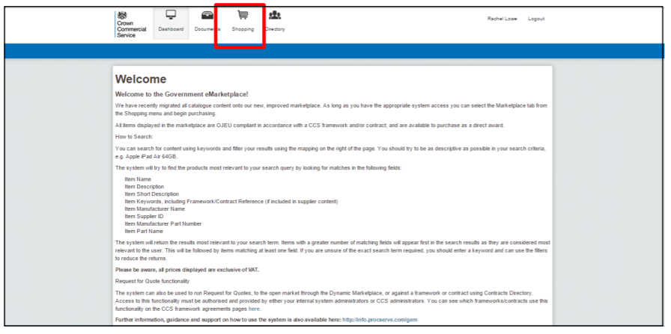
Click on the ‘ shopping ‘ icon at the top of the page

Select the ‘Marketplace’ tab

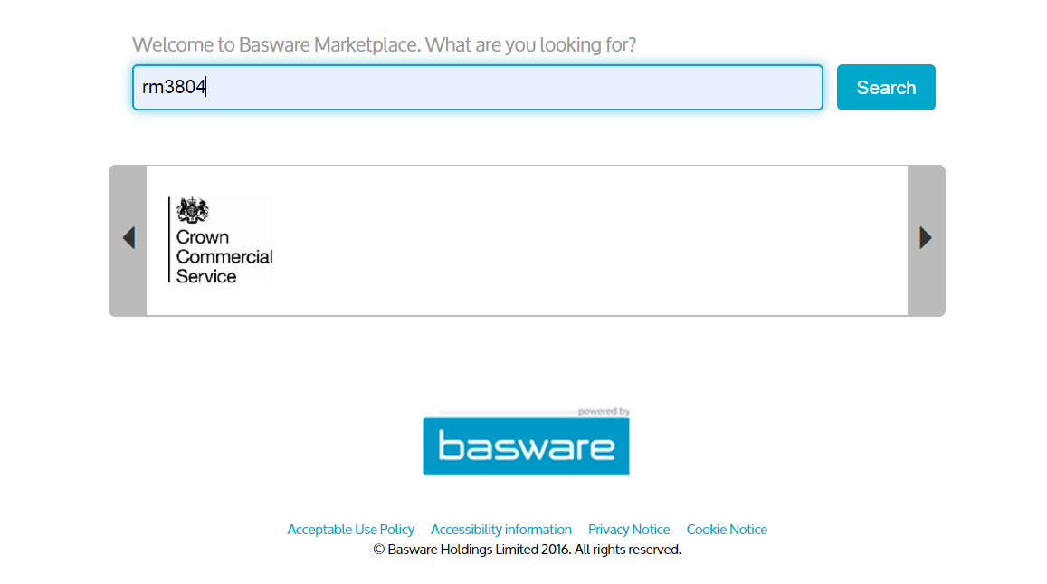

A search bar will appear to allow you to enter your search criteria.

Rather than searching for Service offers using keywords such as Help Desk or LAN, it is strongly recommended that you enter the framework number (RM6100) in the search bar and click the search button.

Once results are displayed, on the right of the screen you will find "Filters", under "Content tag" you can filter on the Lot number that you require to display the currently available Supplier Service Offers within the lot.

Step 4 - View the service offers

Having filtered on a Lot, the list of published current Service Offers available will be displayed. To view an individual Service Offer you need to click on the relevant offer which enables you to review the description. Providing this meets your requirements, you need to click on the additional information links to download all relevant documents to view the full Service Offer including pricing.

It is recommended that you review all available Service Offers on the Government eMarketplace within the appropriate Lot, and evaluate those which meet your requirement.

In the event you are unable to find a suitable Service Offer to meet your requirements, you can issue a Request for Information (RFI) to all the Suppliers on your chosen Lot. Providing all the information to the Suppliers will allow them to either point you in the direction of an existing Service Offer or they can upload a new Service Offer to meet your requirements. We will then complete the evaluation process detailed below.

Step 5 – Evaluate

Once you have downloaded all the Service Offers that are applicable to the Lot and your requirements, you must evaluate them with your Award Criteria to find the most appropriate offering, ensuring that records of your evaluation are kept for transparency. When you have completed your desktop evaluation you will need to follow the guidance in the Call-Off Order form in order to contract this with the Supplier.

The direct award criteria as set out below must be applied when conducting your desktop evaluation of all Suppliers Service Offers.

Full details of the Call-Off Award Procedure and criteria can be found within Framework Schedule 6, Part A (Award Procedure).

Criteria Number | Criteria - ranked in order of importance | Percentage Weightings
1 | Price | 10-90%
2 | Quality (including delivery time, period of completion, sales service, good value(including where applicable the degree to which the Supplier satisfies the Buyer’s Social Value requirements)) | 10-90%

Step 6 - Award

You can place your order with the chosen Supplier by completing the Order Form at Framework Schedule 4, Annex 1 (Template Order Form).

How to complete the Call-Off Order Form

To make a direct award against the TS3 framework you must complete the Order Form and send it to your chosen Supplier.

The Order Form must be completed in accordance with the Supplier’s Service Offer.

Customers must not include additional requirements to those as set out in the Service Offer because the order will then be based on an invalid Service Offer which the Supplier can decline.

The Order Form, when completed, signed and dated by both the Customer and the Supplier, forms the Call-Off Contract.

