Training Estate Services
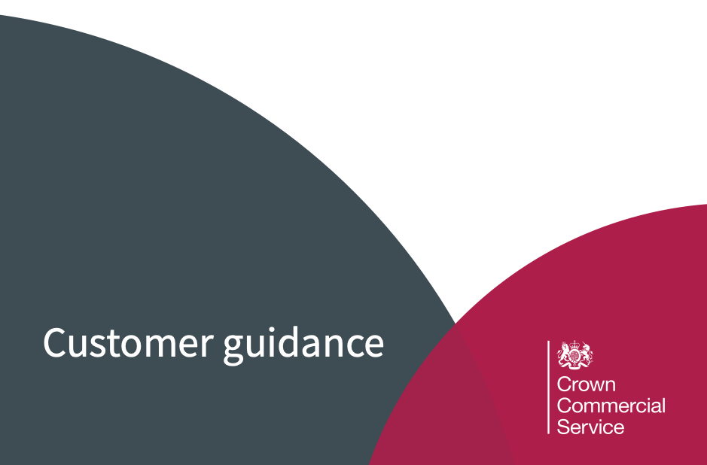
RM6155

Contract Award Notification
PLEASE COMPLETE THE FORM BELOW AND SUBMIT TO CCS VIA EMAIL UPON CONTRACT AWARD

PLEASE NOTE THIS FORM IS MANDATORY FOR ALL SELF-SERVICE BUYERS

Crown Commercial Service
Floor 9, Capital Building
Old Hall Street
Liverpool L3 9PP
Email: info@crowncommercial.gov.uk (Email Subject: RM6155 Contract Award Notification)
Date:

F.A.O CCS RM6155 Commercial Agreement Manager,

We would like to inform you that we have reached Contract Award for a contract let under the Training Estate Services (RM6155) framework via Self-Service delivery.

Buyer’s Organisation Name:
Buyer Contact Name:
Buyer Contact Telephone Number:
Buyer Contact Email Address:
Procurement Route: Further Competition
Supplier Appointed:
Work Packages Selected:
Contract Term:
Optional Extension Periods:
Annual Contract Value:
Total Contract Value:
Any Other Detail:

Yours Sincerely,
Name: _________________________________________________________

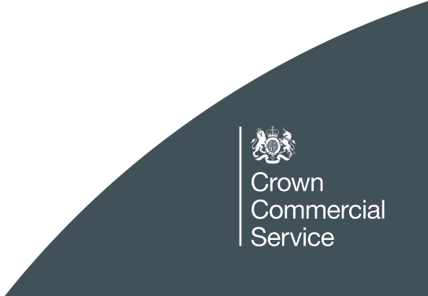

Further information
If you require any further information please contact
info@crowncommercial.gov.uk | 0345 410 222

You can also learn more about Crown Commercial Service at:
Website:  crowncommercial.gov.uk | Twitter:  @gov_procurement | LinkedIn:  Crown Commercial Service

