RM6165 Construction Professional Services (CPS): Customer User Guide

Contents
Terminology: Page 2
Introduction and overview: Page 3
Cabinet Office Spending Controls: Page 4
Framework benefits: Page 5
Framework structure: Page 7
Scope: Page 8
What is the CPS Framework Alliance Contract: Page 9
How to access the Framework Agreement: Page 10
Framework pricing: Page 13
Terms and conditions (the call off contracts): Page 15
Call off process: Page 19
Alliancing: Page 29
Supplier performance: Page 31
Additional support and guidance: Page 32
Further information: Page 33

Terminology
This document is drafted as guidance to Additional Clients awarding contracts under the Construction Professional Services framework, although it will be useful for Supplier Alliance Members to also make themselves aware of this guidance.
For simplicity and clarity, the following conventions have been applied in this document:
“Client” means Additional Client and “Supplier” means Supplier Alliance Member going forward in this document.

Introduction and overview
Crown Commercial Services (CCS) is an executive agency of the Cabinet Office which supports the public sector to achieve maximum commercial value when procuring.
Framework RM6165, along with our Dynamic Purchasing System RM6242, is part of our suite of Construction Professional Services commercial offerings.
This framework provides a broad range of construction related professional services across 6 thematic lots and is designed to support ‘better, faster and greener solutions’ that support recovery from the COVID-19 pandemic and build the economy of the future, while improving building and workplace safety and contributing to social value.
The framework is suitable for all public sector, devolved administrations and third party entities. For more information on who can access this framework, please refer to the Authorised Customer List available on Contracts Finder.
The framework agreement commenced 3 November 2021 and will expire 2 November 2025.

Cabinet Office Spending Controls
Contracting Authorities from the Central Government (including Arm’s Length Bodies) are required to adhere to the Cabinet Office Spending Controls when buying common goods and services. Please refer to the cabinet office controls guidance to find out whether your Construction Professional Services procurement requires pre-approval through the controls process for consultancy.

Framework benefits
- the framework provides a streamlined, guided route to access a comprehensive pre-approved selection of suppliers either through direct award or a competitive process, up to any nominal contract value.
- the framework is free of charge for all public sector buyers to use
- the flexible structure is designed to meet all procurement routes, tendering methods, design methodologies and payment arrangements.
- all of the most commonly used industry standard forms of contract are available for clients to use at call off stage including New Engineering Contract (NEC), Joint Contracts Tribunal (JCT) and Project Partnering Contract (PC2000).
- the framework agreement provides 18 standardised ‘boilerplate’ call off amendments, the boilerplates are developed to ensure consistent implementation of government policy and to reduce the need for unnecessary drafting, creating a more efficient standardised approach
- the framework takes account of key government policy, guidance and standards and aims to encourage collaboration and better strategic relationships between the public and private sectors to drive improvement and innovation within the construction industry
- the framework, through the Framework Alliancing contract (FAC-1) includes optional, advanced, innovative contract arrangements allowing customers to procure programmes of work as self-managed sub-alliances to increase consistency, efficiency and improved value
- Supplier Alliance Members and their strategic suppliers have completed financial and technical compliance reviews
- the Framework Contract includes agreed “success measures'', against which suppliers’ performance will be measured at framework level, however customers can also adopt project level KPI’s which can be amended or supplemented to suit customers’ requirements
- we help you to deliver against government policies such as working with small medium enterprises driving standardisation, fair payment, apprenticeships, modern slavery, social value, modern methods of construction, building information modelling (BIM), digital, and compliance with environmental, security and health and safety standards.
- the framework facilitates a life cycle and whole life cost approach, with a high focus on quality, and clients have the flexibility to alter the quality/cost weightings at competition stage
- the framework is one component of the CCS integrated construction framework offering
- CCS offer the biggest construction frameworks in the country, driving industry change in support of the government’s construction strategy.
- we have a team packed full of industry experience from multiple sectors and all tiers of the supply chain to support customers and suppliers
- through the Knowledge Hub we connect digitally with colleagues and experts, share knowledge, insight and best practice, learn from experiences and inspire innovation and new ways of working.

Framework structure
The framework provides a broad range of construction related professional services across thematic and sector-led lots. Lots are structured with the flexibility to enable Additional Clients to select the most suitable lot that meets their specific project or programme needs.
The framework lots are as follows;
- lot 1 built environment and general infrastructure
- lot 2 urban regeneration
- lot 3 international
- lot 4 high rise
- lot 5 defence
- lot 6 environmental and sustainability technical services
For further details of suppliers per lot, please refer to the Services and Suppliers section of our Construction Professional Services webpage.
If there are any doubts on the appropriate Lot to use, please contact the CCS construction professional services category team at cps@crowncommercial.gov.uk who can assist you.
Customers should be advised that call-offs should not be competed across Lots.

Scope
The framework offers a wide range of construction professional services to support projects and programmes from inception to completion. Typical services under the framework will include:
- architectural design and advisory services
- civil, electrical, mechanical and structural engineering
- building surveys and building services engineering
- project and programme management
- cost consultancy
- urban and town planning
- project planning and master scheduling
- environmental technical services
- architectural feasibility studies
This list is not exhaustive and additional clients will be clear in their project contracts what set of Services and disciplines they require.
The framework structure is designed to be flexible to support a broad range of construction project types, procurement routes, tendering methods and design methodologies. The call off project scope is expected to be developed and defined at call-off stage by users of the framework. For more detailed information relating to the scope of the framework you may wish to take a look at the framework specification Construction Professional Services webpage or take a look at the published tender documents on Find a Tender Service..

What is the Construction Professional Services Framework Alliance Contract (FAC-1)?
The basis of the Construction Professional Services Framework Alliance Contract is the FAC-1 standard form of Framework Alliance Contract, published by the Association of Consulting Architects.
The FAC-1 Construction Professional Services Framework Alliance Contract is an innovative approach that combines the scope of a framework with the collaborative relationships of an alliance to create new systems for achieving greater value.
FAC-1 prototypes and early users have achieved significant cost savings and other Improved value such as:
- innovations and improved design contributions
- extended warranties and more sustainable solutions
- local and regional business opportunities
- training and employment opportunities
- reduced carbon footprint and other environmental benefits
- improved safety and reduced accidents
- effective risk management and dispute avoidance.
The Framework Alliance Contract allows for framework-level Alliancing as well as Sub Alliancing at call-off level.
For more information on Alliancing and Sub Alliancing and how this can be built into your project, please refer to the Alliancing section in this document.

How to access the framework agreement

Step 1: initial framework registration
- to use our framework you must become a Framework Alliance Member (Additional Client) for the Lot(s) that you would like to use by completing a Registration Document, a copy of the Registration Document can be downloaded from our Construction Professional Services webpage
- if there are any doubts on the appropriate Lot to use or if further guidance is needed, please contact the CCS Construction Professional Services Category team by email at cps@crowncommercial.gov.uk
- there is no joining fee and no commitment or obligation to procure from the Framework Alliance Contract once registered
- once registration is successful CCs will issue you with an additional client notice, this will usually take around 24 hours.
- once you have registered you will also be invited to join the Construction Professional Service (CPS) KnowledgeHub
- the KnowledgeHub contains a wealth of support and guidance documents as well as providing a collaborative forum with other Framework Alliance Members.
- for more information you can view our guidance on how to join the Construction Professional Services KnowledgeHub available on our Construction Professional Services webpage.

Step 2. completing an additional client user agreement (ACUA)
- after registration and prior to running a call off procurement you will need to complete an additional client user agreement form.
- a copy of the additional client user agreement form can be downloaded from our Construction Professional Services webpage.
- the ACUA form is filled in prior to customer supply market engagement, commencing your tender or placing order/s through this agreement providing an outline of customer requirements which are intended to be procured through RM6165.
- once CCS have processed your ACUA form we will provide you with a unique reference number for each individual procurement project.
- please ensure that all procurement documentation contains this unique reference number.
- with your permission, CCS will also share details of the project with other alliance members, both customers and suppliers, to encourage collaboration, shared learning and to provide the framework suppliers with as much notice as possible about your project. More details can be found on the ACUA form.
- for more information about the framework agreement, including the specification and the Construction Professional Services Framework Alliance Contract please contact the CCS at info@crowncommercial.gov.uk

Step 3. run procurement and complete award notification form
- once a call off procurement contract is signed/executed we request the Clients complete an award notification form.
- the award notification form can be downloaded from our Construction Professional Services webpage and returned by email to info@crowncommercial.gov.uk
A summary of the process flow of how to access the framework is outlined the process flow chart below.
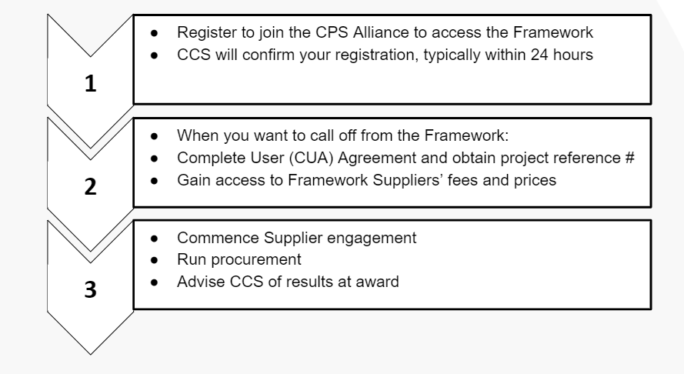
RM6165 Registration and ACUA Process

Framework pricing
Once you have registered to join the alliance, access will be given to the framework rates.
At framework level, time charge daily and hourly rates are available for all lots and framework level project percentage fees are available on lot 3 only.
The prices, fees and rates set out in the framework are the maximum that the supplier may charge pursuant to any project call off contract. Under the Framework the supplier agrees that any prices submitted in relation to call off shall be equal to or lower than the framework prices.
The additional client has discretion to determine the most appropriate method of incorporating the prices and rates into their call off contract.
Time charge rates (all lots)
- rate cards available for all lots and cover a range of defined core disciplines at different professional grade levels
- rates are inclusive of overhead and profit
- rates exclude travel and subsistence cost which is to be agreed at call off
- rates exclude VAT
- At framework level, the framework prices will remain fixed for the first two contract years after which Indexation adjustment shall be determined in line with the agreed price index.
Project percentage fees (lot 3 Only)
- as well as time charge rates framework level project percentage fees are available in lot 3
- the percentage fee for each stage reflects all the services to be completed in accordance with the scope of services for that RIBA plan of work (2020) stage.
- maximum fee percentage for the service to be applied to the Project Cost Band
- fee’s are supplied for each of the different procurement types
- fees are inclusive of all UK travel expenses and subsistence
- fees are inclusive of overhead and profit
- fees exclude VAT
- percentage Fees on lot 3 remain fixed for the duration of the framework
Note: each customer has flexibility to choose a suitable price index to utilise for the purpose of the indexation within their call off agreement. For example using the CPIH, RPI, construction OPI or AWE indices opposed to the CPI index in circumstances where alternative indices provide a more accurate indication of price inflation relating to the additional Client requirements or project nature.

Terms and conditions (call off contracts)
The following standard forms of contract are available for Additional clients to use at call off level under the Construction Professional Services Framework:
- NEC3 and NEC 4 Professional Service Contract (short and long form) Options A, C, E and G (Option G for NEC3 only)
- JCT Consultancy Agreement (Public Sector) 2016
- PPC 2000 (amended 2013) Standard Form of Contract for Project Partnering
Further information regarding Project Contracts can be found in Schedule 5 of the CCS Construction Professional Services Framework Alliance Contract.
Clients are encouraged to use the IPA / CCS Standard Boilerplate Amendments, which can be used to amend the standard forms of contract. They provide a consistent application of non-contentious government-specific clause modifications. Specific amendment sets are produced for NEC3 and 4, JCT and PPC2000.The adoption of these clauses is optional, but strongly recommended.
Insurance level for the Project Contract must be set in line with the potential losses that could occur (not the value of the Project Contract or the level of cover held by potential Supplier Alliance Member). The Client must consider the potential severity/frequency of losses which the Supplier Alliance Member could become liable to pay as a result of claims for any negligent act, error or omission. You must consider the extent to which the Supplier Alliance Member may attend project locations or sites and any physical activity undertaken. If you are in doubt as to the level to apply or how this should be set out seek advice.

Things to consider during the call off process
- when establishing requirements additional clients should engage early with internal colleagues including procurement, finance and legal to draw upon their knowledge, experience and to gain their buy-in
- before procuring external support, a business case is usually required to demonstrate the need
- the business case should be a well-structured document that supports the specific business need, a compelling business case should adequately capture the quantifiable and non-quantifiable characteristics of the proposed project
- you may wish to seek your own legal advice when selecting the most appropriate lot, deciding on the award procedure, drafting the tender documentation, call-off contract, pricing schedule and award questions
- CCS is not allowed to provide any legal advice
- early engagement with suppliers before you issue your tender documents may assist in the development of a more focused specification
- a key principle of public sector procurement is that all suppliers are treated in a fair and equitable manner
Here are some hints and tips:
  - make all suppliers in the lot you will be using aware of the opportunity at the earliest convenience and include proposed timescales, if known
  - if sharing sensitive information with suppliers regarding your requirement you may wish to have the suppliers sign a non-disclosure agreement (NDA)
  - if you require market intelligence or have a specific question for which you require supplier input you may wish to issue a request for information (RFI)
  - this should be sent to all the suppliers on your selected lot. Use of an e-Sourcing portal will provide an audit trail, you can use the CCS e-Sourcing tool or your own portal if you have one
  - share your draft documents (including your specification) with all suppliers in the lot to receive feedback
  - whilst the feedback may be used to help shape your requirement, you need to ensure that you retain control of your requirements and that they are not dictated by suppliers or provide an unfair advantage

A specification is a statement of the requirements to be met by the supplier. It sits at the heart of the contract between the customer and the supplier. A clearly written specification is an invaluable tool which will help you get the right result for your organisation. If you are running a further competition, any quality questions within the tender documents should be linked directly to your specification to ensure the questions you ask, and the suppliers responses, are relevant to the requirement. Establish high level requirements, for example, what do you want to achieve from the suppliers and how will you know that the requirement has been satisfied.

Purposes of a Specification:
  - describes the characteristics of the services required and which the supplier is expected to provide
  - create a contractual tool which forms an integral part of the call-off contract
  - form part of a legally binding agreement which will be binding on both parties
  - inform suppliers about the services required and enables them to propose a solution
  - facilitate effective contract management
  - act as a reference to be referred to in the case of any disputes between you and the supplier(s)

Framework call off process
Before you commence a call off process you may wish to consider whether cost efficiencies can be made by packaging multiple projects with similar characteristics into a single contract, or by managing multiple contracts as a discrete programme of work. This may be based on a similar scope of work; technology or location.
Consideration should also be given to the procurement strategy, including
- procurement Route, for example "Traditional" Lump Sum; Design and Build; Fee Based routes
- tendering Method for example competitive award or direct award
- pricing Mechanism: for example lump sum or target cost
- most appropriate industry standard forms of contract, relative to the potential procurement strategy identified.
The selection of your procurement strategy should always take account of advice from appropriate specialists in your project design and delivery team.
You can opt to use the Crown Commercial Services eSourcing tool or you can use your own procurement portal. If you opt to use your own version of the procurement portal you should ensure that all Supplier Alliance Members invited to bid are made aware of your chosen procurement method and the systems used. We highly recommend that you contact suppliers in advance to make them aware of the opportunity and your chosen procurement portal to allow Suppliers adequate time to register on your chosen procurement portal.
All suppliers in the lot must be given the opportunity to submit a tender or to decline. If they decline, they must give a valid reason.

Call off procurement timeline
Call off duration is not defined as it will depend on the size, scale and complexity of your project or programme. For guidance purposes only a typical timescale from procurement through to contract award for a standard requirement is outlined in the table below.
Standard Requirement
Task | Required/Optional | Task Owner | Working Days | Weeks
Tender Issued | Required | Additional Client | Day 1 | Week 1
Clarification Questions Submission Deadline | Required | Supplier Alliance Member | Day 5 | Week 1
Clarification Questions Response Deadline | Required | Additional Client | Day 8 | Week 2
Tender Submission Deadline | Required | Supplier Alliance Member | Day 15 | Week 3
Tender Evaluation | Required | Additional Client | Days 15 - 18 | Week 3
Contract Award | Required | Additional Client | Day 19 | Week 3-4
Notify CCS of Award (and FTS Notification required) | Required | Additional Client | Day 20 | Week 4

Table 1 – Standard Procurement Timeline
- this timescale of 4 weeks is based on a well-prepared invitation to tender pack (after any market engagement or Capability Assessment stages), if you are unsure of some aspects of pricing, contract particulars or are required to seek additional approvals at any stage then this may extend the procurement period
- similarly, if your scope of work or invitation to tender pack lacks clarity then you will receive more questions and clarifications from suppliers which may extend your timescales
- you should leave a minimum of 2 weeks between the response to the final clarification question and the tender return date, for Suppliers to make an appropriate proposal

Competitive award
Before you commence a competitive award procedure under the framework we recommend you review and familiarise yourself with Schedule 4, Part 2 Direct Award Procedure and Competitive Award Procedure of the Construction Professional Services Framework Alliance Contract
To undertake a competitive award CCS advise that you should;
- develop a project brief setting out the requirements for the contract
- consider running a capability assessment, this will allow prospective bidders to review the Contracting Authority’s initial requirements and consider whether they are likely to bid at further competition stage, or rule themselves out of the bidding process
- the Contracting Authority can then potentially invite only those suppliers interested in bidding for their requirement at further competition stage, if an explicit response is cited as a requirement for invitation to tender
- consider pricing strategy and how to best utilise the project success measures and targets
- amend the weighting against the pre-set criteria shown below
- select the form of agreement, inclusive of any supplementary conditions required
- determine whether an initial phased evaluation based on project specific criteria is required, prior to progressing to secondary evaluation against the main project criteria deliverables.
- this provides an opportunity for the additional client to identify if a bidder(s) can comply with specific project requirements that carry specialist outputs or capability, such as specialist access provisions, security access compliances, etc.
The competitive award criteria at framework level is split between quality and price at a ratio of 75%/25% with clients having the ability to adjust the percentage weighting by +/- 25% for each criteria.
A summary of the evaluation criteria and weightings is provided in the table below.
Evaluation Criteria | Criteria Weighting % | Sub-Criteria | Sub Criteria Weighting %
Quality | 75% (+/- 25%) | To be determined by the Additional Client. For example, Approach to Solution, Resourcing, Mobilisation | To be determined by the Client
Price | 25% (+/- 25%) | Agreed Prices | To be determined by the Client

Evaluation Criteria – Further Competition

To undertake a competitive tender and evaluation you should:
- join the alliance as an additional client
- obtain an additional client user reference number
- commence market engagement with suppliers
- invite (electronically) the Suppliers for the chosen lot to submit a tender based on the Project Brief, this shall be addressed to the Supplier’s representative identified in the Products and Suppliers list on our Construction Professional Services webpage
- set a time limit for the receipt of tenders taking into account the size and complexity of the project
- undertake phased evaluation to reduce pool if required (this is an optional step)
- undertake normal tender procurement process
- assess bids in a fair and transparent manner through application of the evaluation criteria.
- provide unsuccessful suppliers with written feedback on why their tenders were unsuccessful.
- notify CCS of award detail
- manage contract though implementation

A summary of the above process is outlined in the competitive tender flow chart below:
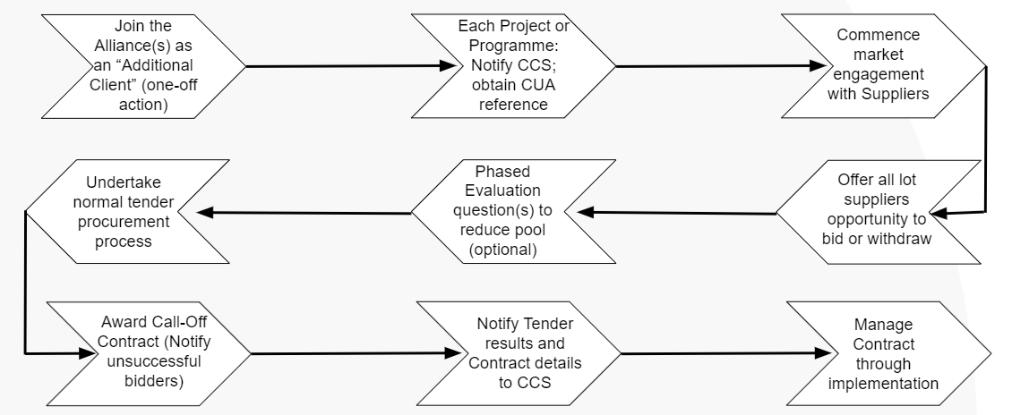
Further Competition Process Flow Chart

Direct award process
- before you commence a direct award procedure under the framework we recommend you review and familiarise yourself with Schedule 4, Part 2 Direct Award Procedure and Competitive Award Procedure of the Construction Professional Services Framework Alliance Contract
Note: it is for the Additional Client to determine and satisfy themselves that their own governance is met and that the direct award process is carried out in accordance with the Public Contract Regulations 2015.
To undertake a direct award procedure you should;
- join the alliance as an additional client
- obtain an additional client user reference number
- develop a clear Project Brief
- develop your assessment criteria and weightings to be applied to the project brief for all suppliers capable of meeting the project brief
- assess the capability of your chosen supplier in the form of a desktop exercise, based on information researched and established by the Additional Client.
- confirm the proposed supplier is interested in delivering the project.
- Issue to the proposed supplier an invitation to submit an offer in writing and set out details of:
the Project Contract,
the Project Contract Conditions to be used,
the relevant pricing model,
the specification / Works Information / Scope etc as applicable
the timetable for the return of the invitation, and
other matters relating to the Project Contract
- understand and document your rationale for a direct award to a particular Supplier Alliance Member for board approval, procurement strategies, mitigation of risk of challenge and full audit trail.
- the supplier must then submit a project proposal in writing, which should be validated/accepted by the Client.
- the Client is not bound to accept any Project Proposal and at its absolute discretion can accept or not accept any Project Proposal submitted.
- if the Client decides to appoint the proposed Supplier, they issue a Project Contract which should be executed and returned within 21 days.
- notify CCS of award detail
- manage contract though implementation
A summary of the above process is outlined in the direct award flow chart below:
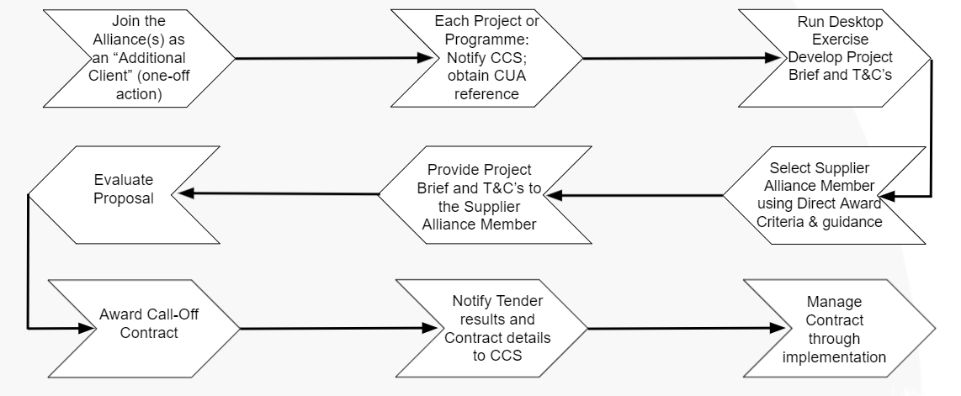
Direct Award Process Flow Chart

Direct award criteria considerations:
The criteria and weightings used to choose the supplier can either be:
- based on those set out by CCS when procuring the framework, or
- specific to the Project
This is always subject to ensuring that any action taken is transparent, non-discriminatory and fair.
- it will normally be more appropriate to use project specific criteria and weightings
- the direct award criteria should be applied to the description of the works or services set out in the relevant Project Brief, for all Suppliers capable of meeting the Project Brief.
- the Quality/Price ratio adopted at Framework level was 75%/25% and this ratio must be maintained when using the Direct Award process
- clients may also consider other subject areas related to the project. The number of criteria to use is at client discretion.
- the weightings of each of the criteria chosen is also at client discretion, as long as the overall 75%/25% Quality/Price ratio is maintained
- an assessment may be carried out across a broad or narrow range of criteria, as appropriate
- the level of complexity of the assessment and evaluation model that you use should normally be reflective of the scale, complexity and risk profile of your project
- assessment techniques such as minimum acceptable scores may be used, as long as the principles of transparency, non-discrimination and fairness are maintained
- the Price assessment should be based on the suppliers’ Framework Prices (These are available from CCS once you have registered to join the framework.)
- once the assessment is completed for all capable suppliers, the Supplier assessed by you to provide the most economically advantageous solution becomes the proposed Supplier.

Failure to secure bids
Should circumstances change or the responses received are deemed inadequate, nothing in the framework agreement obliges contracting authorities to make an award. However, where a no award decision is made due to poor responses from suppliers then CCS would appreciate feedback.

Contract award
The Project Contract is awarded when the relevant documentation is signed by the Client and Supplier. When using our framework clients should always ensure that their own internal processes and governance procedures are followed.
Once you have awarded your contract please confirm the details back to us by completing an Award Notification Form and return it to us at info@crowncommercial.gov.uk with the subject header ‘RM6165 Award Notification Form’.

Responsibility for awards
Each Additional Client is independently responsible for the conduct of its award of Project Contracts under this Framework Alliance Contract. CCS is not responsible or accountable for and shall have no liability whatsoever in relation to:
- the conduct of Other Alliance Members in relation to this Framework Alliance Contract; or
- the performance or non-performance of any Project Contracts between the Supplier and Other Alliance Members entered into pursuant to this Framework Alliance Contract.

Insurances and liabilities considerations
Please ensure that all required insurances, liabilities and contract summaries are comprehensively described in the Project Contract and released with the tender documents, as this will have a direct impact on pricing proposals. You should liaise with your commercial team and/or legal advisors for further advice if you are unsure of any insurance or liability considerations.

Alliancing

Framework level Alliancing
CCS Construction Frameworks are built around an Alliancing structure, using industry standard FAC-1 documentation. This has been done to promote collaboration between all parties, which is recognised and promoted by the government as a major driver of successful project outcomes.
The alliance contracts are built around shared objectives with transparent assessment against agreed success measures and targets. CCS and its suppliers enter into a single multi-party contract, which sets out the award procedures for each project or programme of work. Public sector users who join the alliance also sign up to the same contract. This creates a set of integrated relationships through which clients, suppliers and user members can all learn from each other’s experience.

Lot-Alliances
Each Lot forms a separate Alliance, reflecting the specific Objectives, Risks, Success Factors etc. particular to that market sector.
Additional Clients register to become a member of one or more of the Lot Alliances, depending on their anticipated needs.

“Sub-Alliancing”
The Construction Professional Services agreement also offers an advanced methodology enabling the creation of sub-alliances. This allows for a multi-party structure of Alliance Members and any combination of selected clients, consultants, contractors or suppliers to co-operate on a project or programme of work.
This approach:
- enables a client and its team to obtain better results from a framework
- helps to integrate a team into an alliance
- helps to obtain improved value through building information modelling (BIM)
- can be used in conjunction with any of the permissible project call-off contract forms
The sub-alliancing provisions can be used to, for example:
- integrate professional services, construction works, materials supplies, and Facilities Management to support a whole life cycle approach to procurement
- manage programmes of work or several inter-dependent projects as a discrete and separate “sub-alliance” to achieve specific objectives and outcomes
- link one or more Additional Clients with a common supply chain to drive improved efficiency and value
This is an optional provision within the framework, but offers powerful, advanced project and programme management capability under certain circumstances. Please contact CCS if you would like further specific guidance regarding this facility.

Supplier performance
Success Measures, Targets and Incentives have been set out in Schedule 1, of the Construction Professional Services Framework Alliance Contract to outline performance measurement requirements of Suppliers in delivering their framework contract requirements. Schedule 1 is also designed to support Clients as part of the Alliance in tracking Project Contract Success Measures with an aim to improve their service delivery approach and practices.
The KPIs may be further developed at call off with the supplier to achieve customer service requirements. The use of Project success measures/KPIs is optional, however you are encouraged to consider the use of such performance measures to assist in incentivising improved project value and performance.

Additional support and guidance
If you have any questions about using our Framework Agreement please contact us info@crowncommercial.gov.uk
Once you are registered as a Framework Alliance Member you can join our Construction Professional Services Framework KnowledgeHub.
In KnowledgeHub you will find additional guidance and support in the form of webinars, user guides, and template documents. For more information on how to join please visit the KnowledgeHub Guidance Document.
We can provide an assisted procurement service. To find out more please contact info@crowncommercial.gov.uk.
Our E-sourcing tool. For additional guidance on how to run further competitions using the CCS eSourcing tool please refer to our eSourcing tool: guidance for customers.
The guidance will show you how to;
- register, log in and amend your profile
- run a capability assessment
- select the correct framework for a further competition
- run a further competition
- manage communications with suppliers during your further competition
For additional support on the eSourcing tool please email eenablement@crowncommercial.gov.uk
You can also register for online training by visiting our e-sourcing training site

Further information
You can also learn more about Crown Commercial Service at:
Website:
www.crowncommercial.gov.uk
Twitter:
@gov_procurement
LinkedIn:
Crown Commercial Service

