RM6188

Audit and Assurance Services Framework

(A&AS)

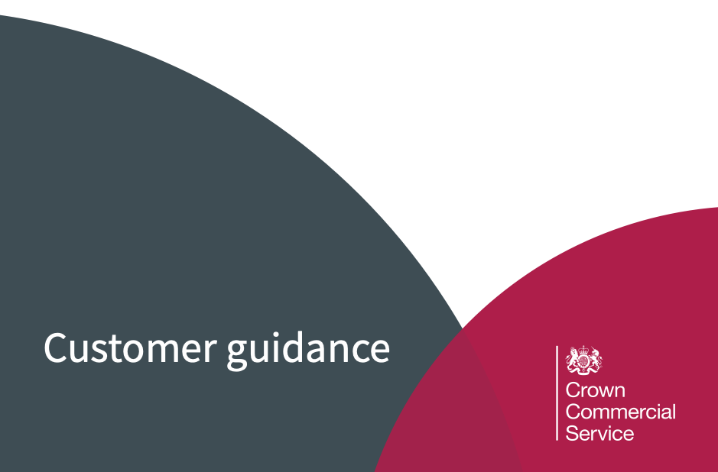

Key information

Framework reference: RM6188

Start date: 11 August 2021

End date: 10 August 2025

Additional support

Guidance and templates

Comprehensive guidance documents and templates can be found under the documents section of the framework web page.

Contact details:

E: info@crowncommercial.gov.uk

T: 0345 410 2222

W: www.crowncommercial.gov.uk

You can also learn more about Crown Commercial Service at:

Website:  crowncommercial.gov.uk | Twitter:  @gov_procurement | LinkedIn:  Crown Commercial Service

Contents

1. Introduction 3
Purpose of this document 3
Who can access this framework 3

2. Using the framework 3
Scope 3
Lot selection 3
Lot structure 4
Shortlisting suppliers 4
Supplier engagement 4
Specification (statement of requirement) 5
Base Location 5

3. Procurement Process 5
Further competition 5
Direct award 5
Timescales 5

4. Constructing your tender 6
Running your tender 6
Contract Documentation - Public Sector Contract 6
Quality award questions 6
Quality and price weighting 6
Social value 7

5. Evaluating your tender 8
Compliance check 8
Price evaluations & abnormally low tenders 8
Quality evaluation 8
Evaluation report

6. Awarding your contract 9
Intention to award 9
Award letters (successful and unsuccessful) 9
Call off contract 9
Contracts finder 9

7. Managing your contract 10
Contract management 10
Changing the call off contract 10
Ending the call off contract 10

Introduction

Purpose of this document

This is not a legal document and is intended to be used as guidance only.

This document is specifically designed to provide advice and guidance on how to use RM6188 Audit and Assurance Services Framework (A&AS). It forms part of a comprehensive suite of guidance and template documents to help you buy audit and assurance services via the framework. The templates are not mandatory however if you decide to use them they should be amended to reflect your specific requirements.

Who can access this framework

A&AS is available for use by all public sector bodies, including central government departments, devolved administrations, the wider public sector and third sector including but not limited to:

- local government
- health (NHS)
- education
- police, fire and rescue
- social housing organisations
- charities, voluntary organisations and community sector bodies
See the Find a Tender contract notice and award notice for full details of who can access the agreement

Using the Framework

Scope
See the framework specification to ensure your requirements are within the scope of this agreement.

Lot selection

You will need to select the lot (detailed below) which best matches your requirement. See the lot descriptions document to assist you in selecting the most appropriate lot to meet your needs. You cannot undertake a further competition across multiple lots.

Lot structure

The Framework has been divided into four lots:
Lot 1 - Internal audit and assurance
Lot 2 - External audit
Lot 3 - Counter fraud and investigation
Lot 4 - Other independent assurance

Shortlisting suppliers
We have created a service line matrix to help you shortlist suppliers. Select which service(s) you require and the tool will create a list of framework suppliers that can meet your requirements.

Further shortlisting can be achieved where suppliers;

- decline to participate in supplier engagement
- do not respond to an expression of interest (EoI)

You need to make it clear to suppliers that they will be excluded from the procurement if they fail to respond to supplier engagement or EOIs

Supplier engagement

Early engagement with suppliers before you issue your tender documents may assist in the development of a more focused specification. A key principle of public sector procurement is that all suppliers are treated in a fair and equitable manner.

- if you intend to shortlist suppliers using the service line matrix mentioned above, this should be done before any supplier engagement
- core term 15 of the agreement states that each party must “ keep all Confidential Information it receives confidential and secure”. If sharing particularly sensitive information you may want to consider using a non-disclosure agreement (NDA)
- engage with all suppliers in the chosen lot to make them aware of the opportunity
- issue a request for information (RFI) if you require market intelligence or have a specific question
- Issue an expression of interest (EOI) to gauge the level of interest from suppliers in your requirement. You will only invite suppliers to your further competition which have responded to your EOI
- use the CCS eSourcing portal or your own procurement portal to provide an audit trail
- share draft documents (including specification) with all lot suppliers for feedback

You need to ensure that you retain control of your requirements and that they are not dictated by suppliers or provide an unfair advantage to one particular supplier.

Specification (statement of requirements)

A clearly written specification will help get the right result for your organisation. It informs suppliers about the services required and enables them to propose a solution. You should state within the specification any qualifications or membership of professional organisations that supplier personnel need to have in order to perform the requirement. The specification provides a legal contractual tool which forms an integral part of the call-off contract which will be binding on both parties. Your specification facilitates effective contract management and can be referenced in the case of any disputes between you and the supplier.

Base location

You need to detail in your tender the base location(s) where the majority of the work will be carried out as the framework rates are inclusive of travel and related expenses to the base location(s).Knowledge transfer

Knowledge transfer should be built into any contract to ensure that future reliance on external advice is minimised and the building of internal capability is maximised.

Procurement Process

Framework Schedule 7 - call off award procedure outlines the two procurement routes allowable under this framework agreement.Further Competition

Further Competition is the default route to market, under this framework.

Direct Award

In specific circumstances where there are compelling reasons you may be able to direct award. You should obtain your own legal advice to ensure direct award is a compliant approach. It is your responsibility to justify this route to market.

Timescales

- set a sufficient time limit for the receipt of tenders. A minimum of 30 working days should be allowed for a simple requirement and significantly longer for more complex requirements
- when planning the tender period you should ensure that you allow a clarification period for suppliers to ask questions and for you to respond to those questions. Once you have issued your final clarification responses, allow sufficient time for suppliers to consider your responses before they submit their bid.

Constructing your tender

Running your Tender

Below is a list of documents you should consider when formulating your tender.

- T2 - Attachment 3 - Statement of requirements
- T3 - Non-disclosure agreement (NDA)
- T5 - Attachment 1 - About the procurement
- T6 - Attachment 2 - How to bid including evaluation criteria
- T7 - Pricing schedule
- Framework schedule 6: Call-off order form

Templates can also be found on the framework web page.

CCS provides free access to our eSourcing portal which enables you to conduct a further competition and provides a fully auditable procurement process. If you wish to use your own internal eSourcing portal you are able to do so.

Contract documentation - the public sector contract (PSC)

You need to decide which schedules to include in your contract and if you need to include any special terms. This will need to be done before you issue your tender so that suppliers know what terms and conditions will apply to your call-off.

For further information on the PSC please see ‘How to use contractual documents’.

Quality award questions

You need to develop questions which allow you to assess a supplier’s ability to meet your requirements. Whilst there is flexibility in what suppliers can be asked, you should ensure questions are in line with your requirements, forward looking and within the scope of the framework specification.

Your specification should identify what you expect to receive from the supplier and how will you know that your requirement has been delivered.

Quality and price weighting

You need to evaluate supplier responses using the most economically advantageous tender (MEAT) criteria. The criteria and weightings below should be applied to suppliers’ compliant tenders submitted through the further competition. You can define the sub-criteria, as part of the further competition process.

Central Government Bodies criteria
Criteria | Percentage Weightings  for Central Government Bodies conducting a further competition | Allowable Variance  Weightings may be modified within the range below
Quality | 45% | + 35% (45% to 80%)
Price | 45% | - 35% (10% to 45%)
Social Value | 10% | +20% (10% to 30%)

Non Central Government Bodies Criteria

Criteria | Percentage Weightings  for Non Central Government Bodies conducting a further competition | Allowable Variance  Weightings may be modified within the range below)
Quality | 50% | + 40% (50% to 90%)
Price | 50% | - 40% (10% to 50%)
Social Value | 0% | + 30% (0% to 30%)

Social value

Take Social Value into account early in the preparation and planning phase of your requirements, and consider how suppliers can deliver broader value as part of their bids.Pre-tender supplier engagement can assist in determining an appropriate and proportional social value element.
Detailed guidance on how to evaluate social value can be found on the GOV.UK website;

For further information on Social Value see PPN 06/20

For central government customers a minimum weighting of 10% of the total score for social value should be applied in the procurement to ensure that it carries a heavy enough score to be a differentiating factor in bid evaluation. A higher weighting can be applied if justified.

Evaluating your tender

Compliance check

On receipt of tenders a compliance check should be undertaken prior to evaluation to ensure:

- the bid is from the same supplier that is awarded to the framework agreement
- suppliers confirm acceptance of framework and call-off terms and conditions
- all mandatory questions are answered
- all requested documentation is completed and attached (if applicable)
- supplier(s) are notified as detailed in your tender document if they have failed the compliance check and that their bid will not be considered in the procurement
- check pricing is completed in line with the guidance with no missing prices
- ensure framework maximum rates have not been exceeded
- if a supplier proposes rates higher than the framework maximum or changes to the terms and conditions please notify CCS

Quality evaluation

The quality evaluation process must be conducted as defined in your tender documents. Responses should be scored individually, ideally by three evaluators. You should then undertake a consensus meeting to agree on final scores following a robust conversation of the bid responses to address any anomalies and resolve opposing views. Detailed records should be maintained.

Price evaluations and abnormally low tenders

You should evaluate pricing, as defined in the tender. Where a tender price appears to be abnormally low in relation to the requirement, you should seek an explanation of the costs proposed, then assess the information provided. If the evidence does not provide a satisfactory explanation you may be able to reject the tender. Legal advice is to be sought prior to rejection.

Evaluation report

Once quality and price evaluations are complete and a combined score achieved to identify the successful supplier, you should create an evaluation report and obtain appropriate approval and sign-off before the award of the contract.

Awarding your contract

Intention to award

If you elected to include a standstill period (10 calendar days) when you developed your tender then you need to issue an intention to award letters to all suppliers. For further advice please speak to your commercial team / legal advisors.

Award letters (successful and unsuccessful)

After the standstill period expires (if used) or at time of award, you need to issue an award letter to the successful supplier and an unsuccessful letter to all other bidding suppliers informing them of the procurement outcome. You should provide feedback to all suppliers on their bids, including the scores and commentary against the evaluation criteria.

Call-off contract

You should populate the call-off order form document with information taken from the successful supplier’s tender or response to the statement of requirements for direct award which should include:

- framework name and lot number
- call-off contract start date
- call-off contract end date
- any potential extension period
- pricing

All parties to the call-off contract should sign the call-off order form.

For information on completing the call-off order form please read “How to use contractual documents” available on the web page.

Contracts Finder

Where a public contract (in excess of £10,000) is awarded, within a reasonable time, you will need to publish on Contracts Finder.

If you are experiencing problems using the Contracts Finder service you can contact our service support team: ContractsFinder@crowncommercial.gov.uk

Managing your contract

Contract management

Following contract award it is important to have a robust contract management process to ensure that suppliers work to the original specification.

Ensure the right resource mix of personnel, for example not too many partners or junior staff.

Throughout the contract duration, you need to ensure you are invoiced correctly in line with your contract to ensure the agreed prices have not been exceeded and that payment is not released until the agreed milestones have been achieved.

For further information on contract management please refer to Call Off Schedule 15 - Call Off Contract Management.

Changing the call-off contract

If you need to change the call off contract see Clause 24 of the Core Terms and use the Joint Schedule 2 - Variation Form.

You may wish to speak with your commercial or legal team for further advice.

Ending the call-off contract

Call-off contracts can be terminated for a variety of reasons as detailed in clause 10 of the Core Terms.


If you need to end the contract early, follow the exit process detailed in the call-off contract.

