RM6190 - Technology Services 4
Digital Platform
Supplier guidance on how to publish catalogue items

Key Steps:

Register | Agree T&Cs | Create your catalogue item | Publish your catalogue item

Introduction:

This guidance is to support suppliers with creating and publishing compliant catalogue items for the Technology Services 4 (RM6190) agreement into the Catalogue Publication Portal – currently Basware.

Your catalogue items will provide buyers with an easy and compliant route to procure simple services and will minimise intervention from CCS for non-compliance.

It is recommended that suppliers read Framework Schedule 7 (Call-Off Award Procedure).
All published catalogue items in the Catalogue Publication Portal must:
- meet the requirements of Framework Schedule 7 (Call-Off Award Procedure) Annex A: Award Without Competition: Objective mechanism for supplier selection
- be set out using the relevant Catalogue Item Template (Schedule 7, Part 3)
- be available on the platform for a minimum of 30 calendar days (Schedule 7, Part 2, para 1.5)
- be open to all buyers and not contain any wording that indicates it’s specific to a particular buyer

Registering for the Framework:

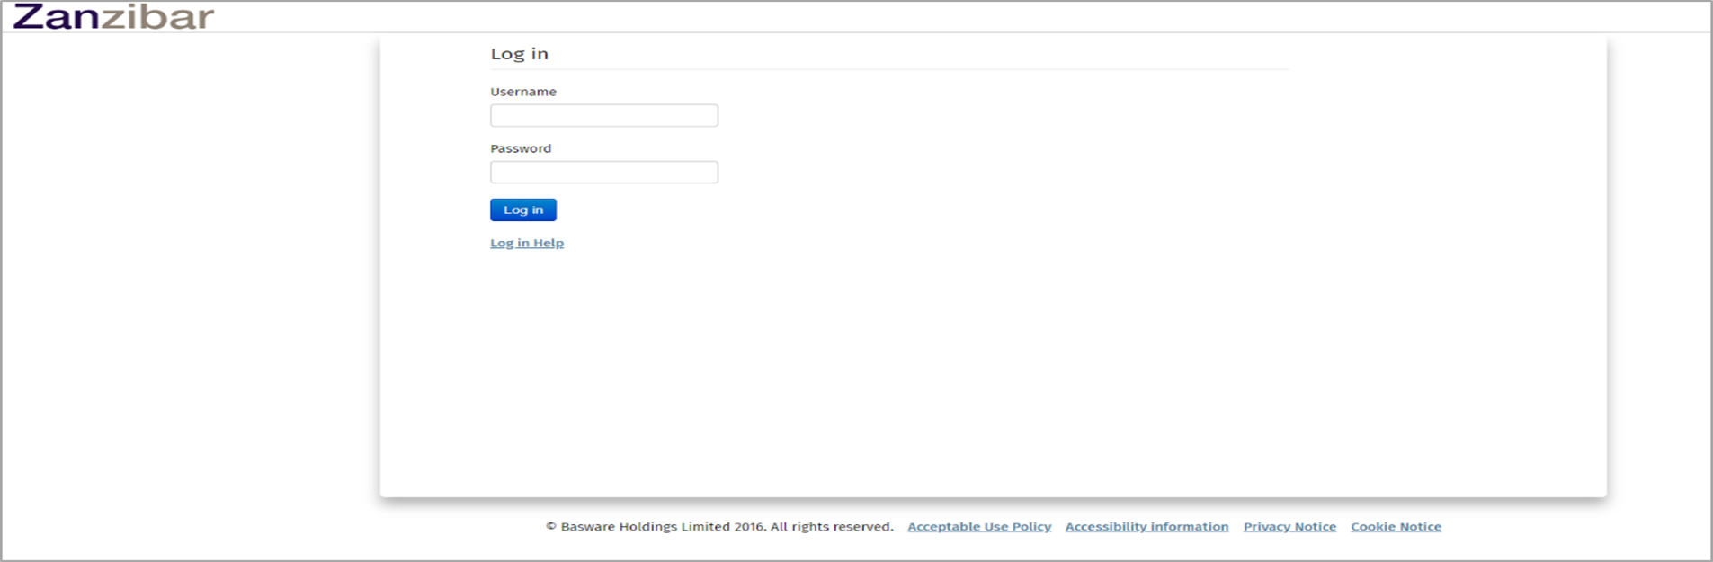

Once you have logged in and arrived at the following landing page, you will need to select the ‘Contracts’ menu.

Once you have entered this menu, you will see all the contracts available for you to publish your offers against. Search “RM6190” in the search field to find contracts related to this guidance and the Technology Services 4 Framework.
Contracts are another name for the RM6190 Lots which you were awarded a place on during the tender stage.
There are 8 AWOC Lots in total, but the number you will see is related to your own profile on the framework and they have been broken down as follows:

Award Without Competition (AWOC) – Lot 1 to Lot 5A
Please ensure you locate the correct Lot and then select either the hyperlinked Lot name or the icon below in the red square. This will then open the applicable contract qualification page.
The example below is for Lot 4A:
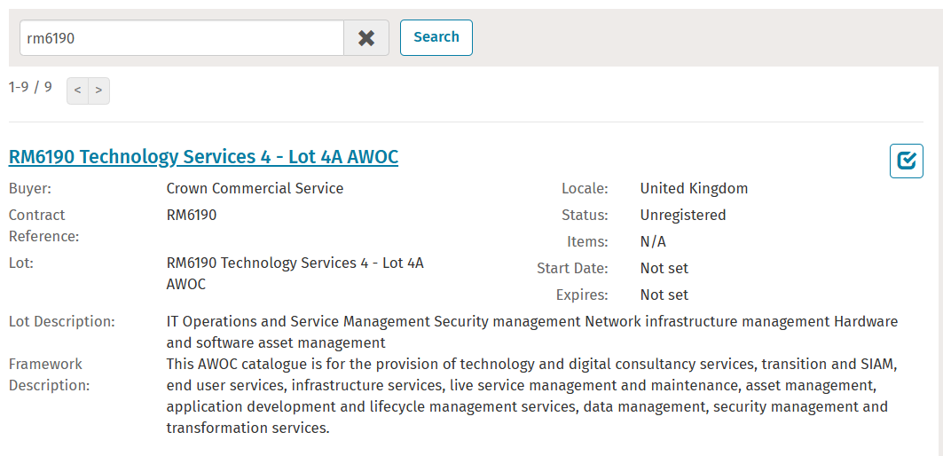
When you click on the Lot name hyperlink or button highlighted by the red square you will see the following screen which will ask you to enter your company email address and sign up to the Lot specific T&Cs.
PLEASE NOTE:
CCS will manage the authorisation process to access these lots, so you may be rejected for one of the following reasons:
- Declaring “No” to accepting the terms will result in rejection. If you believe this was made in error you must contact technologyservices@crowncommercial.gov.uk
- You are not an awarded framework supplier on any lot. You will not be granted access to this platform in any capacity.
- You are not an awarded supplier for this lot but are a framework supplier. You are not permitted to sell services via this lot and will be rejected and cannot be awarded a place for lot at any time
- You are or become a suspended or excluded supplier on our Framework, your access will be rejected or revoked depending on when the action is taken

The first screen you come to will be as below. This will be removed by Basware during an update in Q1/Q2 2026. To pass this screen please select any option on the left hand side.

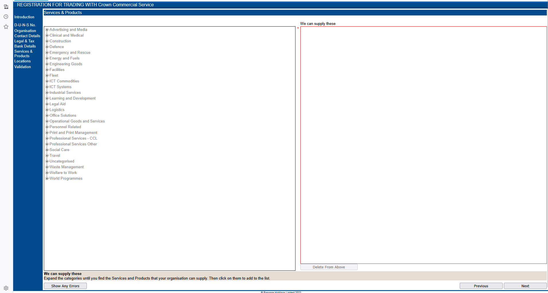
This will then allow you to begin the registration process.
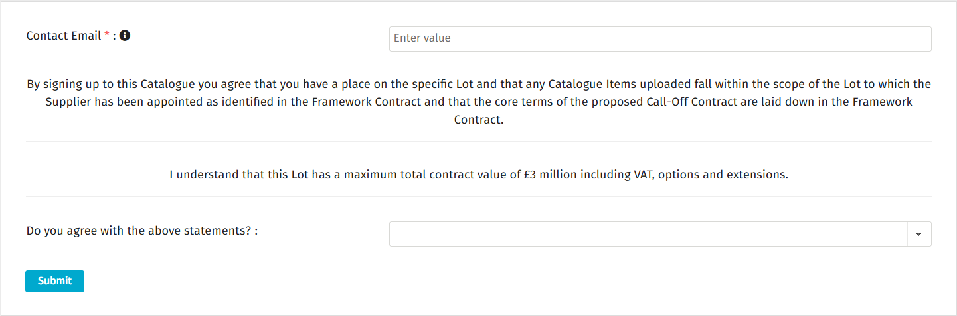

Once you have clicked on the above ‘Submit’ button, you will be placed in a “Pending” status awaiting action from CCS to validate your position and grant you access. This will change to “Approved” once CCS has done this.
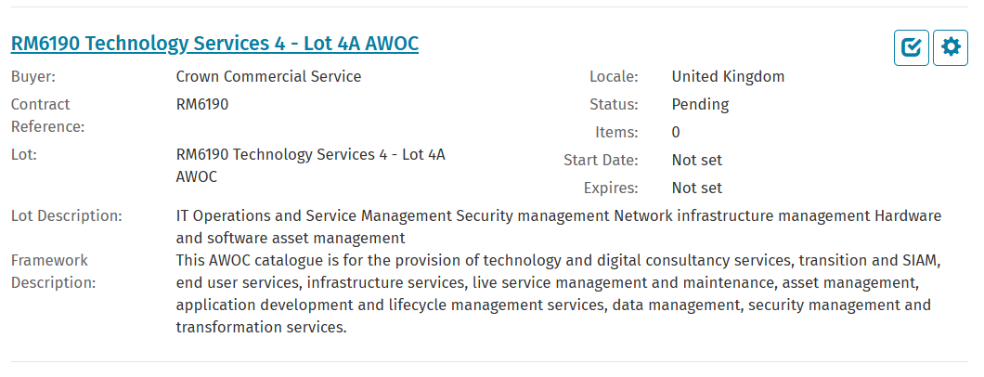
Whilst in the pending status you will still be able to access and populate offers. However, they will not be visible to buyers until CCS approves your lot position. We recommend that you don’t wait for Lot approval to begin the development of your offers.
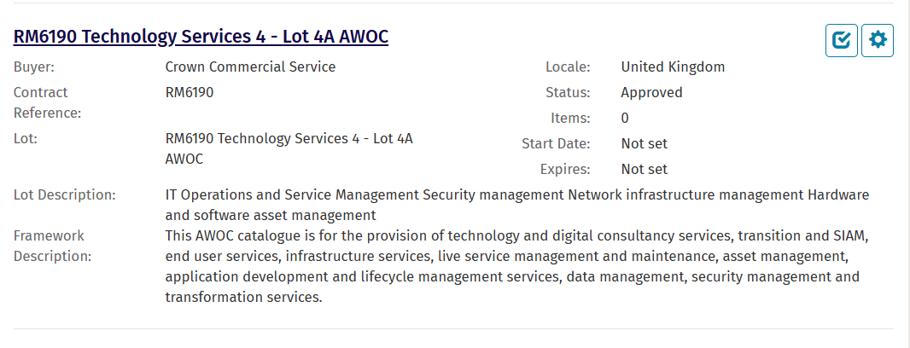
Click on the ‘Manage items’ cog in the red square box as above, and you will then be presented with this screen:

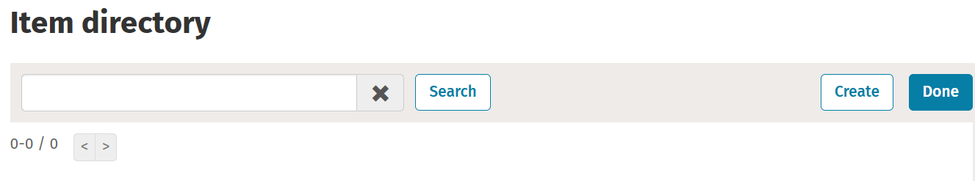
Click the ‘Create’ button on the top right, and then complete all the mandatory criteria in the following 2 screens.
The criteria will include multiple choice, single select and areas for you to type in. Those with a red asterisk are mandatory fields.
This process relies upon you having completed the full catalogue item template, please refer to our guidance to get that developed to complete this process.
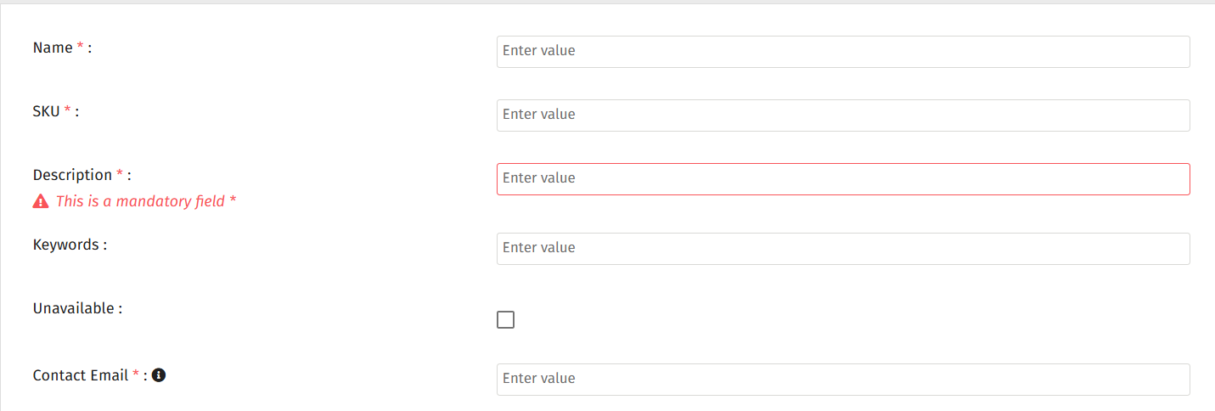

- Name is the title of your offer.
- SKU is the offer ID to fit the item format in the template provided and it must conform to the RM6190-Lot Number-Service Description naming convention
- Description is a high level description of your services
- Keywords are search tags and a full list is available in the full service offer template. These are not mandatory but can help buyers search for offers when browsing the catalogue
- The ‘Unavailable’ box is for the supplier to make their offer invisible to buyers until they are happy for it to be visible. The default position is for this box to be unticked.
- Contact email should be the email of the supplier

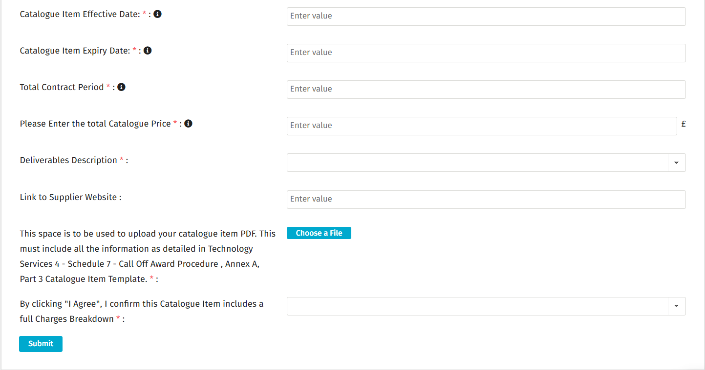
- Catalogue Item Effective Date - Use the format DD/MM/YYYY
- Catalogue Item Expiry Date - Use the format DD/MM/YYYY
- Total Contract Period - this must include any options or extensions. Please enter these as initial contract period + options/extension (eg 12 months + 12 months)
- Total Catalogue Price - this must include VAT
- Deliverables Description - this is a drop down, single select option. Please select the description that matches your offer.
- Link to website allows a supplier to insert a link to their own website.
- Choose a file button is where you will upload the CCS template which will describe your full service offer. You can also upload supplementary documents that demonstrate compliance with specifications on the platform.
- “I Agree” Statement
Once complete, click ‘Submit’ at the bottom of the page.
You will then be presented with this screen, so click the ‘Done’ button:

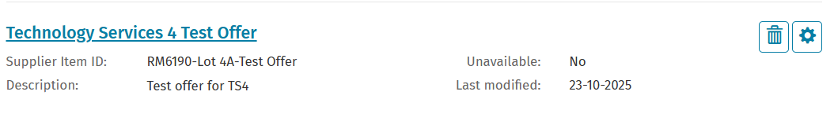

Congratulations! You have now published your offer.
If you are unsure of what the question is asking, tool tips are available on most of the questions under the icon.

Approvals:
Please note that the approvals have all been set to manual approval. CCS will review all Catalogue Items uploaded to check compliance. Catalogue Items will be reviewed throughout the week, but will only be approved on Wednesdays at 9am. If we review your offer and it is not compliant we will send an email to allow you to amend the offer prior to the approval time. All complaint Catalogue Items must be uploaded by 12pm on Tuesday to be approved on Wednesday.
You will receive a notification to confirm that your offer has been approved from no-reply@no-reply.mpuk.basware.com.

Contact points:
If you have any system based queries, there are 3 ways you can do this:
1. Contact the Basware Service Desk by raising a support ticket on:
Catalog Item (public) - Basware Customer Support

From the ‘How can we help you?’ dropdown please select ‘I need help with the UK public sector’.
2. Call 0330 822 8278
3. Use the chat option on the Basware website at:

https://www.basware.com/en/contact-us

However, if your query is around the actual process or compliance, please contact the CCS Technology Services team on technologyservices@crowncommercial.gov.uk.

Useful links:
Log in:
https://suppliers.mpuk.basware.com/SignIn.aspx?ReturnUrl=%2f

Supplier guide:
https://basware.service-now.com/bw?id=bw_kb_article&sys_id=9bc5fac81bad5418570fc9506e4bcb42

Customer Service Portal
Customer Service Portal - Basware Customer Support

