RM6202 Tail Spend Solution

Direct Award Guidance

© Crown Commercial Copyright

When to use the Direct Award route
Direct Award offers a quick and flexible way to access a supplier solution under the Tail Spend Solution framework. It is also compliant with the Public Contract Regulations without the need to run a Further Competition.
Direct Award is suitable to meet a range of customer needs, for example, simple and easily defined requirements that can readily be satisfied and where no additional benefit would be derived from the undertaking of a Further Competition.
It should only be used when a buying organisation can satisfy themselves that the proposed solution offered by one of the two Suppliers meets the requirements of the buying organisation without the need for any amendment to the Contract terms, or any supplementary terms.
Best for:
- ad-hoc
- low value
- quick access
Not suitable for:
- complex requirements
- amending the Call-Off terms

Points to Note
- there are no fees for accessing a solution under this agreement
- there are no minimum or maximum spend commitments in order to access a solution under this agreement
- the maximum Call-Off duration is four (4) years

How to undertake a Direct Award
The Direct Award process is broken down into 4 simple steps, as explained below:

Step 1: Identify your needs (award criteria)
Before reviewing the supplier solutions, it is important that you have established the capabilities you require and what is most important to you. When doing this, areas of consideration should include, but not necessarily be limited to:
- product availability (the products and product categories you will be looking to purchase)
- solution operability (the look, feel and user friendliness of the solution)
- curation (the ability to setup your account to include numerous cost centres, purchase approval hierarchies and hide certain product categories from view)
- reporting functionality (the level and frequency of reporting on purchase activity required)
- social value (how the solution supports your Social Value priorities in line with those set out in the Framework Specification)
- Enterprise Resource Planning (ERP) system integration or other punchout integration
- pricing (obtaining pricing on a sample basket of goods)
Your award criteria should be established in order of importance to ensure that the suitability of each supplier solution is evaluated in line with your needs.

Step 2: Review the supplier solutions
There are two suppliers on this framework, offering their own digital solution to meet Tail Spend requirements. You can view details of their solutions below (these are also in the ‘Documents’ section on the framework homepage):

- OT Group Ltd
- Unite UK

Contained within the above is a restricted demo account login to allow you to sample each solution. In addition, you may want to invite each supplier to provide a demonstration of their solutions or to ask clarification questions of the suppliers to assist you in your award decision.
To request a demonstration or ask any clarification questions please contact the suppliers via the below email address:
OT Group Ltd: ccstailmanagement@otgroupltd.co.uk
Unite UK: CCStailspend@unite.eu

Step 3: Evaluate
Once you have reviewed the solutions of the two suppliers on the framework, you must evaluate them against your needs to ascertain the most appropriate choice.
Your needs should be applied to the two solutions, taking into consideration the importance of each requirement. Your evaluation and rationale should be documented in line with your internal processes and for transparency.

Points to Note
- if you’re unable to successfully align either of the solutions to your requirements due to insufficient information, or the requirement of a more bespoke response to your needs, then a Further Competition may be better suited

Step 4: Award
When you have established which solution best fits your requirements and you have undertaken any internal processes to authorise the award to your chosen supplier, please complete the RM6202 Direct Award template.

The screenshot below will assist you in providing the information required.

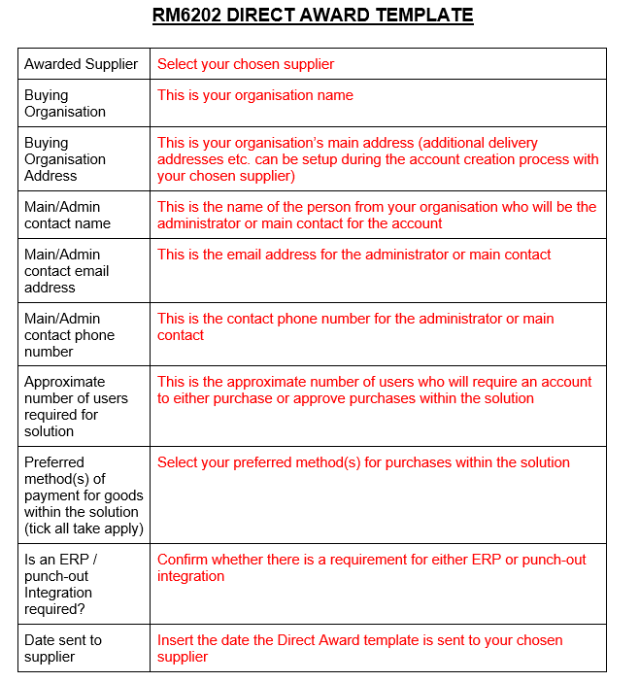

Once complete, send on to your chosen supplier using the email addresses below. They will then contact you to acknowledge receipt and advise of the next steps in your onboarding process within 1 working day.
OT Group Ltd: ccstailmanagement@otgroupltd.co.uk
Unite UK: CCStailspend@unite.eu
You will also be required to complete a Call-Off Contract to formalise the agreement. Your chosen supplier will work with you to complete this upon confirmation of award.
Your chosen supplier will manage your onboarding process to enable account creation, access to your chosen solution and training as required.
Should you need any further assistance, full details of the Call-Off Procedure can be found in Schedule 7 of the Framework Contract.

