eDisclosure and Review Services

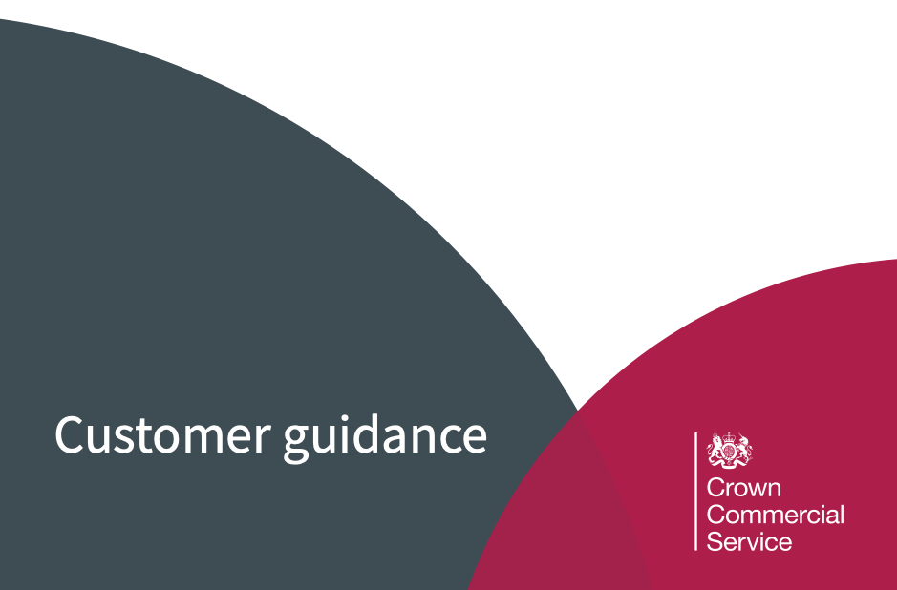
RM6203

Contents

Key Information
Introduction
Purpose
Background
Who can use the Framework Agreement
Using the Agreement
Features and Benefits
Framework Scope
Lot Structure
Lot Selection
Things to Consider
Stakeholder Engagement
Business Case
Project Management
Evaluators
Legal Advice
Supplier Engagement
Specification (Statement of Requirements)
Purpose of a Specification
Call-off (terms and conditions)
Base Location
Award Procedure (further competition / direct award
Quality questions
Pricing
Quality and Price weightings
e-Sourcing
Call-off contract period
Clarification Period (supplier questions)
Tender
Timescales
Evaluation
Social Value
Price evaluation and abnormally low tenders
Post tender clarification / negotiation
Quality evaluation
Evaluation report

Contract award
Intention to award
Award letters
Call-off contract
Contracts Finder
Contract management and exit
Contract variation
Sharing best practice
Exiting the contract
Further Information including contact details

Key Information

Framework Agreement Reference: | RM6203
Panel Title: | eDisclosure and Review Services
Start Date: | 15th June 2021
End Date: | 14th June 2024 (one year extension option available)
Accessible to: | Central government and wider public sector organisations across the UK
OJEU Contract Notice | https://ted.europa.eu/udl?uri=TED:NOTICE:563033-2020:HTML:EN:HTML&tabId=1&tabLang=en
OJEU Award Notice | To be inserted
Available call-off procedures: | - Further Competition  - Direct Award
Mandated quality weightings | There is no mandated quality weighting, allowing flexibility to customers at call-off level
Contact Details | Agreement Manager (RM6203)  0345 410 222 / info@crowncommercial.gov.uk
CCS Website and further documentation: | To be inserted

1. Introduction
Purpose of this document
Crown Commercial Service (CCS) have developed this guidance to assist Government departments and other customers when accessing this framework.
This document is not a legal document and is to be used as guidance only.

Background
This Framework has been established by CCS to provide a simple and compliant route to market for eDisclosure and Review Services and replaces the previous eDisclosure Services Framework (RM3717), taking into account the results of close engagement with the market and a range of customers. This new arrangement covers the supply of a wide and comprehensive menu of eDisclosure Services designed to cover the requirements of the ‘Electronic Discovery Reference Model (EDRM) illustrated below excluding Information Governance. This includes documents and electronic data protectively marked at Secret and Top Secret.

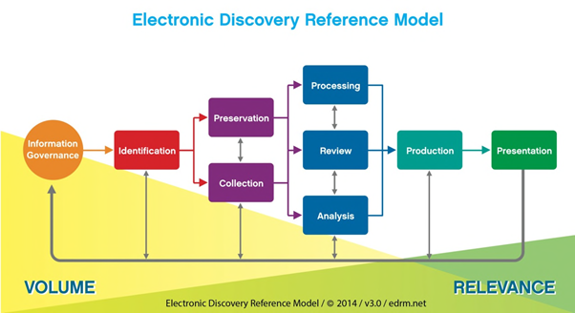

The Framework has been set up following a joint procurement project between CCS and the GLD with CCS as the contracting authority.
The Framework comprises four (4) Lots of quality assured services provided by eight (8) suppliers

Who can use the Framework Agreement
This Framework is available for use by UK Public Sector and third sector organisations. Further details can be found within the OJEU contract notice
Using the Agreement
The Service provisions under the lot-based structure span a wide, diverse customer base and require a variety of specialist services encompassed by the EDRM, but broadly some, or all of the following eight (8) stages:
- strategic oversight, advice and support;
- document identification;
- document preservation and collection;
- document processing;
- document review;
- document production;
- disclosure from other opponent parties; and
- presentation at trial
Robust data security requirements are built into each Lot and the Framework is structured to offer a contracting authority flexibility and choice. It is a matter of judgement however for the contracting authority to decide which particular Lot(s) is the most appropriate to meet their specific requirements.
Features and Benefits
The Framework has been developed by combining Crown Commercial Service (CCS) procurement and project management expertise with Government Legal Department (GLD) experience and knowledge.
Competitive tenders were evaluated following an ‘Open Procedure’ procurement process based on a 70/30 Quality/Price ratio according to the Lot in question. The quality evaluation (through question/responses) was conducted by a team that included senior practitioners from GLD and other public sector bodies. Price (Value for Money) was evaluated through careful consideration of supplier tenders according to a range of ‘cost models’ specific to each Lot.
Procuring any legal support service can be both costly and time consuming for customers and suppliers. In particular, eDisclosure Services are normally required against a backdrop of demanding time constraints, use of this Framework will reduce the time and costs associated with selecting a supplier by offering a suite of services that offer Value for Money and high quality suppliers who have been competitively tendered and quality assured.
- a compliant route to market with an improved lot structure that is better aligned to customer requirements and reflects the main areas of usage and expertise, with the correct capacities in each genre of service to enable fast and responsive action
- all suppliers must comply with high standards of security - information on further security requirements can be found within their respective service documents
- commoditised pricing in relation to certain elements of handling electronically stored information, providing clarity and ease of comparison
- a more streamlined call-off process with simplified documentation which places less demand on customers and suppliers to provide further information
- a large proportion of SMEs awarded a place on the agreement
- reduced customer “time to engage” Supplier(s) to enable improved “time to court” cycle
- increased availability of emerging technologies to enhance service delivery
- streamlined process and reduced costs of procurement
- captures the requirement for continuous improvement from Suppliers
2. Framework Scope
Lot Structure
Please note that the detailed specifications of the individual services are contained within the Framework Schedule 1 (Specification)
Lot Selection
Lot 1 - Simple Low Volume Work Service Package for documents and data with a security classification up to ‘Official’ (and including ‘Official Sensitive’)
The scope of this Lot is the provision of eDisclosure Services in respect of an overall initial dataset (pre-processing) of no more than 5GBs Electronically Stored Information (“ESI”) plus no more than 1,750 pages of hardcopy documents (as defined in Pricing – Attachment 3). The exercise will comprise the processing of one tranche of data (applying one set of date ranges and search terms, plus de-duplication and email threading), provision of a review platform, one production and potentially the loading and review of the other side’s data only.
The Supplier shall be able to provide the following Services, including all mandatory requirements that specifically relate to Lot 1, as detailed in Section 4 of the Framework Schedule 1:
Mandatory requirements for Lot 1 are detailed at 4.6, 4.7, 4.8, 4.9, and 4.11 of this document:
• document processing
• document review
• document production
• disclosure from other opponent parties; and
• security requirements
Lot 2 - End to End Service package for documents and data with a security classification up to ‘Official’ (and including ‘Official Sensitive’)
The Supplier shall be able to provide the following Services, including all mandatory requirements that specifically relate to Lot 2, as detailed in Section 4 of the Framework Schedule 1:
Mandatory requirements for Lot 2 are detailed at 4.3, 4.4, 4.5, 4.6, 4.7, 4.7a, 4.8, 4.9, 4.10 and 4.11 of this document
• strategic oversight, advice and support
• document identification
• data preservation and collection
• document processing
• document review
• document reviewers
• document production
• disclosure from other opponent parties
• presentation at trial
• security requirements
Lot 3 - Document Reviewers for documents and data with a security classification up to ‘Official’ (and including ‘Official Sensitive’)
The Supplier shall be able to provide the following Service, including all mandatory requirements that specifically relate to Lot 3, as detailed in Section 4 of the Framework Schedule 1:
Mandatory requirements for Lot 3 are detailed at 4.7a and 4.11 of this document:
· document reviewers
· security requirements
Lot 4 - End to End Service for documents and data with a security classification up to and including ‘Secret’ and ‘Top Secret’
The Supplier shall be able to provide the following Services, including all mandatory requirements that specifically relate to Lot 4, as detailed in Section 4 of the Framework Schedule 1:
Mandatory requirements for Lot 4 are detailed at paragraphs 4.3-4.11 inc (same as lot 2)
• strategic oversight, advice and support
• document identification
• data preservation and collection
• document processing
• document review
• document reviewers
• document production
• disclosure from other opponent parties
• presentation at trial
• security requirements
3. Things to Consider
Stakeholder Engagement
When establishing requirements you should engage early with internal colleagues including procurement, finance and legal to draw on their knowledge and experience and gain their buy-in.
Business Case
Before procuring external support a business case is usually required to demonstrate the need. It should be a well-structured document that supports the specific business need. A compelling business case should adequately capture the quantifiable and non-quantifiable characteristics of the proposed project.
Large, complex or high profile projects often require a comprehensive and highly structured business case. For other projects the business case may be brief and informal. Information included in a formal business case could include an overview of your organisation, project background, options considered including do nothing (risks / costs / lost opportunities of doing nothing), expected business benefits, expected costs and anticipated risks.
Project Management
Developing a robust project management process may assist you in securing your requirements on time and within budget via this framework.
Evaluators
You should nominate suitable evaluators to assess the quality questions within the award questionnaire and pricing schedule, where you are running a further competition. This is key to the success of the procurement and you should give careful consideration to any specific skills that are required. You must ensure that there are no conflicts of interest and the evaluators have the relevant experience. Where a conflict of interest exists or evaluators do not have the relevant experience they will not be able to evaluate. During evaluation the evaluators need to ensure responses / comments are concise and accurately recorded for audit purposes. We would encourage evaluators to contribute to the drafting of the specification. It is also important to ensure evaluators are available within the required time frame. It is advisable to have backup evaluators to avoid unnecessary delays.
Legal Advice
You may wish to seek your own legal advice when selecting the most appropriate lot, deciding on the award procedure, drafting the tender documentation, call-off contract, pricing schedule and award questions. CCS is not permitted to provide any legal advice
Supplier Engagement
Early engagement with suppliers before you issue your tender documents may assist in the development of a more focused specification. A key principle of public sector procurement is that all suppliers are treated in a fair and equitable manner. Here are some hints and tips:
· make all suppliers in the lot you will be using aware of the opportunity at the earliest convenience and include proposed timescales, if known. This could be face to face, (e.g. all supplier events), or via webinars or teleconferences.
· if sharing sensitive information with suppliers regarding your requirement you may wish to have the suppliers sign a non-disclosure agreement (NDA).
· if you require market intelligence or have a specific question for which you require supplier input you may wish to issue a request for information (RFI). This should be sent to all the suppliers on your selected lot. Use of an e-Sourcing portal will provide an audit trail. You can use the CCS eSourcing tool or your own portal, if you have one.
· share your draft documents (including your specification) with all suppliers in the lot to receive feedback.
Whilst the feedback may be used to help shape your requirement, you need to ensure that you retain control of your requirements and that they are not dictated by suppliers or provide an unfair advantage.
Specification (Statement of Requirements)
A specification is a statement of the requirements to be met by the supplier. It sits at the heart of the contract between the customer and the supplier. A clearly written specification is an invaluable tool which will help you get the right result for your organisation.
If you are running a further competition, any quality questions within the tender documents should be linked directly to your specification to ensure the questions you ask, and the suppliers responses, are relevant to the requirement.
Establish high level requirements, e.g. what do you want to achieve from the suppliers and how will you know that the requirement has been satisfied.
Purpose of a Specification
· describes the characteristics of the services required and which the supplier is expected to provide
· create a contractual tool which forms an integral part of the call-off contract
· form part of a legally binding agreement which will be binding on both parties
· inform suppliers about the services required and enables them to propose a solution
· facilitate effective contract management
· act as a reference to be referred to in the case of any disputes between you and the supplier(s)
Call-off (terms and conditions)
You will need to review all of the highlighted sections within the call-off order form populating all necessary sections, paying particular attention to the following
Call-Off Incorporated Terms and Special Terms
Tailor the contract to your needs and the relative simplicity or complexity of your requirement by including or excluding optional schedules or, if you are using a further competition, inserting additional terms.
Deliverables
Thoroughly describe your Deliverables including details such as place of performance and any additional security requirements, or refer back to your Specification which can be incorporated as Call-Off Schedule 20.

Maximum Liability
The standard maximum liability is £5m or 150% of Estimated Yearly Charges, but this can be amended in the order form to reflect your level of risk if needed.
Additional Insurances
Add any insurances required beyond the standard professional indemnity insurance, public liability insurance and employer’s liability insurance set out in Joint Schedule 3.
Base Location
Place of performance for services to be delivered to be agreed at call-off e.g. at the supplier premises or on-site
Award Procedure (further competition / direct award)
You can run a Further Competition or Direct Award across Lots 2-4
Lot 1 is Direct Award only
Further Competition
See Framework Schedule 7 of the Call-off award procedure for detailed further competition guidance.
The first step in a successful call-off contract is to establish exactly what service you require from a supplier, and to communicate that requirement clearly in the form of a specification, or statement of requirement.
An Expression of Interest (EOI) stage may be helpful in order to assist with shaping a specification and/or down selection of suppliers
Your responsibilities
· develop a robust specification
· identify the most appropriate lot
· invite tenders by conducting a further competition
· invite all suppliers within the lot identified
· set a time limit for the receipt of tenders which takes into account factors such as the complexity of the subject matter of the proposed call-off contract and the time needed to submit tenders
· keep each tender submitted confidential until the deadline for tender returns has expired
· evaluate the tenders against the award criteria detailed in the tender
Supplier responsibilities
· the supplier will confirm that either they will respond to the tender or decline to tender for the services. If they are not submitting a tender, the supplier should inform the customer as to the reason(s) why.
· prices will be based on the charging structure as set out in framework schedule 3 (framework prices and charging structure) and as detailed in the tender.
· the response from the supplier will remain valid for 90 working days unless otherwise advised.
Direct Award
You should obtain your own in-house legal advice to ensure Direct Award is a compliant approach in your specific requirements.
It should only be used if you can determine that:
· the supplier provides the most economically advantageous solution for your requirements (which may be difficult to establish without seeking solutions from other suppliers)
OR
· your requirements can only be met by one supplier; and
· all of the terms of the proposed contract are laid down in the Framework and the call-off terms do not require amendment or any supplementary t’s and c’s
Contracts awarded via direct award under this framework can form any duration up to and including the limits applied by the framework agreement (i.e. the contract should last no longer than 2 years following the expiry of the framework agreement).

Quality questions
You should seek a supplier proposal and consider criteria and/or the development of questions which will allow you to assess a supplier’s ability to meet your requirements. Whilst there is flexibility in what suppliers can be asked in terms of award questions, you should ensure they are in line with your requirements, are forward looking and within the scope of the framework agreement specification.
Pricing - maximum rates
The framework contains maximum prices per unit.
Discounted rates cannot be requested under a direct award.
Suppliers may be able to reduce these maximum rates during a further competition.
Public sector bodies can view the rates via the rate card following registration onto the CCS eSourcing tool or by emailing info@crowncommercial.gov.uk
Quality and Price weightings
You need to evaluate supplier responses using the most economically advantageous tender (MEAT) criteria. Please review the flexible criteria suggested in Framework Schedule 7 Annex B to apply what best suits your requirement.
You can define the sub-criteria, including weightings as part of the further competition process. You may wish to speak with your commercial/procurement team for further advice.
eSourcing
We provide free access to our eSourcing portal which enables you to conduct a further competition and provides a fully auditable procurement process. If you wish to use your own internal eSourcing portal, you may do so.
Call-off contract period
You will need to determine the length of your call-off contract and the period of any extensions you may wish to apply. Our recommendation is that a call-off should typically be no longer than four years and should expire no later than 2 years following the Framework expiry date.

Clarification Period (supplier questions)
When planning the tender period you should ensure that you allow sufficient time for suppliers to ask questions and for you to respond to those questions. You should also set a deadline for questions and answers.
Once you have issued your final response to the clarification questions allow sufficient time for suppliers to consider your responses before they submit their bid. Remember to respond to all bidders with the same information and anonymise the clarification log
4. Tender
Below is a list of documents you may wish to consider when formulating your tender
· invitation to tender
· terms of participation
· specification (statement of requirements)
· call-off contract / order form including any optional schedules
· response guidance (award questionnaire)
· pricing schedule
· non-disclosure agreement (if applicable)
Timescales
Set a time limit for the receipt of tenders which takes into account factors such as the complexity of the subject matter, time needed to submit tenders and resource availability. A minimum of 7-10 working days is recommended for a simple requirement and greater for more complex requirements.
Evaluation
Once tenders have been received a compliance check should be undertaken before evaluation begins to ensure that
· the bid submitted is from the same supplier that is awarded to the framework agreement
· suppliers have confirmed acceptance of the framework and call-off contract terms and conditions - should a supplier propose any changes to the terms and conditions please notify CCS of the non-compliance
· mandatory questions are answered
· all documentation is completed and attached as requested in the tender
· supplier/s are notified as detailed in your tender document if they have failed the compliance check and that their bid will not be further considered in the procurement
· a compliance check of the pricing matrix is undertaken to establish that there are no missing prices and it has been completed in line with the guidance
· the framework maximum pricing has not been exceeded. Should a supplier propose a rate higher than the framework maximum price please notify CCS immediately
Social Value
Social value legislation requires buyers of public sector services to consider whether there are any related social, economic or environmental benefits that can be delivered throughout a contract. Following Public Procurement Notice 06/20 this must be explicitly evaluated in all Central Government procurements where this is relevant and proportionate. To enable this a range of social value priorities are set out in the Framework Specification with detailed guidance. You need to be confident that you choose the right commercial solutions to help you deliver real benefits - whether that’s creating more apprenticeships, reducing carbon emissions within your local area or your own unique local priorities
Price evaluation and abnormally low tenders
You should evaluate the price as defined in the tender.
Where a tender appears to be abnormally low in relation to the requirement you should seek an explanation of the price / costs in the proposed tender from the supplier and then assess the information provided. If the evidence provided does not provide a satisfactory explanation then you may be able to reject the tender. Legal advice should be sought prior to rejection.

Post tender clarification / negotiation
Under the Public Contract Regulations you are not permitted to undertake post tender negotiation.
Post tender clarifications may be necessary during the evaluation of tenders where there are aspects of the bids which are unclear or contain minor errors. Where post tender clarification is undertaken this needs to be transparent and auditable and you will need to liaise with your commercial team / legal advisors for further advice.
Quality evaluation
The quality evaluation process must be managed and conducted as detailed in the tender.
Where you have elected to undertake individual scoring by evaluators it is advised that you should undertake a consensus meeting, which will provide a consensus following a robust conversation on the bids which will include discussion on any anomalies and resolution of any opposing views. This will also ensure that the appropriate response guidance and evaluation rationale has been used. Detailed records should be maintained.
Evaluation report
Once the evaluation has been completed and the successful supplier identified, you should create an evaluation report and obtain appropriate approval and sign-off before the award of the contract.
5. Contract award
Intention to award
If you elect to include a standstill period (10 calendar days) when you develop your tender then you need to issue an intention to award letters to all suppliers.
For further advice please speak to your commercial team / legal advisors.
Award letters
After the standstill period expires (if used) or at time of award, you need to issue letters to all suppliers informing them of the outcome. You should provide feedback to all suppliers regarding their bids, which includes the scores and commentary against evaluation criteria.
Call-off contract
You should populate Framework Schedule 6 (Order form template and Call-off schedules), with information taken from the successful supplier(s) tender (further competition) or response to the statement of requirements (direct award) which shall include as a minimum
· lot name
· call-off start date
· call-off end date
· potential extension period
· pricing
· benefits
All parties to the call-off contract should sign the letter of appointment call-off terms and conditions document.
Publishing your contract on Contracts Finder
Where a public contract (in excess of £10,000) is awarded, within 90 days of contract award, you should publish the details on Contracts Finder. If you are using a procurement portal with the help of CCS or your commercial team, this will be completed as part of that process otherwise, you will be required to manually upload at least the following information:
● name of the supplier
● date on which the contract was entered into
● value of the contract
● whether the contractor is a SME or VCSE
● redacted contract document
In addition to the compulsory information listed above, we request that you also include the agreement reference number (RM6203) in your description.

6. Contract management and exit
Following the award of a contract, it is important that you have in place a robust contract management process in line with your requirements as detailed in the tender. This should be used to ensure that suppliers work to the original brief.
Central Government departments should follow the principles of strategic supplier relationship management issued by the Government Commercial Organisation. Public Sector organisations should follow their own contract management process.
Throughout the duration of your contract, you need to ensure you are invoiced correctly ensuring that the agreed prices have not been exceeded in order to comply with the agreed contract.
You should also ensure that you have the right resource mix of personnel.
It is important to hold regular contract management meetings where appropriate with the supplier to ensure both parties understand their responsibilities and that they are fulfilled in accordance with the contract.
Progress against required delivery should be monitored and any issues preventing the requirements from being delivered should be identified to the appropriate person in a prompt manner.
Once the contract is live, you should schedule the contract management meetings and set a standard meeting agenda. In the meetings, you should discuss the following, as appropriate
· progress against the contract requirements including the implementation plan
· adherence to the specification, the service level agreement (SLA) the standards of service you have agreed with your supplier) and any key performance indicators (KPI’s) how you measure the performance of that service
· acknowledging where the supplier has performed to the required standard
· identifying areas of concern as early as possible and what the supplier will do
· reviewing joint risks and issues logs
· review management information
· benchmarking and continuous improvement
· new service / product developments
You should minute the meetings and include any agreed actions and timescales. The minutes should be circulated promptly after the meeting.
Contract variation
You may need to vary the contract, to do this you will need to follow the variation process as detailed in the call-off contract. You may wish to speak with your commercial or procurement team for further advice.
Sharing best practice
You should provide details of best practice with CCS so that it can be shared across the public sector
Exiting the contract
You should start preparing for the end of the contract in advance of the expiry date. You may need to consider how you will
· ensure the transfer of any data from the supplier to your organisation
· end any joint arrangements with suppliers
· collect passes from suppliers (if applicable)
· return suppliers equipment (if applicable)
· remove or dispose of any unwanted items
You may wish to consider holding a lessons learned meeting to explore what went well and what didn’t, so that learning can be incorporated into future contracts.
If you need to end the contract early, you should follow the exit process detailed in the call-off contract.

Further information
If you require any help with this guidance please contact;
info@crowncommercial.gov.uk
0345 410 2222
You can also learn more about what we offer online
www.gov.uk/ccs
@gov procurement
Crown Commercial Service

