Vehicle Charging Infrastructure Solutions

RM6213

Introduction

This guidance has been produced by Crown Commercial Service (CCS) to help you understand how to use the Vehicle Charging Infrastructure Solutions (VCIS) commercial agreement via the Dynamic Purchasing System (DPS). This guidance document covers

the scope of the VCIS DPS

how to use the DPS to identify a supplier list

what to include in your specification

the information you need to provide when issuing a Call for Competition

managing your contract with your appointed supplier(s)

The VCIS DPS was advertised in OJEU on 8th April 2020 under contract notice reference 2020/S 072-173486 and will expire on 7th April 2024. CCS are responsible for managing the DPS processes and suppliers at agreement level and for providing you with the advice and guidance to help you get the best out of the agreement when creating an Order Contract (also known as a Call-Off Contract).

You are responsible for managing your Order Contract with your appointed supplier. However, we can help with any queries you may have such as the best way to appoint a supplier and advice on structuring your evaluation criteria. We are also able to help with any issues you may have that require escalating, see the guidance on ‘How to manage your Order Contract’ for further details.

While this guidance provides you with the best practice approach to using the agreement, additional information to support your procurement approach can be found in the VCIS key considerations document. You may also wish to seek additional advice from your own commercial team if you have a particularly complex requirement.

What is a Dynamic Purchasing System (DPS)?

A DPS is a public sector sourcing tool for services and goods (Public Contracts Regulations 2015). It is similar to an electronic framework, but new suppliers can join at any time. This is an electronic way of sourcing which means that both suppliers and buyers do not need any special IT equipment. It therefore eliminates unnecessary activity for the supplier up front.

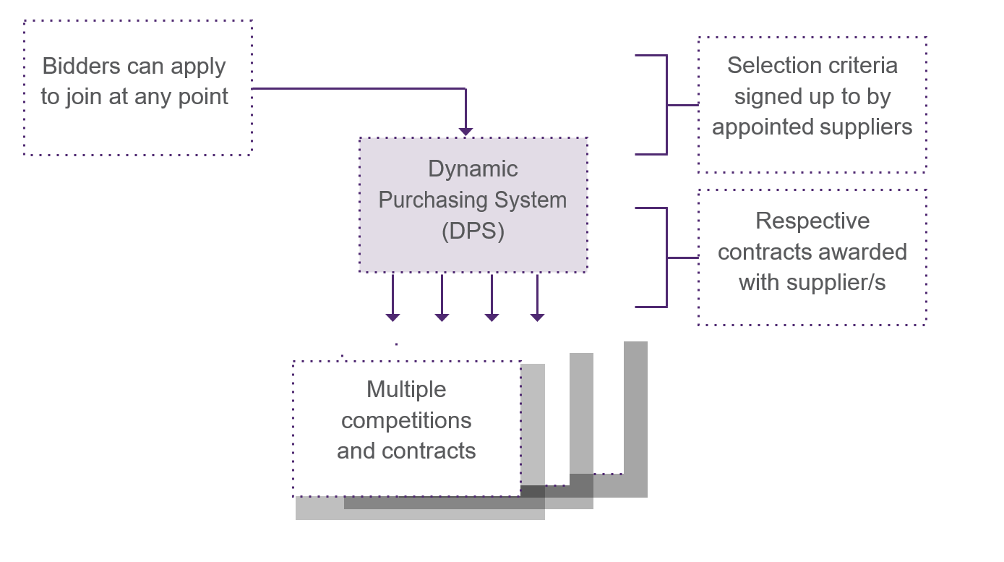

The DPS is a 2-staged approach:

Firstly, CCS publish a contract notice. Suppliers then have a 30 day window to apply for a place on the DPS prior to it being formally launched and open for business. New suppliers can apply to join at any point during the life of the DPS.

After the initial 30 day start-up period has elapsed, buyers can access the DPS, compete their requirements with suppliers and award their contracts.

Key benefits

There are a number of key benefits for buyers using the VCIS commercial agreement. The DPS:

is flexible and new suppliers can apply to join at any point. This increases the potential capacity and capability in the market that is available to you;

offers you more choice through increased scope and scale of service offerings;

allows you to filter supplier service offerings, ensuring that suppliers receive notifications of relevant competitions and that you are dealing with the suppliers who can deliver against your requirements;

is dynamic and allows you to build specifications, competitions and contracts in a way that suits you;

supports localism and social value by enabling suppliers to bid for business either locally, regionally or nationally. It also allows you to undertake competitions on both a local or national basis, depending on your requirements;

gives you the opportunity to access the wider supply chain for specialist services or where a supplier may previously have been a subcontractor;

is a simpler, quicker process and supports SMEs looking to access public sector business; and

is an automated and electronic process using existing supplier selection tools and systems available to you from CCS.

Scope of VCIS agreement

The intent of this agreement is to provide buyers with the full scope of VCIS available in the market which will enable them to define and procure appropriate services and products to meet their individual needs. This includes, but is not limited to, the installation of VCIS for public sector fleets and their workforce, home charging, and vehicle charging facilities which provide a service to the general public in locations such as on-street residential areas and off-street car parks.

Buyers may procure individual services (such as feasibility and consultancy services, hardware only supply or back office services) or a full end to end service, depending on their own requirements. A full list of the products and services available under the DPS can be found in Annex 1.

This agreement can be used by all UK government and public sector bodies which includes:

Central Government Departments, Arm’s Length Bodies and Executive Agencies;
- Non Departmental Public Bodies;
- Devolved administrations;
- Local Authorities;
- NHS bodies;
- Charities; and
- Universities, colleges, schools, further education providers.

The Buyer Journey

This section details how you are able to access the VCIS DPS and undertake a competition amongst suppliers.
You should note that as part of the process for joining the DPS, Suppliers have been asked to self-certify that they are able to meet a range of minimum standards set out in the VCIS Selection Questionnaire. When you have completed your competition and intend to award to a supplier, you should request that the Supplier provides you with the evidence that they meet the Selection Questionnaire standards and undertake compliance checks. This process can be undertaken electronically through the DPS system.
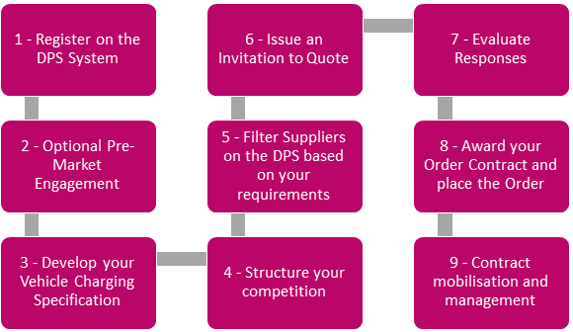

Step 1 - Registering on the System

You will need to register on Supplier Registration Service (SRS), navigate to the DPS for VCIS and access by agreeing to terms of use,
Step 2 - Pre-Market Engagement (optional)
Vehicle Charging is an evolving market. Therefore, you may find it beneficial to develop a specification that not only delivers your short term requirements but also provides flexibility for long term planning. In support of this you may wish to consider undertaking some pre-market engagement, this involves consulting with suppliers before you go out to market which can
- help you refine your business case and benchmark costs;
- define the procurement plan and timetable for implementation;
- help you better understand the vehicle charging sector and what is available in the market to best meet your needs, avoiding unnecessary over specification and costs;
- enable you to ask questions relevant to any potential procurement and support clarifying your specific requirements;
- check what suppliers will need to do to meet your needs in the short and long term, avoiding errors and costly mistakes further down the line,
- be undertaken face to face or remotely
This agreement can support you by providing a list of capable suppliers to invite to your pre-engagement, as outlined in Step 5
Step 3 - Develop your Vehicle Charging Infrastructure Specification
The specification sets out a full and accurate statement of what is required and forms part of the documentation that is sent out to all suppliers when inviting them to quote. It has 3 main aims:
- To communicate to potential suppliers what is required
- To provide a clear and transparent evaluation criteria for proposals to be measured against
- Ensure that open competition is achieved
A good specification should:
- provide a clear and concise description of what is required, including contract management reporting requirements and any Key Performance Indicators (KPIs)
- highlight the features that are essential to you
- provide an opportunity for suppliers to offer technical solutions
- allow potential suppliers to provide a price for the services they offer

Step 4 - Structure the competition
Under a DPS you are able to determine how you structure your contract. This means that you can choose the competition and evaluation criteria to best suit your requirement, in accordance with public procurement regulations. This gives you complete flexibility - for example you may want:
- a short or long term contract;
- to appoint a single supplier for all your vehicle charging requirements, and;
- to separate out your requirements into stages. For example you may prefer to initially undertake some consultancy and feasibility activity, followed by civil engineering and construction, and to award separate contracts for each stage.
Some key specification areas that should be included are:
- Pricing and cost models - You should design a pricing schedule that best fits the end requirement, ensuring clarity and fairness. Best practice would be to consider using whole life cost or total cost of ownership models.
- Evaluation criteria and weightings - Evaluation should concentrate on the supplier’s ability to best meet the outlined requirements and pricing/cost model. The evaluation weightings that you intend to use should be issued as part of your ITQ and you have the flexibility to set your own specific weightings and measures.
- Timescales - You should carefully consider delivery and timescales requirements. Good practice would require suppliers to share their build project plans and regularly communicate updates on delivering against these timescales.
- Financial standing - CCS has tested appointed suppliers’ financial standing at the point of them joining the DPS, and will monitor them through the life of the DPS. For VCIS a threshold Dun and Bradstreet (D&B) score of 45 has been set, so all appointed suppliers will have met or exceeded this score, or their accounts have been reviewed and sufficient financial assurance has been provided.
- Insurances - In order to join the DPS, suppliers have confirmed that they comply with all statutory insurance requirements. You can determine the levels and types of insurances you require as part of your contract, and test this through the competition.
- Key Subcontractors - It is advisable that you seek the detail and assurances of any key subcontractors that will be used by the supplier you appoint as part of their supply chain. This can be asked for as part of the competition, and the contract terms can reflect the requirement to keep you updated with regards to any key subcontractor changes.
- Non-Disclosure Agreements - If your Invitation to Quote (ITQ) includes sensitive or confidential information, you may wish to protect the content of the competition from being released into the public domain. Whilst there are confidentiality clauses in place within the contract template under this DPS, these do not apply until a contract is signed between the Buyer and the successful Supplier. Therefore, you may choose to include an additional layer of confidentiality to protect your brief and the information contained within it by using a Non-Disclosure Agreement (NDA).
Step 5 - Use the Filters to generate a list of capable Suppliers

You can use the DPS filters to reflect your contract requirements, filter the capable suppliers (see Annex 1), and export these as a shortlist to be used when issuing your ITQ or when inviting to your pre-market engagement.
It is important that once you have exported the list of potential suppliers from the DPS system, you run the competition within 48 hours. This is because the DPS is constantly changing as new suppliers join and become eligible to bid for your contract. After 48 hours, the list you have exported could be out of date as the list of eligible suppliers may have changed.
Step 6 - Issue an Invitation to Quote
To ensure compliance with current procurement regulations, you must issue the Invitation to Quote (ITQ) to all capable suppliers. Under a DPS, this means all suppliers on the shortlist obtained after filtering against specific your requirements in Step 5.
Details of the procurement process, timeline, award criteria and evaluation procedure must be published to all capable suppliers at the same time the ITQ is published.
If suppliers ask any clarification questions during the ITQ process, all suppliers must be treated fairly and equally without discrimination. Any questions received must be anonymised, making sure that they do not reveal the identity of the originator, or reveal any potentially commercially sensitive information relating to the originator. Appropriate responses must be issued, sharing both the question and answer to all participating suppliers, at the same time.
Under a DPS, a minimum of 10 calendar days must be allowed for suppliers to submit their bids.
You may use whichever eProcurement system you deem suitable to run your competition. You are also able to make use of the CCS eSourcing Suite which enables you to:
- respond to supplier clarification questions
- track bid responses
- send reminders to bidders
- communicate to successful and unsuccessful suppliers
- provide feedback to all parties
For information on how to do this, please refer to the eSourcing Suite user guidance.
Step 7 - Evaluate Responses
After the bid submission closing date, supplier responses will need to be evaluated in accordance with the evaluation criteria and procedures that were set out within your ITQ. You must ensure that you maintain a fully documented audit trail of the results and final award decision.
Step 8 - Award your Order Contract and place your Order
Awarding the Order Contract
Following evaluation, you can then proceed to request supporting evidence from the supplier(s) intending to be awarded. This can be requested and viewed via the DPS system, using the original DPS session used to shortlist the suppliers. Suppliers will receive a notification of the request to provide supporting evidence via the system, and can choose either to share documentation they have already uploaded to the system with you, or to add new evidence which may be relevant to your specific contract.
Once satisfied with the evidence provided, and with the outcome of the competition, you can proceed to award by notifying suppliers through the eProcurement system you have used to undertake the competition. You should also inform CCS of the award via the DPS system and complete the Buyer Feedback document within Annex 2.
Some buyers are also obliged to publish details of their award on Contracts Finder. You should follow your own organisation’s guidance on this, and can also refer to Procurement Policy Note 07/16.
Placing the Order
This DPS includes a standard set of suggested contract terms and conditions which can be found in Schedule 7 of the DPS Agreement on the VCIS web page. This contract format sets out the legal relationship between the buyer and the supplier. At the time of ordering, the supplier will need to send a signed copy of the contract to you to confirm that the project has been accepted.
Step 9: Contract mobilisation and management
As part of the supplier contract award, you should put the appropriate management processes in place to ensure the supplier is meeting both your reporting and KPIs requirements as set out in your ITQ. CCS can be used as an escalation point to support you with issues of underperformance during the life of the contract.

Managing your contract and being a good Buyer
There are a number of obligations you have in managing your contract, including:
- agreeing at the start of the project how frequently you expect to receive reports from your supplier (if required). This should be in line with the requirements in your specification.
- track and manage project delivery
- communicating with your supplier on a regular basis to discuss progress;
- checking invoices against the rates and deliverables agreed in your contract;
- paying your supplier in line with contract terms;
- promptly manage any issues with your supplier;

Managing issues
By ensuring you have regular communication with your supplier you should be able to avoid any major issues. In the event that you do experience performance issues with your supplier, you should take the following steps to address the issue as quickly as possible.
- Raise the issue with your supplier lead as soon as possible
- Clearly set out your concerns and agree a plan of action with the supplier including a deadline for resolution. You can put in place more frequent status updates if necessary.
- If the issue fails to be resolved to your satisfaction, contact CCS as a point of escalation and support - either via email or via phone on 0345 410 2222.

Useful information

This section provides you with further information you may need to consider as part of your specification development depending on type and location of your organisation.
Devolved Administrations
- Scotland
Transport Scotland has produced guidance and recommendations for electric vehicles (EV) charging equipment to be used as part of the ChargePlace Scotland network. The Common Requirements and Good Practice for the ChargePlace Scotland Network sets out the minimum standards and common requirements for the safe, reliable and efficient operation of EV charge points on the ChargePlace Scotland network. It provides guidance on the following areas:
- minimum common requirements for charging equipment and its installation;
- minimum common requirements for the ChargePlace Scotland Charge Point Network Operator and associated network communications; and other good practice guidance and information resources.

- Wales
There is currently no specific guidance available.
- Northern Ireland
Following a consultation exercise which commenced in 2019 the Utility Regulator published its decision on the application of Maximum Resale Price (MRP) to Ultra Low Emission Vehicles (ULEVs). The decision introduces an exemption to the MRP for the resale of electricity where it relates to the propulsion of ULEVs with effect from 31 March 2020
Office for Low Emission Vehicles (OLEV)
The Office for Low Emission Vehicles (OLEV) is a team working across government to support the early market for ultra-low emission vehicles (ULEV).
OLEV comprises staff and funding from:
- Department for Transport
- Department for Business Innovation & Skills
- Department of Energy & Climate Change
OLEV administers government grant schemes for the installation of electric vehicle charging infrastructure and provide useful advice and guidance for you to consider.
Energy Saving Trust
The Energy Saving Trust is an independent UK-based organisation focused on promoting action that leads to the reduction of carbon dioxide emissions. They are funded by the UK government, devolved governments and the private sector.
Their website contains plenty of useful information which can help with the transition to electric vehicles.
- Switching to Electric Vehicles
- Developing an electric vehicle charging infrastructure
- Fleet Advice
- Local Government Support Programme
- Consumer / fleet driver guidance

The Association for Renewable Energy and Clean Technology (REA)

The REA offers advice and guidance on a range of topics, including electric vehicles. Their website contains useful information that can support transition to electric vehicles.

In March 2020 it was announced that UK Electric Vehicle Supply Equipment Association (UKEVSE) would merge with REA – their procurement guide is now available to download.

- Procurement Guide

Guidance on Outsourcing

In response to a call for greater clarity on approaches to outsourcing services guidance was issued in 2019. This guidance outlines eleven key policies that all central government departments are expected to follow and should be considered best practice for all public sector organisations.

By following the guidelines, rules and principles associated with these new policies, departments can expect to:

get more projects right from the start;

develop robust procurement strategies;

engage with healthy markets;

contract with suppliers that want to work with us; and

be ready for the rare occasions when things go wrong.

Frequently Asked Questions
Q. Can a direct award be made under the VCIS DPS?
No, direct awards cannot be made under the VCIS DPS

Q. How do I register as a buyer?
Buyers register on the Supplier Registration Service, via the ‘Access as a buyer’ link.

Q. Are there template docs for me to use?
There are currently standard terms and conditions and call of templates which can be accessed by buyers. VCIS specific guidance and templates are being developed and will be published in January 2021.

Q. How long does it take to run a competition?
Minimum time to run a further competition under the VCIS DPS is 10 days, as per Regulation 34(11) of the Public Contract Regulations (11). There is no maximum timeline.

Q. Can buyers determine their own specification, evaluation and contract terms?
Yes, buyers can decide upon their own specification, how they wish to evaluate and the contract format they require.

Q. Do I need to publish my award?
Yes - responsibility for publication of award remains with the buyer

Q. Does CCS charge the buyer a commission for using the VCIS DPS?
No. Commission is not charged to the buyer. A supplier rebate of 0.5% is applied.
Q. How do we encourage suppliers to join the VCIS DPS?
Suppliers register on the Supplier Registration Service, and complete the Selection Questionnaire for the DPS they wish to be appointed to.

Q. Are the number of suppliers which can join the VCIS DPS restricted?
No, supplier numbers cannot be restricted under a DPS.

Q. How long will the VCIS DPS operate for and how long can resulting contracts last?
The VCIS DPS will be for a four year term with annual reviews to ensure it remains fit for purpose. CCS will provide three months’ notice should we decide to terminate the arrangement

Q How long can the buyer’s VCIS contacts last?
Buyer’s order contracts can last for as long as is reasonable in the context of the market, and can go beyond the term of the DPS agreement.

Q. Will the VCIS DPS support SMEs and social value?
Yes, the very nature of a DPS with its electronic, automated and standardised approach to selection supports both SME access and social value.

Q. Can buyers determine their own specification, evaluation and contract terms?
Buyers can decide upon their own specification, how they wish to evaluate and the contract format they require provided they remain within the scope of the DPS.

Annex 1: VCIS Products and Services Matrix
Service Filters
The VCIS DPS services filters directly relate to how the Buyer wants to pay/fund the purchase of goods and services - either from their own budget, a grant or by outsourcing to a supplier. The filter options are as follows:
- provision of VCIS Buyer funded products and services;
- provision of VCIS Supplier funded products and services;
- provision of consultancy/feasibility services where the funding route has yet to be decided.
Table A: Buyer Funded VCIS
DPS Level 1 Filter | Funding Option A: Buyer Funded
DPS Level 2 Filter  Location, Products and Services | Installation Location
 | Consultancy and Feasibility
 | Groundworks (Civil Engineering and Construction)
 | Hardware and Accessories
 | Installation and Decommissioning Services
 | Servicing and Maintenance
 | Software and Back Office solutions
 | End to End service

Table B: Supplier Funded VCIS
DPS Level 1 Filter | Funding Option B: Supplier Funded Models
DPS Level 2 Filter  Location, Products and Services | Installation Location
 | End to End Service

Table C: Funding route to be decided
DPS Level 1 Filter | Funding Option C: Funding route to be decided
DPS Level 2 Filter  Location, Products and Services | Installation Location
 | Consultancy and Feasibility

Annex 2 – Buyer Feedback
Once your contract has been awarded to your Supplier(s) please complete the Buyer feedback template below and submit to CCS.

This template will enable CCS to develop robust commercial benefits for this agreement and know when spend is likely to reported for each call off competition.

Further information
If you require any further information please
Contact us at info@crowncommercial.gov.uk
Visit the VCIS webpage https://www.crowncommercial.gov.uk/agreements/RM6213
You can also learn more about Crown Commercial Service at:
Website:  crowncommercial.gov.uk | Twitter:  @gov_procurement | LinkedIn:  Crown Commercial Service

