Call-Off Schedule 15A (Health Supplier and Contract Management)

- DEFINITIONS
  - In this Schedule, the following words shall have the following meanings and they shall supplement Joint Schedule 1 (Definitions):
“Agile” | a generic term to cover agile ways of working within the digital environment;
“Backlog” | has the meaning given to it in paragraph 2.2.1;
“Balanced Scorecard” | has the meaning given to it in paragraph 2.2.8;
“Buyer SM Event” | has the meaning given to it in paragraph 2.2.7;
“Call-Off Contract Management” | has the meaning given to it in paragraph 2.1.2;
“Call-Off Rate Card” | means the table of rates for different roles as captured in Call-Off Schedule 5A (Pricing Details);
“Collaborative Buyer/Supplier Event” | has the meaning given to it in paragraph 2.2.9;
“Commercial Contract Manager” | the commercial contract manager appointed for the Supplier and for the Buyer in accordance with Annex 6 of this Schedule;
“Commercial Planning/Review Events” | has the meaning given to it in paragraph 2.2.4;
“Executive Sponsor” | has the meaning given to it in paragraph 6.26;
"Operational Board" | the board established in accordance with paragraph 2.2.6 of this Schedule;
"Operational Contract Manager" | the operational contract manager appointed for the Supplier and for the Buyer in Annex 6 of this Schedule;
“Operational Planning Event” | has the meaning given to it in paragraph 2.2.2;
“Operational Review Events” | has the meaning given to it in paragraph 2.2.3;
“Orange Book” | means the Orange Book: Management of Risks – Principles and Concepts accessible at: https://assets.publishing.service.gov.uk/government/uploads/system/uploads/attachment_data/file/191513/The_Orange_Book.pdf
“Programme” | means a programme of work, as identified by a portfolio number or equivalent;
“Scrum Sprint” | means a time boxed period of time in which a useable product increment is created per the Scrum Guide™ (an Agile methodology);
“SOW Management” | has the meaning given to it in paragraph 2.1.1; and
“SOW Variation” | has the meaning given to it in paragraph 2.2.5.

- OVERVIEW OF SUPPLIER AND CONTRACT MANAGEMENT
  - There are five levels of relationship and contract management covered by the various parts of this framework:
    - Statement of Work Management (“SOW Management”) covering how Statements of Work (SOWs) are managed. SOW Management starts with SOWs being created and ends, typically with handover to the next SOW, as a SOW ends (see paragraph 3.1);
    - Call-Off Contract Management (“Call-Off Contract Management”) covering the specific contract management obligations between Supplier and Buyer relating to a specific Call-Off Contract (see paragraph 3.8);
    - Buyer/Supplier Management covering individual relationships between the Buyer and a single Supplier. These relationships are anticipated to develop as an early part of Call-Off competition as Suppliers bid for potential work. These relationships are also anticipated to persist beyond individual Call-Offs for the duration of the Framework (and beyond, assuming Call-Offs extend beyond the formal term of the Framework) (see paragraph 3.31);
    - Buyer Specific Framework Management, involving the Buyer and all Suppliers under the Framework with whom the Buyer has a relationship. This level of relationship is anticipated to evolve as Call-Offs are awarded. This level of relationship is anticipated to persist beyond individual Call-Offs (see paragraph 3.40); and
    - Framework Buyer/Supplier Management covering “user group” topics such as:
      - Innovation;
      - New developments in technologies;
      - Changes in digital services (e.g. the incorporation of SFIA 8 and changes to Digital, Data and Technology roles);
      - Opportunities to improve the operation of the overall framework; and
      - Proposed updates to the framework;

  - For the avoidance of doubt, by signing any individual Call-Off Contract, suppliers are obliged to meet the terms of this Schedule, as required by the Buyer, for the durations indicated at each level of relationship.
  - There are a number of key mechanisms for managing this Call-Off Contract set out below. This list is not an exclusive list but is designed to focus on the key principles underpinning each level of management. Also, whilst logically separated below, the Buyer may elect to combine such mechanisms:
    - Product Backlog (Scrum ™) or Prioritised Requirements List (AgilePM®) (the “Backlog”) which, within the context of this Contract, should be considered to be the cornerstone of ongoing operational management. As such it should be considered to be a live contract artefact (see paragraph 4.1);
    - “Operational Planning Events” or equivalent, managing the granular level refinement from Commercial Planning/Review Event level (typically at requirement/Increment level down to Scrum Sprint / Timebox (AgilePM) sized task level (to be held at the frequency given at paragraph 3.6);
    - “Operational Review Events” or equivalent, which provide the basis for among other things, reviewing achievements out of individual Sprints/Timeboxes, learning lessons from the previous activity and understanding the actual effort used. A summary of this will be fed into the Commercial Planning/Review Events (Scrum Sprints or reporting performance and progress of tasks into the Commercial Planning/Review Events is described below at paragraph 3.7);
    - “Commercial Planning/Review Events” (usually combined but may be separate events for planning and review):
      - These events will refine and prioritise the main Backlog (at Deliverable Increment/user story level and above) for feeding into the more detailed SOW task level backlog managed under the Operational Planning Events described above. If the Incremental Fixed Price charging mechanism is in use under a SOW, these events will agree the “price” for a Deliverable Increment (backed up by an estimate of effort linked to the Call-Off Rate Card).
      - From a review perspective, the Commercial Planning/Review Event will assess completeness of tasks and map this into acceptance of Deliverables or Deliverable Increments as well as collate actual effort spent. Acceptance certificates may be used to acknowledge completeness. The review will typically lead to invoicing and payment.
      - Whilst the frequency of Operational Planning Events is likely to reflect the operational practices specific to the SOW, Commercial Planning/Review Events will normally be held on a monthly basis.
      - These events are seen at the main focus points for Call-Off Contract Management activities (see paragraph 3.8).

    - Variation and Change Management covers minor changes to Statements of Work (“SOW Variations”) and more formal changes to the contract (see paragraph 4.2 below);
    - Events such as Operational Board meetings, where the programme or project teams may escalate topics for resolution or where material decisions may need to be made. (see paragraph 6.21 below);
    - “Buyer SM Events” designed to aggregate Call-Off Contract activity into an overarching view of Supplier performance and provide a means to take a holistic view of the performance and relationship with the Supplier as well as address topics escalated from individual Call-Off Contracts. If the Buyer only has one or two Call-Off Contracts with an individual supplier these events may be combined with Commercial Planning/Review Events, however the intent is to focus at the Supplier level rather than the Call-Off Contract level (see paragraph 3.39 below);
    - The “Balanced Scorecard”, providing the mechanism to visually summarise the status of either the Call-Off and/or Supplier performance. Whilst a large individual Call-Off may warrant a dedicated Balanced Scorecard, within the context of this framework it is anticipated the Balanced Scorecard will operate at the overall Buyer/Supplier level (and this is the assumption underpinning the illustrations making up the rest of this Schedule) (see 4.3 below);
    - “Collaborative Buyer/Supplier Events” intended to provide a mechanism to share learning, develop collective improvements, share future plans, and discuss topics which may be forwarded for consideration at the Framework level. (see 3.40 below); and
    - in order to manage the time dimension relevant to the Call-Off Contract the Buyer will require some form of delivery planning. This may be in the form of Gantt charts or project plans, or it may be in the form of agile tools such as roadmaps, Epic boards, Elaboration and/or Sprint Boards, Kanban boards, etc. (see paragraph 4.4 below).
  - Throughout the lifetime of both individual Call-Off Contracts and the framework relationship between the Buyer and Suppliers there are risks. Risk management practices applied at Call-Off Contract level are described further at paragraph 5.
  - Suppliers should be aware that the Buyer will also undertake ongoing Supplier risk management activities (such as ongoing financial credit rating checks) as part of its Call-Off Contract management processes.

- SUPPLIER AND CONTRACT MANAGEMENT LEVELS

Statement of Work Management
  - Other than the first SOWs under a Call-Off Contract, which will be defined by the Buyer, SOWs will generally be developed involving joint exploratory discussions between the Buyer and the Supplier. Generally speaking, inputs to the SOW are likely to include:
    - some form of road map (the context);
    - initial views on initial resource profile and technology stack and so on, used to inform the sizing of the SOW;
    - which Accountability Model (Sole Responsibility, Self-Directed Teams or Rainbow), each as defined in Framework Schedule 1 (Specification); and which pricing mechanism (Fixed Price, Capped Time and Material, or Incremental Fixed Priced); and
    - an initial Backlog (detailing requirements at an appropriate level of detail), provisional resource profile and technologies.
  - The operation of the Backlog is described under paragraph 4, however, at operational level it is intended to be the basis for agreeing, accepting and capturing tasks as well as related effort. There shall be a continuous alignment between the main Backlog held at Call-Off Contract level and any SOW Backlog (the Call-Off Contract level Backlog focuses on Deliverable Increments whilst the SOW Backlog level focuses on the more detailed tasks). At SOW level the Backlog should largely be operational and should be being refined to a level that can be allocated to the next sprint, timebox or equivalent (aiming to task size).
  - In addition to the Backlog, there will be information required by the Buyer for the purposes of recording resources (e.g. for controlling access to infrastructure), measuring performance (e.g. burn charts, etc), evidencing delivery (e.g. acceptance certificates) and so on. Annex 1 provides a provisional, non-exclusive, list of information types which may be used by the Buyer to initially specify typical requirements.
  - Whilst individual SOWs may operate under the Fixed Price or Incremental Fixed Price pricing mechanisms, all Call-Off Contracts shall be underpinned by an agreed set of Supplier Call-Off Rate Cards. Under all circumstances, regardless of pricing model, Suppliers shall maintain an accurate record of actual resource utilisation and to make this available to the Buyer on request.
  - When capturing effort, the Supplier is required to link such effort to the SOW and to the respective entry on the applicable Call-Off Rate Card as well as include period start and end date and utilised effort (in hours, days or fractions thereof as determined by the Buyer).
  - Operational Planning Events will be held at a frequency determined by the Buyer. The purpose will be to agree the next iteration of work (e.g. Scrum Sprint) and to refine the Backlog. The principle of ongoing refinement is a key Agile concept.
  - Operational Review Events will be held at a frequency determined by the Buyer. Typically, these will be at regular intervals (e.g. every month or every Scrum Sprint). Two contractual related purposes of Operational Review Events are to:
    - identify when tasks are completed and provide evidence to the Commercial Planning/Review Events that work is “done”; and
    - capture actual effort taken (versus the forecast) as a means of improving future estimates and providing the raw data for invoicing purposes.

Call-Off Contract Management
  - Within the context of this Call-Off Contract, taking into account the other levels of contract management, the primary purpose of Call-Off Contract Management includes:
    - establishing and managing the information flows relevant to the Call-Off Contract;
    - managing the overarching Backlog and ensuring it is continuously refined to reflect the evolving work;
    - establishing new SOWs, providing oversight of SOWs in progress and ensuring handover between SOWs as appropriate;
    - acting as the bridge between SOW management (operational) and commercial matters such as raising and managing invoices and payment, and tracking and managing commitment and spend against the overall Call-Off Contract value estimate;
    - providing oversight of the resources (Supplier Staff, Subcontractors, etc.) required to deliver the Deliverables under the Call-Off Contract;
    - creating and maintaining Implementation Plans (as set out in Call-Off Schedule 13A (Health Implementation Plan and Testing);
    - co-ordinating with stakeholders and the Operational Board if applicable;
    - managing overall Call-Off Contract level risks, issues, escalations and commercial matters;
    - managing formal Variations;
    - acting as the linkage point into Buyer/Supplier Management;
    - maintaining and updating the Contract specific Call-Off Rate Card(s);
    - contributing to the maintenance of programme/project artifacts such as business cases, procurement packages, roadmaps, etc;
    - ensuring smooth transition and hand-over to the recipient of Deliverables (always the Buyer, but it may also be to another supplier if there is another major phase of work to be undertaken by the other supplier under a separate Call-Off Contract or SOW); and
    - monitoring Supplier performance against Material KPIs.
  - Typically, the Buyer shall expect oversight of SOWs to form part of the role of a core team who will persist for the duration of the Call-Off Contract. The Buyer shall consider executing a dedicated SOW (typically a rainbow team, on a Capped Time and Materials basis) for defining and managing Call-Off Contract Management activities. This would be in addition to any specific delivery SOWs. This role is not anticipated to be full time, but rather periodic (e.g. no more than a few days per month). If a single SOW is operating at any given time, the role may to be combined with others.
  - Whereas SOWs will often be sequential, there is no restriction on the number of SOWs that are able to be effective at any point in time. Likewise it is highlighted that Service Provisions under this framework are not lots. This means a Call-Off Contract may involve more than one Service Provision (with individual SOWs possibly commissioned to deliver distinct services).
  - The above activities are logically defined under the heading of Call-Off Contract Management for the purposes of this Call-Off Contract however the Buyer may choose to capture the above requirements in a manner of their own choosing.

Establishing and Managing Information Flows
  - Annex 2 provides an initial list of information which may be requested by the Buyer in connection with Call-Off Contract Management. The Buyer may add to this list at any point in time by notifying the Supplier in writing.
  - The information set out in Annex 2 shall be expected to be kept up to date by the Supplier at the refresh frequency set out in that Annex. The Supplier is required to maintain tight version control and, where noted, obtain Buyer approval to updates as the work progresses.

Managing the Backlog
  - The Backlog is a key artifact for Call-Off Contract Management. The Backlog shall track Deliverable Increments as they are refined during the Call-Off Contract Period, will identify which SOWs cover each Deliverable Increment, will size them (and cost them under either the Fixed Price or Incremental Fixed Price models),will provide the basis for “accepting” them and will track various other information as set out in Annex 4.
  - Whilst the Buyer may choose to have a single Backlog covering each SOW and the Call-Off Contract, at Call-Off Contract level the Backlog is intended to capture the Deliverable Increments whilst delegating the detailed task-level management down to the SOW Backlog.
  - Payment under the either the Fixed Price or Incremental Fixed Price pricing mechanism will be based on the price agreed in advance. However, the Supplier will be expected to provide a resource estimate which, when combined with Call-Off Rate Card prices, will provide the transparent basis for the fixed price.
  - The Buyer may elect to use acceptance certificates for all Deliverable Increments agreed as “done” or only for key Deliverable Increments. Under the Fixed Price or Incremental Fixed Price pricing mechanisms, there shall be a clear linkage between an invoiced amount and the relevant Deliverable Increment.
  - In all cases there shall be a clear linkage between the Backlog and invoices submitted.
  - Invoice frequency may not align with Operational Review Events (e.g. invoicing may be monthly but review/planning events every two weeks). Under such circumstances, for clarity of receipting and audit purposes, unless agreed otherwise by the Buyer, work yet to be accepted at the Commercial Planning/Review Event shall be held back to the next appropriate invoice period.

Oversight of Statements of Work
  - Subsequent to the first SOW, new SOWs will be created and agreed under the concept of Call-Off Contract Management. It is anticipated that the team involved in Call-Off Contract Management shall develop the SOW requirements, work with the Supplier to agree the content of the SOW, and decide on the resourcing and pricing models prior to signing off the SOW.
  - It is the responsibility of the respective Commercial Contract Managers to ensure SOWs are within the scope of the overarching Call-Off Contract and that budget is available under the Call-Off Contract.
  - It is envisaged that minor variations to in-place SOWs will be coordinated under the concept of Call-Off Contract Management

Providing oversight of resourcing
  - Whilst detailed planning of resource allocation to SOW tasks is handled at SOW Management level, there is an ongoing requirement to understand the total resourcing view and where resourcing is deployed at the Call-Off Contract level.
  - Under the Rainbow Team Accountability Model, the Buyer may have mandatory induction processes to be followed. The Supplier shall ensure that all such requirements are met where required prior to beginning work under any Call-Off Contract or SOW.
  - The Supplier is also responsible for ensuring that its staff (directly or indirectly employed) perform any data handover / cleansing obligations where applicable at the end of a Call-Off Contract. Call-Off Contract Management is accountable for ensuring this is done.

The bridge between SOW Delivery and payment / Call-Off Contract budget management
  - The Supplier shall, at all times, maintain an audit path linking delivery information together with invoice information.
  - In an Agile environment, the contract value agreed at Call-Off Contract level is typically a maximum possible value rather than a committed sum. Subject to the terms of this Call-Off Contract, committed charges shall be set out in each SOW.
  - At all times, the Supplier shall track budgets, forecasts and actuals at purchase order level, SOW level and Call-Off Contract level and shall provide a level of granularity (e.g. monthly) as required by the Buyer.
  - The Supplier shall update such financial summaries to reflect any changes agreed under the formal Variation process.
  - The Supplier shall notify the Buyer of any forecast overspend at least 60 days in advance of such an overspend occurring.

Buyer/Supplier Management
  - Buyer/Supplier Management covers the overall relationship between Buyer and Supplier. If there is only one Call-Off Contract in place between the Buyer and Supplier the below activities may be combined under Call-Off Contract Management. However, Buyer/Supplier Management contains obligations which extend beyond specific Call-Off Contracts as set out below.
  - Buyer/Supplier Management is considered to formally start on the commencement of the Call-Off Contract. However, it is anticipated that Suppliers start to engage in Buyer/Supplier Management on an informal basis as they first become involved in a Further Competition Procedure.
  - From the Call-Off Contract Start Date the Supplier shall nominate a Buyer Account Manager and the Buyer shall nominate a Supplier Manager
  - It is expected, as part of non-Call-Off Contract-specific Supplier engagement, that the Supplier makes efforts to “understand” the Buyer. In order to improve competition and ensure a level playing the Buyer shall support attempts by the Supplier to “understand” the Buyer, without prejudicing any Further Competition Procedure.
  - It is recommended that, where a Supplier has not previously had a relationship with the Buyer, or specific relevant parts of the Buyer’s business, that “get to know events” are facilitated by the Buyer.
  - Buyer/Supplier Management is considered to end on the End Date of the last effective Call-Off Contract between the Buyer and Supplier.
  - Whilst it is recognised that Buyer/Supplier Management may be incorporated within Call-Off Contract Management, there is certain information which may be aggregated up or is pertinent to the relationship with the Supplier. Examples of such information are listed under Annex 3.
  - On an ongoing basis, the Buyer and Supplier shall collaborate to ensure appropriate prioritisation of resources, focus and continuous improvement across all Call-Off Contracts between the Buyer and the Supplier.
  - Buyer SM Events, for handling the above matters, shall be held at a frequency determined by the Buyer.

Collaborative Buyer/Supplier Events
  - Periodically, the Buyer may elect to meet with all Suppliers with whom it has Call-Off Contracts or who are actively participating in Framework business with the Buyer.
  - Typically such events will be held quarterly, but the frequency shall be determined by the Buyer. Suppliers should make every reasonable effort to participate in, and contribute to, such events.
  - The purpose of such events will typically be to:
    - provide the Buyer with the opportunity to share, on an equitable basis, future pipelines of work;
    - provide the Buyer with the opportunity to share future technology trends from the Buyer’s perspective;
    - provide Suppliers with the opportunity to suggest overall improvements to the way the Framework Contract is working with the Buyer;
    - share emerging technologies coming out of Supplier activities;
    - identify where there may be market shortages in skills and discuss mechanisms (training, knowledge sharing, buddying/mentoring, etc.) to address such shortages;
    - agree proposals for possible changes to be considered by CCS;
    - discuss opportunities to improve the operation of the overall Framework Contract;
    - discuss proposed updates to the Framework Contract; and
    - any other activity which may be proposed by the Buyer.
- KEY MECHANISMS
  - Product Backlog (Scrum®) or Prioritised Requirements List (AgilePM®) or equivalent:
    - Typical information to be held in the Backlog may be found in Annex 4;
    - The Backlog should be considered to be the operational equivalent of a change control log capturing refinements, changes, additions and deletions. The Backlog demonstrates the value delivered (even if only at Deliverable Increment) and provides an indicator on how much change the project/programme has had to absorb;
    - The Backlog evidences value delivered; and
    - Since the Backlog captures ongoing refinement, Variations should only be required to changes to funding, scope and high level Milestones/timescales.
  - Variation and Change Management
    - The term “SOW Variation” is used to describe changes to budget, timescales, and scope at the SOW level. Other than the Buyer ensuring finances are still available and that the scope of the SOW remains inside the Call-Off Contract, such SOW Variations are intended to be managed within the Call-Off Contract. As such extended Buyer governance is not anticipated.
    - The term “Variation”, in this context, is used to describe changes to overall contract value, overall contract milestones and/or term and where overall scope requires to change and such Variations shall follow the procedure set out at Clause 24.
    - The Supplier is required to maintain copies of all Variation and SOW Variation documentation.
  - Balanced Scorecard
    - Where the Buyer determines, the Supplier shall work with the Buyer to develop the detail of a Balanced Scorecard.
    - The Buyer shall give notice to the Supplier as to when the Balanced Scorecard shall become effective.
    - The principles outlined in Procurement Policy Note 09/16: Procurement for Growth Balanced Scorecard (or any later replacement) shall apply.
    - The Parties shall refer to the Balanced Scorecard Paper, Annex A: Diagram and Annex B: Strategic Themes and Critical Success Factors associated with Procurement Policy Note 09/16 (or latest equivalents) when formulating a Balanced Scorecard.
    - The Buyer may elect to apply a Balanced Scorecard either per Call-Off Contract or at Supplier level.
    - The frequency of update to the Balanced Scorecard shall be determined by the Buyer (but will generally align with Commercial Planning/Review Events at Call-Off level and/or Buyer SM Events at Supplier level).
    - An example of a Balanced Scorecard may be found in Annex 5.
- RISK MANAGEMENT
  - Reference is made to the HM Treasury Green Book supplementary guidance on risk (https://www.gov.uk/government/publications/green-book-supplementary-guidance-risk).
  - In particular, the principles and concepts contained in the Orange Book shall underpin the risk management practices implemented under this Schedule.
  - Both Parties shall pro-actively manage risks attributed to them under the terms of this Call-Off Contract.
  - The Buyer will aim to ensure that the placement of risk is appropriate (i.e. risk is placed where it can be influenced).
  - The Supplier shall develop, operate, maintain and amend, as agreed with the Buyer, processes for:
    - the identification and management of risks;
    - the identification and management of issues; and
    - monitoring and controlling project plans.
  - The Supplier shall allow the Buyer to inspect at any time within the Supplier’s working hours the accounts and records which the Supplier is required to keep.
  - The Supplier will maintain a risk register of the risks relating to the Call-Off Contract which the Buyer and the Supplier have identified.
  - The Buyer may elect, at any point in time, to conduct ongoing Supplier risk management as follows:
    - the Buyer may choose to use credit rating checks (such as those offered by Experian and Dun & Bradstreet) to monitor the financial health of the Supplier;
    - should the Buyer determine that a Supplier could be at financial risk, the Buyer may request financial details (including current unpublished accounts) in order to better understand any risk which could have an impact on the Call-Off Contract;
    - on request by the Buyer, the Supplier shall provide and work to a financial risk mitigation plan as a means of protecting the interests of the Buyer; and
    - the Supplier shall take reasonable steps to ensure the financial health of any Subcontractors it engages with. In the event of a potential risk with any Subcontractor the Supplier shall notify the Buyer of such risks and the mitigation actions it is taking to protect the interests of the Buyer.
- KEY ROLES
  - Key Roles and Key Staff are identified and named in each SOW.
  - The Supplier and the Buyer shall each nominate an Operational Contract Manager for the purposes of this Call-Off Contract through whom the provision of the Deliverables shall be managed day-to-day.
  - The Supplier and the Buyer shall each nominate a Commercial Contract Manager for the purposes of this Call-Off Contract through whom commercial matters may be escalated as and when needed and at a regular frequency as determined by the Parties.
  - The Parties shall ensure that appropriate resource is made available on a regular basis such that the contract management aims, objectives and specific provisions of this Call-Off Contract can be fully realised.

Operational Contract Managers
  - Operational contract management shall cover matters including:
    - developing technical scope for individual SOWs;
    - ongoing joint management of Backlog item lists;
    - resource monitoring; and
    - progress against Deliverables and reporting and receipting of the same.
  - The Supplier's Operational Contract Manager shall be:
    - the primary point of contact to receive operational communications from the Buyer and will also be the person primarily responsible for providing operational information to the Buyer;
    - able to delegate his position to another person at the Supplier but must inform the Buyer before proceeding with the delegation and it will be delegated person's responsibility to fulfil the Operational Contract Manager's responsibilities and obligations;
    - able to cancel any delegation and recommence the position himself; and
    - replaced only after the Buyer has received notification of the proposed change.
  - The Buyer’s Operational Contract Manager is the Buyer side of the Operational Contract Management relationship, providing operational communications to the Supplier, acknowledging receipt of Deliverables, and having equivalent obligations with respect to delegation and notification of any changes.
  - The Buyer may provide revised instructions to the Supplier's Operational Contract Manager in regards to the operation of the Call-Off Contract and it will be the Supplier's Operational Contract Manager's responsibility to ensure the information is provided to the Supplier and the actions implemented.
  - Receipt of communication from the Supplier's Operational Contract Manager by the Buyer does not absolve the Supplier from its responsibilities, obligations or liabilities under the Call-Off Contract.

Commercial Contract Managers
  - Commercial Contract Management shall cover matters including:
    - development of commercial scope for individual SOWs;
    - ensuring compliance with Call-Off Contract terms;
    - oversight of commercial performance of the Call-Off Contract; and
    - resolution of commercial issues, including any need for contractual dispute resolution or escalation.
  - The Supplier's Commercial Contract Manager shall be:
    - the primary point of contact to receive commercial communications from the Buyer and will also be the person primarily responsible for providing commercial information to the Buyer;
    - able to delegate his position to another person at the Supplier but must inform the Buyer before proceeding with the delegation and it will be delegated person's responsibility to fulfil the Commercial Contract Manager's responsibilities and obligations;
    - able to cancel any delegation and recommence the position himself; and
    - replaced only after the Buyer has received notification of the proposed change.
  - The Buyer’s Commercial Contract Manager is the Buyer side of the Commercial Contract Management relationship, providing commercial communications to the Supplier and having equivalent obligations with respect to delegation and notification of any changes.
  - The Buyer may provide revised instructions to the Supplier's Commercial Contract Manager in regards to the commercial aspects of the Call-Off Contract and it will be the Supplier's Commercial Contract Manager's responsibility to ensure the information is provided to the Supplier and the actions implemented.
  - Receipt of communication from the Supplier's Commercial Contract Manager by the Buyer does not absolve the Supplier from its responsibilities, obligations or liabilities under the Call-Off Contract.

Supplier Manager and Account/Buyer Manager
  - The Buyer side Supplier Manager, if named by the Buyer, is the individual with oversight of the Supplier as a whole and shall be the prime contact for the Supplier’s Account/Buyer Manager.
  - Buyer matters which are not able to be dealt with at the Call-Off Contract level shall be escalated to the Supplier Manager.
  - The role shall delegate to the Buyer’s Commercial Contract Manager if not named.
  - The Supplier side Account/Buyer Manager, if named by the Supplier, is the individual with the relationship with the Buyer as a whole and shall be the prime contact for the Buyer’s Supplier Manager.
  - Supplier matters which are not able to be dealt with at the Call-Off Contract level shall be escalated to the Supplier’s Account/Buyer Manager.
  - The role shall delegate to the Supplier’s Commercial Contract Manager if not named.

Contract Boards
  - One or more Contract Boards may, at the Buyer’s sole option be established for the purposes of this Call-Off Contract. At minimum the Supplier and the Buyer shall be represented on the board.
  - Where required, the board members, frequency and location of board meetings and planned start date by which the board shall be established shall be set out in Annex 6.
  - In the event that either Party wishes to replace any of its appointed board members, that Party shall notify the other in writing for approval by the other Party (such approval not to be unreasonably withheld or delayed). Each Buyer board member shall have at all times a counterpart Supplier board member of equivalent seniority and expertise.
  - Each Party shall ensure that its board members shall make all reasonable efforts to attend board meetings at which that board member’s attendance is required. If any board member is not able to attend a board meeting, that person shall use all reasonable endeavours to ensure that a delegate attends the Operational Board meeting in his/her place (wherever possible) and that the delegate is properly briefed and prepared and that he/she is debriefed by such delegate after the board meeting.
  - The purpose of the board meetings will generally be to review the performance of the Call-Off Contract. The agenda for each meeting shall be set by the Buyer and communicated to the Supplier in advance of that meeting.

Executive Sponsors
  - Each party may elect to nominate an Executive Sponsor for the purposes of ensuring corporate alignment with the overall Buyer/Supplier relationship as well as acting as a point of escalation to assist in removing potential corporate blockers.
- KEY INFORMATION
  - The Buyer requires the Supplier to provide the management information as identified in the Annexes to this Schedule. These requirements are without limitation to the Buyer’s right to require the submission of information, reports, records and data as set out elsewhere in the Call-Off Contract.
  - The Supplier shall, within 30 days of the earliest of:
    - the date which is 30 days before the end of the Call-Off Contract Period;
    - receipt of a Termination Notice;
    - notification by the Buyer of an actual or intended Service Transfer; or
    - a written request by the Buyer,

provide the Buyer with a complete set of up to date information in respect of all types of information set out in the Annexes.
- INVOICING AND PAYMENT
  - The frequency of invoicing shall be on a Monthly basis, unless agreed by the Buyer, in writing, as otherwise.
  - Invoices for the preceding Month shall be submitted within 10 Working Days of the end of the Month unless agreed, in writing, by the Buyer as otherwise.
  - Separate invoices shall be provided for each SOW, clearly identifying the Call-Off Contract and SOW which the invoice relates to.
  - The information to be provided by the Supplier with each Invoice shall be that identified in Annex 7.
  - In order to facilitate prompt payment of invoices, the Supplier shall coordinate with the Buyer to ensure acceptance of Deliverables completed.
  - The Buyer shall notify the Supplier of any incorrect Invoice submissions within 5 Working Days of receipt. Incorrect invoices shall include (without limitation) invoices for work which has not been accepted by the Buyer and invoices based on incorrect rates. The Supplier shall resubmit invoices once corrected.
  - Unless otherwise agreed, the Buyer shall pay all accepted invoices within 30 days of submission.
- MATERIAL KPIs
  - The Supplier’s performance shall be measured by the Material KPIs set out in the Order Form.
  - The Supplier shall comply with the Material KPIs and establish processes to monitor its performance against them and the Supplier’s achievement of Material KPIs shall be reviewed during Commercial Planning/Review Events.
  - The Buyer reserves the right to adjust, introduce new, or remove Material KPIs throughout the Call-Off Contract Period, however any significant changes to Material KPIs shall be agreed between the Buyer and the Supplier in accordance with the Variation Procedure.
  - The Buyer reserves the right to use and publish the performance of the Supplier against the Material KPIs without restriction.
  - In the event that the Buyer and the Supplier are unable to agree the performance score for any Material KPI during a Commercial Planning/Review Event, the disputed score shall be recorded and the matter shall be referred to the Buyer Authorised Representative and the Supplier Authorised Representative in order to determine the best course of action to resolve the matter (which may involve organising an ad-hoc meeting to discuss the performance issue specifically).
  - In cases where the Buyer Authorised Representative and the Supplier Authorised Representative fail to reach a solution within a reasonable period of time, the matter shall be referred to the Dispute Resolution Procedure.
  - Failures to meet Material KPIs shall be addressed in accordance with Paragraphs 5.4 and 5.5 of Framework Schedule 4 (Framework Management).

Annex 1: SOW Management Related Information

Topic | Frequency or Details
Operational Planning Event Frequency | [insert frequency]
Operational Review Event Frequency | [insert frequency]

The following table provides a list of information required by the Buyer as part of the SOW Management process.

Notes:
- There are some artifacts which held at Call-Off Management level which could equally apply at this level. Please read that list too (Annex 2).
- Supplier and Subcontractor related topics are covered under Buyer/Supplier Management
- This list is non-exclusive, and the Buyer may elect to include other information.

Ref. | Type of Information | Required? | Refresh Frequency
A1.01 | Backlog (Task level) | Yes | Operational Planning Event
A1.02 | Forecast Resource Profile | Yes | Operational Planning Event
A1.03 | Actual Resource Utilisation | Yes | Operational Review Event
A1.04 | Task Completion Status | Yes | Operational Review Event
Typical Agile Artifacts
A1.10 | Sprint Burndown Report | [Yes/No] | [specify]
A1.11 | Velocity Chart | [Yes/No] | [specify]
A1.12 | Epic and Release Burndown Chart | [Yes/No] | [specify]
A1.13 | Agile Control Chart | [Yes/No] | [specify]
A1.14 | Cumulative Flow Diagram | [Yes/No] | [specify]
A1.15 | Value Delivered Chart | [Yes/No] | [specify]
A1.16 | Work Item Age Chart | [Yes/No] | [specify]

Annex 2: Call-Off Contract Management Information

Topic | Frequency or Details
Commercial Planning/Review Event Frequency | [insert frequency]

The following table provides a list of information required by the Buyer as part of the Call-Off Contract Management process (note that this is a logical model and the Buyer may elect to operate “events” under different labels).

Notes:
- This list is non-exclusive, and the Buyer may elect to include other information.
- This list is also illustrative and non-exhaustive. It is anticipated the Buyer will review and edit these tables as part of preparing a Call-Off Contract (and reserves the right to amend during the Call-Off Contract Period).

Ref. | Type of Information | Required? | Refresh Frequency
Contract Management Artifacts
A2.01 | Backlog (Deliverable Increment Level) (including agreements to Acceptance, Pricing, Status, etc – see Backlog for details) | Yes | Commercial Planning / Review Event
A2.02 | List of Supplier Staff including: SOW, Unique ID, Name, Job Role, link to Call-Off Rate Card, rate, Start Date, End Date, Planned Days, Forecast Days, Actual Days, Security Level, Contractor Status, IR35 determination, etc as specified by the Buyer) | Yes | Commercial Planning / Review Event
A2.03 | Cost/Spend Cash Flow Data including: SOW, Budget, Forecast, Actual, links to POs, Variations, etc as specified by the Buyer | Yes | Commercial Planning / Review Event
A2.04 | Risks, Issues (and Opportunities) Log including impact assessment, mitigation details, etc. | Yes | Commercial Planning / Review Event
A2.05 | Any remediation plans agreed, and any progress against an agreed remediation plan. | Yes | Commercial Planning / Review Event
A2.06 | Statement of any commercial issues by the Supplier during that period (late payment). Report of resolution of any previously noted items. | Yes | Commercial Planning / Review Event
A2.07 | Copies of notices received and/or issues by the Buyer, and referrals to any Dispute Resolution Procedure | Yes | On demand by the Buyer
A2.08 | Variations detailing material changes to scope, cost, major milestones and/or overall timescales | Yes | On demand by the Buyer
A2.09 | Stakeholder Map | [Yes/No] | On demand by the Buyer
A2.10 | Communications Plan | [Yes/No] | On demand by the Buyer
A2.11 | Copies of all Contract related documents including referenced documents, relevant Sub-Contracts and any ancillary documents (including amendments) | [Yes/No] | On demand by the Buyer
A2.12 | Current contact and address for notices under the Call-Off Contract. | Yes | Immediate and updates following any changes

Ref. | Type of Information | Required? | Refresh Frequency
Typical AgilePM® Products (ref: Agile Project Management Handbook by the DSDM® Consortium)
A2.20 | Terms of Reference | [Yes/No] | [specify]
A2.21 | Business Case | [Yes/No] | [specify]
A2.22 | Solution Architecture Definition | [Yes/No] | [specify]
A2.23 | Development Approach Definition | [Yes/No] | [specify]
A2.24 | Delivery Plan (also under Implementation Plans) | [Yes/No] | [specify]
A2.25 | Timebox Plans (also under Implementation Plans) | [Yes/No] | [specify]
A2.26 | Timebox Review Records | [Yes/No] | [specify]
A2.27 | Management Approach Definition | [Yes/No] | [specify]
A2.28 | Feasibility Assessment | [Yes/No] | [specify]
A2.29 | Foundations Summary | [Yes/No] | [specify]
A2.30 | Project Review Report | [Yes/No] | [specify]
Other Agile Products (courtesy Blended Agile Delivery www.thebadtoolkit.com)
A2.40 | VMOST Mission Boards | [Yes/No] | [specify]
A2.41 | ROI Projections | [Yes/No] | [specify]
A2.42 | EPIC Board (also under Implementation Plans) | [Yes/No] | [specify]
A2.43 | User Stories | [Yes/No] | [specify]
A2.44 | Release Propositions | [Yes/No] | [specify]
A2.45 | Proof of Concepts (POCs) / Spikes | [Yes/No] | [specify]
A2.46 | Designs / UX (User Functionality) | [Yes/No] | [specify]
A2.47 | Business Architecture Changes | [Yes/No] | [specify]
A2.48 | Data Changes | [Yes/No] | [specify]
A2.49 | Candidate Architectures | [Yes/No] | [specify]
A2.50 | PTEST Requirements | [Yes/No] | [specify]
A2.51 | Elaboration Boards (also under Implementation Plans) | [Yes/No] | [specify]
A2.52 | Spring Boards (also under Implementation Plans) | [Yes/No] | [specify]
A2.53 | Delivery Metrics | [Yes/No] | [specify]
A2.54 | Health Checks | [Yes/No] | [specify]

Ref. | Type of Information | Required? | Refresh Frequency
Contributions to Other Programme / Project Management Artifacts (not listed above)
A2.60 | Technical Requirements (Functional / Non-Functional) | [Yes/No] | [specify]
A2.61 | Technical Constraints (e.g. compatibility with existing systems) | [Yes/No] | [specify]
A2.62 | Pre-procurement support activities | [Yes/No] | [specify]
A2.63 | Make or Buy Analysis | [Yes/No] | [specify]
A2.64 | Technical Stack Specification | [Yes/No] | [specify]
A2.65 | Technical Road Map | [Yes/No] | [specify]
A2.66 | Target Operating Model | [Yes/No] | [specify]
A2.67 | Skills Requirements Profile | [Yes/No] | [specify]

Ref. | Type of Information | Required? | Refresh Frequency
Security and Personal Data Reporting Information
A2.70 | DSP Toolkit Submissions | [Yes/No] | [At Call-Off award]  [On demand by the Buyer]  [Annually in arrears]
A2.71 | Copies of required security clearance certificates for all staff (where staff process Patient Identifiable Data or are on Buyer Premises or access Buyer Systems) | Yes | [On demand by the Buyer]  [In advance of commencement of activity]
A2.72 | Unique individual identifier number and full name of staff handling Patient Identifiable Data (where staff process Patient Identifiable Data or are on Buyer Premises or access Buyer Systems) | Yes | [On demand by the Buyer]  [In advance of commencement of activity]
A2.73 | Updated DPIA | Yes | [At Call-Off award]  [On demand by the Buyer]  [At each Variation impacting data processing]
A2.74 | Completed ISM Document Set | [Yes/No] | [On demand by the Buyer]
A2.75 | Evidence of data destruction certification | Yes | [On demand by the Buyer]
A2.76 | Notices of any breach of data provision or security provisions | Yes | [On occurrence]

Ref. | Type of Information | Required? | Refresh Frequency
Handover / Exit Related Information
A2.80 | Records required by Law as they relate to the provision of the services (including in relation to health and safety matters and health and safety files), such records to be prepared in accordance with any applicable laws or regulations. | Yes | On demand by the Buyer
A2.81 | All training, implementation, operation and maintenance manuals related to the provision of the Deliverables. | [Yes/No] | On demand by the Buyer
A2.82 | All certificates, licences, registrations or warranties related to the provision of Deliverables | [Yes/No] | On demand by the Buyer
A2.83 | Exit Plan (and any requested updates) | [Yes/No] | (see Call-Off Schedule 10: Exit Management)

Ref. | Type of Information | Required? | Refresh Frequency
TUPE Information
A2.90 | Details of service functions that have provided services to the Buyer, and the denoting characteristics that delineate the functions (including but not limited to function code references and names used on the Supplier’s finance system, and period of time for which such code has existed). | [Yes/No] | On demand by the Buyer
A2.91 | Details of the number of customers supported by the Supplier’s named service functions. | [Yes/No] | On demand by the Buyer
A2.92 | The Staffing Information (as defined in Call-Off Schedule 2 (Staff Transfer) Buyer in relation to an anticipated potential Service Transfer or as required to be provided under the Schedule | [Yes/No] | On demand by the Buyer

Annex 3:
Buyer/Supplier Management Information
Topic | Frequency or Details
Buyer SM Event Frequency | [insert frequency]

The following table provides a list of information required by the Buyer as part of the Buyer/Supplier Management process (note that this is a logical model and the Buyer may elect to operate “events” under different labels).

Notes:
- This list is non-exclusive, and the Buyer may elect to include other information.
- This list is also illustrative and non-exhaustive. It is anticipated the Buyer will review and edit these tables as part of preparing a Call-Off Contract (and reserves the right to amend during the Call-Off Contract Period).
- Information which could be seen to be advantageous to all Suppliers or which would be of benefit to all parties are dealt with under Buyer Specific Framework Management.

Ref. | Type of Information | Required? | Refresh Frequency
Supplier and Sub-Contract Related Information
A3.01 | Report from the Supplier of any change to its financial standing / any change to its group structure. | Yes | On demand by the Buyer
A3.02 | Request for use of any additional Subcontractors not forming part of the original Framework either:  - As part of a proposed response to a new Further Competition Procedure; or  - During execution of an existing Call-Off Contract | Yes | Prior to competition.  Prior to mobilisation  (as appropriate)
A3.03 | Written confirmation by the Supplier, confirmed in writing by the Subcontractor(s), that they have in a place a contract which mirrors the provisions of the Call-Off Contract with the Supplier | [Yes/No] | On demand by the Buyer
A3.04 | Written assurance by any Subcontractor that the provisions under A3.03 are also cascaded down their supply chain | [Yes/No] | On demand by the Buyer
A3.05 | Copies of published financial accounts | [Yes/No] | On demand by the Buyer
A3.06 | In the event of the Buyer becoming aware of any financial difficulties being faced by the Supplier (as reasonably judged by the Buyer), copies of current accounts (whether published or not) | [Yes/No] | On demand by the Buyer

Ref. | Type of Information | Required? | Refresh Frequency
Aggregated Views
A3.10 | Summary of all Call-Off Contracts, Variations and SOWs from a performance perspective (possibly in the form of a traffic light report). All as required by the Buyer | [Yes/No] | Buyer SM Event
A3.11 | Summary of cash flow (budget, forecast, actual) for all Call-Off Contracts and SOWs | [Yes/No] | Buyer SM Event
A3.12 | Summary of resources deployed and any people issues requiring resolution | [Yes/No] | Buyer SM Event
A3.13 | Summary of escalated risks, issues and other escalation topics (e.g. around obligations) | [Yes/No] | Buyer SM Event
A3.14 | Quality Review Heat Map (or equivalent) capturing an assessment of quality against things like User needs, roadmaps, technology, delivery, transparency, decision making, go-live readiness, etc as defined by the Buyer | [Yes/No] | Buyer SM Event
Supplier (and Buyer) Performance and Continuous Improvement
A3.20 | Overall “Temperature Checks” or “Office Vibe” status or equivalent – providing 360° feedback on things like relationships, recognition, growth and development, wellness, happiness, etc  (May also be at individual Call-Off Contract level) | [Yes/No] | Buyer SM Event
A3.21 | Balanced Scorecard (as defined in detail in paragraph 4.3) | [Yes/No] | Buyer SM Event
A3.22 | Mutual personnel development opportunities | [Yes/No] | As mutually agreed
A3.23 | Continuous improvement / opportunities | [Yes/No] | As mutually agreed
Overall Supplier Governance
A3.30 | Summary of agreed remediation actions and their status | [Yes/No] | Buyer SM Event
A3.31 | Mutual Review and endorsement of Call-Off Contract Variations | [Yes/No] | On demand by the Buyer
A3.32 | Recommendations to be taken to framework level (under the management of the Authority) | [Yes/No] | As mutually agreed

Annex 4:
Product Backlog/Prioritised Requirements List
The following table provides the information which should typically be maintained with the Backlog:

Field | Purpose
Level 1 No | A number to identify level 1 in the Backlog hierarchy. In typical agile terminology this will be an “Epic” level reference, where the Epic is a high level (ideally busines related) requirement which loosely defines what is needed. In more traditional language it might be described as a goal.
Level 2 No | A number to identify level 2 in the Backlog hierarchy. In typical agile terminology this will be a “User Story” level reference. In more traditional language it might be termed a specific Deliverable or Milestone or SMART (Specific, Measurable, Achievable, Relevant and Timebound) Objective.  As time progresses Epics, and more is known about the topic are able to be refined into User Stories.  Under the Incremental Fixed Price or Fixed priced models of payment, it will usually be at this level that payment will be made on achieving a milestone.
Level 3 No | A number to identify level 3 in the Backlog hierarchy. In the context of this framework this is Deliverable Increment, something which can be delivered over a finite period of time (typically between 1 and 4 weeks), which can be accepted as having been done (often recognised by an acceptance certificate).  Once into detailed planning User Stories are further refined into Deliverable Increments (a recognisable contribution to the User Story). Typically it is Deliverable Increments which will command payment within an Incremental Fixed Price model, with the Increment being sized and priced close to the point of delivery (but in advance).  It is also at this level that actual time and materials should be captured.  This is usually the lowest level of granularity to be captured at Call-Off Contract Management level
Level 4 No | A number to identify level 4 in the backlog hierarchy. Usually referred to as a task. Tasks are the individual / team activities which are needed to complete the Increment. This will be the detailed level used for SOW Management and will typically be managed using a tool such as JIRA.
Title | Brief text to describe the Backlog Item
Description | A longer description (or reference to a longer description) to help the reader understand the Backlog Item
Created On | The date the item was created (helpful to understand when the item was first created or added to the backlog – typically as a result of ongoing refinement)
Contract Milestone | Reference to a key contractual milestone
Updated On | The date the item was last updated
Status | Live, On Hold, Superseded, or Deleted. The whole concept of agile is that items can come and go as more is learnt. This can even include whole Epics. It’s important to capture Deleted and Superseded items because the backlog is used for Operational Change reporting purposes.
Planned Date | Date the item was original due to be completed by
Forecast/Actual Date | Date the item is now forecast to be completed by if not yet completed, or actual date if completed
Fixed Date | Identifies if the delivery date is fixed (and potentially subject to performance credits or liabilities if missed)
Priority | Using something like MoSCoW (Must Have, Should Have, Could Have and Won’t Have) which, in combination with dates, helps prioritise items.
Progress | Not Started, In Progress, Completed or Accepted.
Estimated Size | Under Agile this will normally be something like a “T-Shirt Size” (XL, L, M, S, XS or equivalent) or a “Poker Size” (?, 0, ½, 1, 2, 3, 5, 8, 13, 20, 40, 100, ∞)
Fixed Price | Populated once the price is agreed (at the start of the SOW if Fixed Price, on agreement of the Deliverable Increment under Incremental Fixed Price).
Actual Cost | To capture the actual cost, regardless of pricing model. This is useful to help improve future estimating
Acceptance Criteria | Used to summarise (or reference) the agreed acceptance criteria for the item.

Annex 5: Balanced Scorecard (Example)
- In addition to the Supplier’s performance management obligations set out in the Framework Contract, the Buyer and the Supplier may agree to the following Balanced Scorecard & KPIs for this Call-Off Contract (see Balanced Scorecard examples below). However, the Balanced Scorecards may change and be amended over the life of the Contract.

Example 1

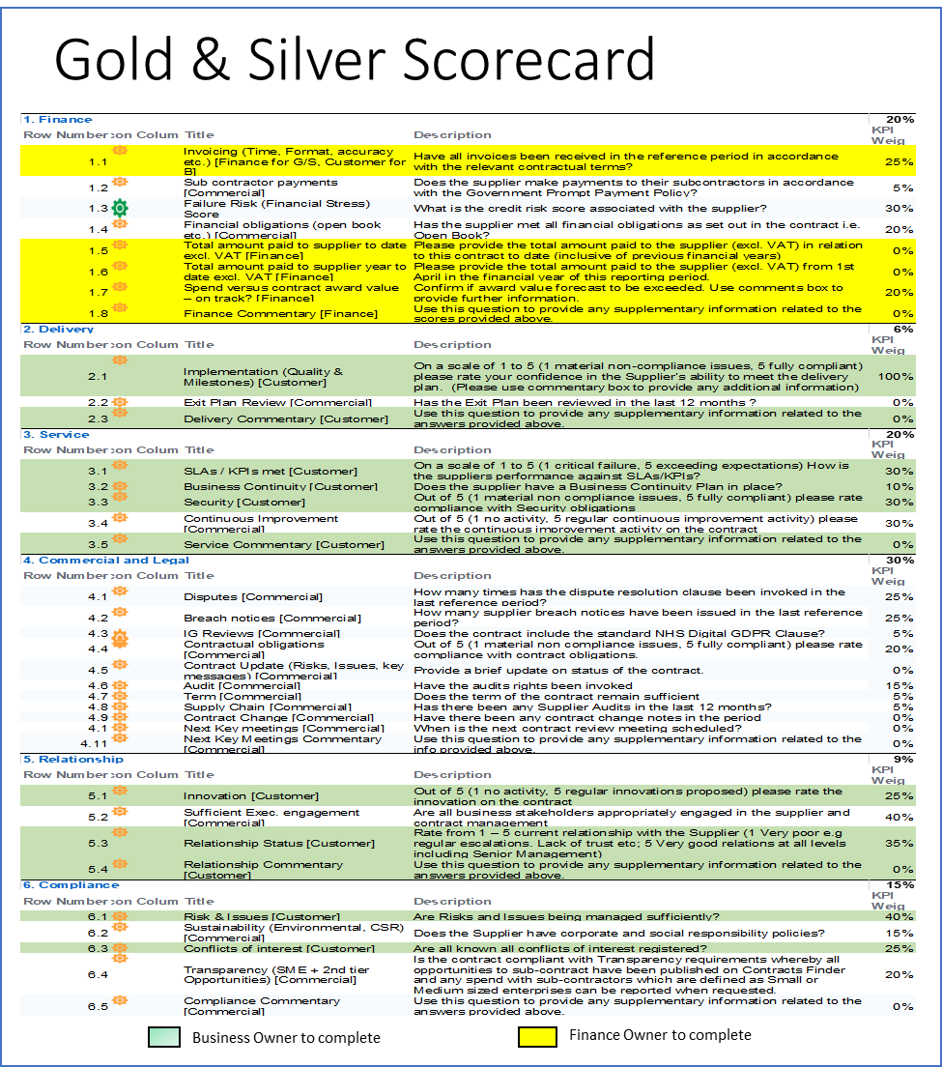

Example 2

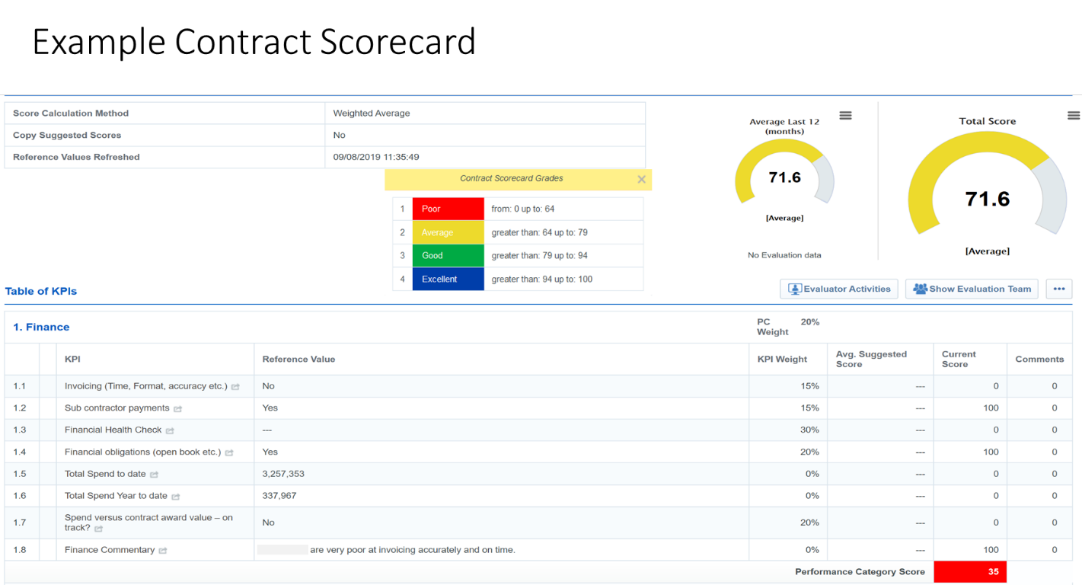

Example 3

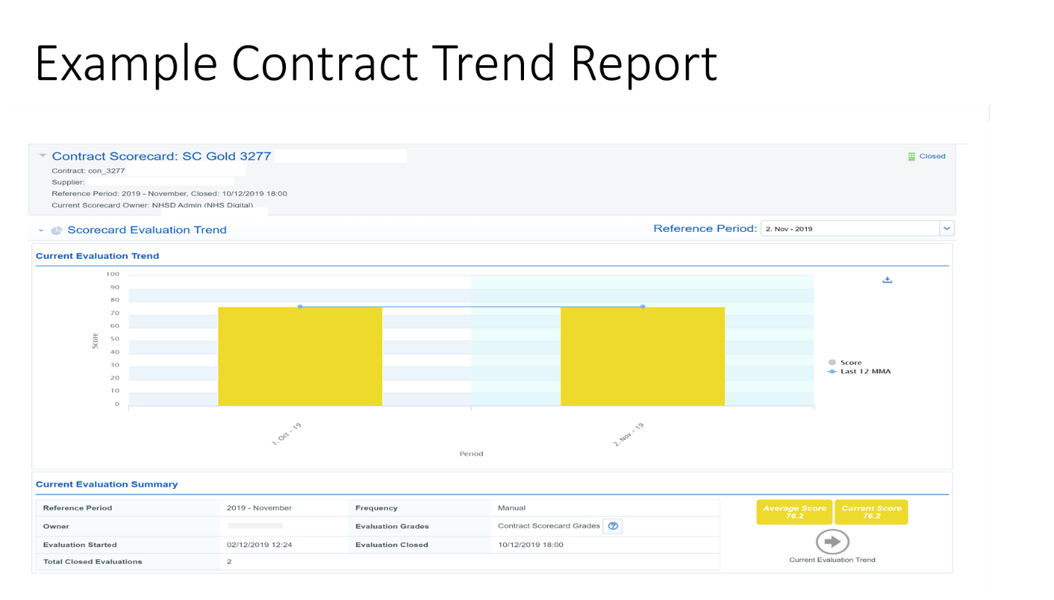

Example 4

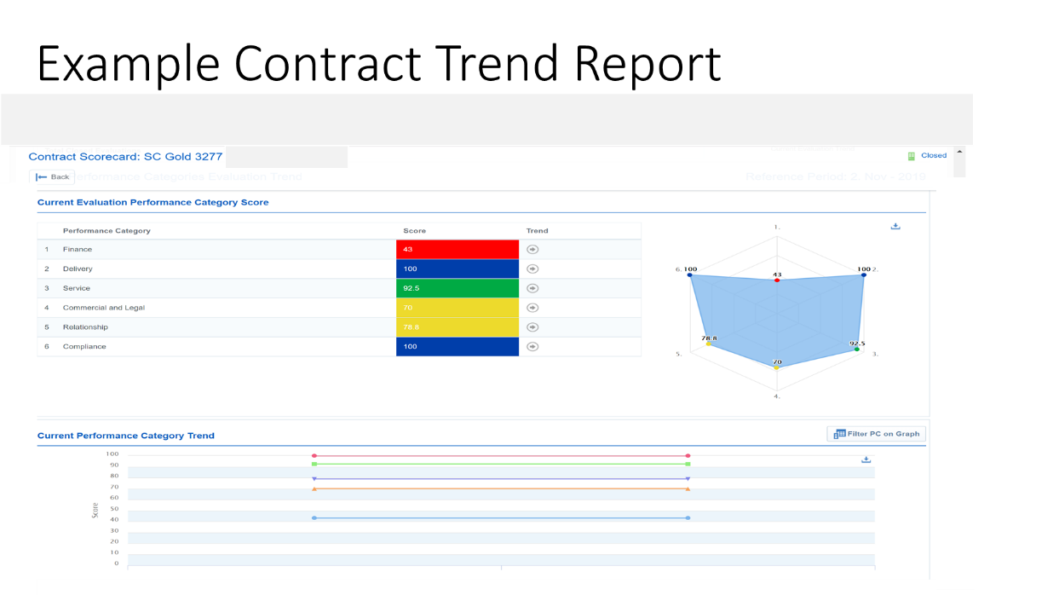

Example 5

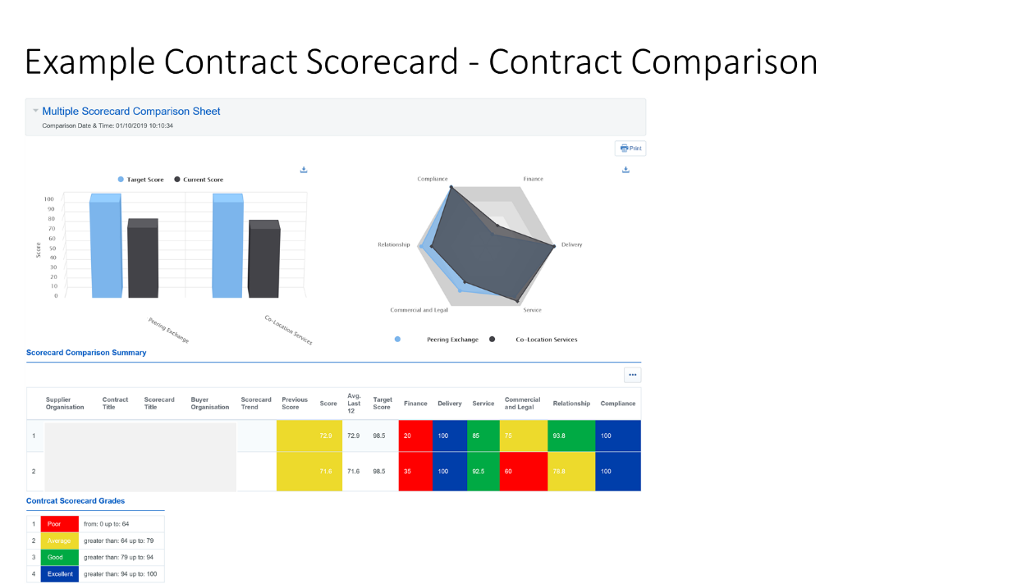

2. The purpose of the Balanced Scorecard is to promote contract management activity, through measurement of a Supplier’s performance against key performance indicators, which the Buyer and Supplier should agree at the beginning of a Call-Off Contract. The targets and measures listed in the example scorecard (above) are for guidance and should be changed to meet the agreed needs of the Buyer and Supplier.

3. The recommended process for using the Balanced Scorecard is as follows:
- The Buyer and Supplier agree a templated Balanced Scorecard together with a performance management plan, which clearly outlines the responsibilities and actions that will be taken if agreed performance levels are not achieved.
- On a pre-agreed schedule (e.g. monthly), both the Buyer and the Supplier provide a rating on the Supplier’s performance
- Following the initial rating, both Parties meet to review the scores and agree an overall final score for each key performance indicator
- Following agreement of final scores, the process is repeated as per the agreed schedule.

Annex 6: Contract Boards
The Parties agree to operate the following boards at the locations and at the frequencies set out below:
[Guidance note: Details of additional boards to be inserted (including Terms of Reference].

Named Operational Board Members
Buyer
[Title 1] | [insert name]
[Title 2] | [insert name]
Supplier
[Title 1] | [insert name]
[Title 2] | [insert name]
Other
[Title 1] | [insert name]
[Title 2] | [insert name]

Annex 7: Information to be provided on Invoice
The following information is required the be provided along with each invoice:
Ref. | Type of Information | Which Services does this requirement apply to? | Required regularity of Submission
1.1 | Details of the reference for the Call-Off Contract. | All | with each invoice
1.2 | Details of the reference of the Statement of Work. | All | with each invoice
1.3 | Details of the reference of the Variation. | All | with each invoice
1.4 | Unique invoice number. | All | with each invoice
1.5 | Buyer Purchase Order number (allocated on a per Programme basis by the Buyer). | All | with each invoice
1.6 | Date of invoice. | All | with each invoice
1.7 | Portfolio reference and programme name. | All | with each invoice
1.8 | The period(s) to which the relevant Charge(s) relate. | All | with each invoice
1.9 | Details of payments due in respect of achievement of a milestone. | All | with each invoice
1.10 | Details of any service credits or similar incentives that shall apply to the charges detailed on the invoice. | All | with each invoice
1.11 | The total charges gross and net of any applicable deductions and, separately, the amount of any disbursements properly chargeable to the Buyer under the terms of this Call-Off Contract, and, separately. | All | with each invoice
1.12 | Any VAT or other sales tax payable in respect of the same. | All | with each invoice
1.13 | A contact name and telephone number of a responsible person in the Supplier's finance department in the event of administrative queries. | All | with each invoice
1.14 | The banking details for payment to the Supplier via electronic transfer of funds (i.e. name and address of bank, sort code, account name and number). | All | with each invoice
1.15 | Detailed time sheets for any time and materials-based pricing, including unique individual identifier number (and same number to be used in all correspondence, reports, provision of information etc. in relation to Supplier’s staff), and full name. | All | with each invoice
1.16 | Copies of invoices including VAT information for any expenses-based disbursements and deductions. | All | with each invoice
1.17 | Asset number of any purchased / licensed / leased items. | All | with each invoice
1.18 | Where appropriate, details of user stories worked on by each individual. | Software Development services | with each invoice

