Crown Commercial Service Newsletter Edition No 7 May 2022
Dear Stakeholder,
Welcome to the seventh edition of the Food category newsletter and an update on Buying Better Food. This edition features:
- Commercial Agreement overview
- events
- timelines
- useful Contacts

Commercial Agreement Overview
Crown Commercial Service is continuing customer and supplier engagement during this important phase to help us to shape the agreement; we value and welcome your input and suggestions. Get in touch with the team at food@crowncommercial.gov.uk
Key principles we are working towards for the commercial agreement are:
- free at the point of use for public sector customers
- customers will be able to access and purchase via a digital platform
- next day delivery capability
- Dynamic Purchasing System principles at its core to enable food and drink producers to on board and off board at any time
- fast and simple invoicing and payment process
- customer choices to buy local across available products
- local/regional supply and distribution networks
- pilot initially with full capacity across the country
This will be an agreement managed with a single access point, using a Tier 1 supplier as an umbrella to simplify the customer journey. The agreement covers all public sector customers and all food and drink sub-categories, and we welcome the opportunity for single suppliers, a consortium or a Special Procurement Vehicle (SPV) style approach to meet the requirements. Information can be found in the Prior Information Notice (PIN)
Food and Drink progress updates on the procurement agreement can be found on the CCS website. Click to view the Food and Drink webpage

Events
Members of the Food Team have been out and about and were delighted to attend the Regional Food and Drink Summit at Edgbaston Cricket Ground, hosted by our colleagues at the Department for Environment, Food and Rural Affairs (Defra) and the Public Sector Catering Expo at the NEC last month.
It was lovely to engage with so many suppliers and to meet with lots of small and medium-sized enterprises (SMEs).
We also attended the Food and Drink Expo at the NEC in April.
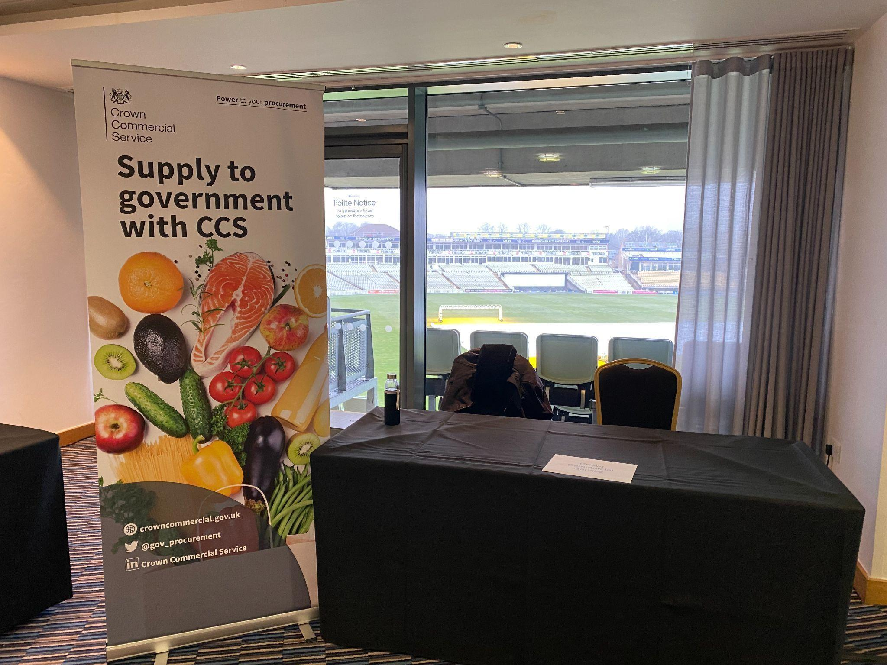
Photograph of pull up banner at Regional Food and Drink Expo, Edgbaston Cricket
Ground
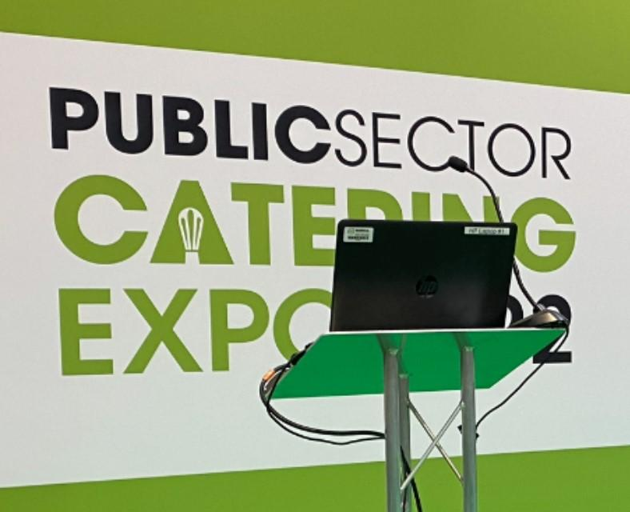
Photograph of laptop on lectern at the Public Sector Catering Expo at the NEC

The team played a key part in a recent event hosted by Grow Yorkshire. Key points covered included:
- Bob Doherty, Professor of Marketing and Chair in Agrifood at the University of York, talked about the size of the market and the series of positive economic/social/environmental benefits from changing food procurement
- Martin Traynor OBE, Small Business Crown Representative, set out what Government are doing to support SMEs
- Defra provided an update on their progress refreshing the Government Buying Standards for Food (GBSF)
The questions and answers from the webinar were:
Q. Simplicity and support will be key for SMEs to enable them to have the confidence to put the time and resource into engaging with this. How is this being considered?
A. Government has a commitment to obtain value for money and support small businesses and start-ups through procurement. We understand the challenges and barriers, especially for smaller firms, and are committed to tackling them. We want to tackle obstacles that they face when supplying or contracting with government departments and agencies.More information can be found by clicking on the link:
https://www.gov.uk/guidance/small-and-medium-business-hub
Q. How does the Crown Commercial Service Food and Drink agreement fit with the work that is being done by Dynamic Procurement UK, which seems to be working on building the digital platform regionally through which small producers could access public procurement? There seems to be no guarantee of funding to support these regional platforms and these are a critical step to SMEs being able to access the public sector?
A. Dynamic Purchasing UK (DPUK) is an independent procurement activity. CCS is not involved in this work. CCS is committed to developing an agreement that is free to use for all customers.
Q. Crown Commercial Service has recently stated that the ‘Prime Supplier’ will be required to be a Tier 1 supplier with national logistics capability. There are only a handful of such companies in the UK and the vast majority of all public sector food spend flows through these companies already today. Please can you summarise the capabilities and experience you expect the Prime Supplier to be able to demonstrate that give you confidence that a significant change versus the status quo will be delivered?
A. The details of the specific supplier capabilities and experience (or Consortia) will be detailed in the Bid pack when we go to market. The key strategy is to ensure the objectives of:
- free for all customers
- support all food producers (including small to medium sized enterprises or SMEs) in accessing public sector food opportunities
- support sustainable food production
- support the public sector in accessing local food produce at the right price
- support public sector food buyers in buying better quality, safer, sustainable food that meets The Government Buying Standards for Food
- support public sector customers in meeting carbon net zero goals
- build and monitor social value through public sector food procurement
- support investment in local communities, equality and diversity, reduction in
Modern Slavery risks, resource efficiency and environmental sustainability

- the agreement will incorporate the updated Defra Government Buying Standards for Food once they are published

Q. Isn't there contradiction between the desire to encourage more local supply versus the absolute centralisation of a single body through which all supplies are to be accessed?
A. The details of the specific supplier capabilities and experience (or Consortia) will be detailed in the Bid pack when we go to market. The key strategy is to ensure the objectives, which are listed above.
In addition, the Government Buying Standards for Food (GBSF) is being updated and Defra will be consulting on a definition of locally produced food in their consultation on public sector food and catering policy which will be launching shortly. This consultation will include a proposed definition of local, and will also gather feedback on alternative definitions and how ‘regions’ could be defined. The proposed definition of locally produced food in the consultation is currently “Ingredients produced/grown/caught within the same region as it is consumed, or a neighbouring county (for counties at regional boundaries – this may include counties in Scotland and Wales). Multi-ingredient foods may qualify as ‘locally produced’ if at least 50% quantity (Kg or L) of their ingredients are produced/grown/caught in the local region.

Earth Day April 2022
For the past 50 years, Earth Day has been celebrated by billions of people around the globe, annually every April 22, to join together in promoting awareness for the health of our environment.
You don’t need to make huge changes to your diet to help make reductions in your carbon footprint.
Buying meat from an organic producer also ensures the meat you do consume is grown with the health of the environment and nature in mind.
These approaches enable all of us to benefit from the advantages of grazing animals including:
- helping to lock in carbon in the soil
- reducing the need for chemical fertilisers
- reducing the amount of meat makes it more of an occasion or treat

Timelines
As the team continues to develop the strategy, revised timelines are as follows:
Find a Tender Q3 2022
Contract Award Q1 2023
Go Live Q2 2023

Useful Contacts
You will also find a full list of all our commercial agreements, alongside details of how we can help you build policy considerations into your procurement, in our interactive digital brochure.
We believe your buying decisions have the power to make life better for citizens across the country. I hope we can help you make those decisions with Crown Commercial Service.
If you would like to talk to someone and don’t know who your local account manager is please contact your regional/sector lead:
- CCS North - lucy.flint@crowncommercial.gov.uk
- CCS South - andrea.fitzgerald@crowncommercial.gov.uk
- CCS Central - matthew.freeman@crowncommercial.gov.uk
- CCS London - nicola.rees@crowncommercial.gov.uk
- CCS Health - gemma.northover@crowncommercial.gov.uk
- CCS Local Government - david.bemrose@crowncommercial.gov.uk
- General queries - info@crowncommercial.gov.uk
We know these remain difficult times, so please do not hesitate to get in touch if there is anything we can help you with. Call us on 0345 410 2222 or email food@crowncommercial.gov.uk
Stay safe and well
The Food Team

Stay Up to Date

