RM6347 - Transport Technology
Digital Platform
Buyer guidance on how to award a Digital Platform Competitive Selection Process (also known as an Award With Competition)

Introduction:

This guidance is to support buyers through the Digital Platform Competitive Selection procedure through the Digital Platform (currently Basware) under the Transport Technology (RM6347) agreement.

The Digital Platform Competitive Selection procedure will enable buyers to procure any deliverables as defined in Framework Schedule 1 (Specification) in an easy and compliant route.

Please read Framework Schedule 7 (Call-Off Award Procedure) for full information on the various compliant procurement routes to market.

Registration process:
To register for the Digital Platform please complete the form on the following page: https://www.crowncommercial.gov.uk/emarketplace-registration-form/

Once you are registered you will be able to login using the following link:
https://buyers.procserveonline.com/admin/login/auth?locale=en&marketplaceId=2

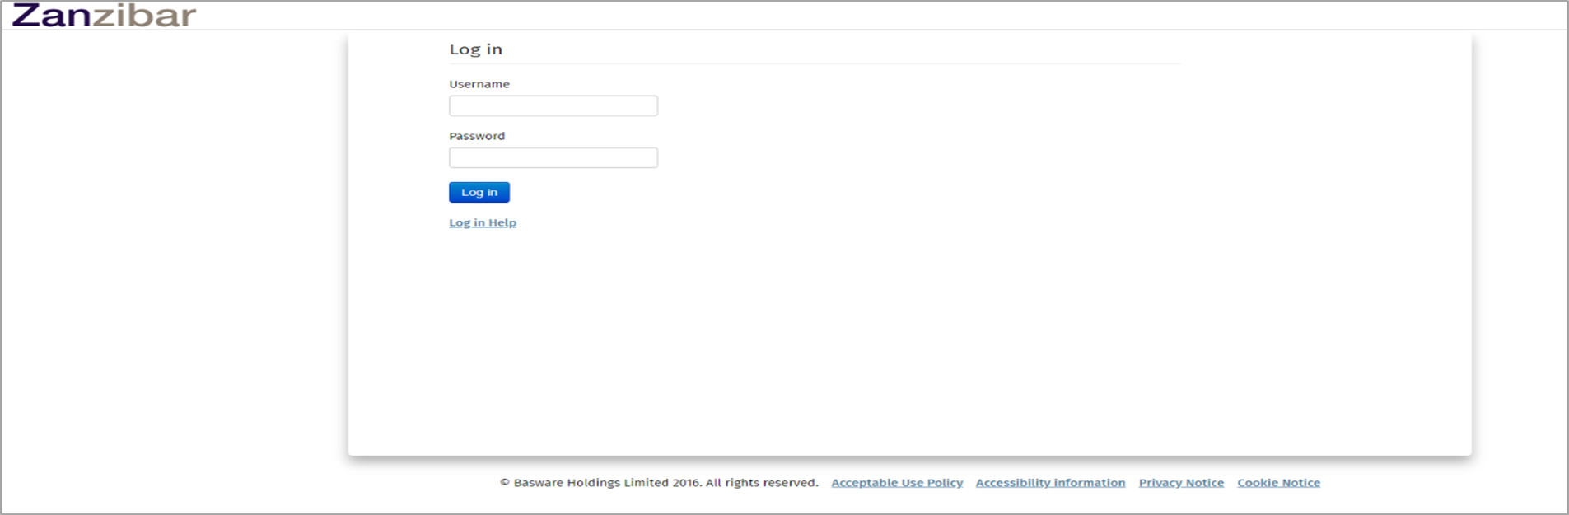

Once you have logged in you will see the following landing page where you can navigate to ‘Shopping’:

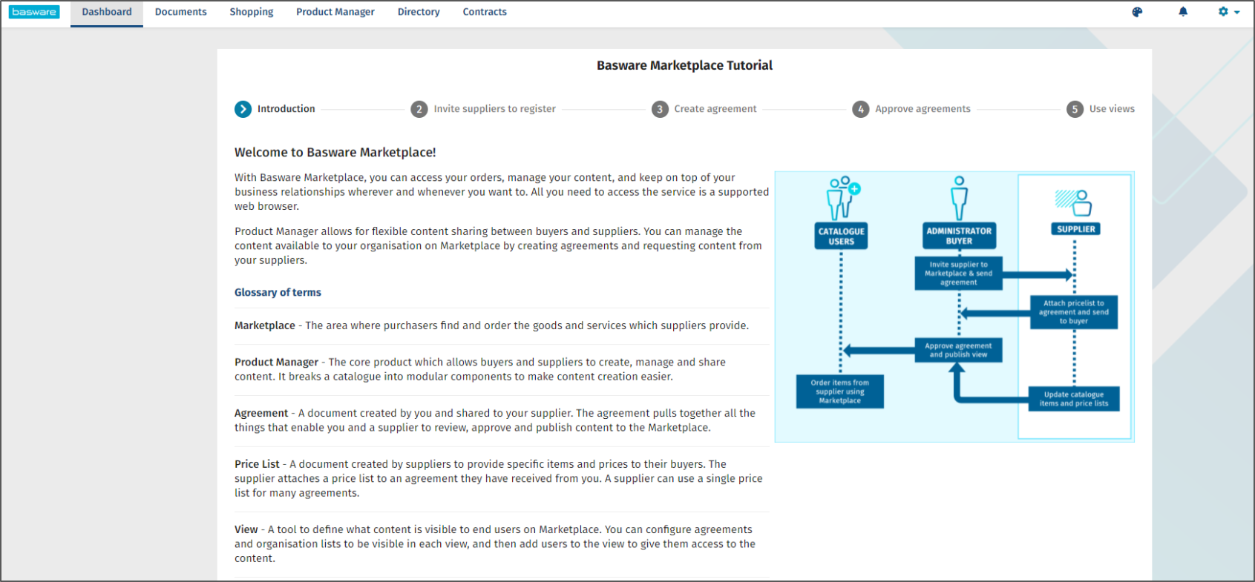

You will be taken to the ‘Marketplace’ tab where you can enter search terms into the search bar at the page below:

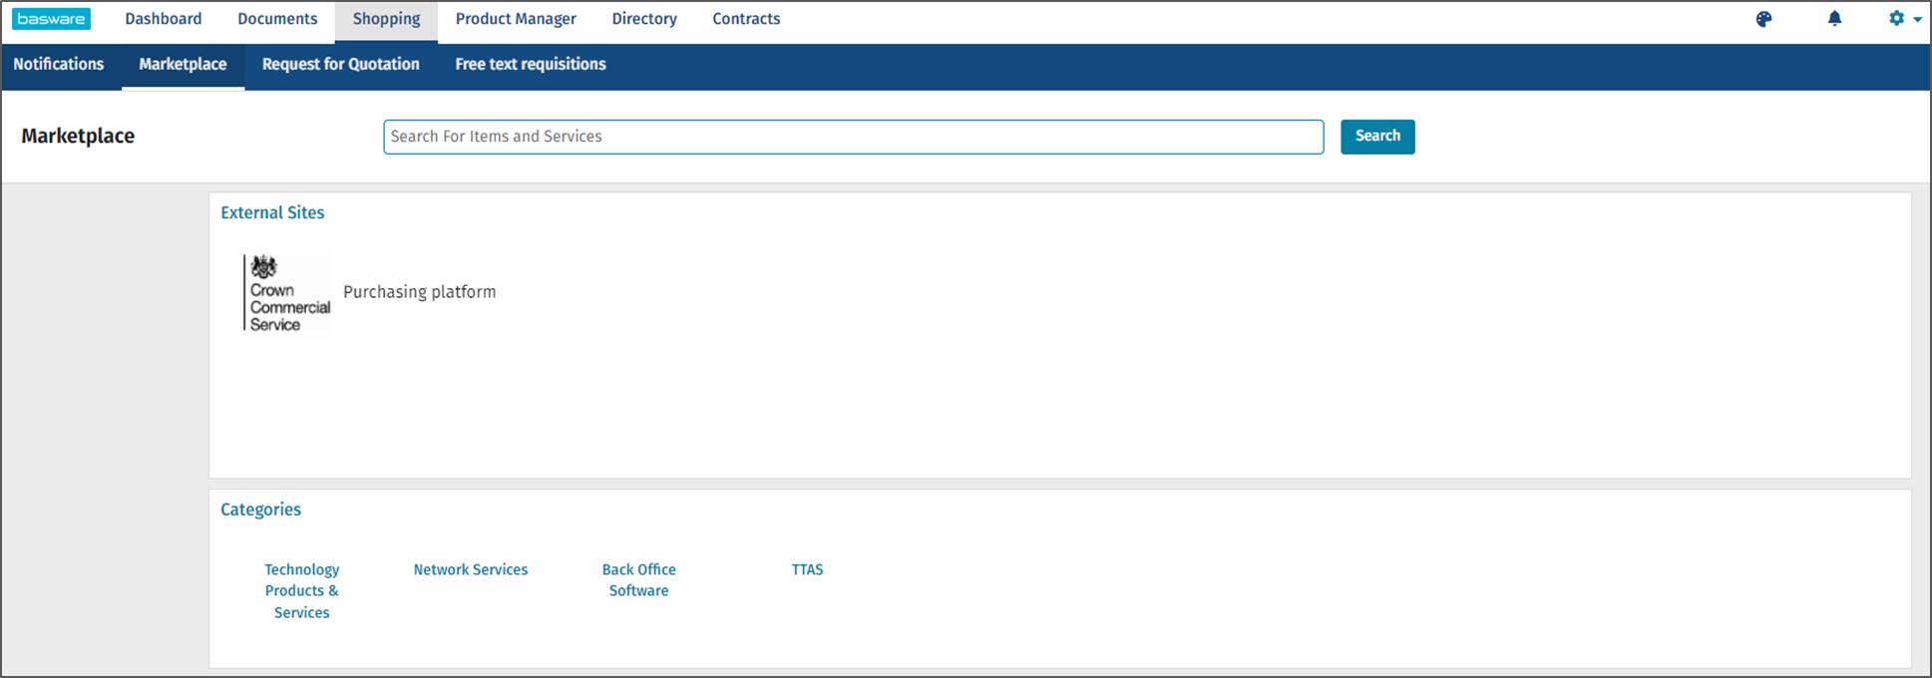
In the search bar, enter the term “RM6347”. This will then display all the Lots available under the agreement.

You will then see a Contract Reference filter on the left where you will select the procurement route (AWOC or Digital Comp) you wish to take. For this guidance document process, select “RM6347-Digitalcomp (14)”. This will show 14 results.

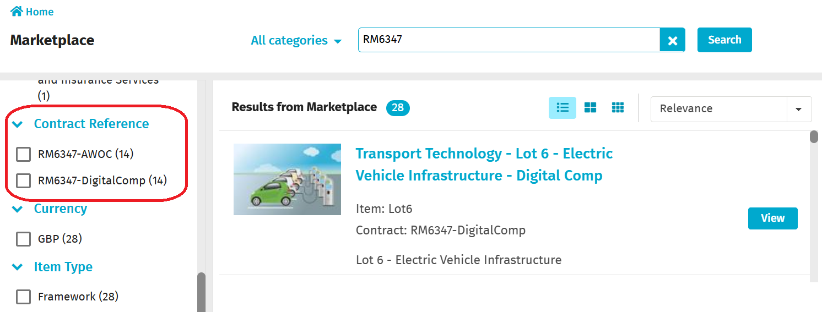

All the available lots will be visible for you to choose. The example on this screen is the Digital Competition route, and there are 14 Lots:

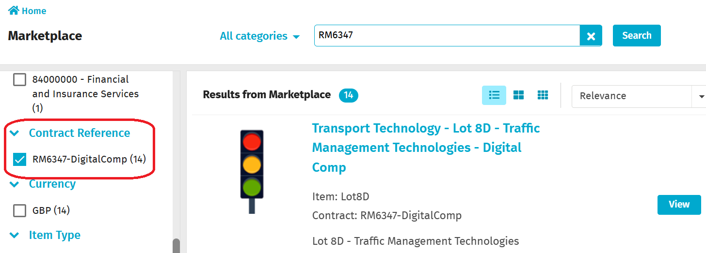

Find the Lot that you are interested in (for which the example here is Lot 8D) and Click on the View button

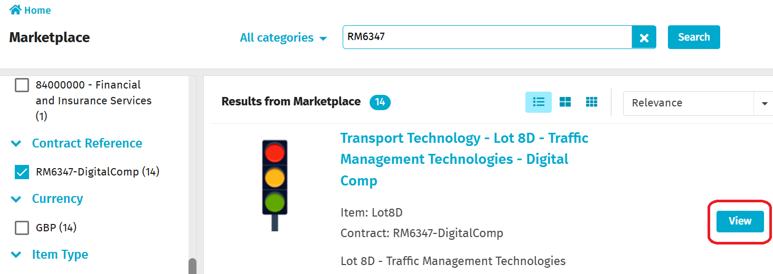

At this screen you will be able to ‘Select Suppliers’ who have published an offer against your chosen capabilities and/or specifications on this Lot.

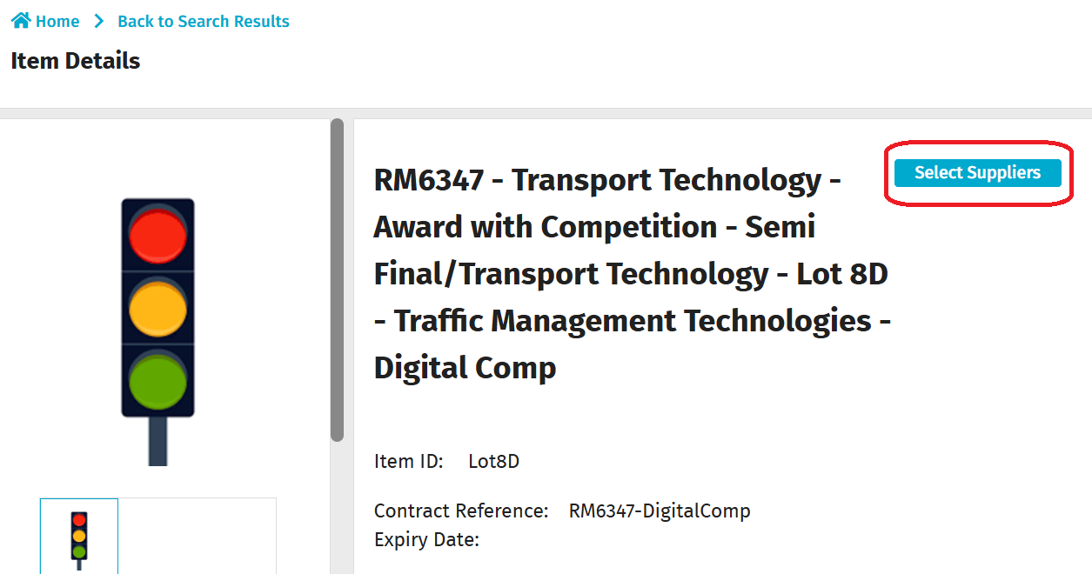

At this screen, you will need to select the ‘Capabilities’ that are relevant to your requirement using the filter on the left hand side. The full list of capabilities can be found in Framework Schedule 1 (Specification) or in the supplier’s full service offer template.

The example capability on this screen is ‘Permanent Traffic Signaling Solutions’, and you will see the list of Suppliers who will be able to provide this service. To raise a request for quote, you must then put a tick in the ‘All’ button and then click on ‘Get quotes’.

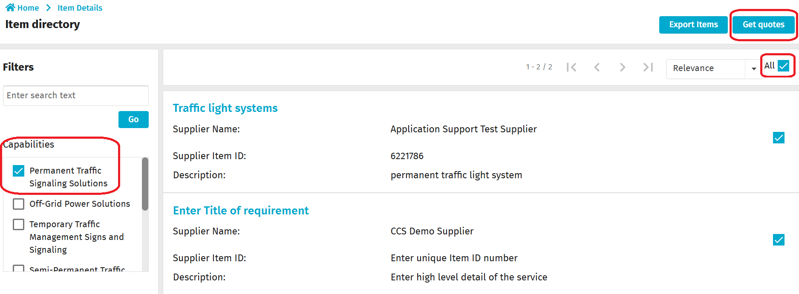

Once you have clicked on the ‘Get quotes’ button, you will see the following ‘Request details’ screen which will enable you to provide further details of your RFQ to the eligible suppliers. The fields with a red asterisk are mandatory.
If the fields are not immediately editable, click the blue pencil on the right hand of the section you need to edit.

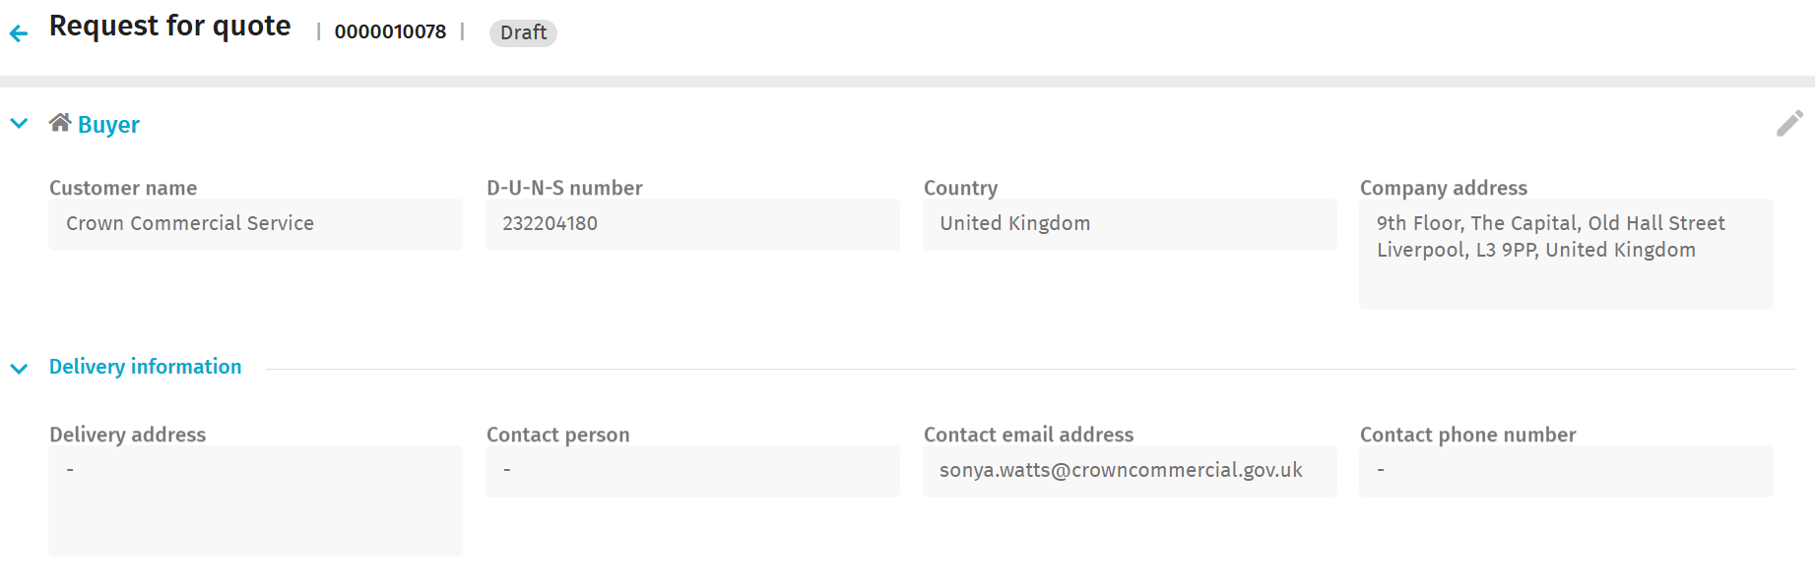
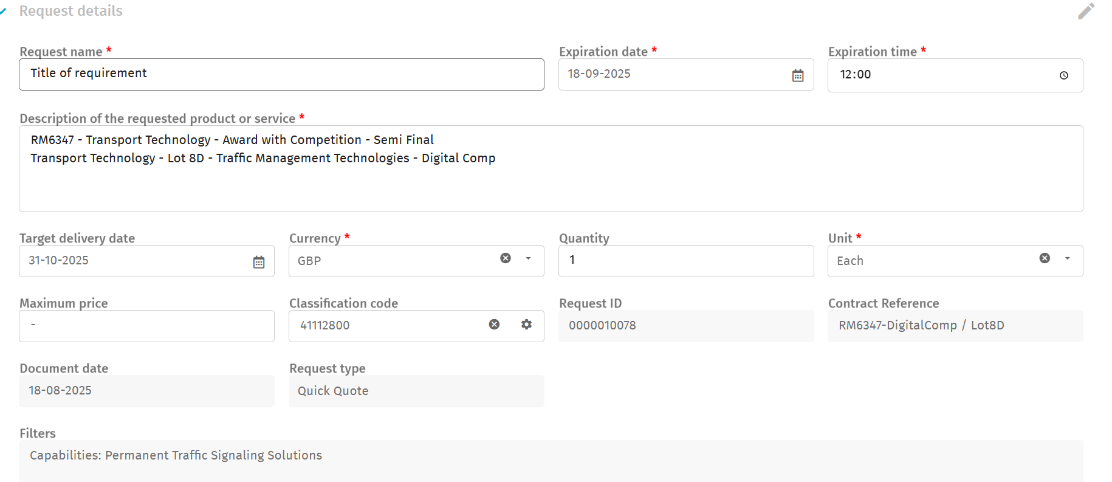
- Your Request name should be related to the requirement you have
- The Expiration date is when the suppliers must respond to your request. You can also adjust the Expiration time
- The Description of the requested product or service is intended to be high level because your request for quote template will hold the detail
- Target Delivery Date is when you require the contract to begin delivery
- Currency and Unit are mandatory and do not need to be modified. Leave quantity as “one” in this section
- Maximum price is not mandatory, but will assist suppliers if you have a maximum budget
- Classification Code is not used in our system, this can be left empty or as the default
- Request type is the feature we chose, and cannot be adjusted.
- Filters is a reflection of your journey to raise the RFQ and is used to inform our internal data
It will also allow you to select the ‘Document access’ if you want a Restricted or a Sealed bid process.
Response format allows you to insert line items for items to be quoted against. Only Line Name is mandatory so if this is used, please relate it to the scope of works inside in your Request for Quote template.
The Attachments section enables you to upload the Request for Quote template. We recommend using the CCS provided template to ensure the smoothest procurement, but you can upload your own suitable equivalent. You can also add any other details required. When complete, click on the ‘Save’ button:
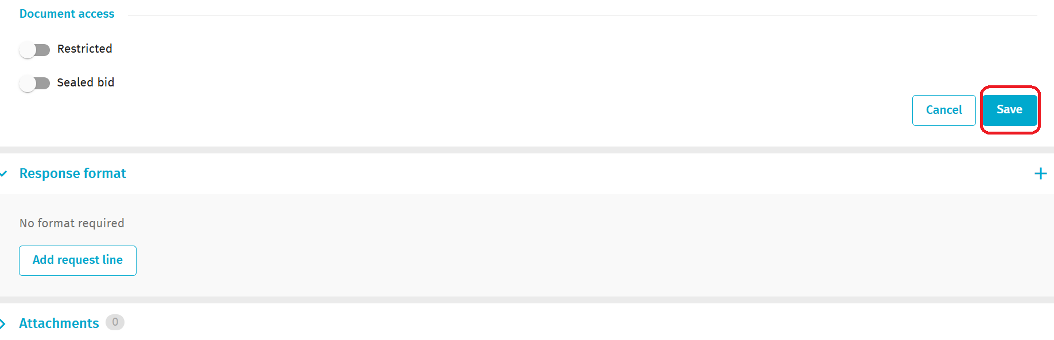

You will then see the following screen where you will need to click on the ‘Send request’ button. The supplier(s) will then receive a notification from the Digital Platform alerting them to your RFQ instruction:

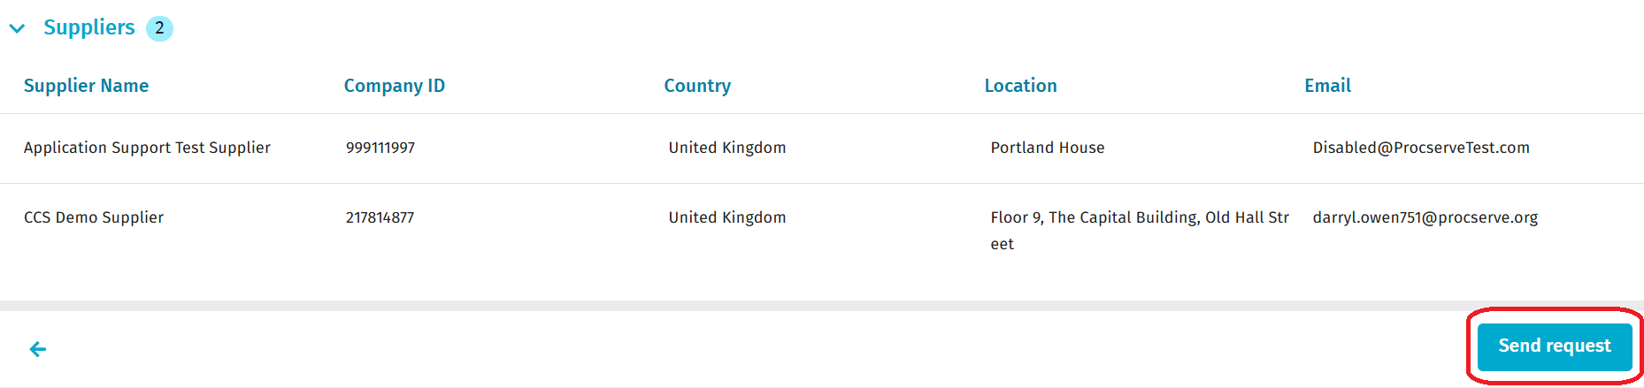

The next screen will confirm that you have an RFQ with an Open status:

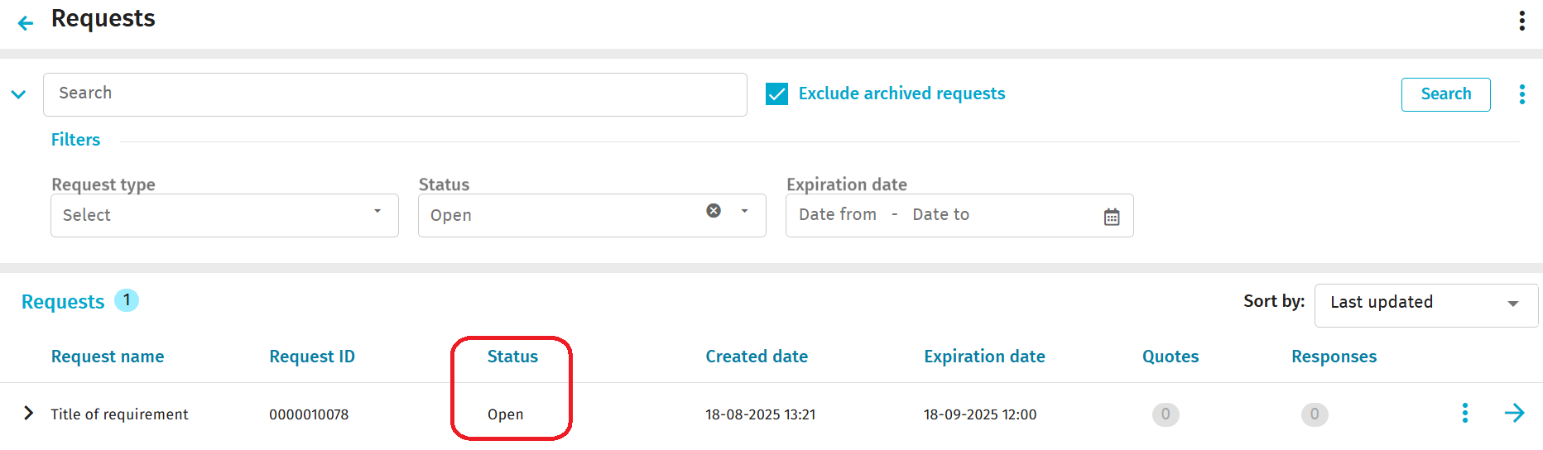

When a supplier has responded to your RFQ request, you will receive an email from the Digital Platform in line with the screen below. Please note that you will only receive an email for the first quote received and not any others:

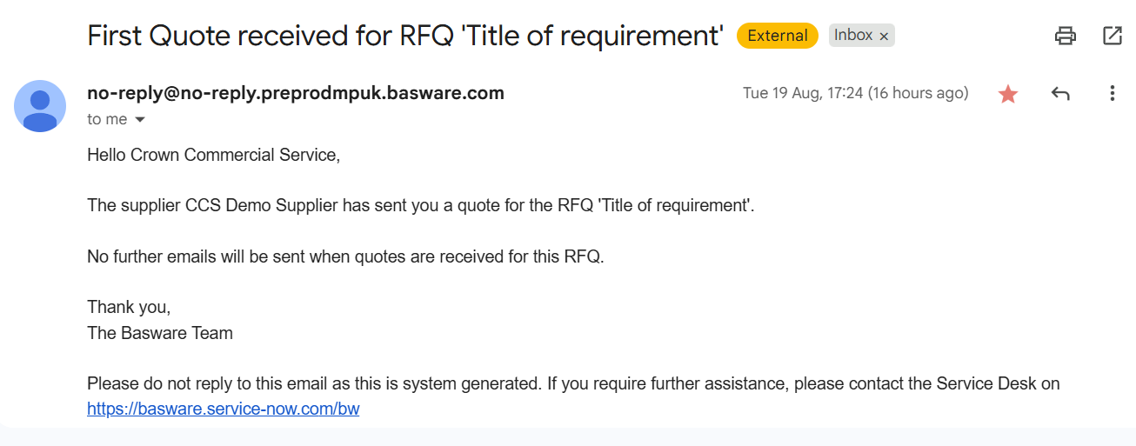

You will then need to log into the Digital Platform, and click on the ‘Shopping’ tab and then click on the ‘Quick Source’ tab. At this screen, you will see that you have an ‘Open’ request:

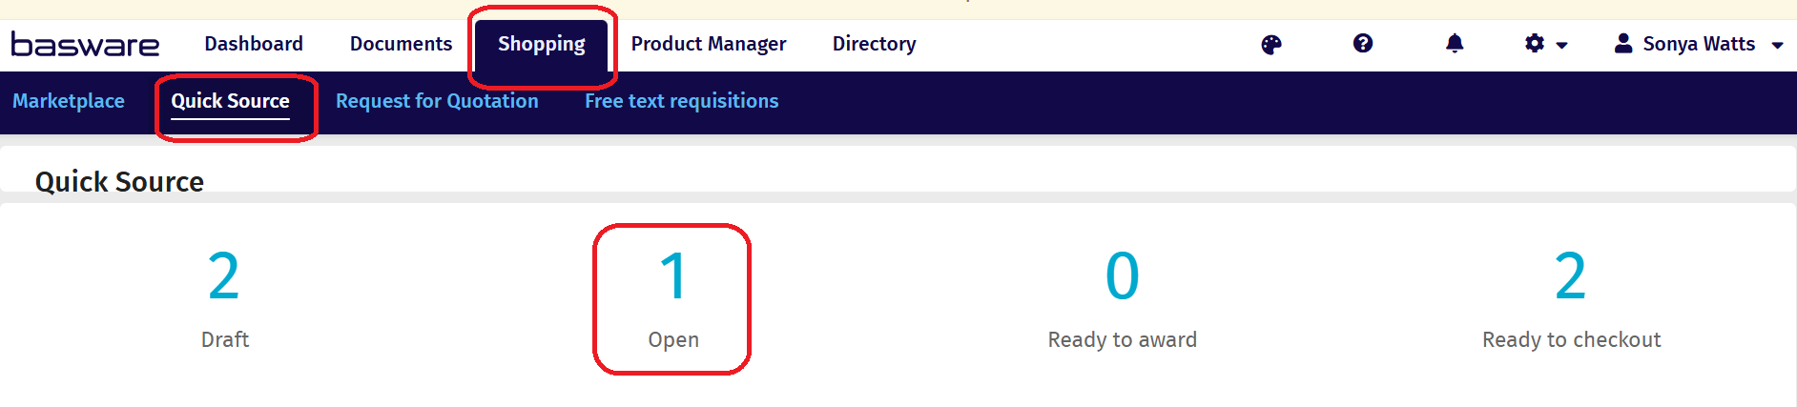

Click on the ‘Open’ request and you will see the high level details of the supplier's response. If you then click on the blue arrow, you will see the full details of the RFQ which you sent to the supplier:

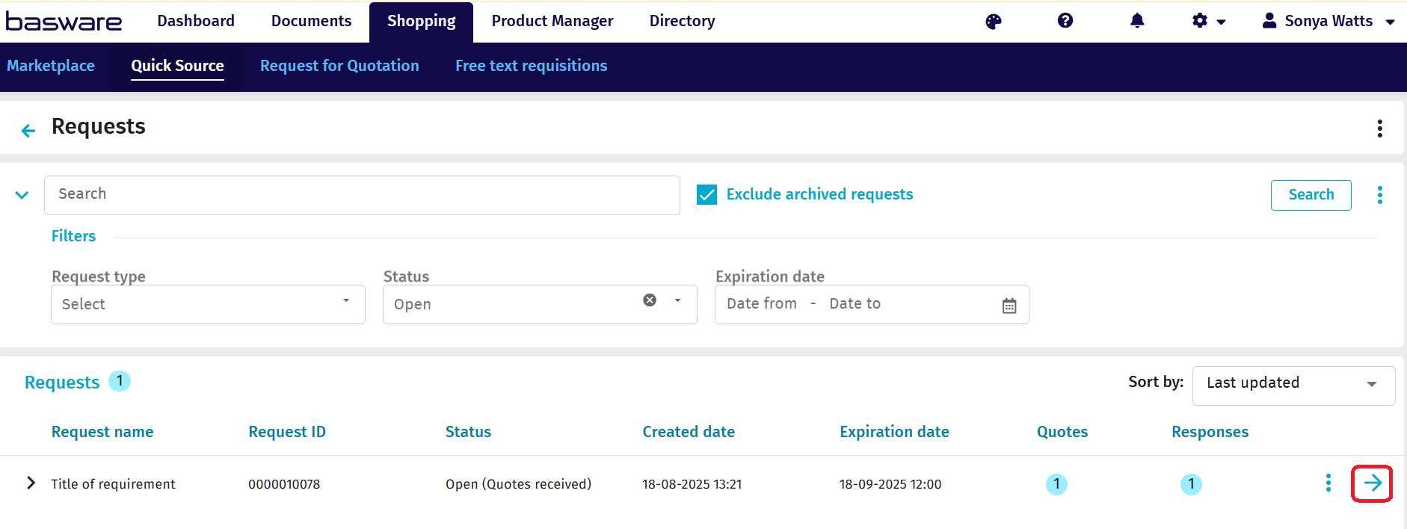

At this screen, you will need to click on the ‘View responses’ button:

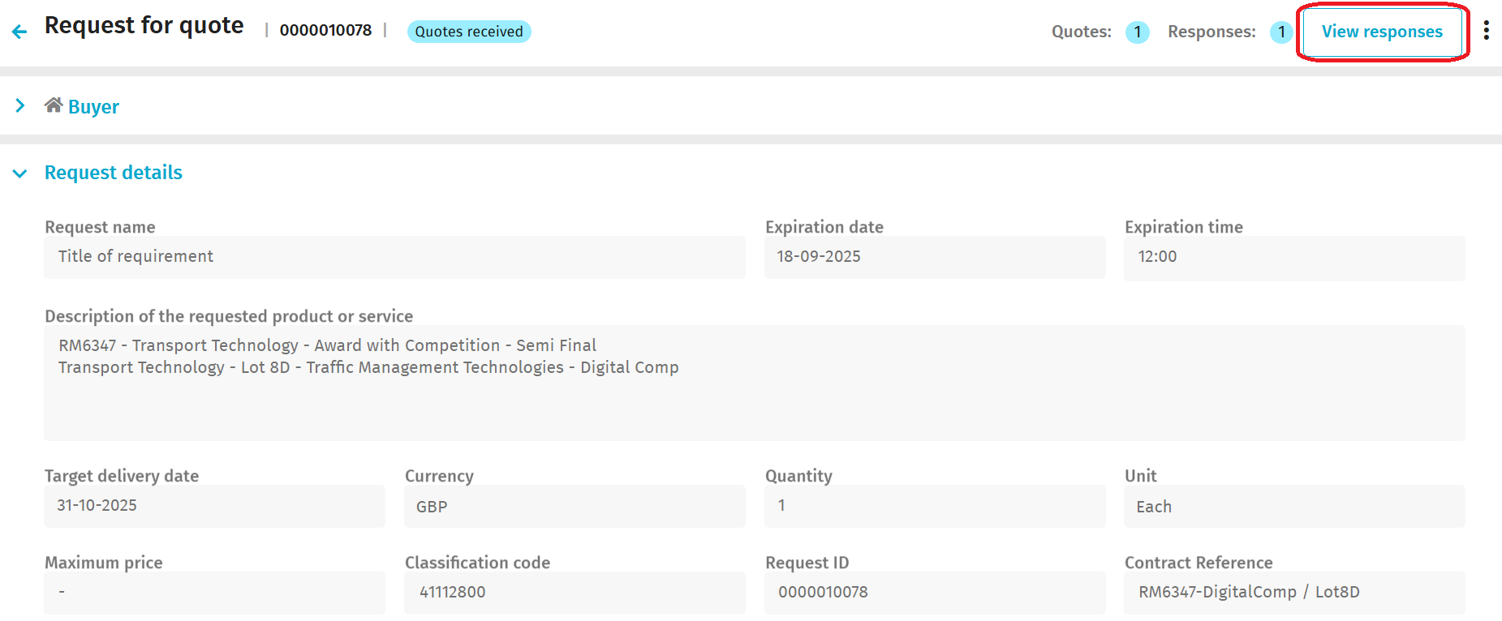

At the next screen you will see the full list of all the suppliers who have either responded, withdrawn or not responded. You will also be able to see any messages sent to you by the supplier. If you wish to send a message to a supplier, you will need to click on the ‘Send message’ button:

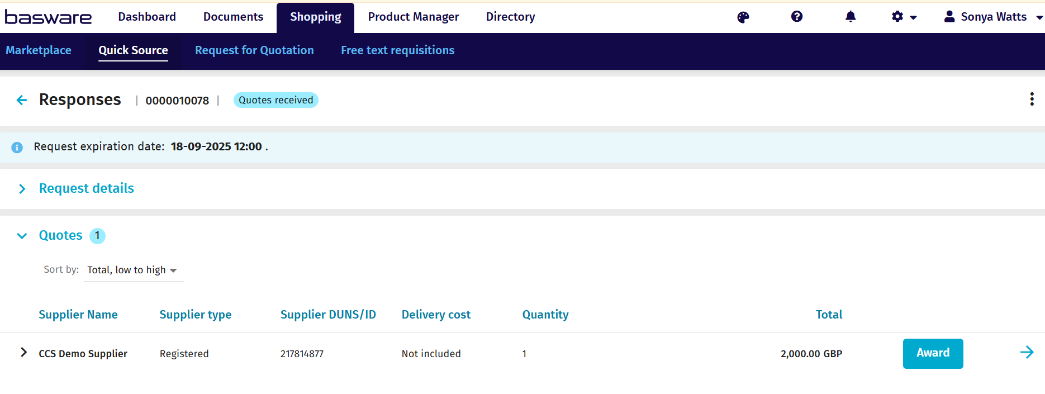

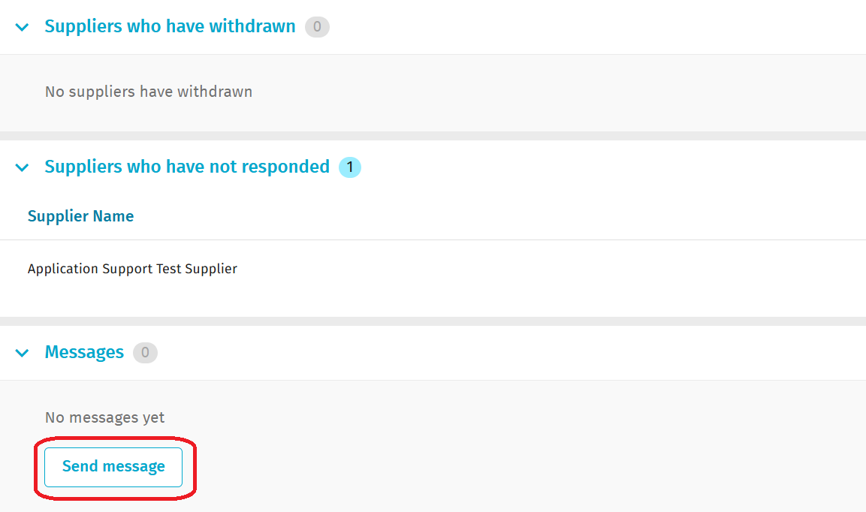

To see the full response from the supplier, click on the blue arrow alongside the supplier who has provided a quote. If you have received a few quotes from suppliers, you can sort them in a variety of ways to help analyse them (eg., by supplier, low to high quote etc):

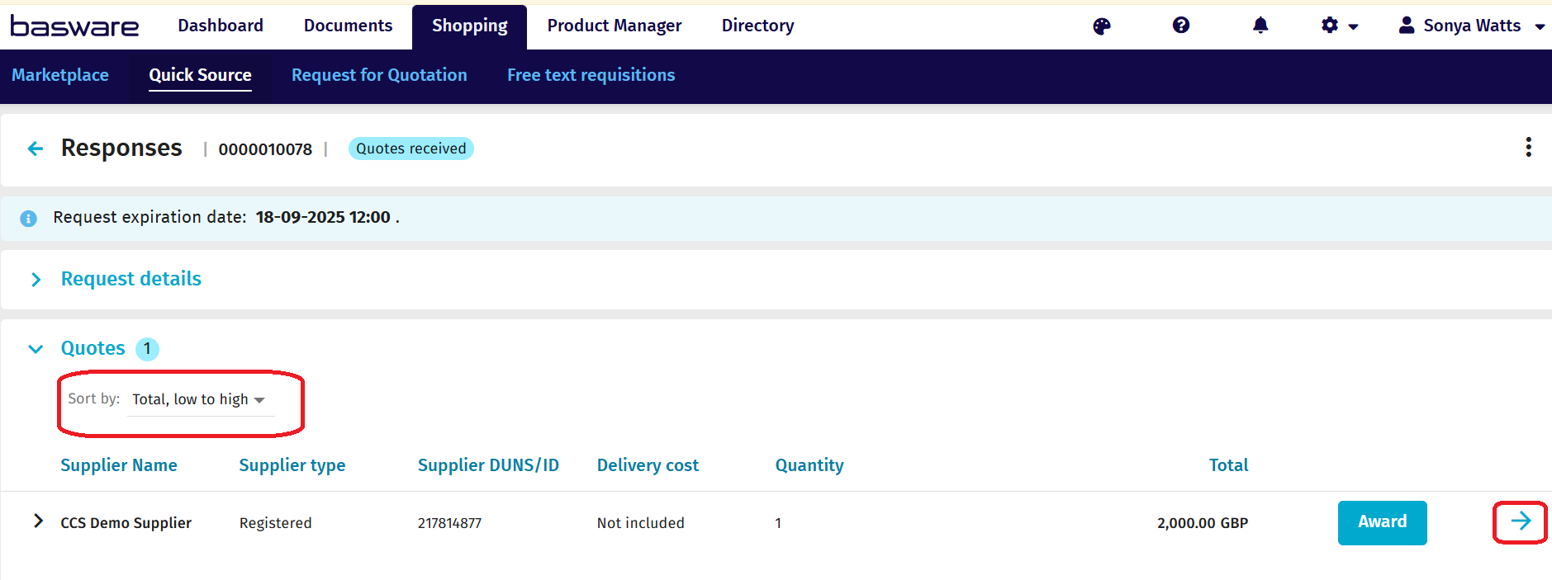

After you have clicked on the blue arrow, the full details of the quote will then appear together with any accompanying attachments:

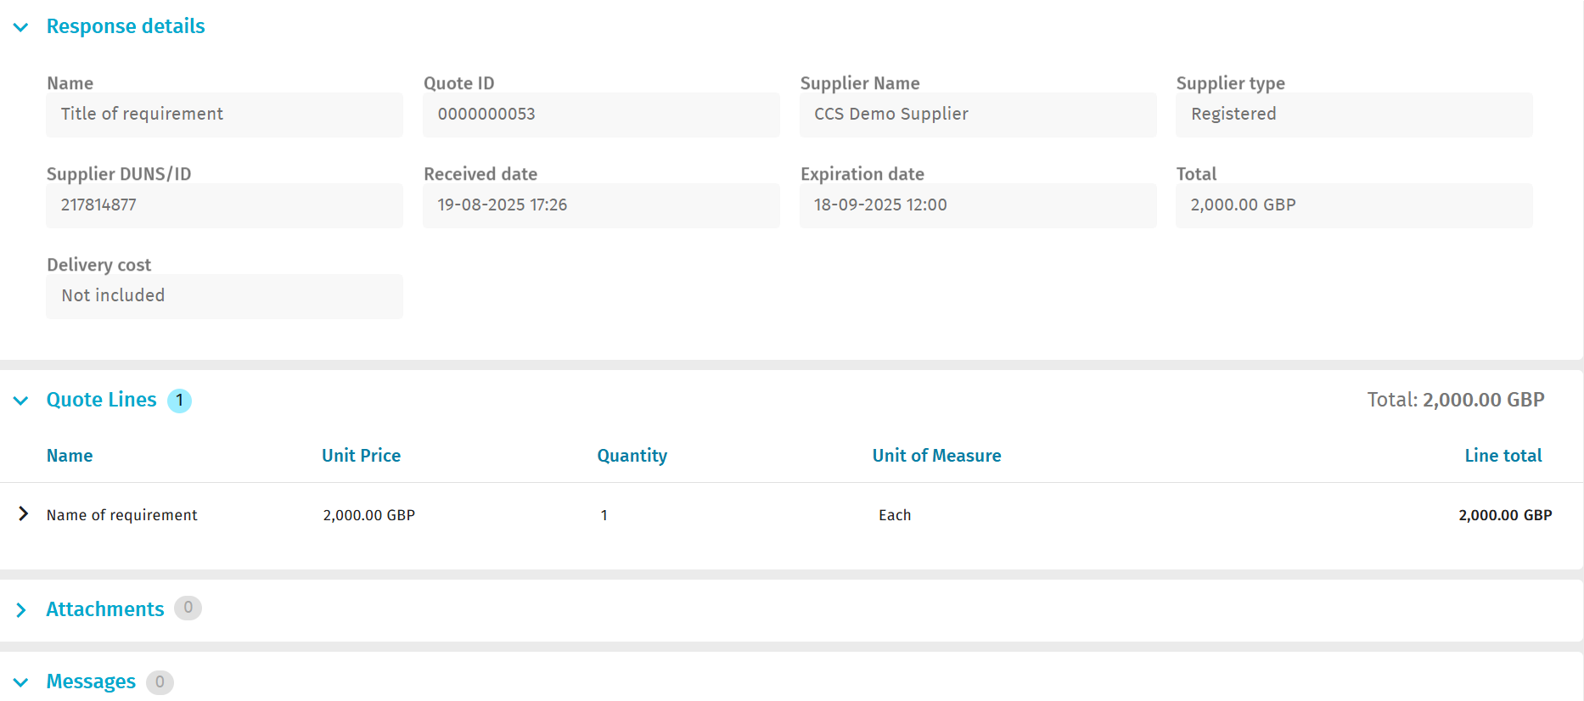

When you find the most advantageous tender, go back to the previous screen (using the blue back arrow alongside the ‘Responses’ heading) and click on ‘Award’:

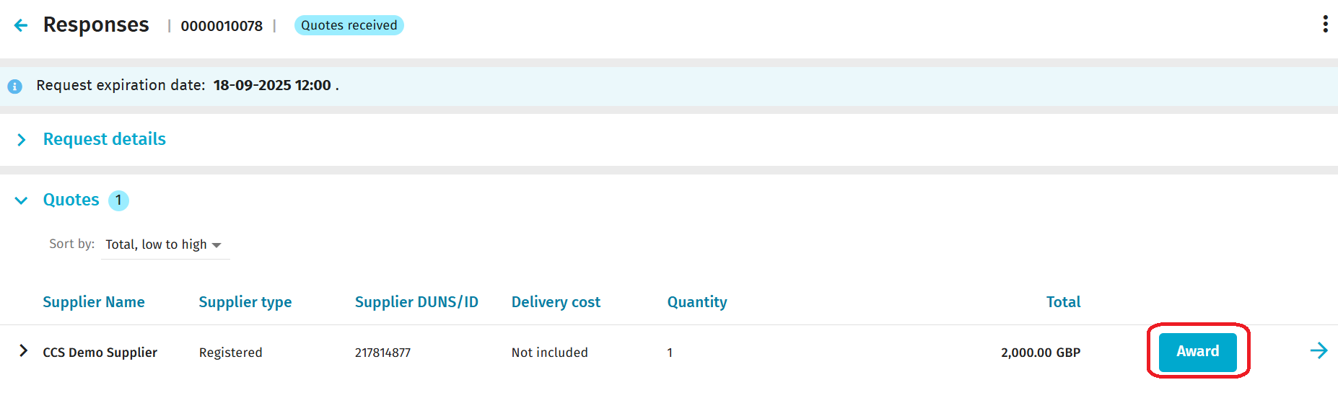
After you have clicked on the ‘Award’ button, you will see the following screen. This is where you will see the name of the supplier you have awarded to, and it will also ask you to confirm the reason why you have awarded to that particular supplier by clicking on the down arrow alongside the ‘Reason for awarding’ field. You will then click to click on the ‘Award’ button:

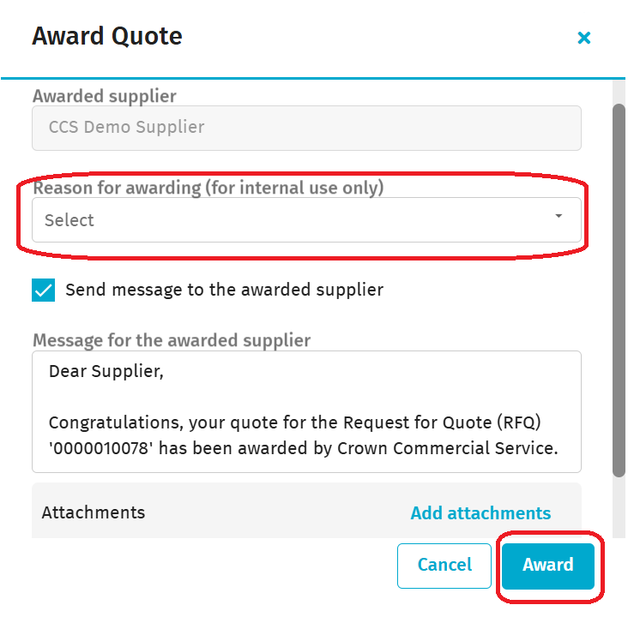
On this same screen, we recommend you also tick the rejected supplier message that will autopopulate. Additional details you feel are relevant can be included.
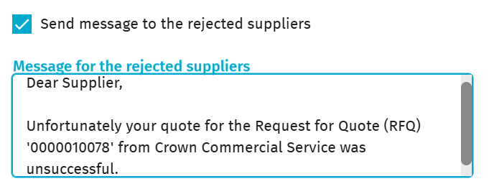

After you have clicked on the ‘Award’ button, you will get a message confirming that the quote has been awarded to the successful supplier.

If you then click on the ‘Quick Source’ tab, you will see that the number has increased in the ‘Ready to checkout’ field:

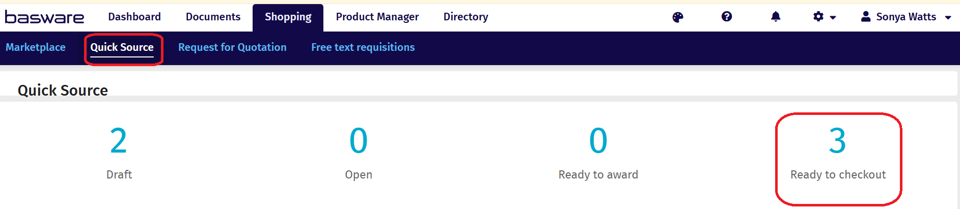

When you click in the ‘Ready to checkout’ field, you will see this screen which confirms the RFQ has been awarded:

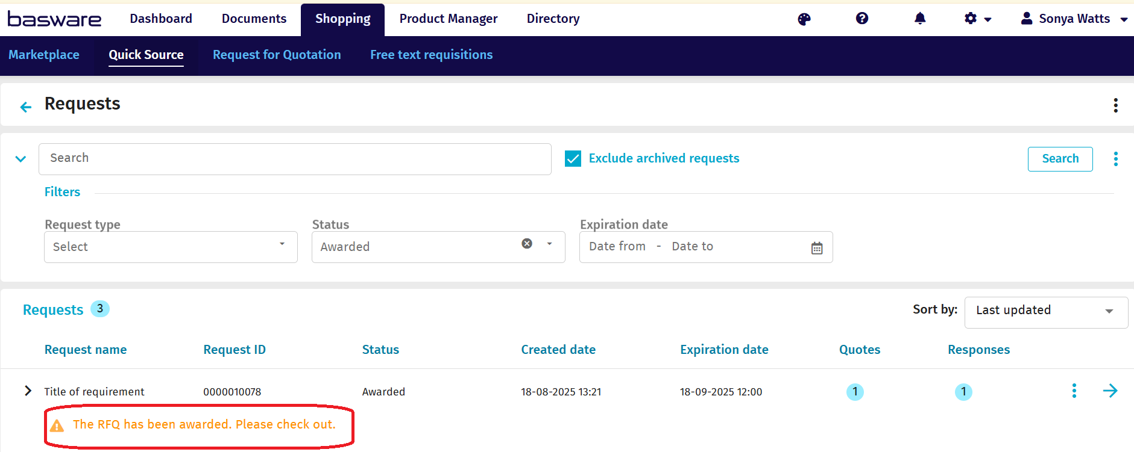

The supplier will then receive a notification from the Digital Platform that the RFQ has been awarded to them. Please note that you will now need to follow the steps below to satisfy the necessary contractual documentation.

Award and complete the Order Form:
To make the contractual award, you must complete the Order Form at Framework Schedule 6 and send it to the successful supplier.

The Order Form must be completed in accordance with the RFQ, and no additional requirements should be included.

When the Order Form has been completed, signed and dated by both the Buyer and the Supplier, it will act as the binding call-off contract for the duration of the term.

If you need to amend your signed Call-Off Contract, it must be completed through formal Contract Variation Joint Schedule 2.

Contact points:
If you have any system based queries, there are 3 ways you can do this:
1. Contact the Basware Service Desk by raising a support ticket on:
Catalog Item (public) - Basware Customer Support

From the ‘How can we help you?’ dropdown please select ‘I need help with the UK public sector’.
2. Call 0330 822 8278
3. Use the chat option on the Basware website at:

https://www.basware.com/en/contact-us

However, if your query is around the actual process or compliance, please contact the CCS Transport team on transporttechnology@crowncommercial.gov.uk.

Useful links:
Log in:
https://buyers.procserveonline.com/admin/login/auth

Supplier guide:
https://basware.service-now.com/bw?id=bw_kb_article&sys_id=9bc5fac81bad5418570fc9506e4bcb42

Customer Service Portal
Customer Service Portal - Basware Customer Support

