Your guide to buying Marketing, Communications and Research Services through CCS

Our agreements
Our agreements cover the whole marketing and communications journey from research, insight and planning through to developing and delivering campaigns. Our offering also includes events, media buying, auditing and analysis and monitoring and evaluation. You can access a wide range of agencies with specialist expertise to help you deliver public service information and campaigns on a regional, national, and international basis. The agreements can be used by central government, local government and public sector organisations such as charities and education providers.

We have an agreement in place for every stage of your communications lifecycle: Research Marketplace; Behavioural Insights; Campaign Solutions 2, Communication Marketplace, Media Buying; Communication Performance Audit & Analysis & Media Monitoring

The diagram is to illustrate a communications lifecycle only.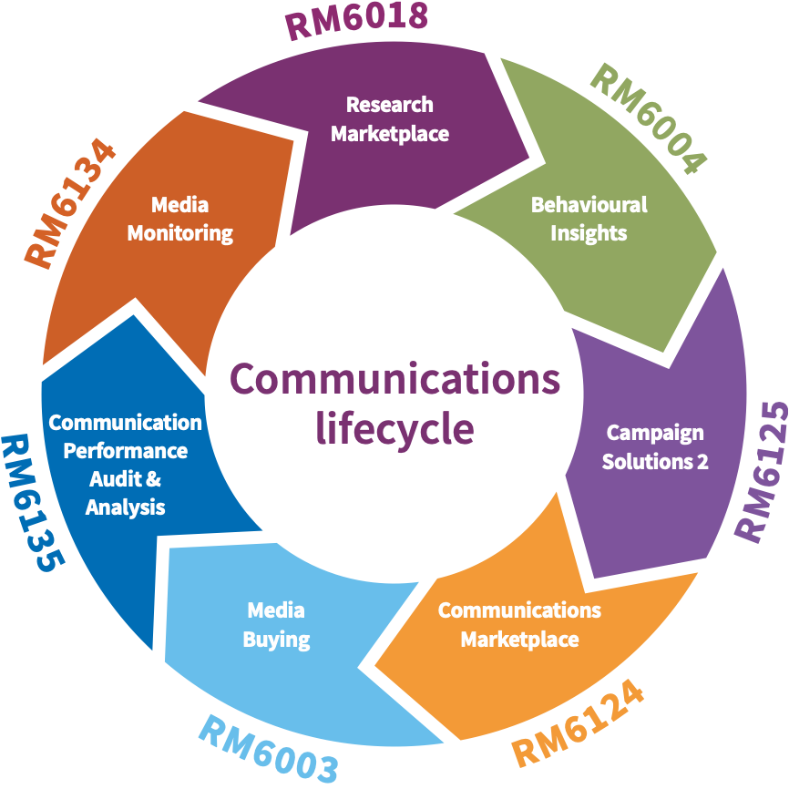

Inform action and build knowledge

Research Marketplace RM6018

Covers social, economic and market research services.
Use filters to shortlist suppliers by:

- subject area
- research method
- specific participation group
- research location
- multi-supplier dynamic purchasing system
- wide range of suppliers of all sizes and specialist expertise
- quicker process for new suppliers to join at any time
- access through call off competition only
- ends 15 February 2022

Understand your audience

Behavioural Insights RM6004

Wide range of applied behavioural insights services to inform policy and service design by using behaviour change.

- policy analysis, development and advice
- facilitates an innovative approach to decision making
- service insight, design, delivery and organisational reform

- design, implementation, evaluation and reporting of trials
- capability building including training
- single lot, 6 suppliers (2 SMEs)
- wide range of applied behavioural insights services to inform policy and service design
- facilitates an innovative approach to decision making
- access by further competition only
- ends 04 February 2022

Design a solution

Campaign Solutions 2 RM6125

For integrated end to end campaign solutions - domestic and international. With 26 agencies across five lots, the agreement covers:

Lot 1: End to end campaign solutions such as creative, partnerships, marketing and PR
Lot 2: Media, strategy and planning

Lot 3: Fulfilment services such as translation, transcreation and versioning
Lot 4: Stock imagery, footage and sound
Lot 5: Major or strategically important events
Access by call off competition only
Ends 07 September 2023

Communications Marketplace RM6124

A broad range of specialist marketing and campaign services for standalone contracts or to support an integrated campaign. Agencies can join this dynamic marketplace at any time. Use filters to shortlist agencies by service, audience, outcome and location for delivery. Access by call off competition only.
Services include:
- creative development
- direct marketing
- sponsorship
- events
- production
- public Relations (PR)
- social marketing and emerging channels
- campaign coordination
- marketing and advertising technology advice
- data science
- in-house agency services
- recruitment advertising
- partnerships
- content aggregation marketing
- marketing and communications strategy
- marketing strategic advice and consultancy
- data provision, management and augmentation
- internal communications and engagement
- innovation and experience

Buy media space for your campaign

Media Buying RM6003

Single agency who has set up a media team to buy across all off- and online channels in the UK and overseas.

- television
- radio
- cinema
- press
- out-of-home (including ambient)
- digital
- partnerships
- sponsorship
- lots more

Single agency, Manning Gottlieb OMD. Focus on quality, transparency, viewability & brand safety
Access by completing the CCS briefing template and requesting a quote directly from the agency
Ends 21 May 2022

Communication Performance Audit and Analysis RM6135

Provides all the services needed to improve campaign outcomes by increasing value across all paid communication activities, establishes best practice, identifies inefficiencies, and improves behaviours.

Lot 1 - Contract and Pricing Compliance
Lot 2 - Effectiveness and Outcomes
Lot 3 - Ecosystem Strategic Advice and Support

- 3 lots, 5 agencies (3 SMEs)
- review total campaign spend, or specific elements
- measure performance in real-time
- assess existing marketing contracts including those not through a CCS framework

- lot 1 and 2 by direct award, lot 3 by further competition
- ends 08/03/2023 (option for one year extension)

Media Monitoring and Associated Services RM6134

Allows you to:

- monitor, analyse and evaluate media coverage (print, broadcast, online, digital and social media)
- evaluate communication campaigns

- optional services include databases, automated evaluation and analysis, parliamentary monitoring and social media monitoring tool

Access a range of media monitoring and associated services (including automated evaluation, forward planning and media contact databases and parliamentary monitoring) in one place

A range of suppliers with a broad range of experience, expertise and commitment to quality

Manage emerging news stories quickly and effectively based on keywords and topics
Single lot, 5 agencies

Access by further competition, or direct award value is up to £20k per annum

Ends 31 May 2022 (option for two-year extension)

Before you buy

Central government customers spending over £100k must seek Professional Assurance Approval. Other public sector organisations should obtain relevant internal approval before using the Media Buying, Campaign Solutions 2 and Communications Marketplace frameworks and procuring campaign related activities through the Research Marketplace. The customer guidance notes can be found on each framework’s webpage.

Government bodies using the Campaign Solutions 2, Communications Marketplace, Media Buying and Media Monitoring frameworks are required to pay the Government Communication Service (GCS) Levy. This is 1% of the total net contract value.

Further detail are available it he respective Customer Guidance Notes.

Contact us

To get in contact with us, you can use the following:
Email address: marcommsandresearch@crowncommercial.gov.uk
Telephone: 03454102222
Website: www.crowncommercial.gov.uk

Contact us
For further information in relation to your brief and
general advice about using Crown Commercial Service
marketing and research agreements please contact our
Customer Service Centre:
0345 410 2222
info@crowncommercial.gov.uk
www.crowncommercial.gov.uk

@gov_procurement

Crown Commercial Service
Central government customers spending over £100k must
seek
Professional Assurance Approval
Other public sector
.
organisations should obtain relevant internal approval
before using the Media Buying, Campaign Solutions 2 and
Communications Marketplace frameworks and procuring
campaign related activities through the Research Marketplace.
The customer guidance notes can be found on each
framework’s
webpage

.
Government bodies using the Campaign Solutions 2,
Communications Marketplace, Media Buying and Media
Monitoring frameworks need to pay the Government
Communication Service (GCS) levy. This is 1% of the total net
contract value.
Further details are available in the respective Customer
Guidance Notes.

